Here is a GitHub project that may help:-

<https://github.com/anshulc55/Jenkins_Upgradev3>

Installing Jenkins on a Cloud based machine (below link is a $100 free voucher):-

<https://www.digitalocean.com/?refcode=98ed549bfab5&utm_campaign=Referral_Invite&utm_medium=Referral_Program&utm_source=CopyPaste>

Sign in to Cloud Digital Ocean account.

Click the ‘Create’ button and select ‘Droplets’:-

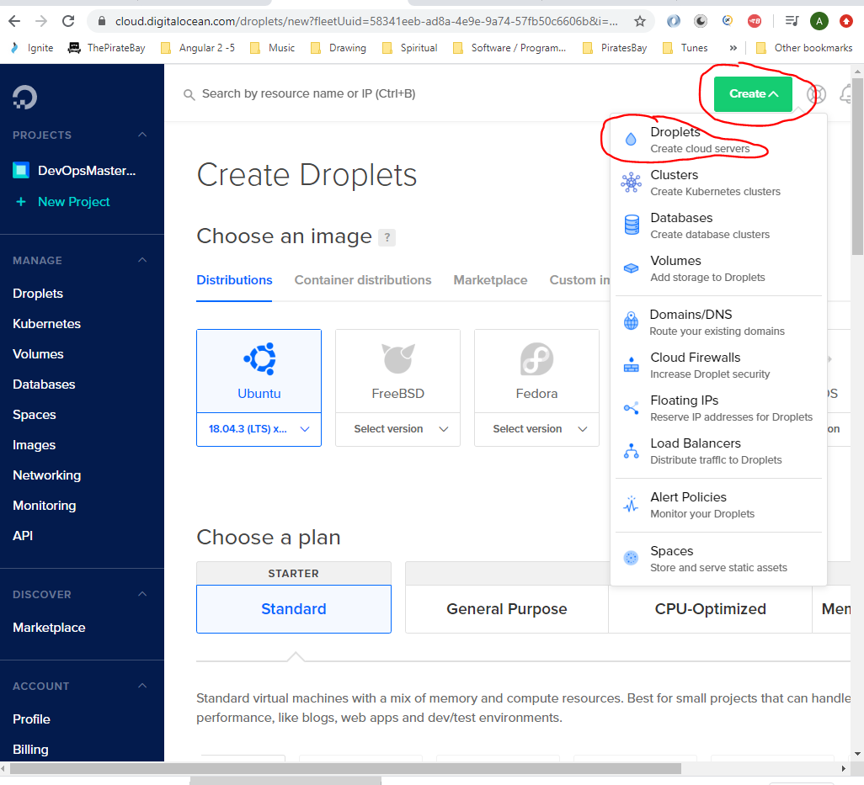

Then select:-

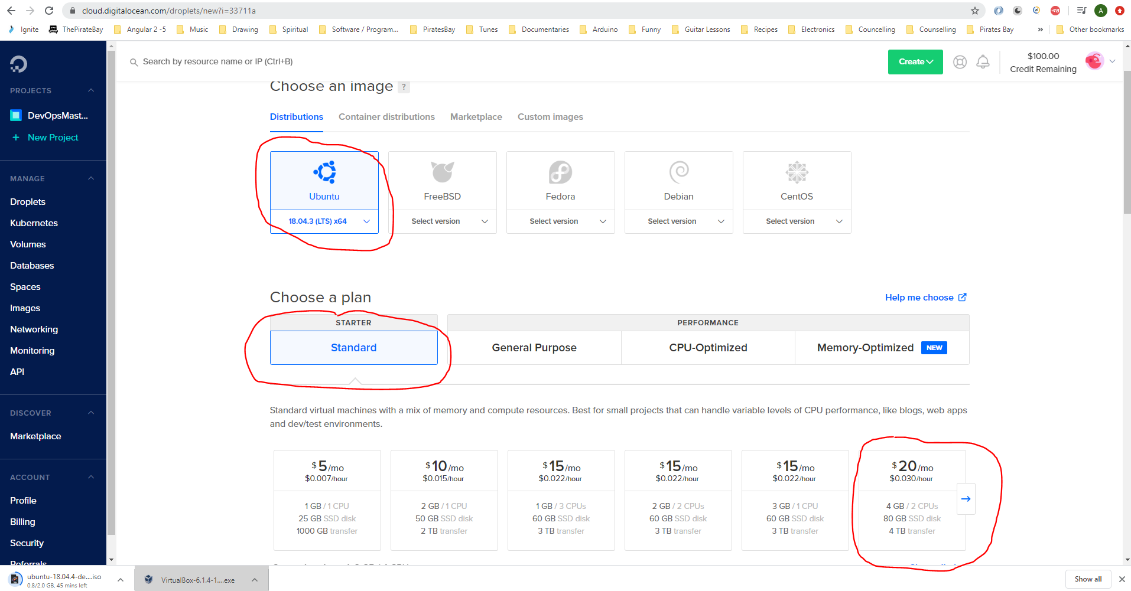

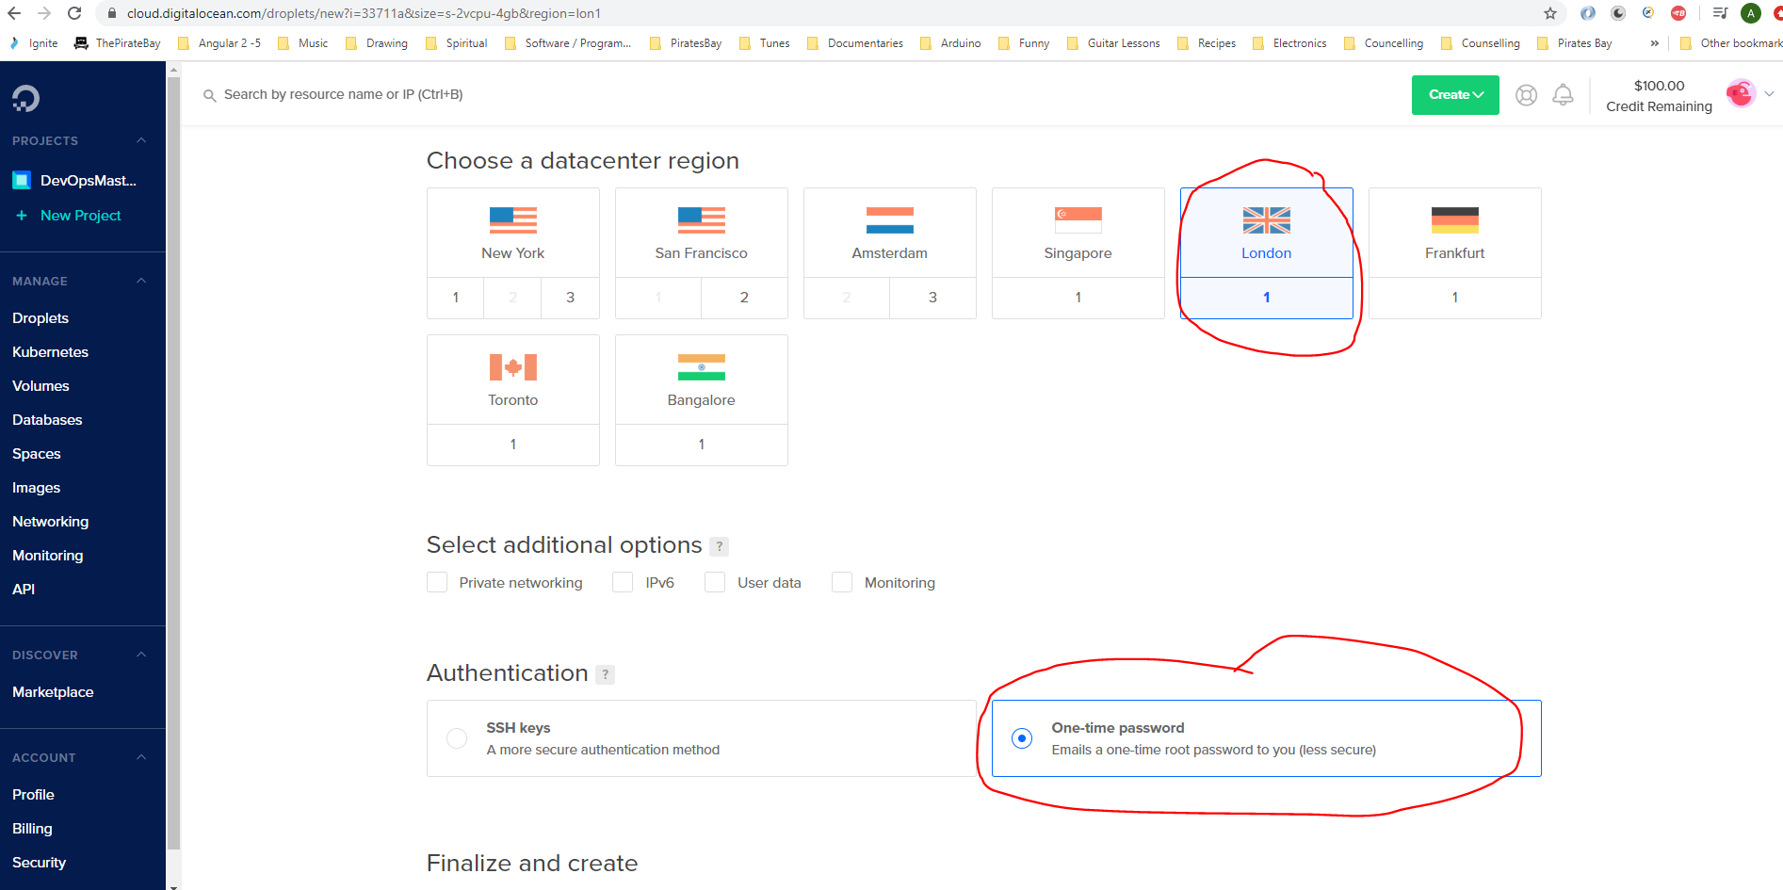

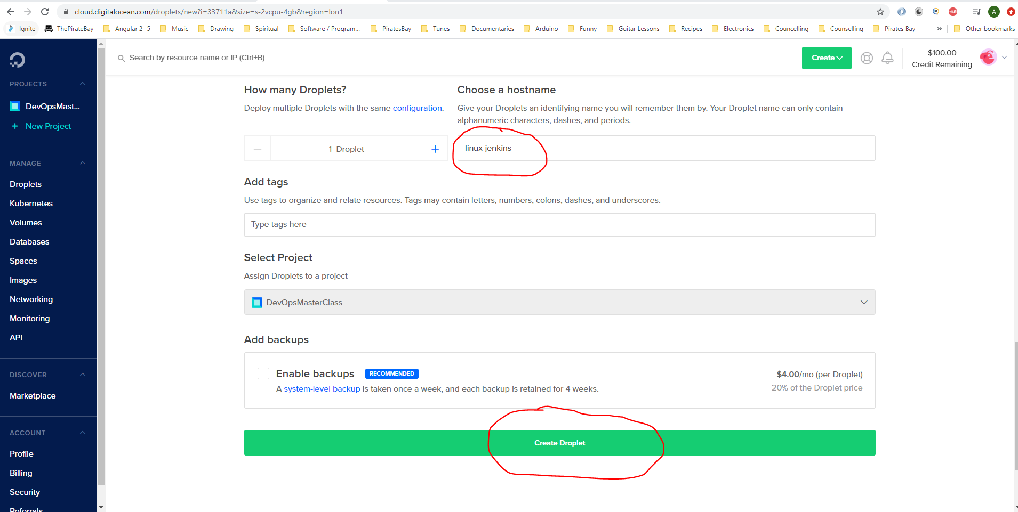

When the machine has been built and is ready copy the ip address:-

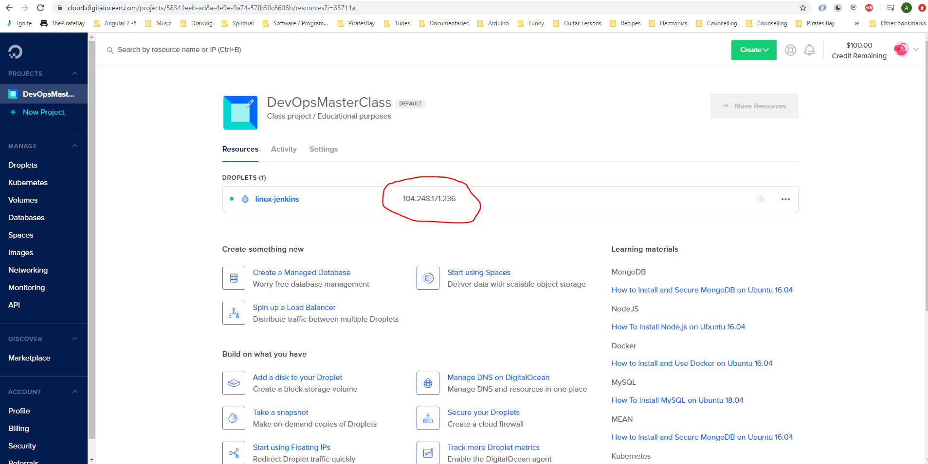

Download Putty:-

<https://www.ssh.com/ssh/putty/download#download-putty-installation-package-for-windows>

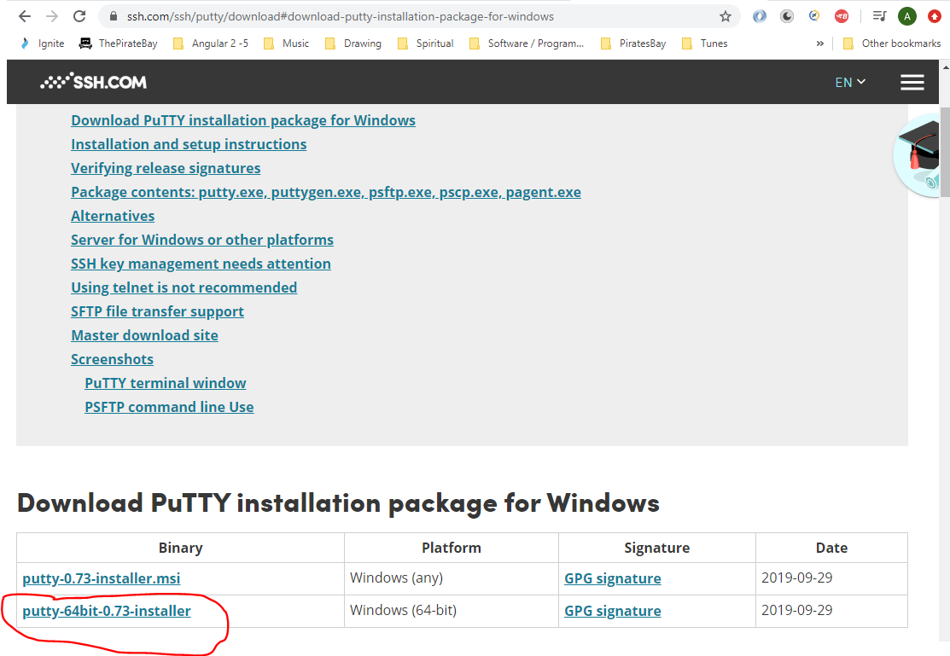

Open putty:-

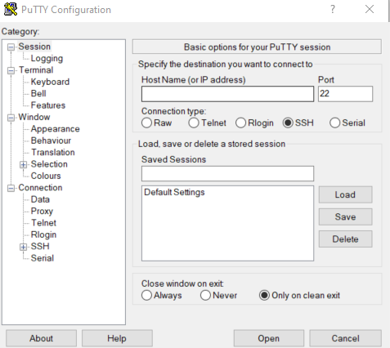

Paste the ip address here:-

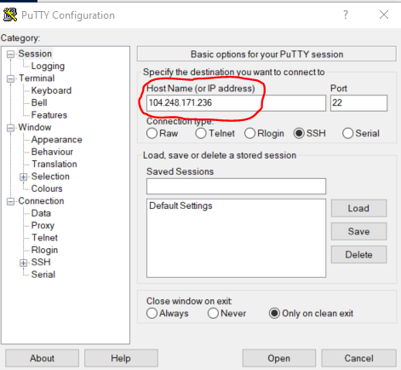

This opens this:-

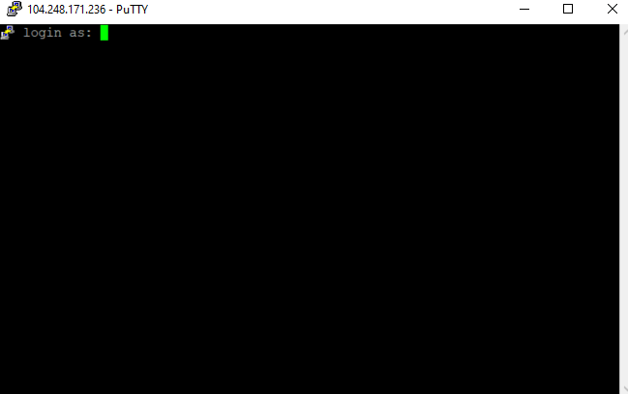

Enter username – root.

Password - will be found in the email sent to your email address from Digital Ocean:-

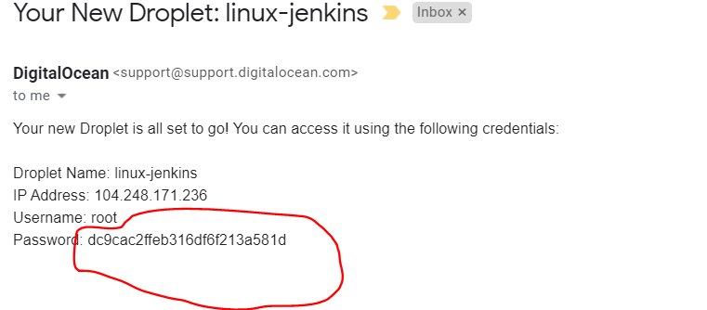

It will ask you to change your password, but you will have to fierst enter the old password twice:-

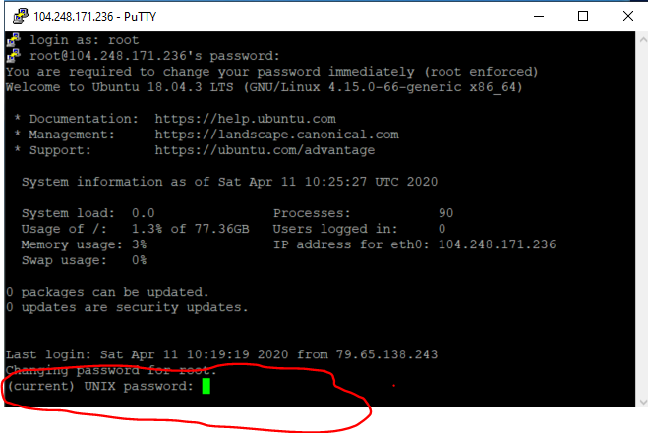

Changed password to dudeegg1977

You will now be in to your cloud based Ubuntu machine:-

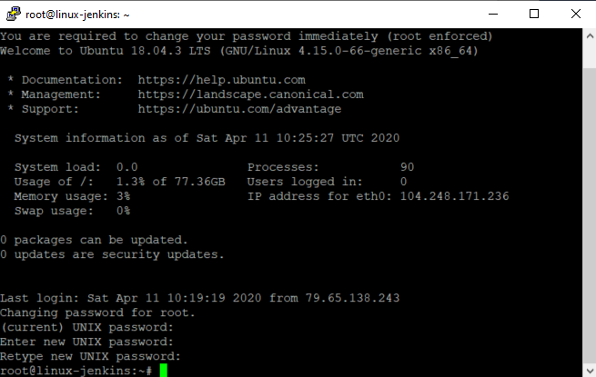

Install Java 8 on your cloud based Ubuntu machine (Jenkins is only compatible with Java 8):-

Type the following into your Putty session to see if Java is installed:-

java --version

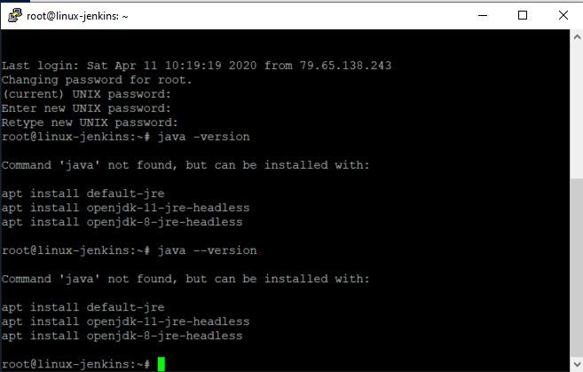

As you can see Java is not installed

So to install Java on this machine type the following:-

*sudo add-apt-repository ppa:webupd8team/java*

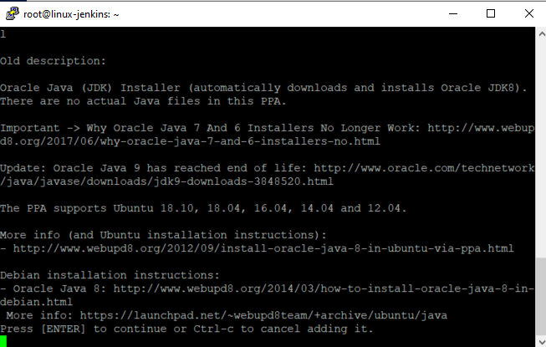

Press [Enter] to continue.

Then enter:-

*sudo apt-get update*

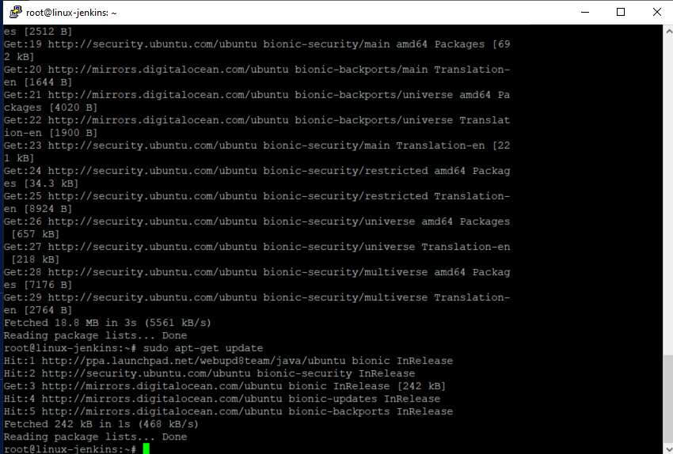

Then enter:-

*sudo apt install openjdk-8-jdk*

Press ‘Y’ to continue

Test that Java has been installed by typing:-

java -version

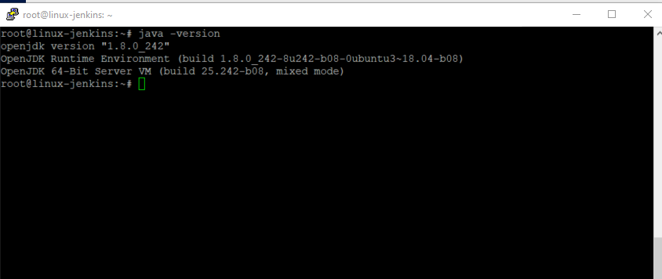

**Now install Jenkins onto the Cloud Based Ubuntu machine**

Enter the following into the Putty terminal session (**DO NOT** copy and paste the below line – you will need to manually enter it):-

*wget -q -O - https//pkg.jenkins.io/debian/jenkins.io.key | sudo apt-key add –*



Now enter the following:-

*sudo sh -c ‘echo deb* [*https://pkg.jenkins.io/debian-stable binary/*](https://pkg.jenkins.io/debian-stable%20binary/) *> /etc/apt/sources.list.d/Jenkins.list’*



Now enter the following:-

*sudo apt-get update*

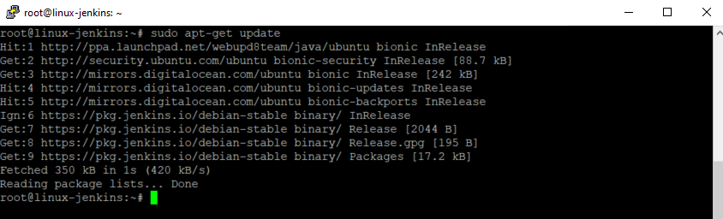

Now enter the following:-

*sudo apt install jenkins*

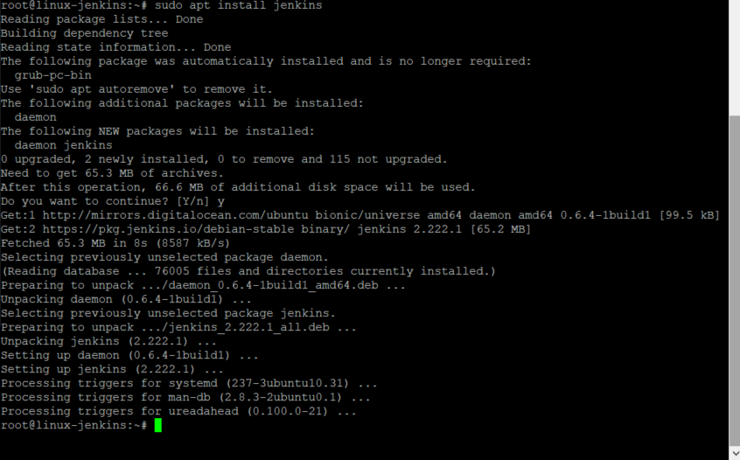

Check that the Jenkins process is active on your machine, type:-

*systemctl status jenkins*

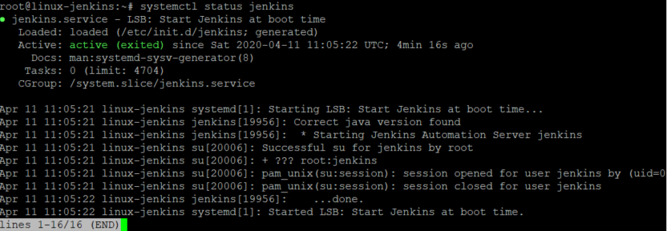

Get the Ubuntu machines ip address by typing:-

*ip addr show*

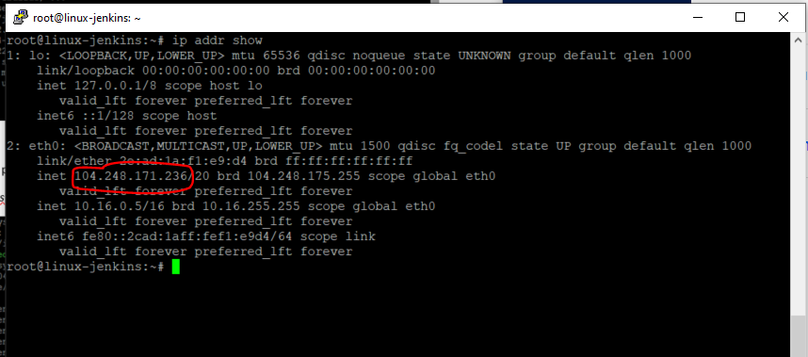

Copy the above ip address and paste into a browser and append the port number – 8080:-

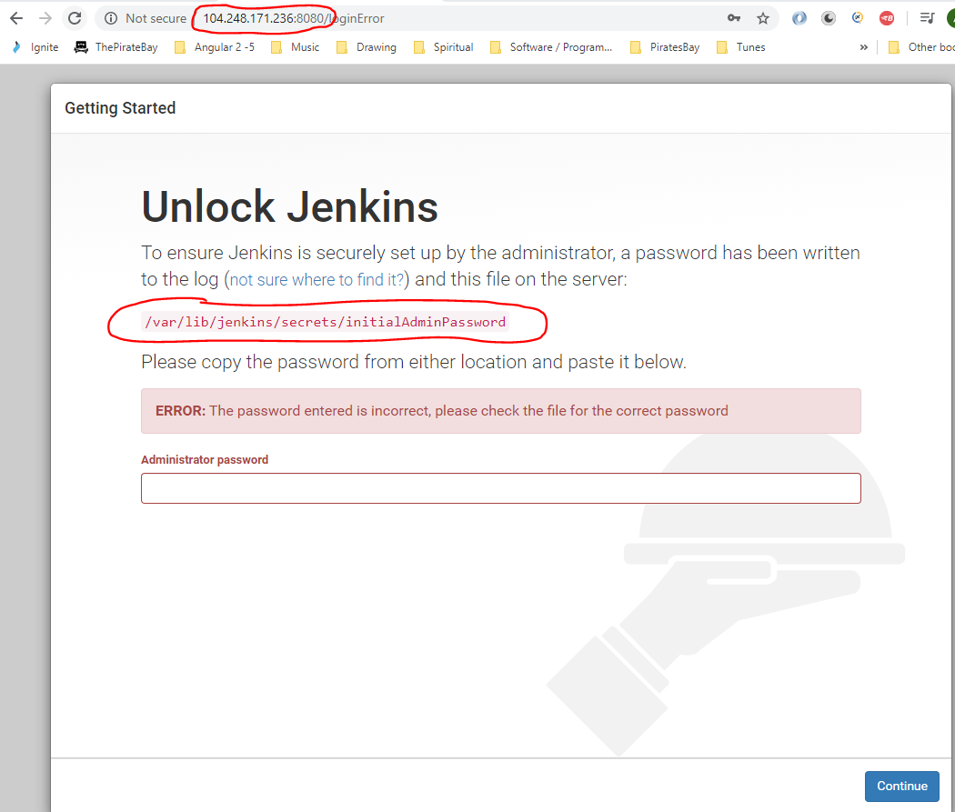

Copy the above directory and use in Putty:-

Enter ‘cat’ followed by the directory path:-

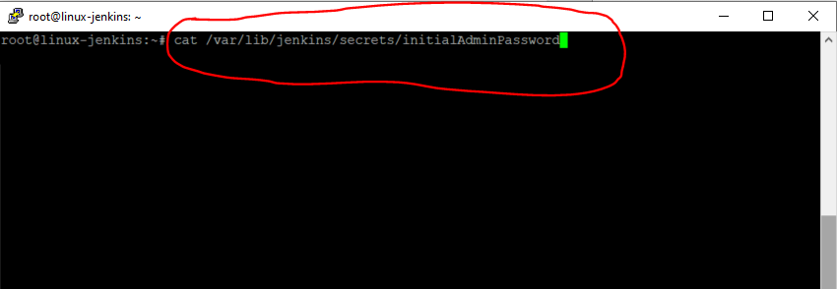

Pressing [Enter] returns this password:-

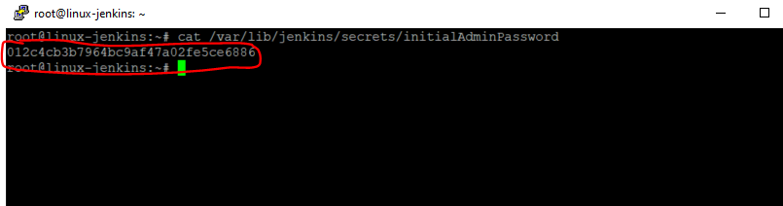

Copy the password and paste into browser.

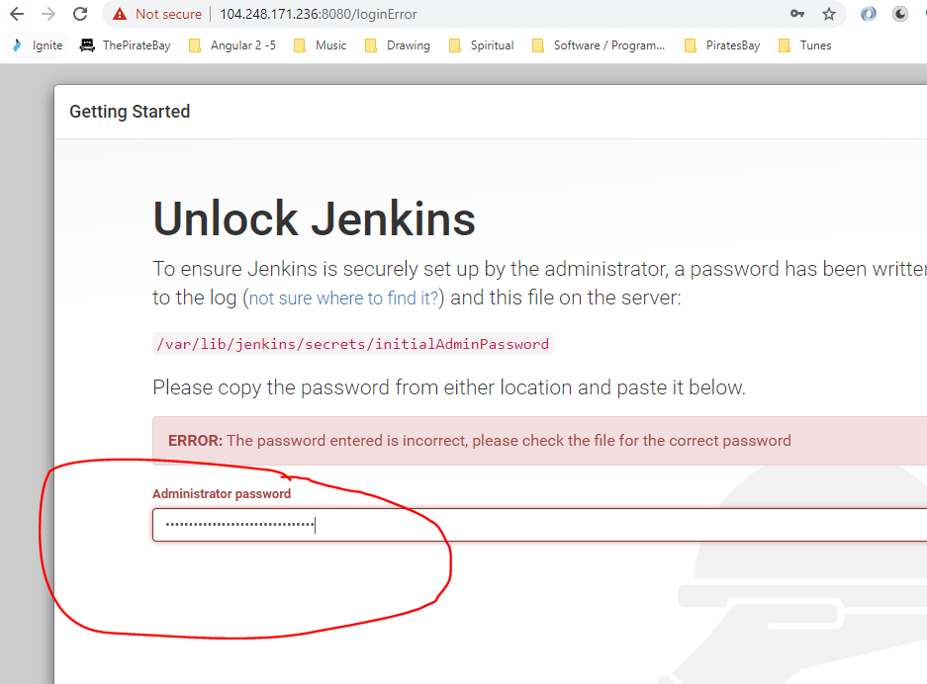

Click this to install the plugins:-

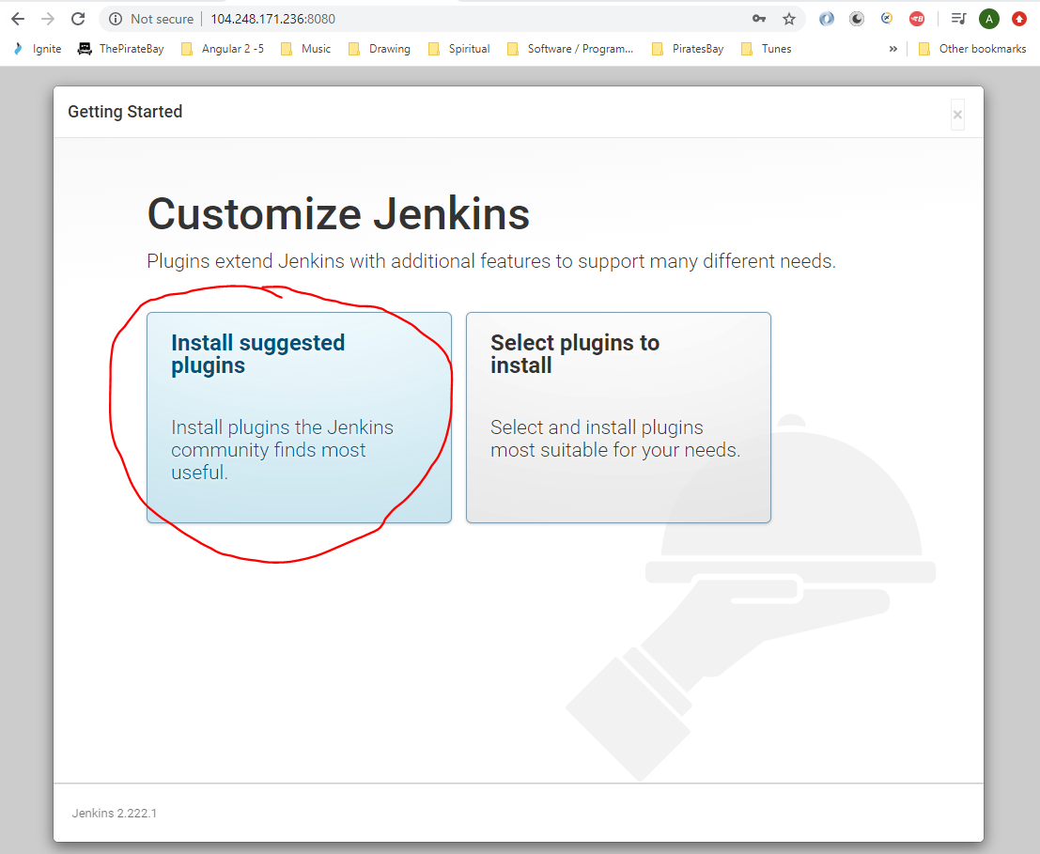

When the following page opens enter:-

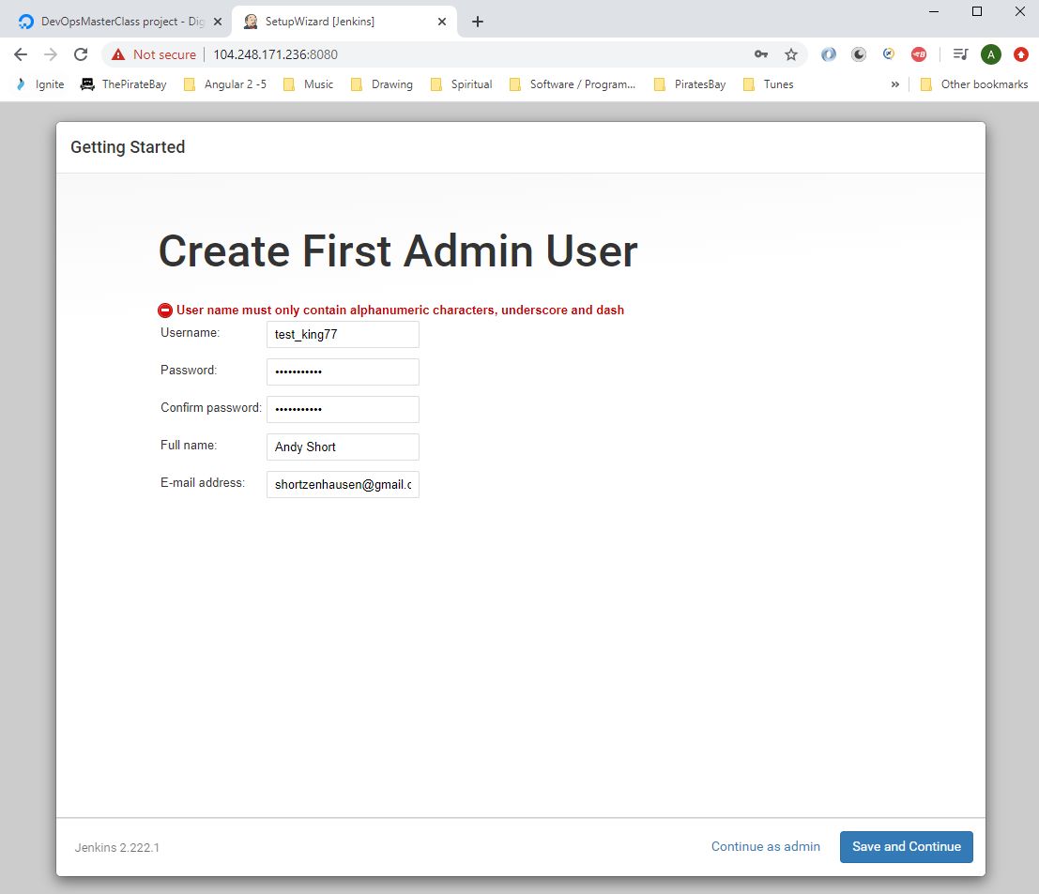

Username – test_king77

Password – dudeegg1977

Then click ‘Save and Continue’.

See Jenkins <url:->

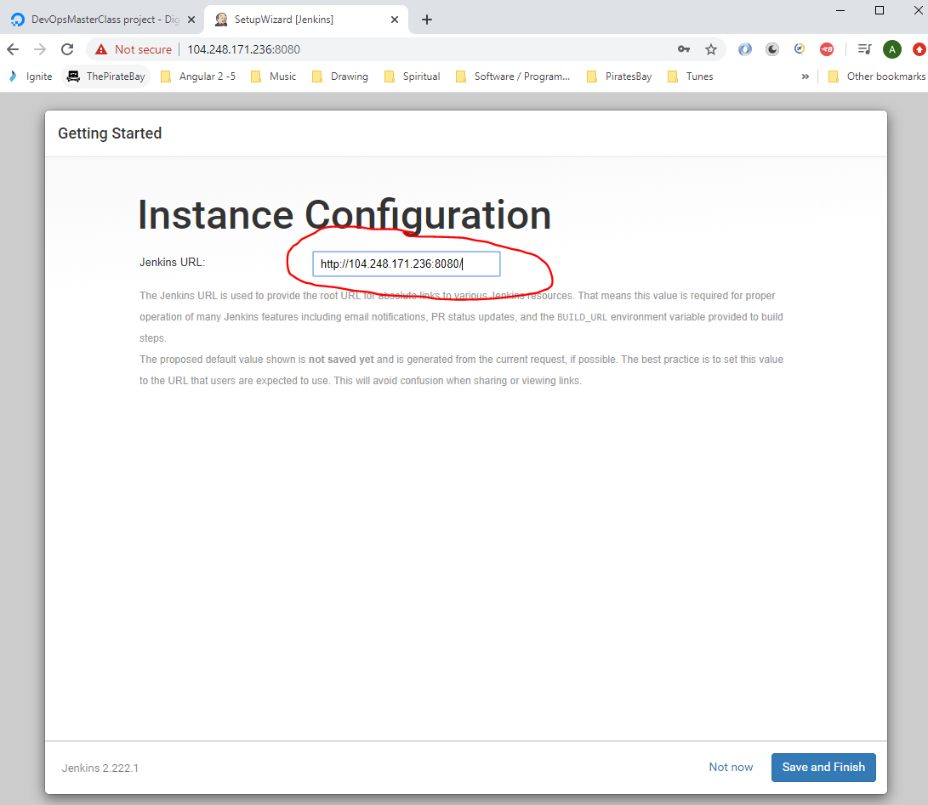

<http://104.248.171.236:8080/>

Click ‘Save and Finish’.

Then click ‘Start using Jenkins’:-

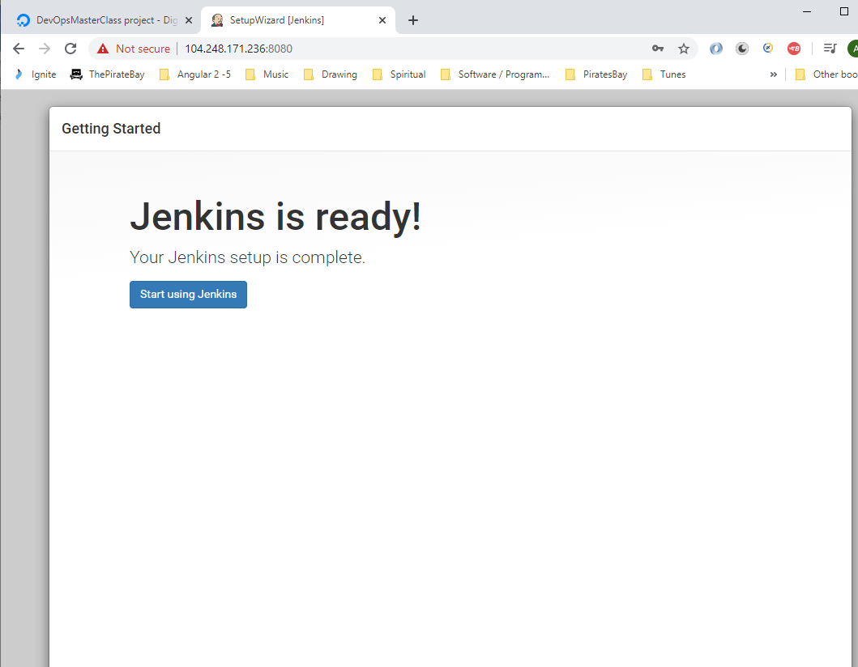

See Jenkins open:-

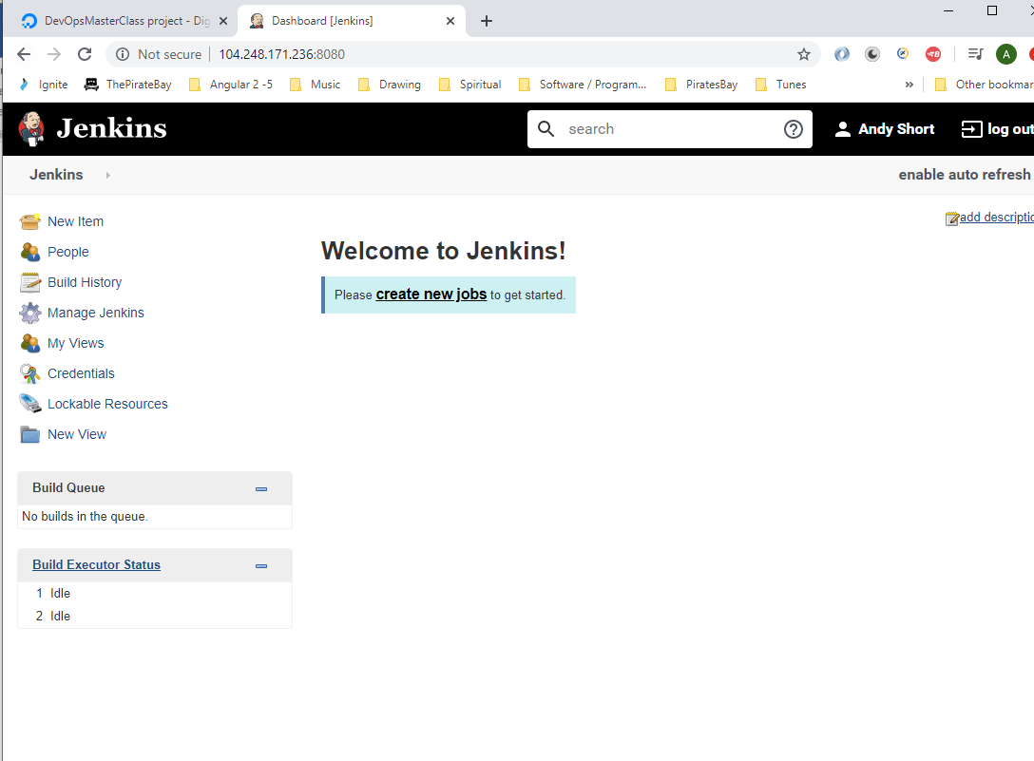

You can stop Jenkins by typing the following into the Putty session:-

*systemctl stop jenkins*

To check the status of Jenkins type:-

*systemctl status jenkins*

To start the Jenkins server:-

*systemctl start jenkins*

**Installing Jenkins on Windows**

<https://jenkins.io/download/>

Download this:-

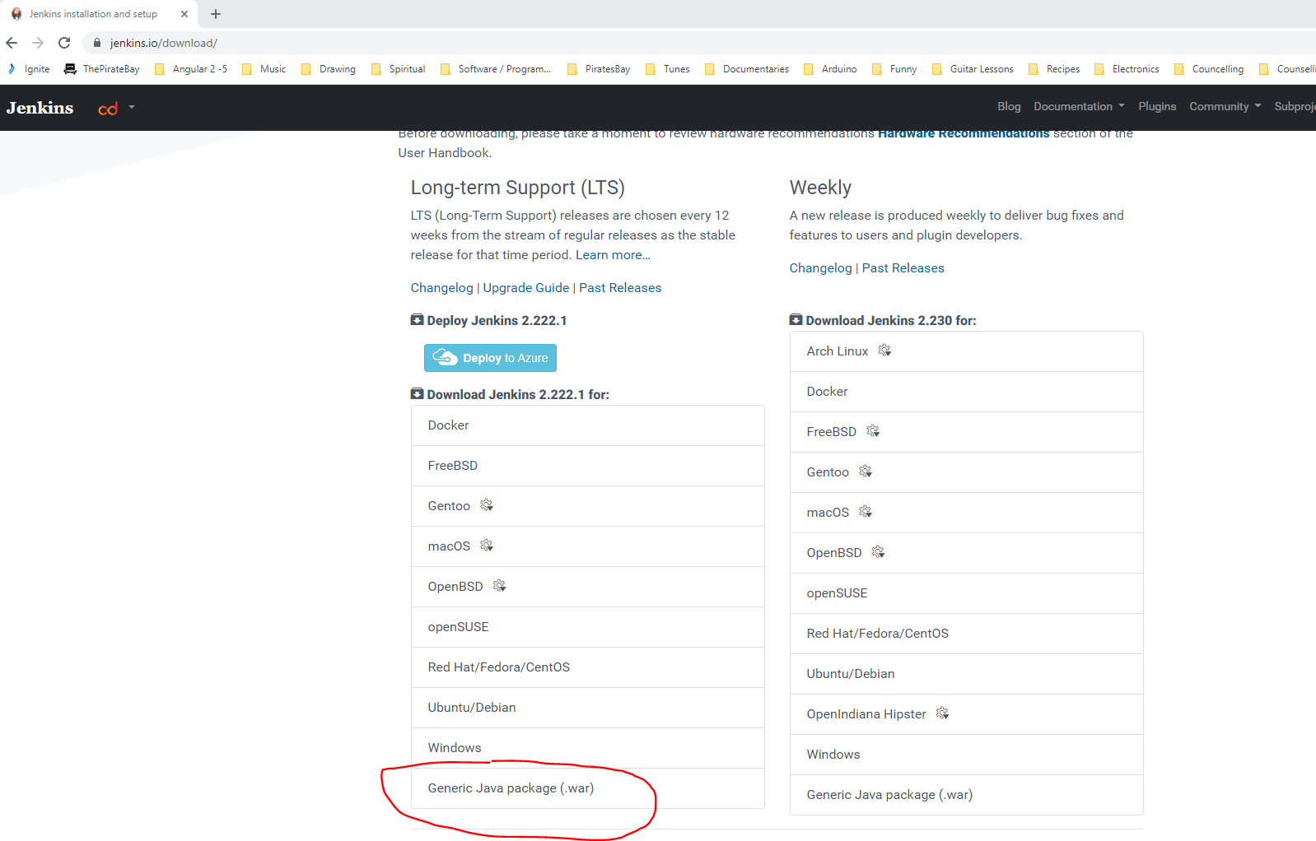

Create the following folder on your C: drive:-

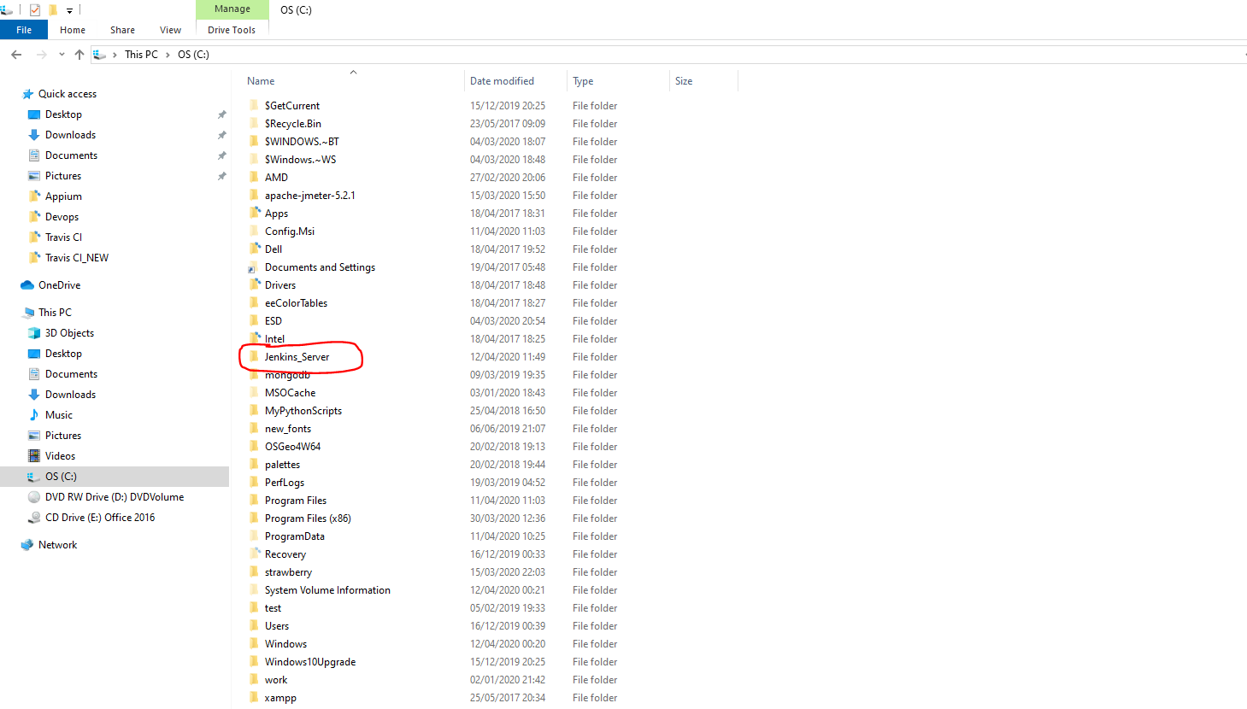

Paste the downloaded .war file here:-

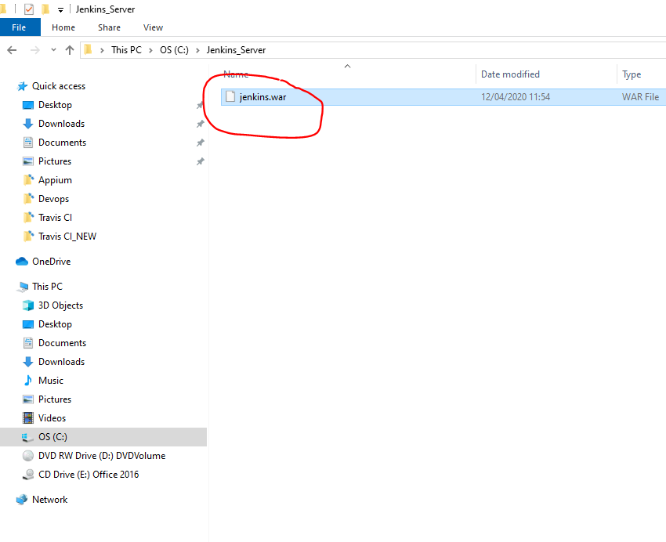

Open command prompt and navigate to the above folder. Then type:-

java -jar jenkins.war --httpPort=9090

Open a browser and enter –

Localhost:9090

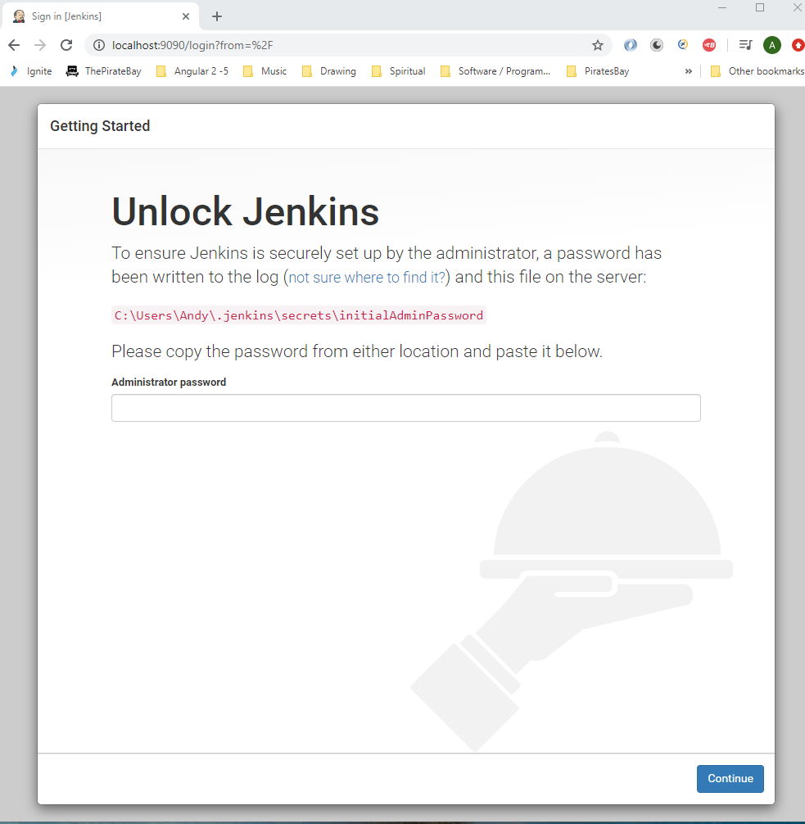

Get the password from the above path:-

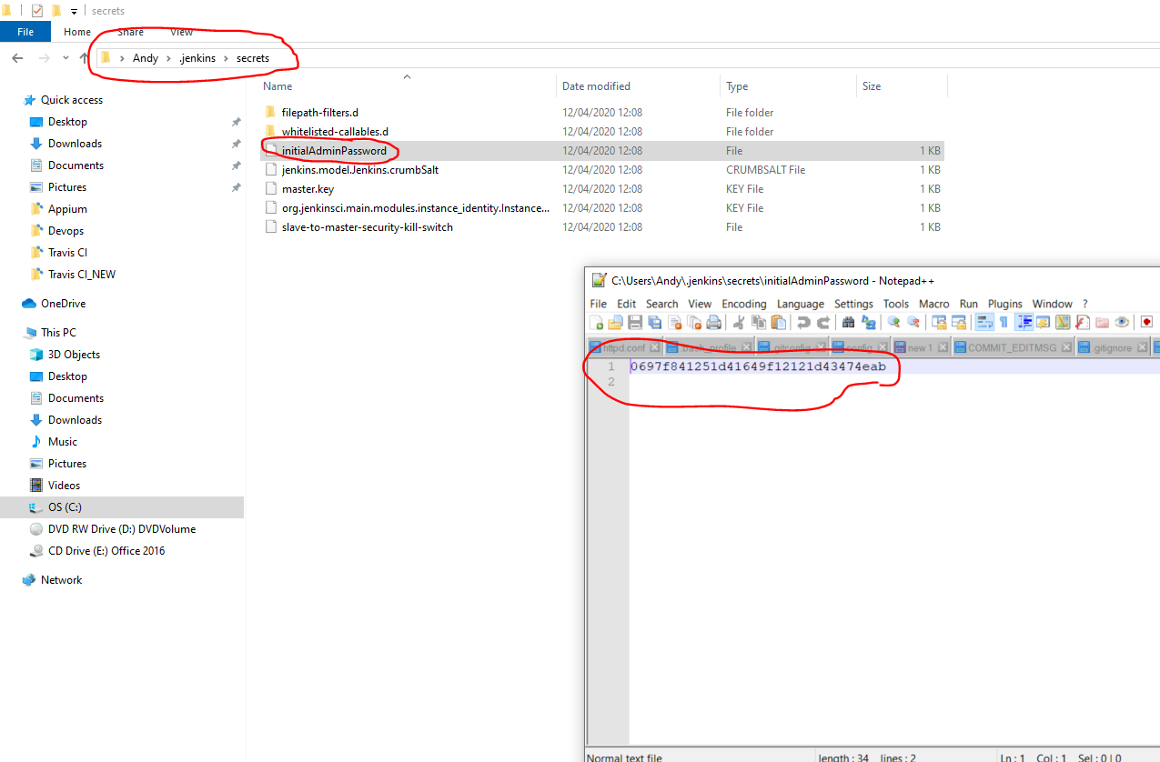

After pasting password press continue then select the left button for default plugins.

Wait for plugins to download.

Enter the following details:_

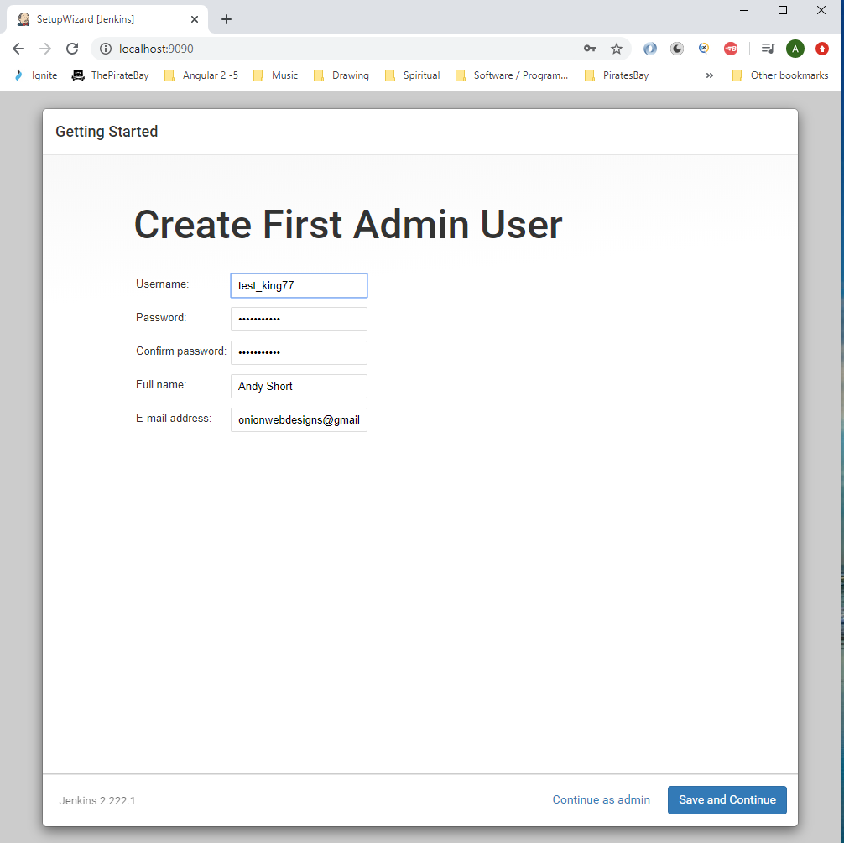

Click save and continue.

Click Save and Finish.

**Creating a Jenkins Job**

Open Cloud installed Jenkins on browser:-

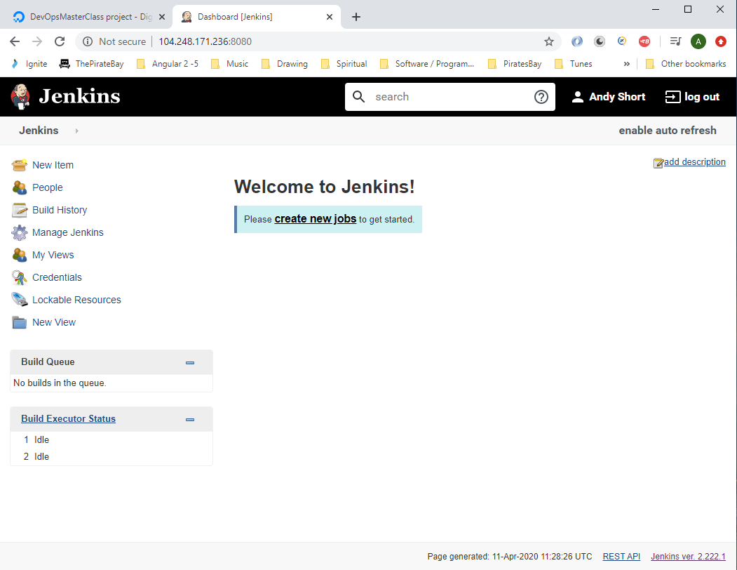

Click ‘New Item’.

Enter – ‘ First Simple Job’

Click ‘Freestyle project’.

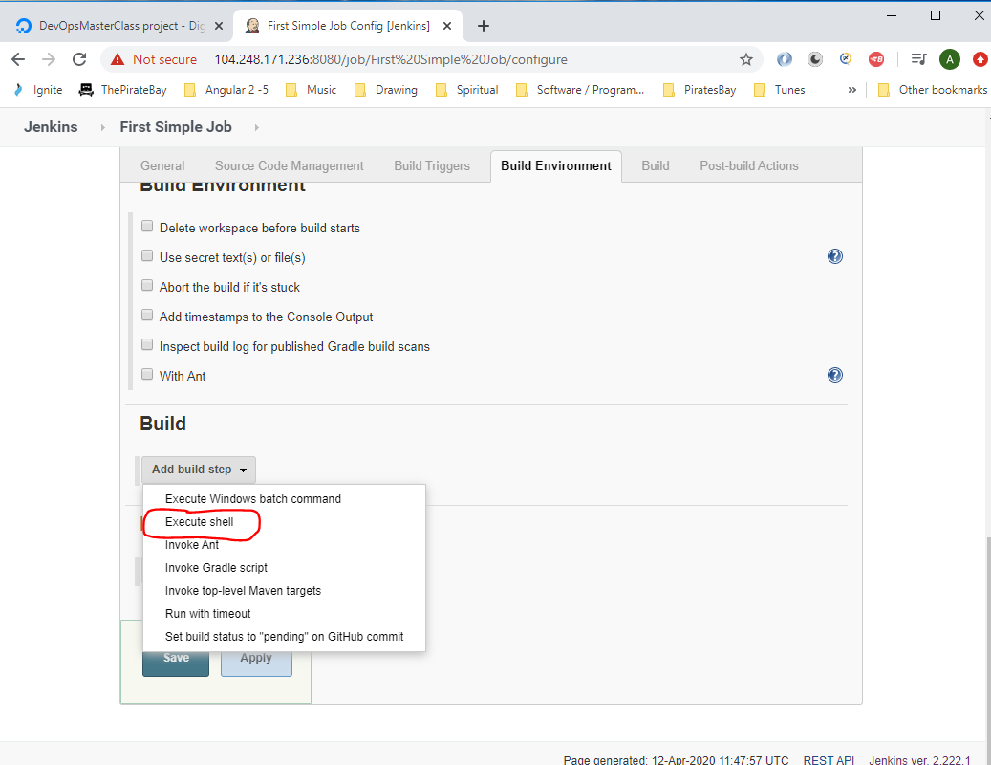

Enter this:-

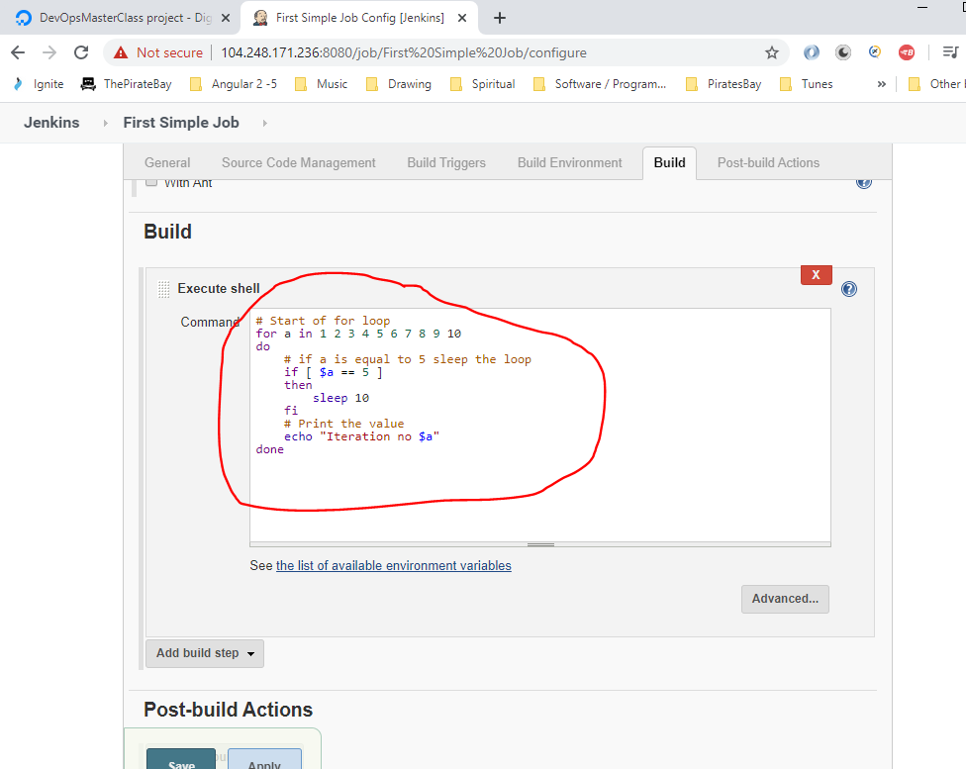

Click ‘Save’

Go to Jenkins home:-

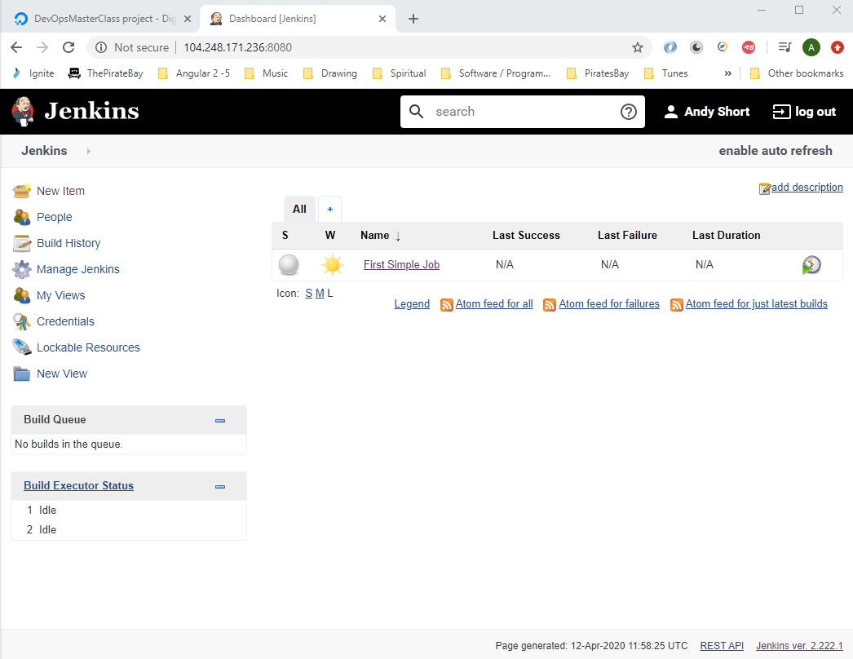

To run job click ‘Build Now’:-

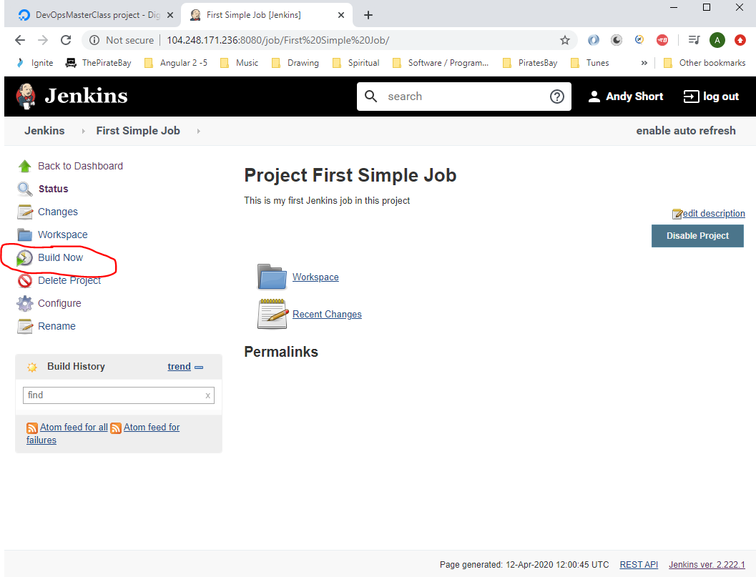

**Jenkins Integration with GitHub**

Go to this project:-

<https://github.com/anshulc55/Jenkins_Upgradev3/tree/master/maven-samples/single-module>

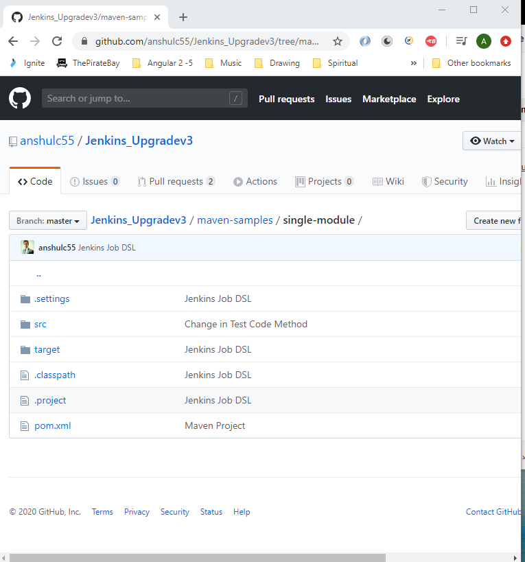

You now need to install Git on the Jenkins machine:

Go to Putty and connect to your Jenkins Cloud based Ubuntu server:-

When logged into server test to see if git is installed by typing:-

git -- version

You can see from below that Git is installed:-

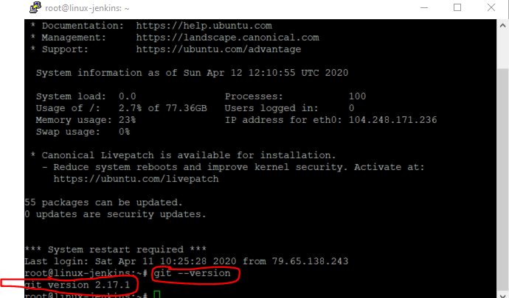

If it is not installed the the following:-

*sudo apt-get install git*

You will now need the GitHub Jenkins plugin:-

Go to Jenkins and click ‘Manage Jenkins’:-

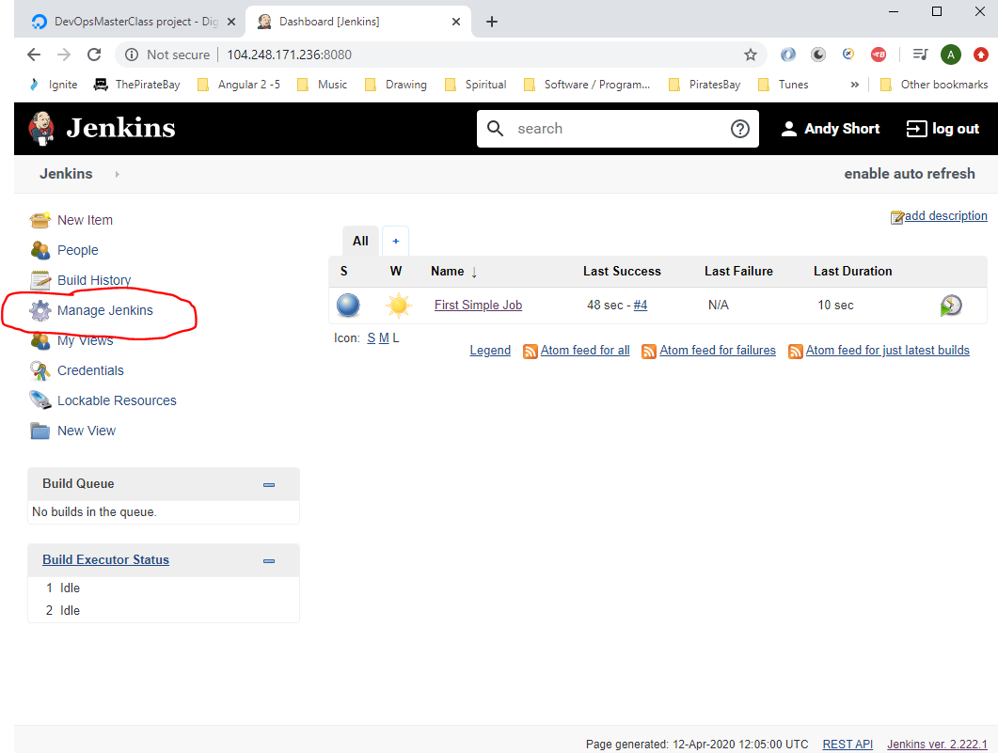

Then click ‘Manage Plugins’:-

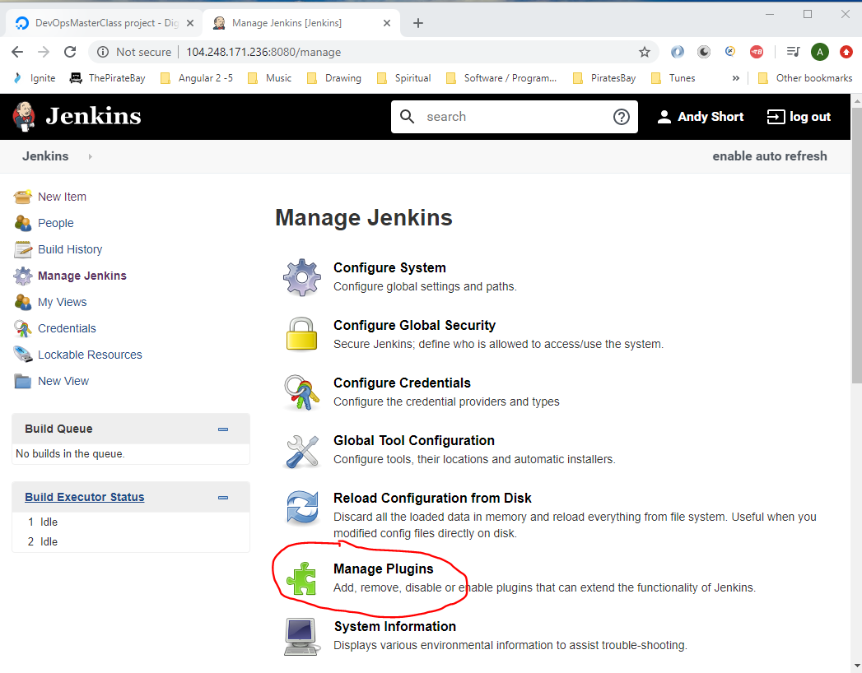

Click ‘Available’ tab:-

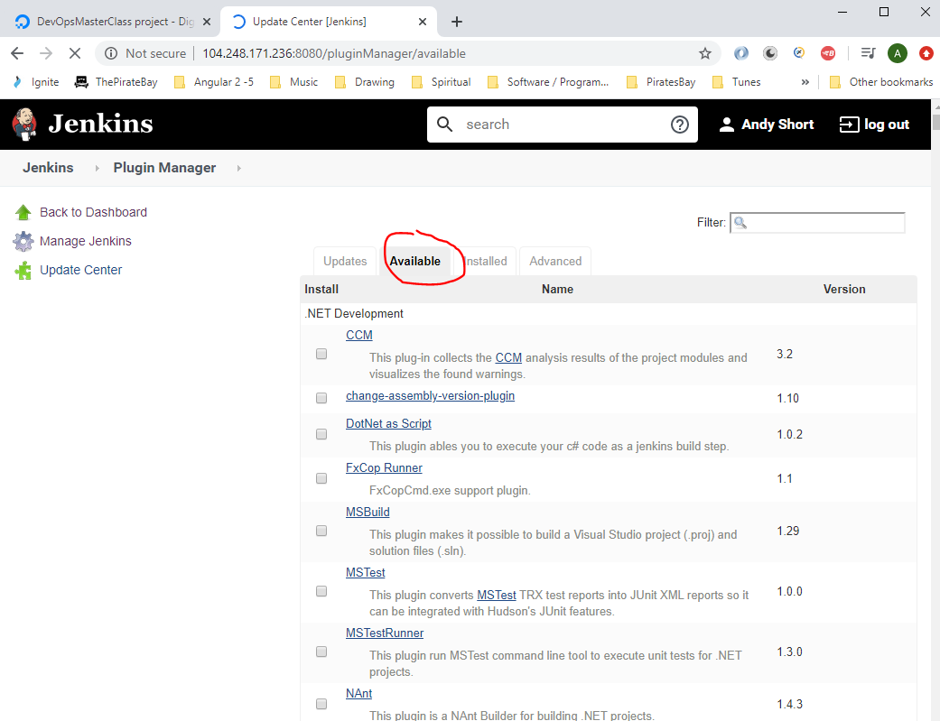

Enter ‘GutHub’ into search box then select/check the ‘GitHub Integration’ checkbox item:-

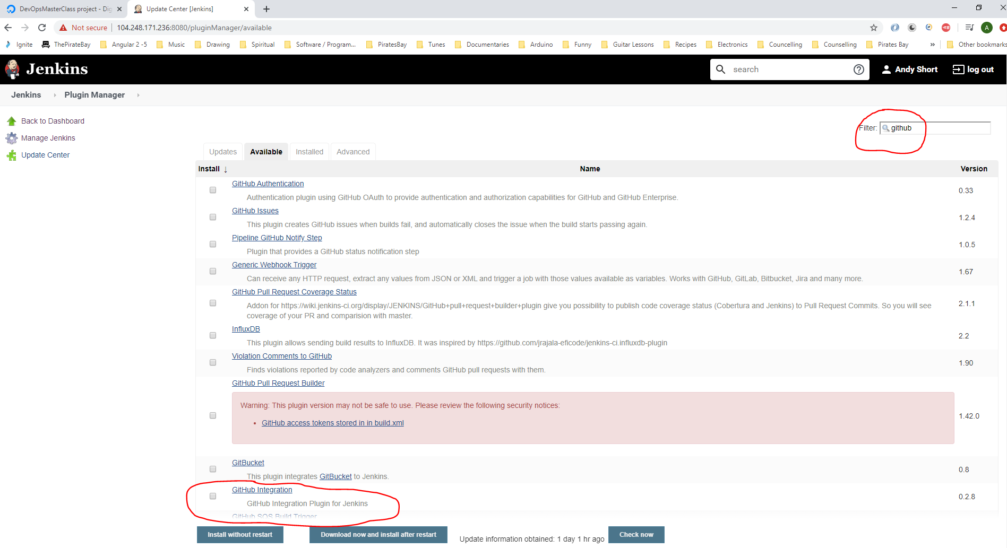

Then click the ‘Install without restart’ button:-

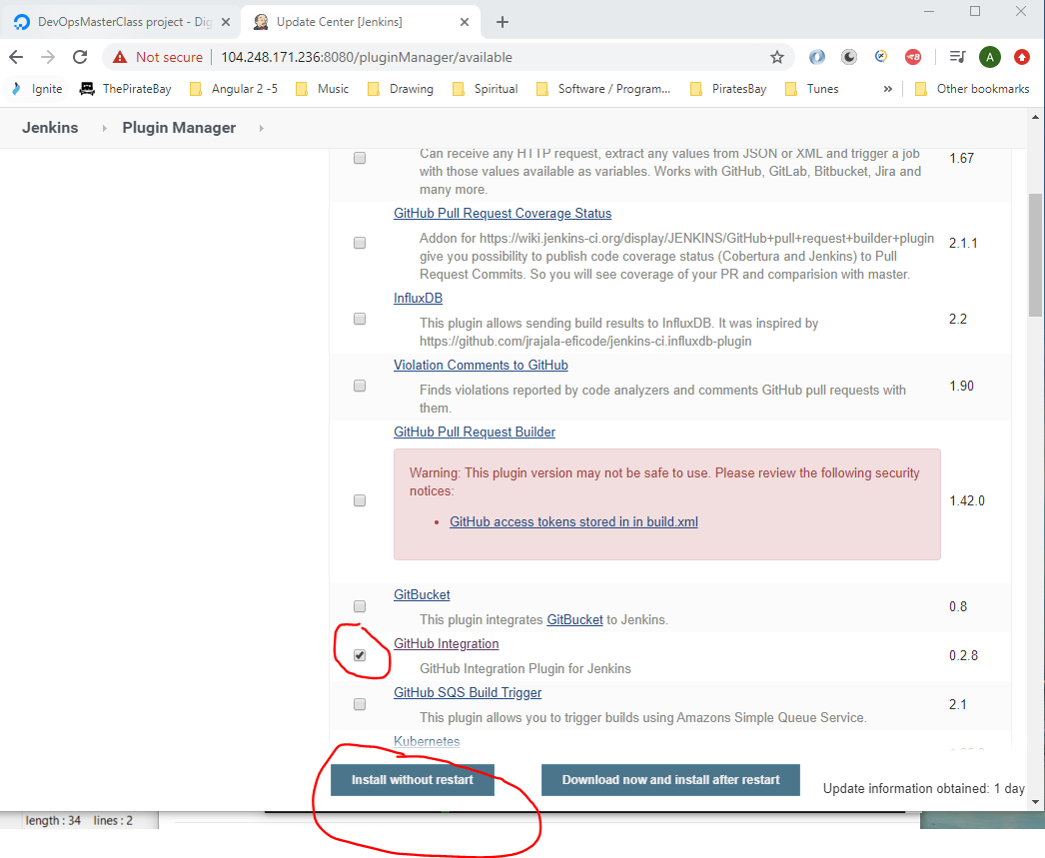

**Download Maven**

Install Maven onto the machine that is executing Jenkins. In this case the Ubuntu machine in the Cloud.

Connect to server using Putty and entering the following to check to see if Maven is installed:-

mvn --version

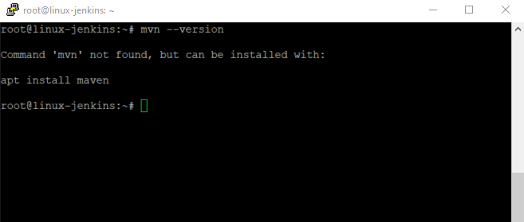

To install maven type:-

sudo apt-get install maven

**Installing Maven on Windows Machine**

Text Direction : Install Maven on Windows

**Step 1) Install JDK and Add ‘JAVA_HOME’ Environment Variable**

To install java, [download JDK installer](http://www.oracle.com/technetwork/java/javase/downloads/index.html) and **add/update the JAVA_HOME variable to JDK installation folder.**

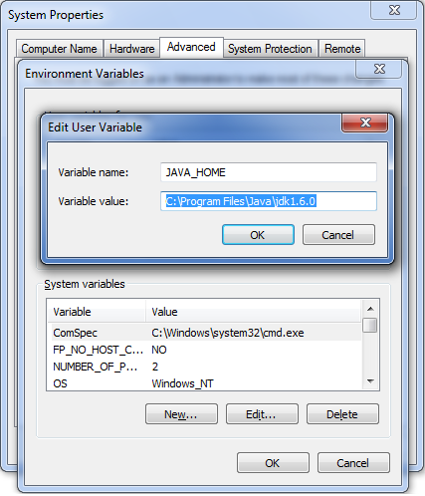

**Step 2) Download Maven and add ‘MAVEN_HOME’ and ‘M2_HOME’ Environment Variables**

Maven can be downloaded from this [**location**](https://maven.apache.org/download.cgi):-

<https://maven.apache.org/download.cgi>

Download then extract this:-

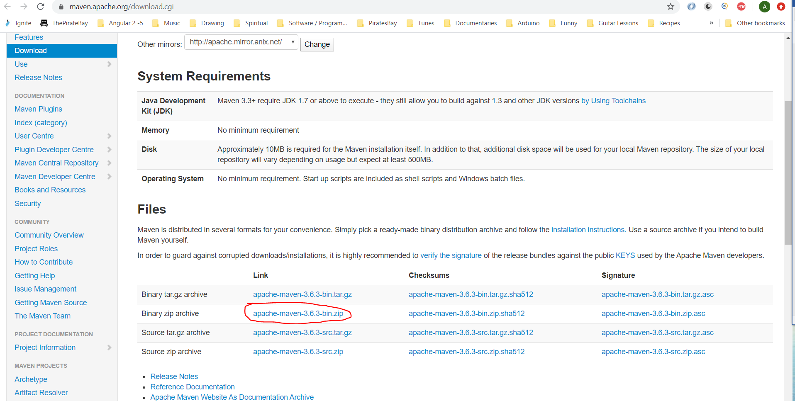

I have extracted it in location – C:\Maven\apache-maven-3.6.3-binn.

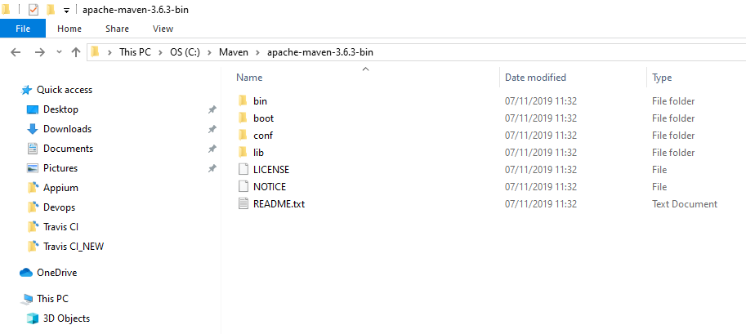

**Set the M2_HOME and MAVEN_HOME variable to the maven installation folder.**

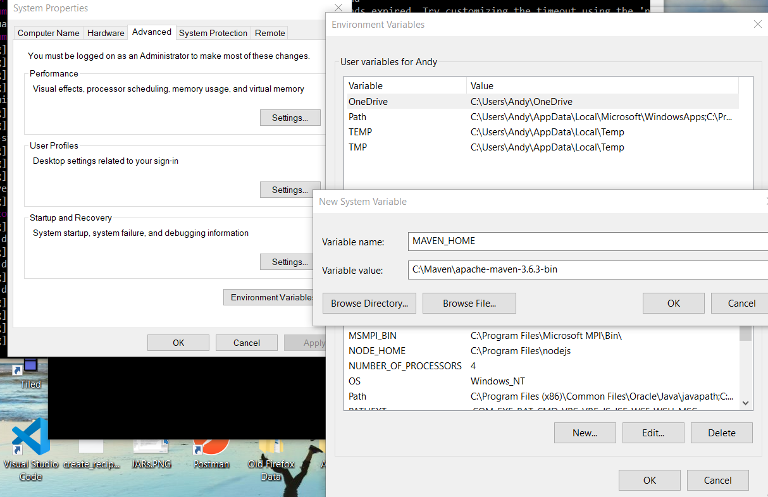

**Step 3) Include ‘maven/bin’ directory in the ‘PATH’ variable**

**To run a maven from the command prompt, this is necessary. Update the PATH variable with 'Maven-installation/bin' directory**.

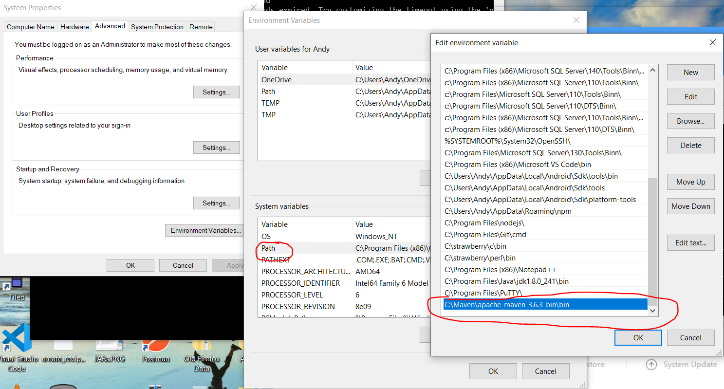

**Step 4) Verify maven in console**

Maven installation is complete. Now, let's test it from windows command prompt.

1. Go to start menu and type cmd in the application location search box.
2. Press ENTER. A new command prompt will be opened.
3. Type mvn -version in command prompt and hit ENTER.

Console$ mvn -version

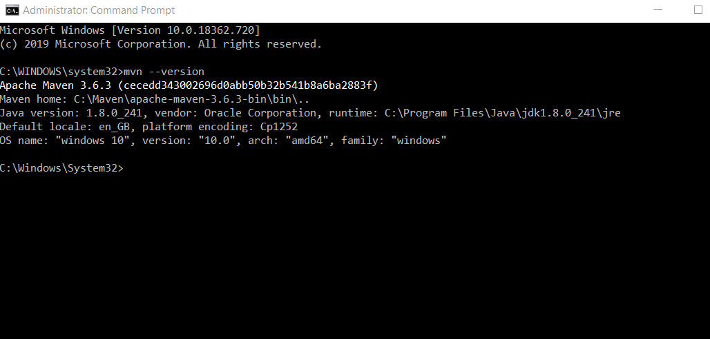

This should show the version information of the maven installed. If there is any error shown, cross-check all the above steps.

**Configure Jenkins to work with Maven**

In Jenkins click on ‘Manage Jenkins’:-

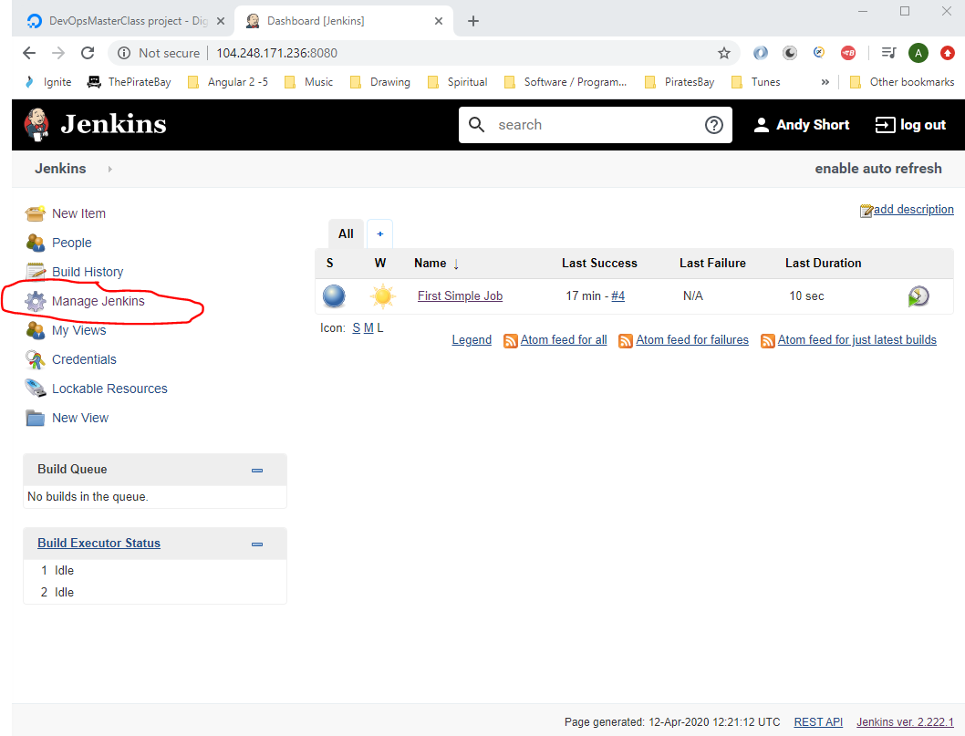

Select ‘Gobal Tool Configuration’:-

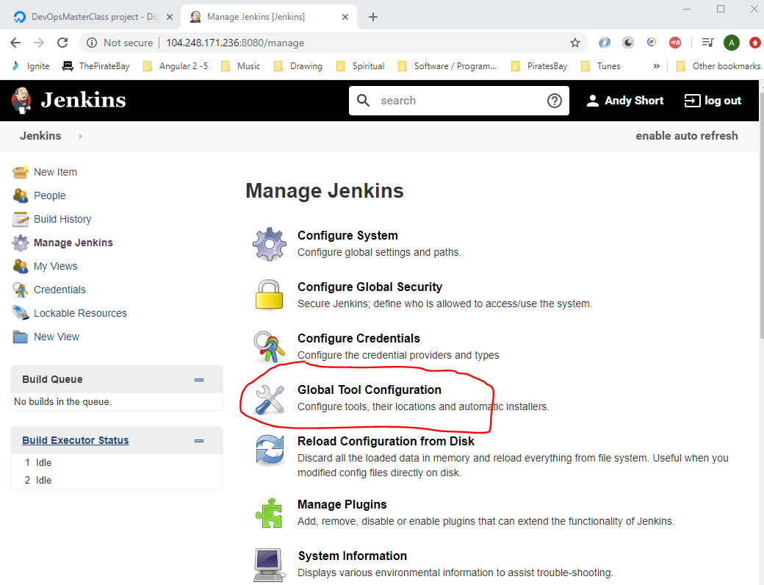

Click ‘Add JDK’ button:-

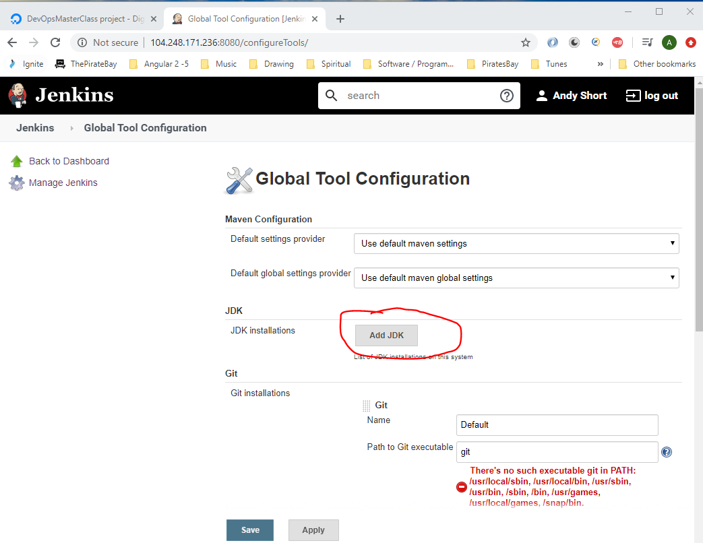

Add a name of ‘LocalJDK8’:-

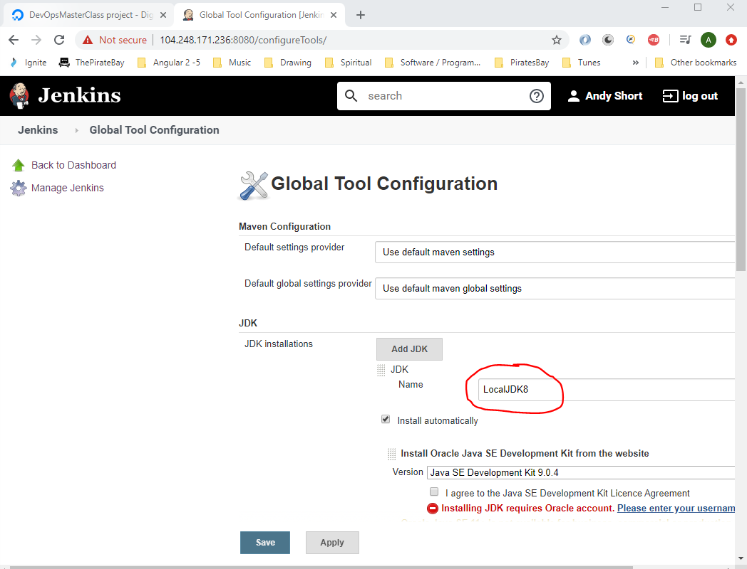

Uncheck the ‘Install automatically’ checkbox:-

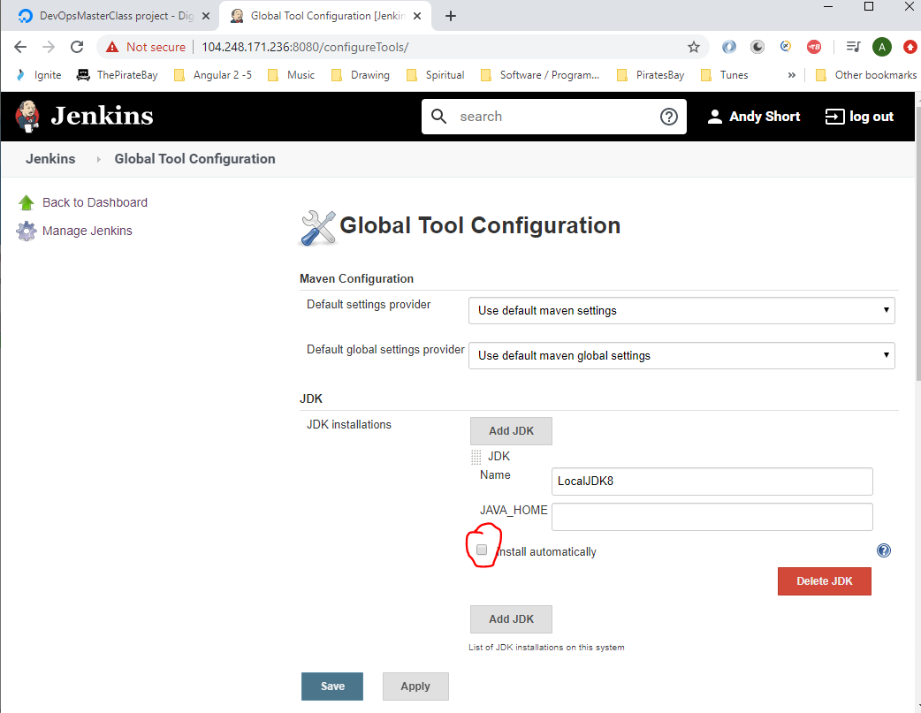

Check where Java is installed on your cloud based Jenkins server by opening Putty and navigating here:-

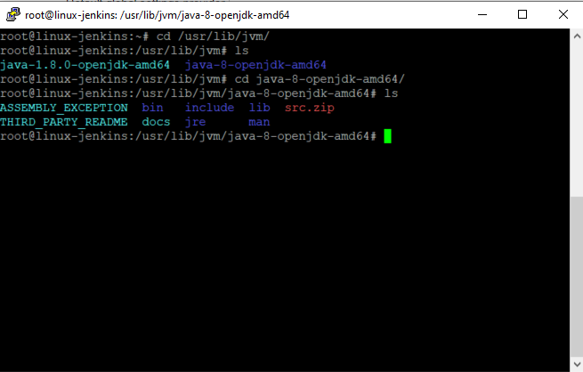

You will see from the above screen shot that this is the location of where Java is installed. Add this path to Jenkins (type ‘pwd’ into putty to get actual path - /usr/lib/jvm/java-8-openjdk-amd64):-

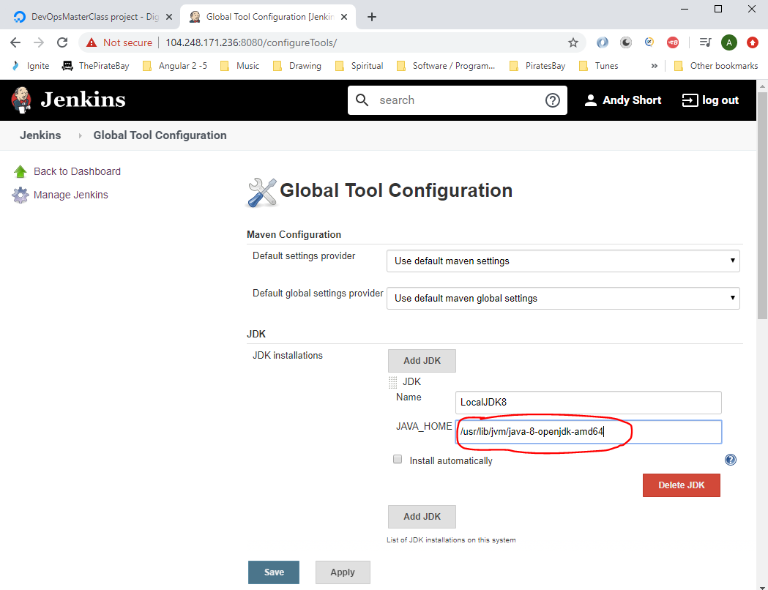

In Jenkins add this:-

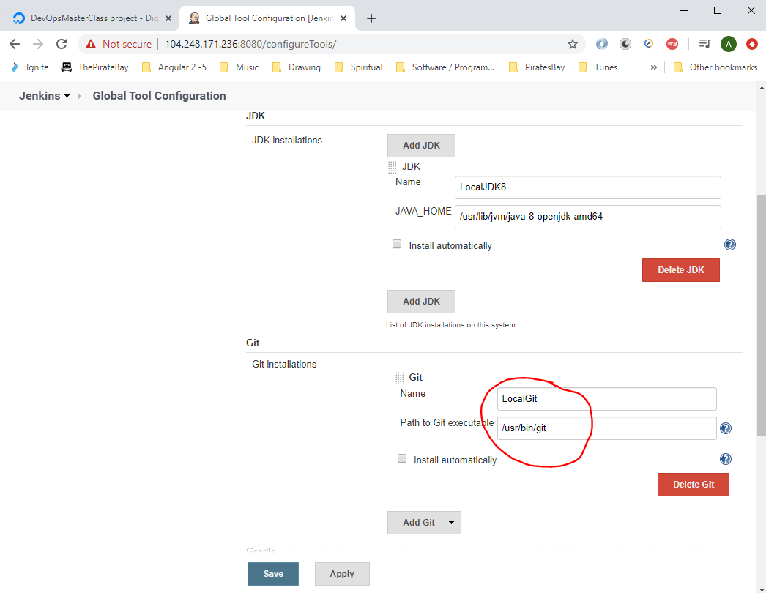

Now click the ‘Add Maven’ button:-

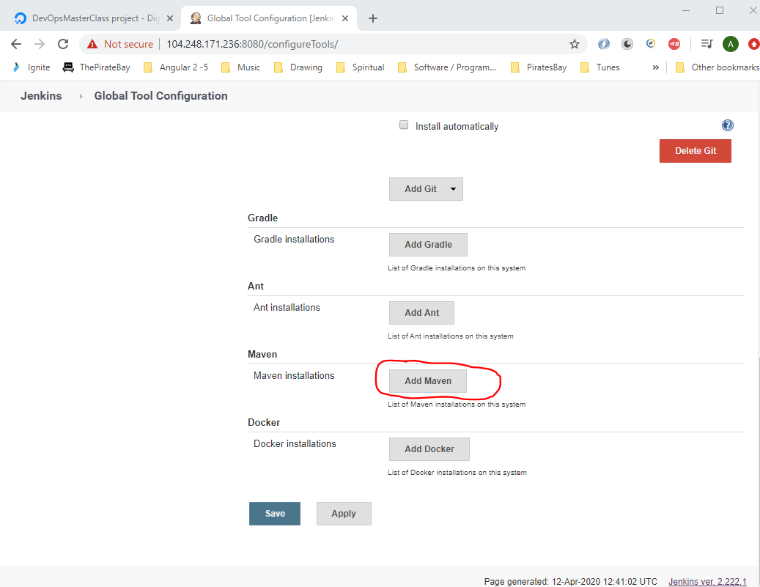

Find the location pf where Maven is installed on Cloud based Jenkins server:-

Open Putty and navigate here:-

cd /usr/share/maven-repo/org/apache/maven

Copy this:-

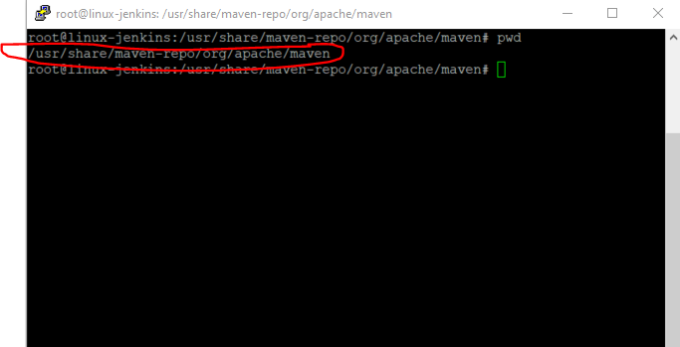

Paste into Jenkins:-

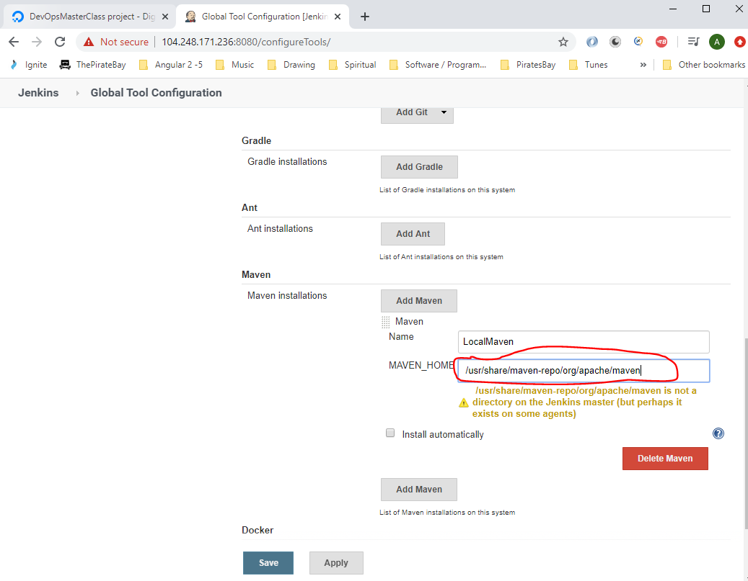

Notice this error message:-

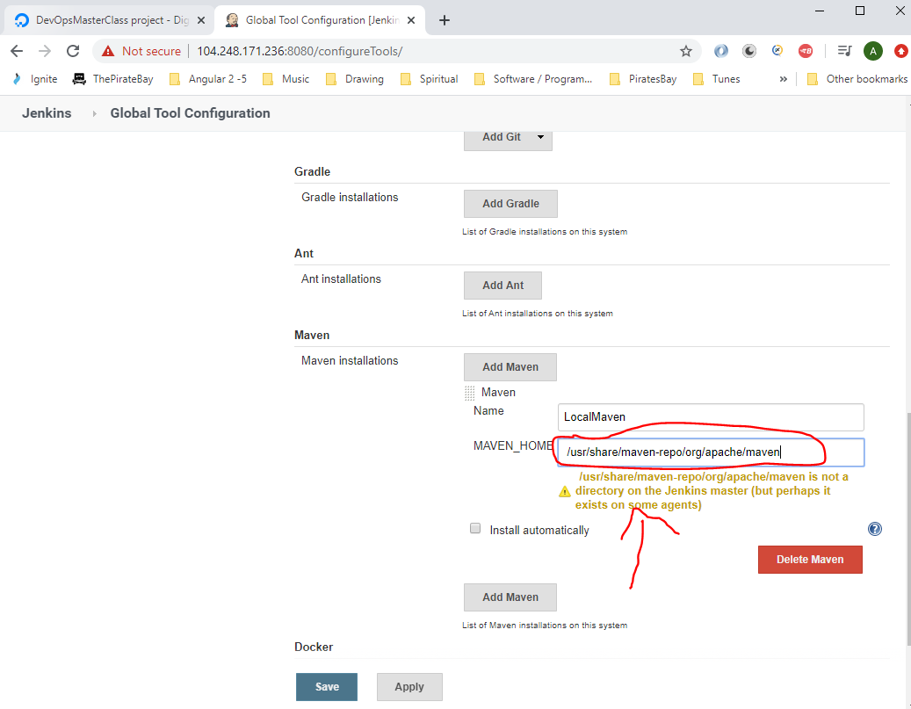

You will need to change the path to this:-

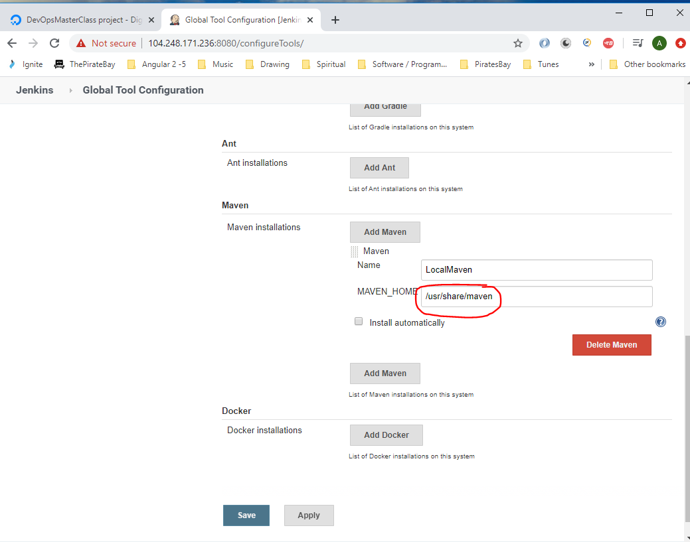

Now click the ‘Save’ button.

**Setup Maven Project with Jenkins**

Go to GitHub account:-

<https://github.com/anshulc55/Jenkins_Upgradev3/tree/master/maven-samples/single-module>

Click the ‘Fork’ icon to get this project into your GitHub account:-

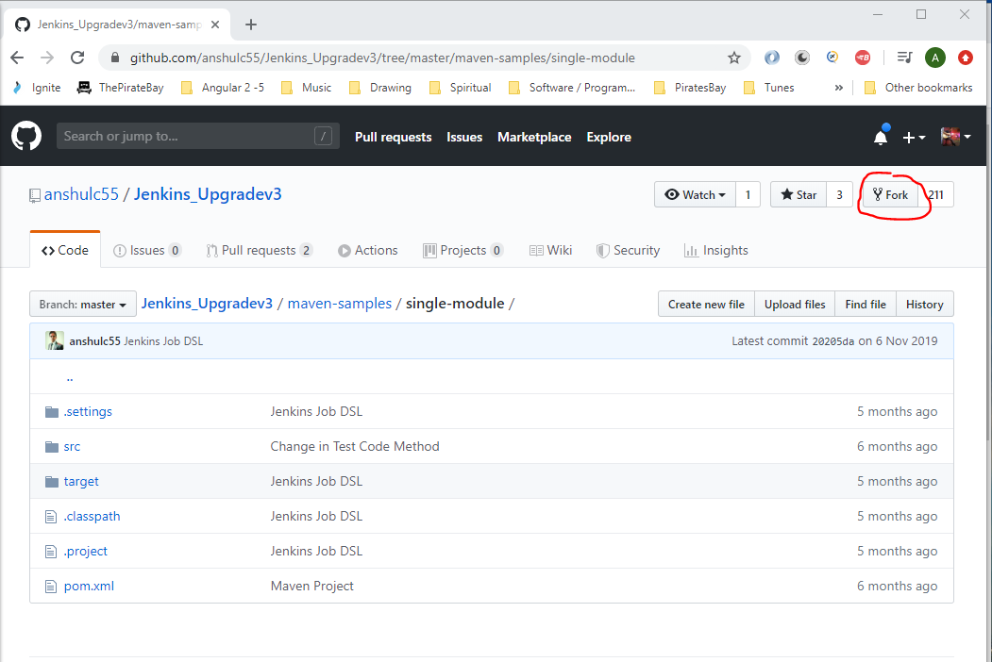

Now see that project now exists in your GitHub account:-

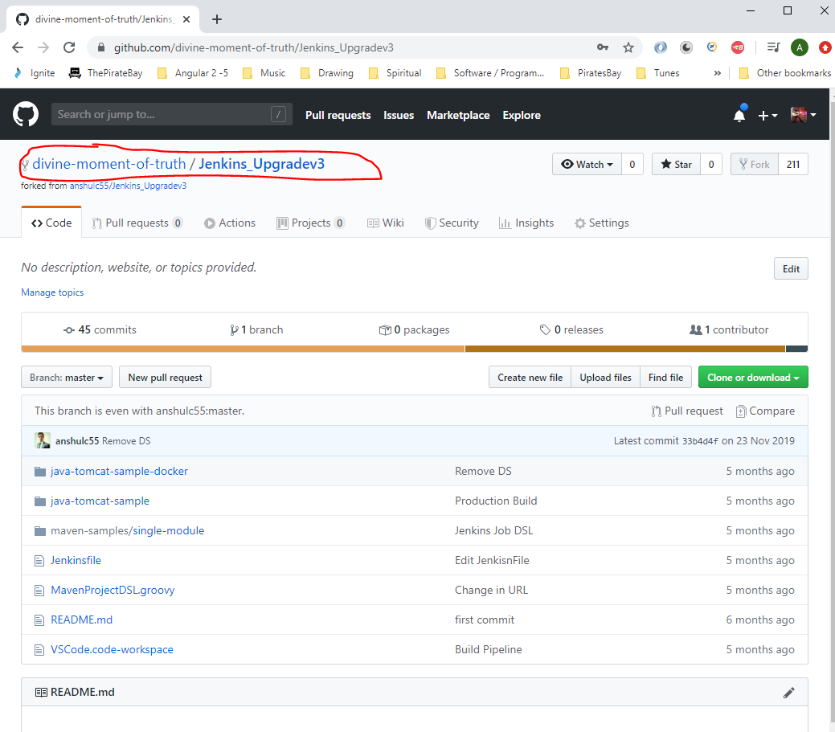

Click the clone or download button in GitHub and copy the url.

Create a folder on your ocal machine where you want to have this project saved:-

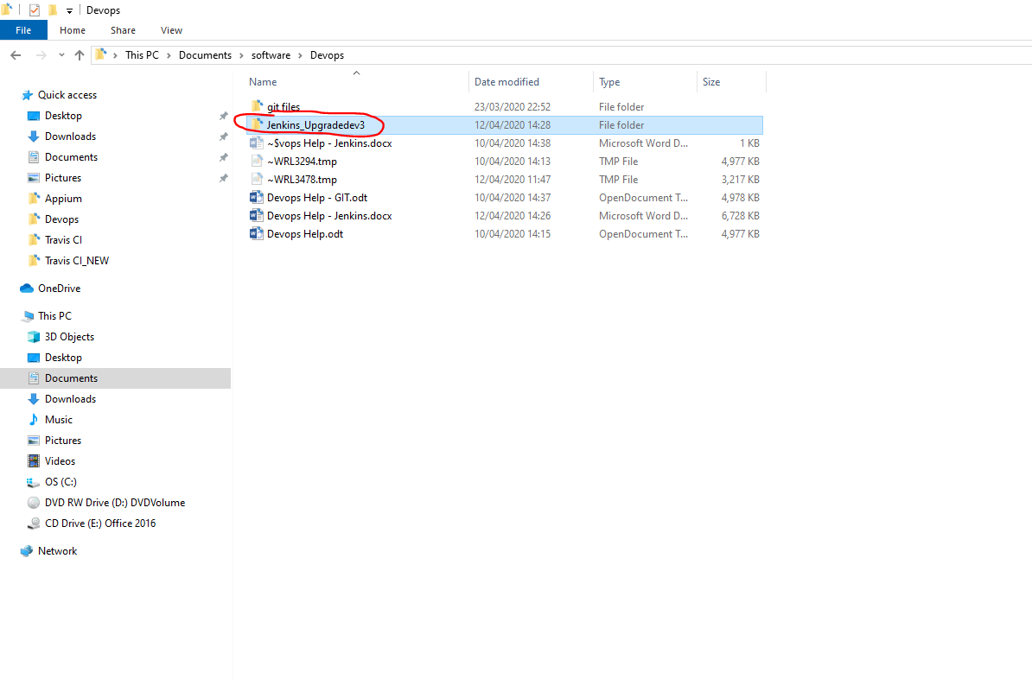

Go into the above folder and open Git Bash:-

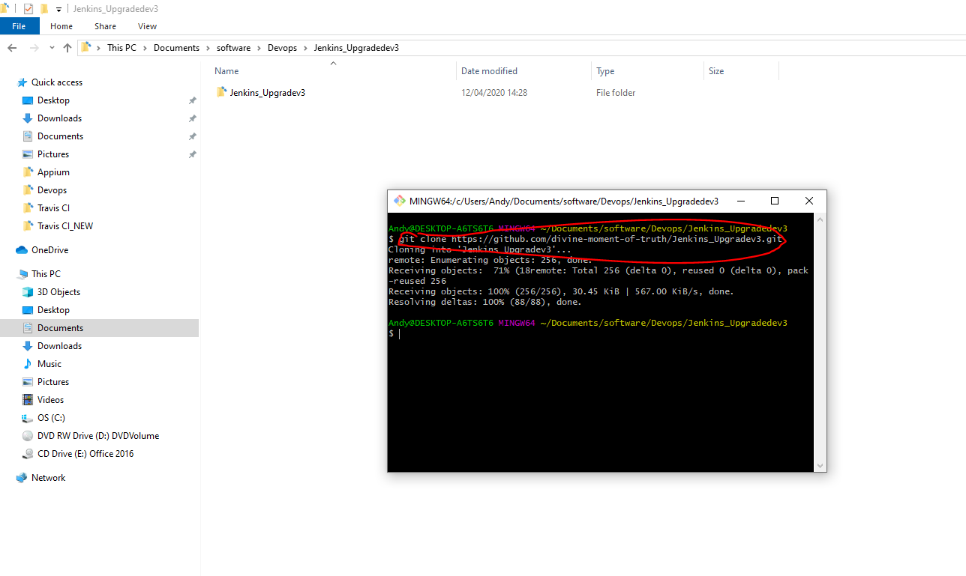

Enter the following –

*git clone* [*https://github.com/divine-moment-of-truth/Jenkins_Upgradev3.git*](https://github.com/divine-moment-of-truth/Jenkins_Upgradev3.git)

This will clone the repo onto your local machine.

Open Visual Studio code and navigate this this location:-

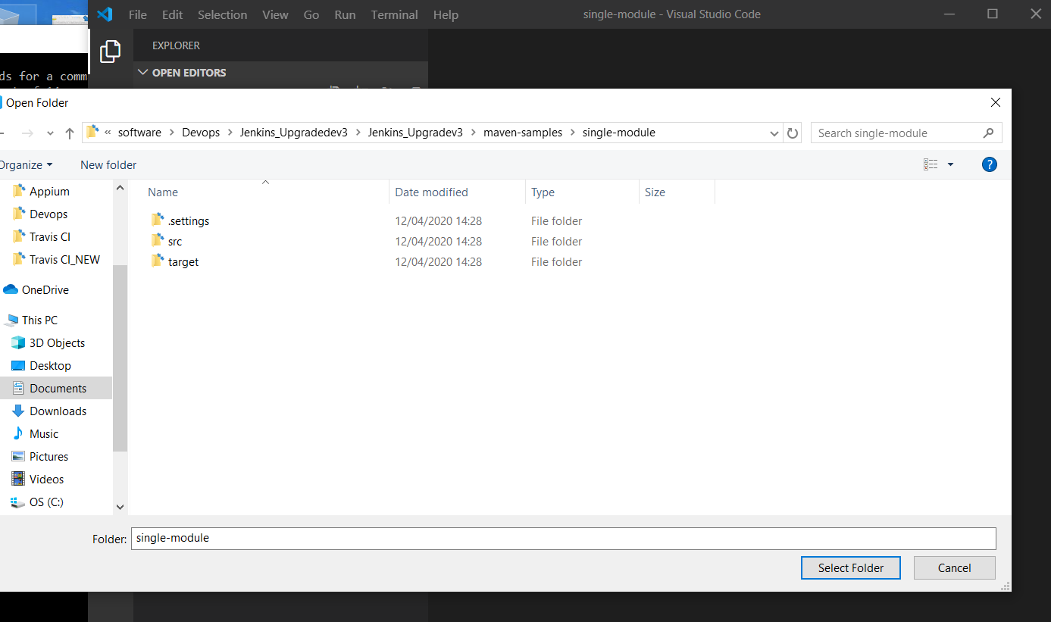

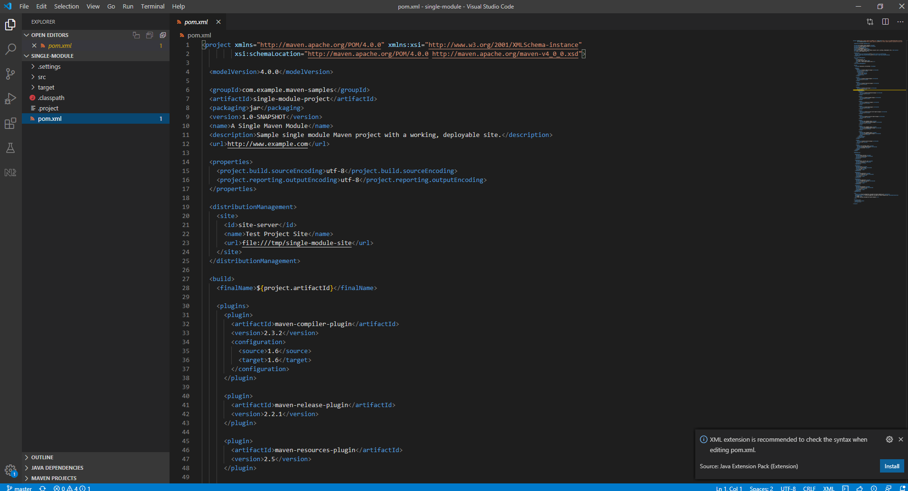

Now, go back to Jenkins and create a new job, enter a name and click ‘Freestyle project’:-

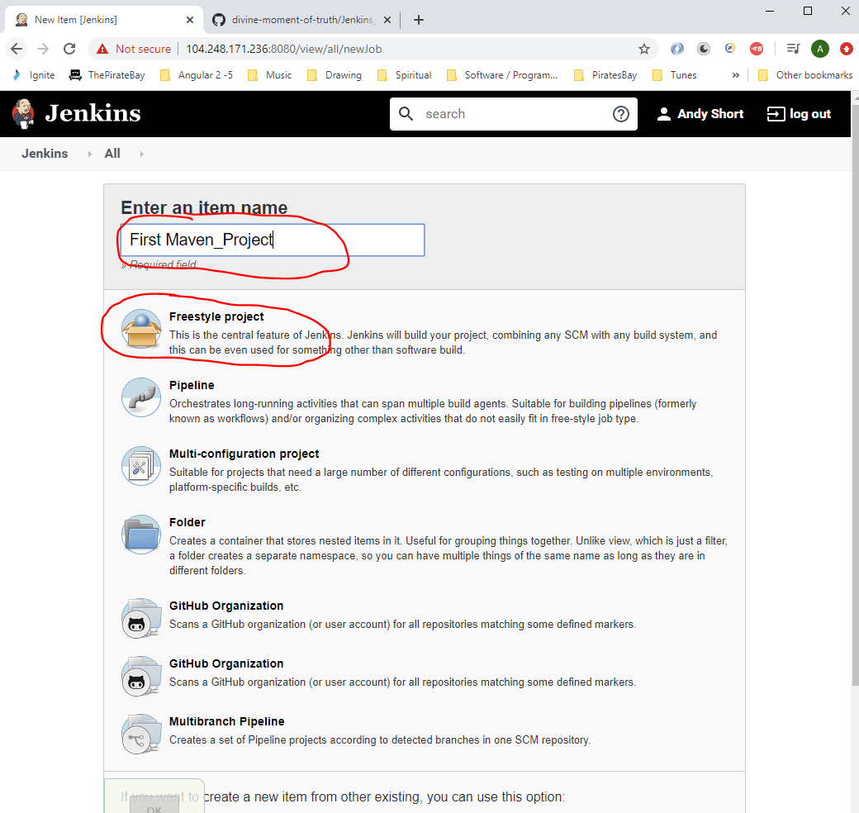

Under ‘Source Code Management’ select ‘Git’ radio button:-

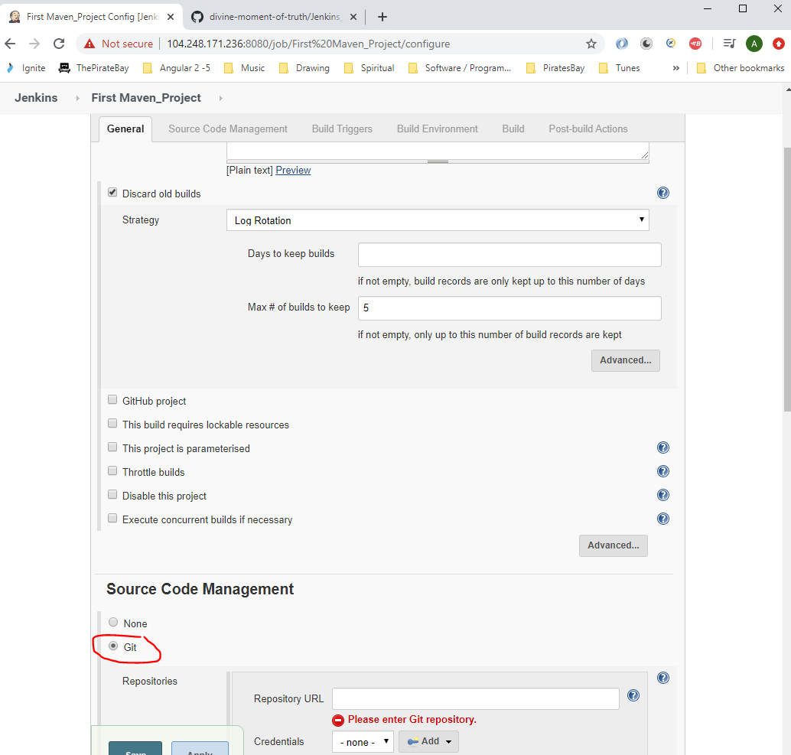

Go to GitHub where the project is saved and click the ‘Clone and download’ button and click the copy url button:-

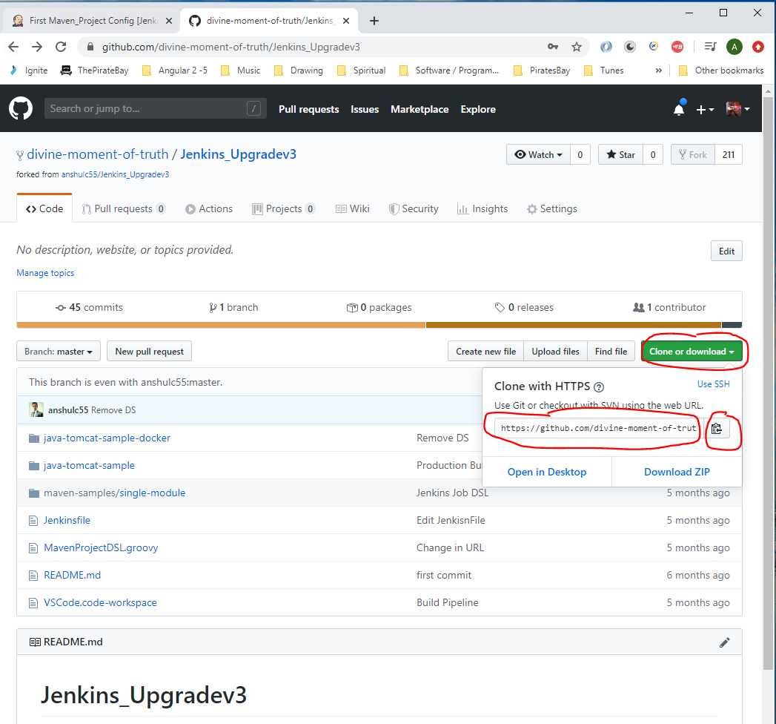

Paste the url into Jenkins:-

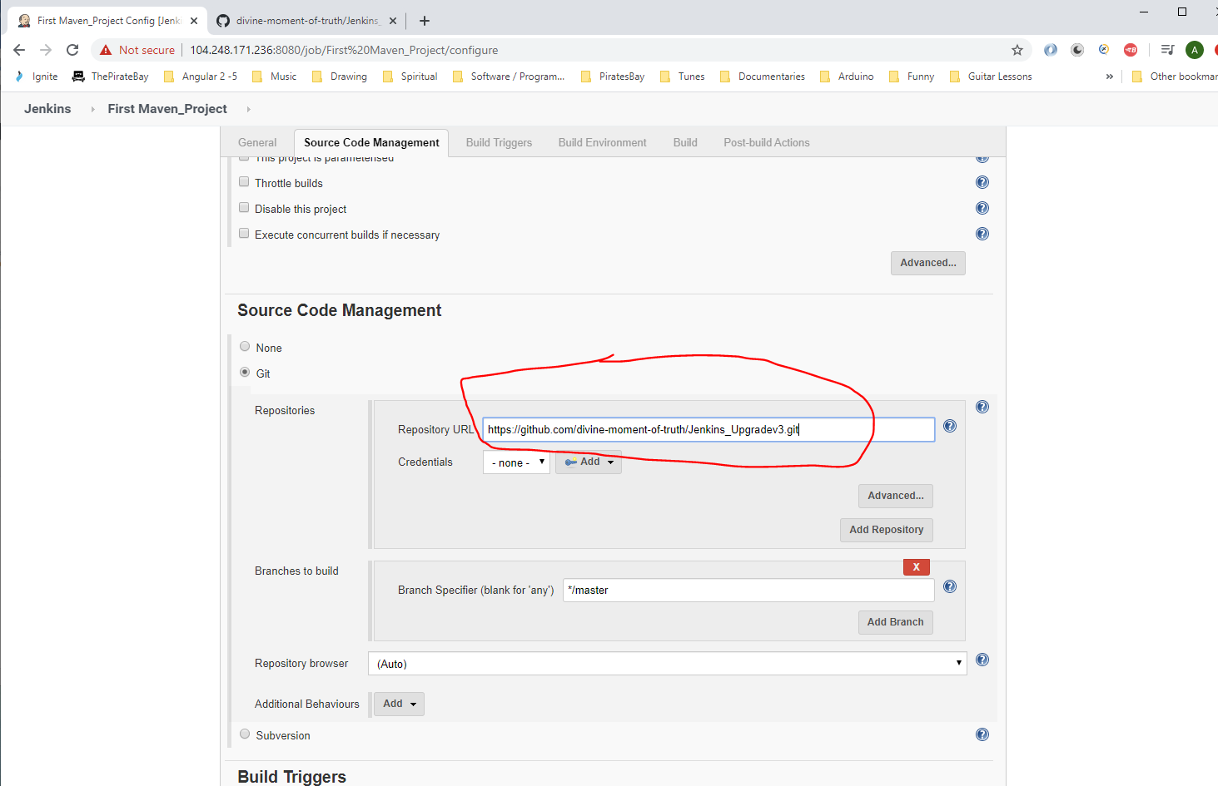

Now set the ‘Build Environment’:-

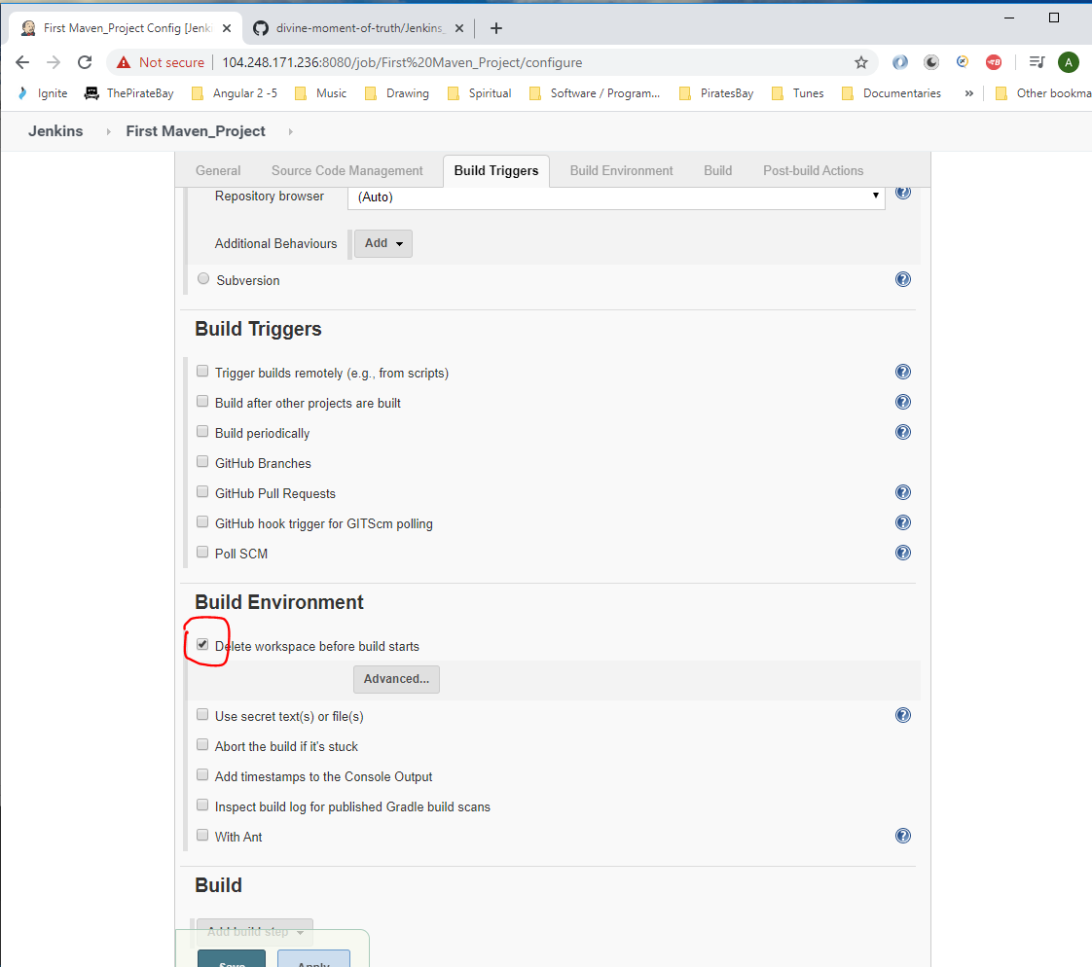

Now, select the following from the ‘Build’ -> ‘Add build step’ drop down:-

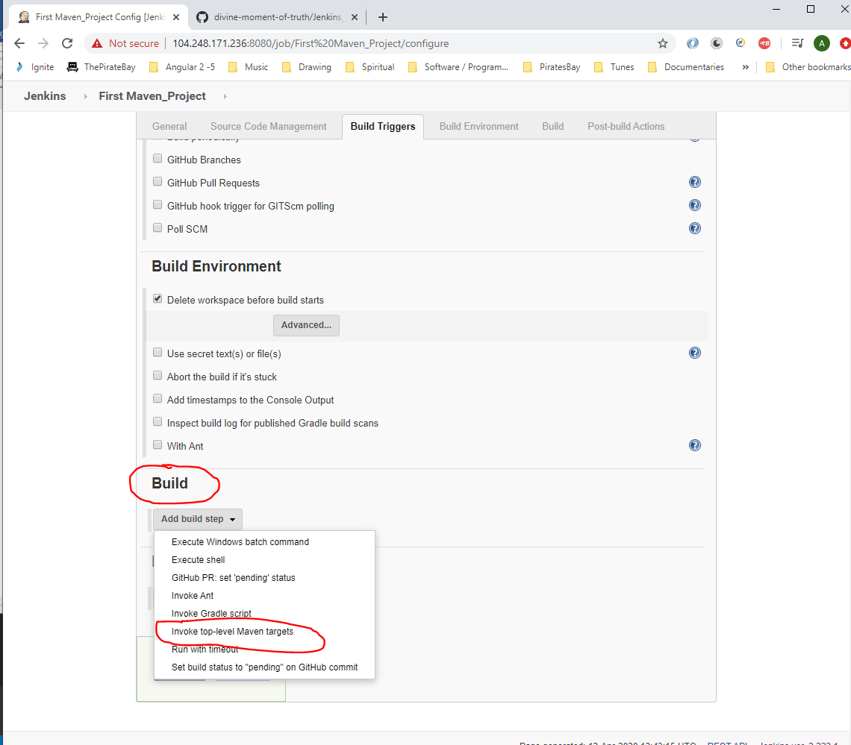

Enter the following under ‘Build’:-

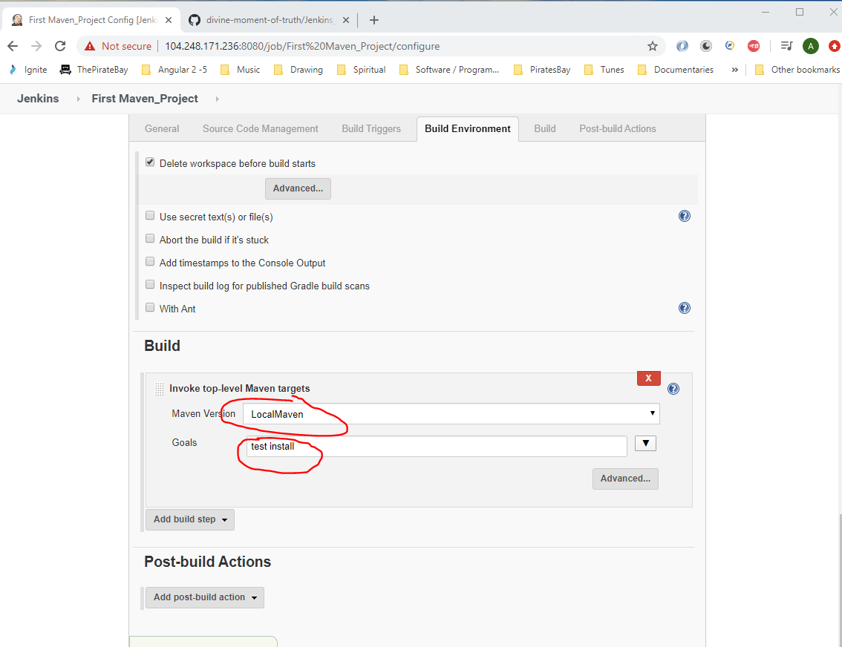

Select the ‘Advanced’ button and enter the location of your POM.xml directory which will be found in GitHUb here:-

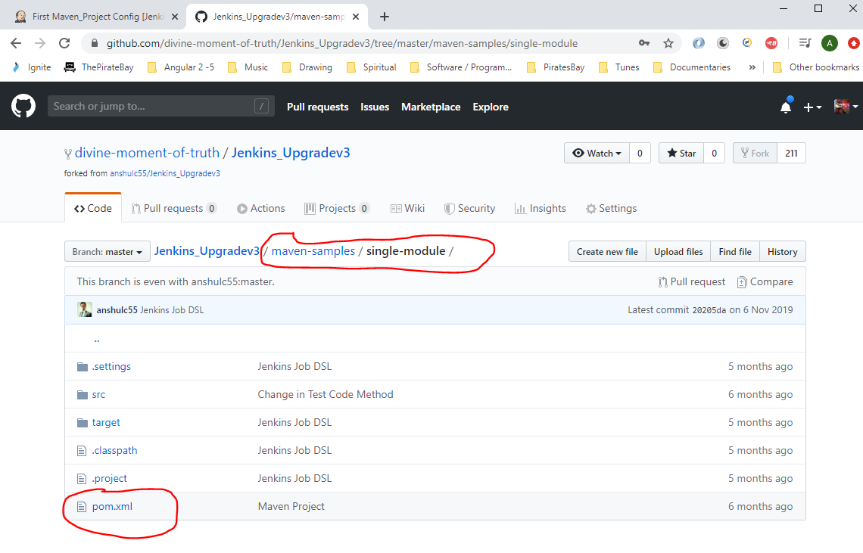

So enter the following into Jenkins:-

(maven-samples/single-module/pom.xml)

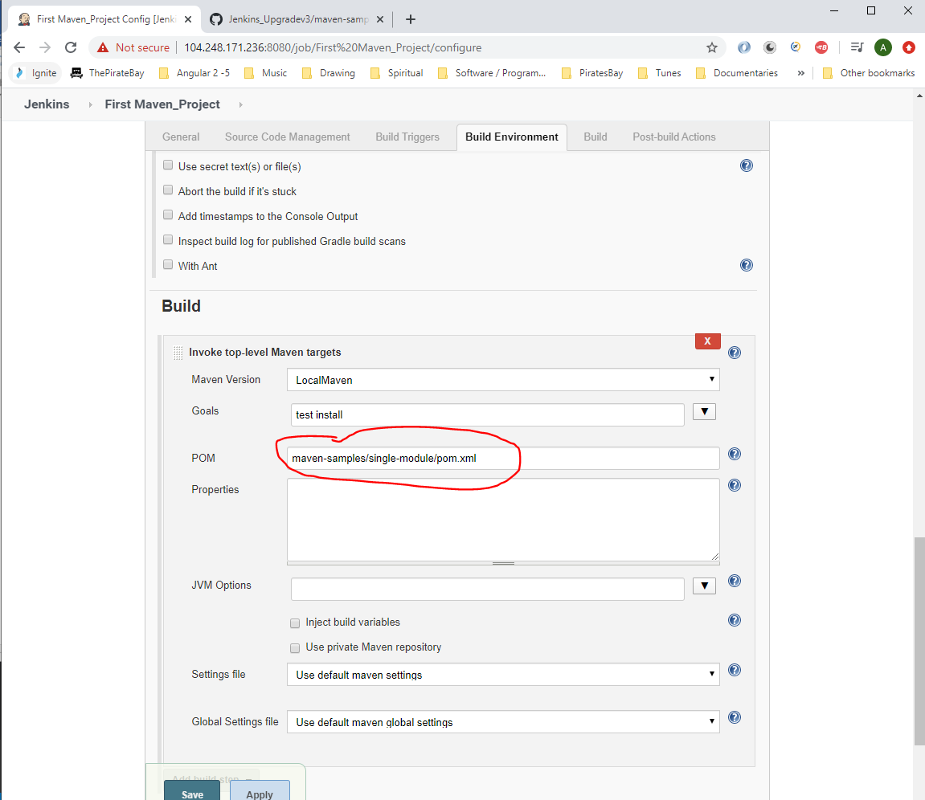

Then click the ‘Save’ button.

Now execute build, by clicking ‘Build Now’:-

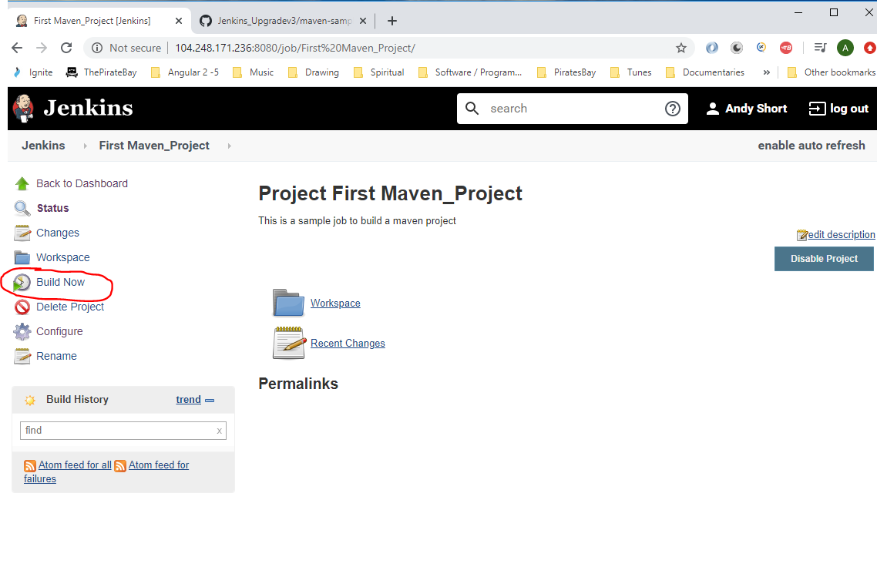

See build console output:-

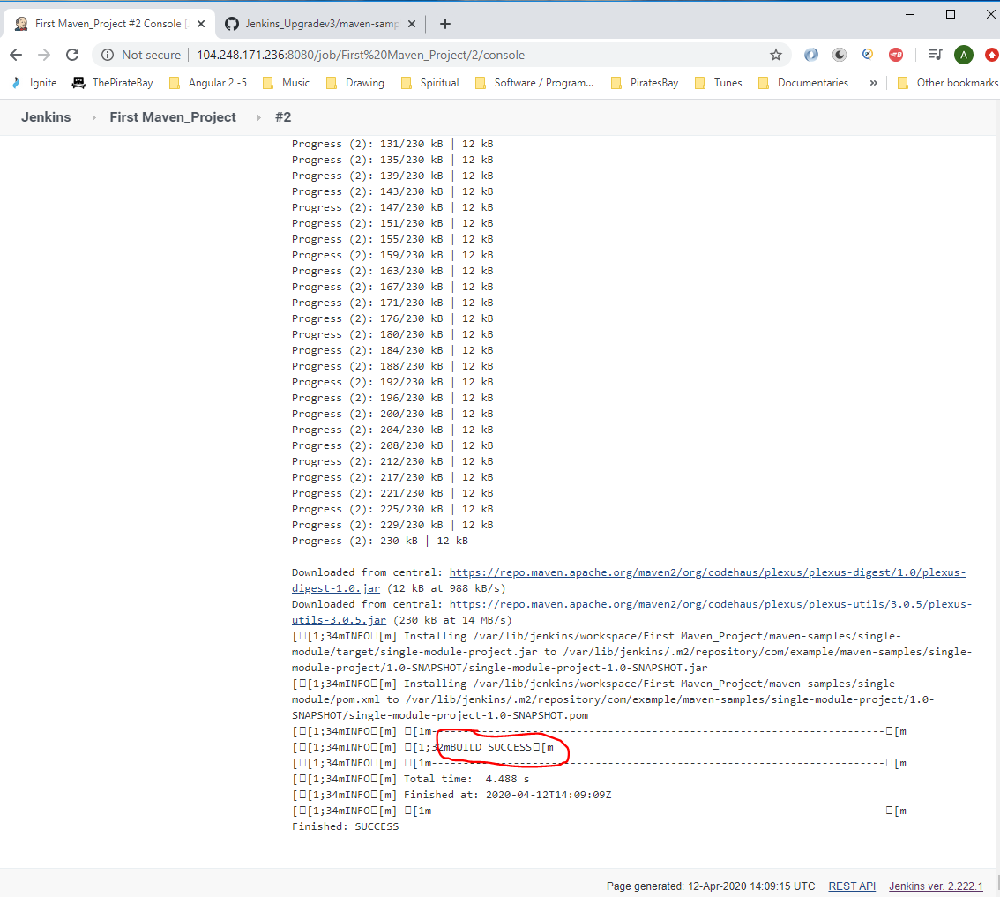

Now change the ‘Build Goals’ by editing the Jenkins job configuration to this:-

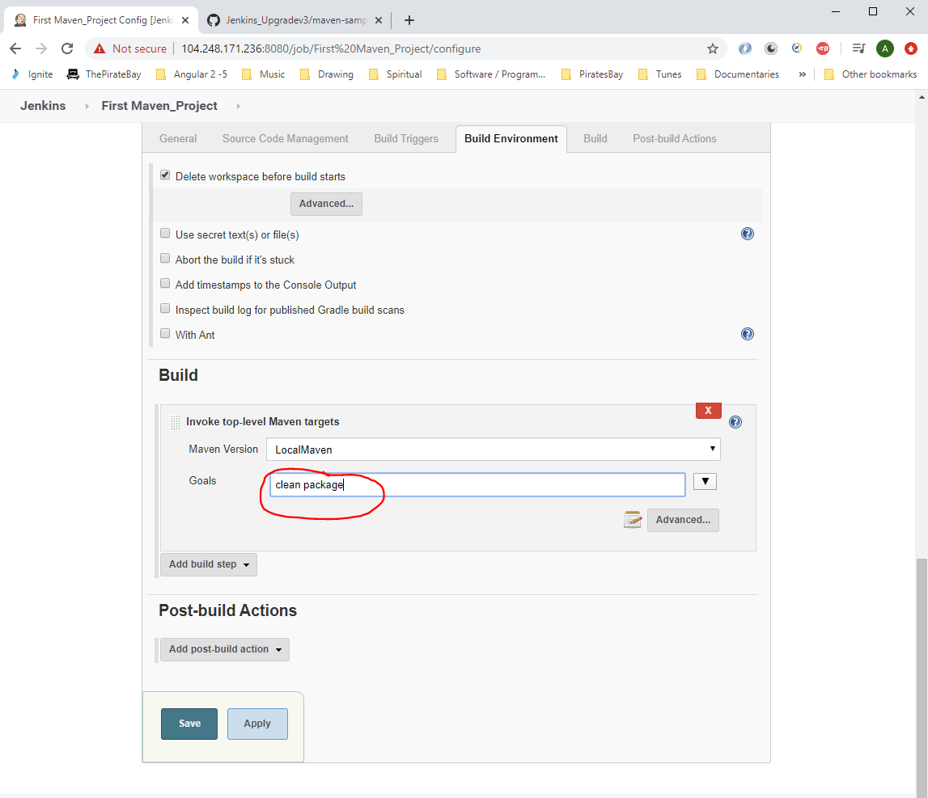

Then click ‘Save’ button. Then build again – ‘Build Now’.

Then go to the Console Output and copy this (this contains the location of the build java .jar file):-

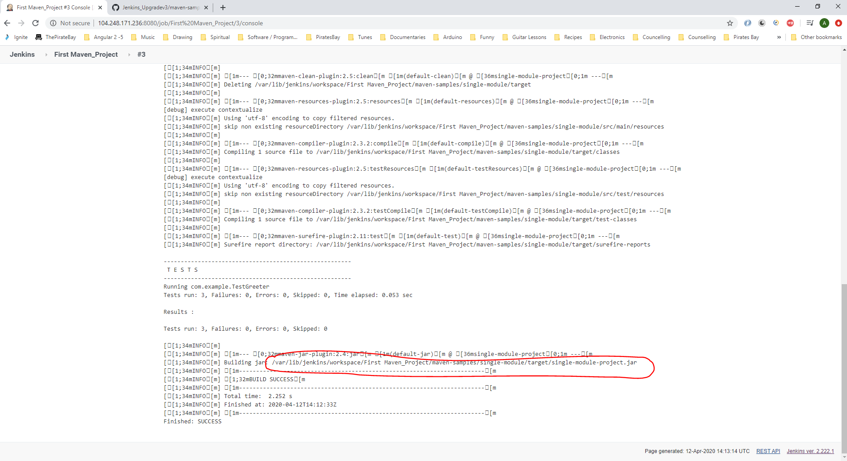

Go to Putty and change directory to the above location:-

cd /var/lib/jenkins/workspace/First Maven_Project/maven-samples/single-module/target/

When doing this you will notice an error because the path has a space in it:-

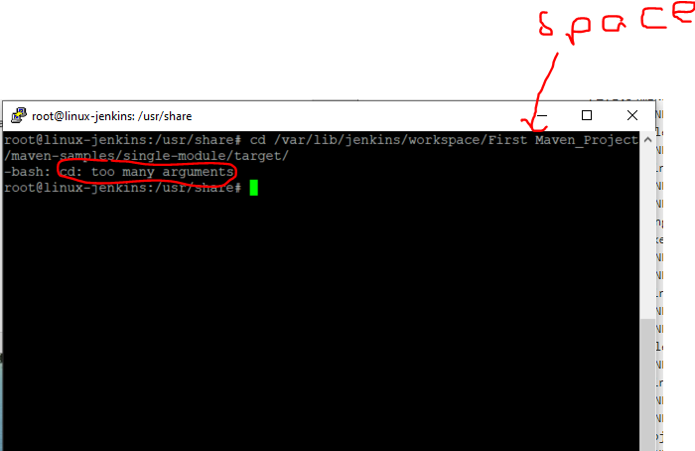

You need to escape the above space so enter a back slash before the space:-

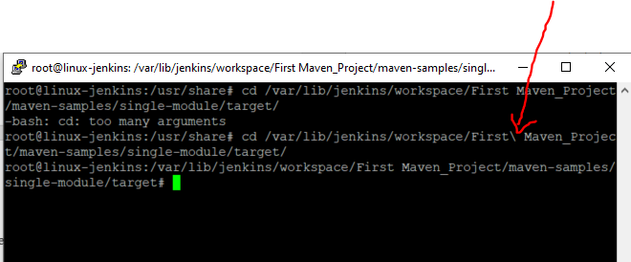

Now type ‘ls’ to show files:-

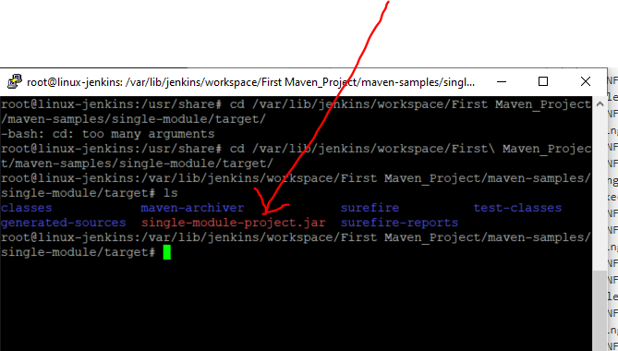

See the build .jar file above.

**Jenkins: Source Code Polling**

Go to Jenkins -> Configure:-

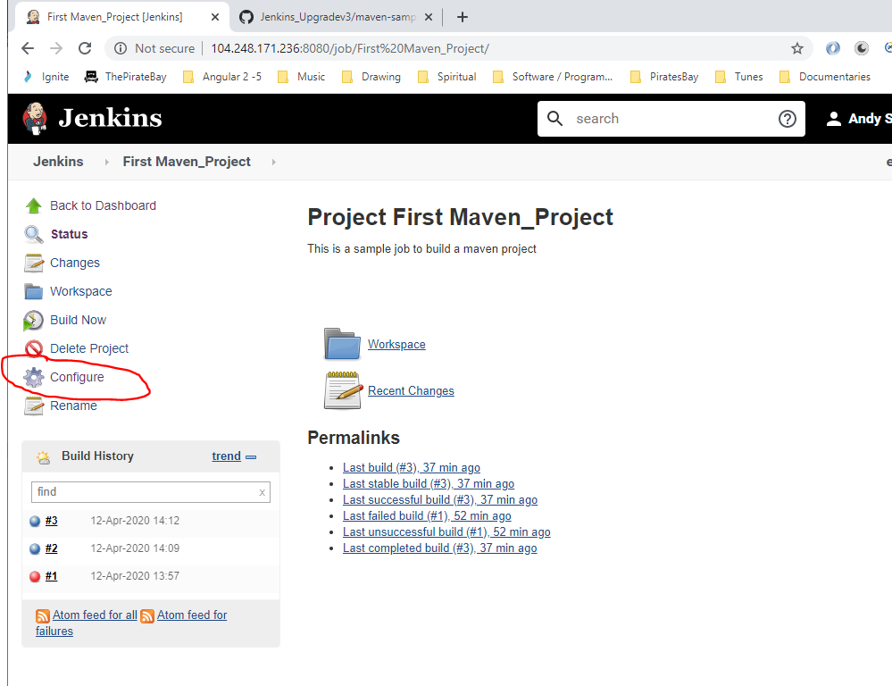

Go to ‘Build Triggers’ and tick ‘Poll SCM’ checkbox:-

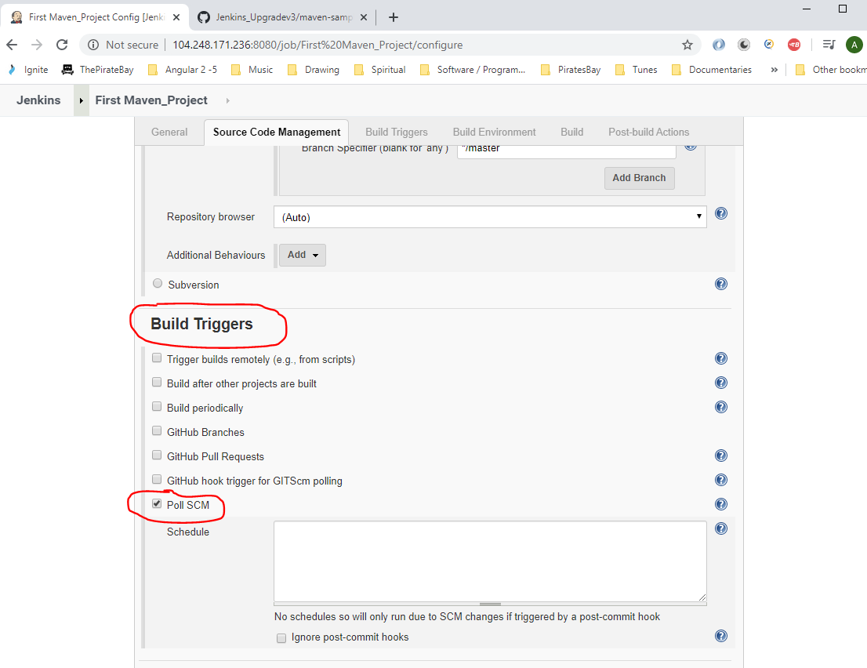

Use this for setting up a schedule:-

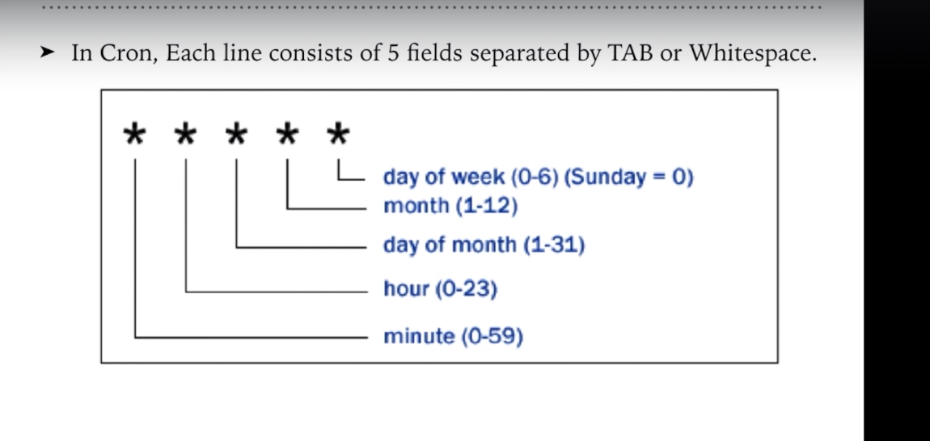

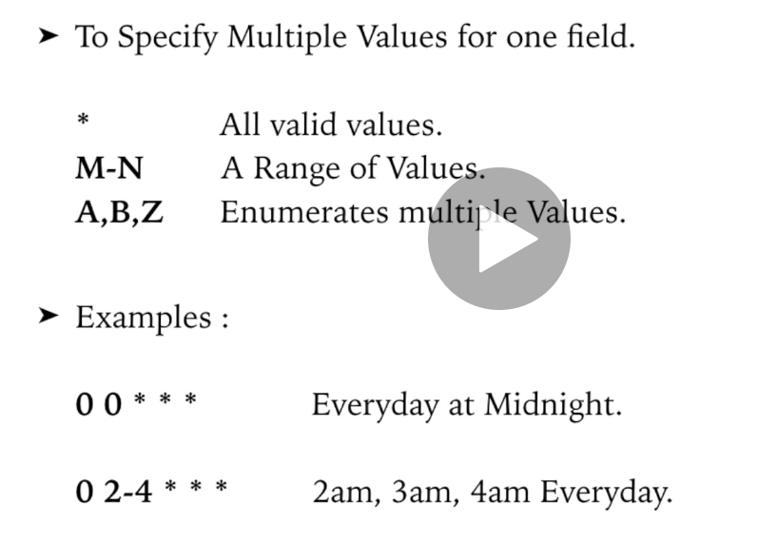

To poll every minute enter:-

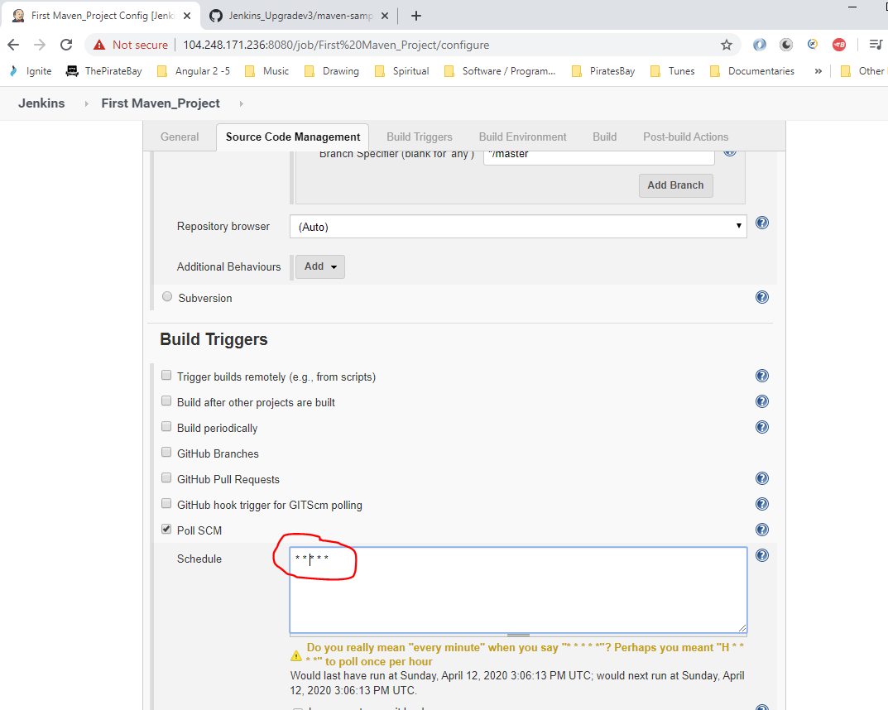

Then click ‘Save’ button.

Now go to Visual Code and insert a new test case:_

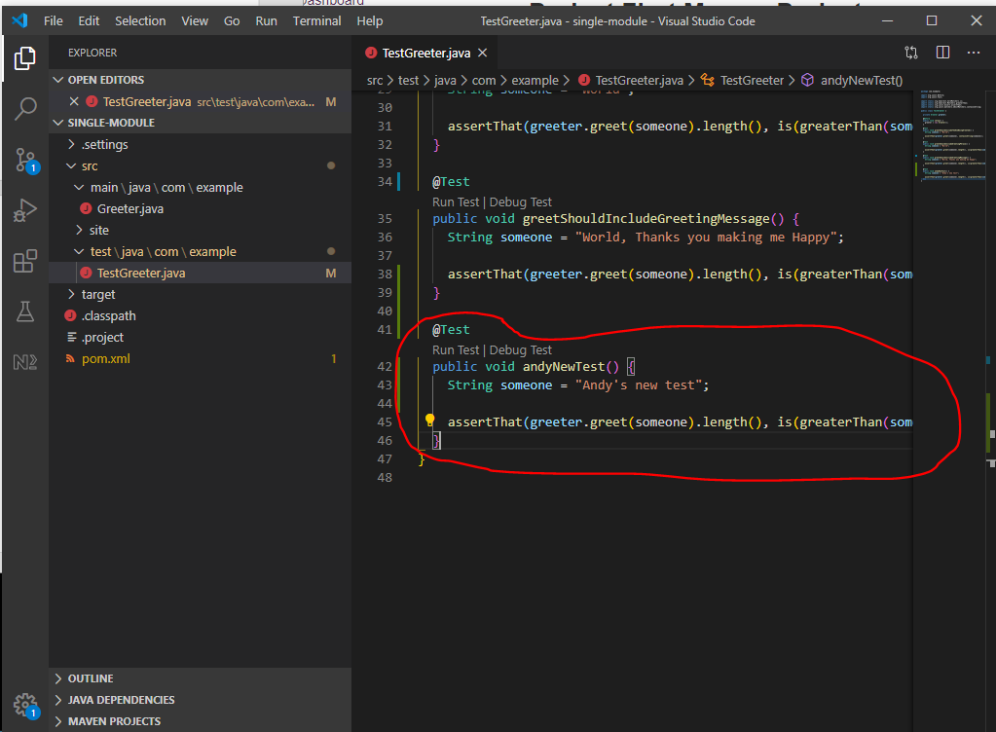

Go to Git Bash and type – git status

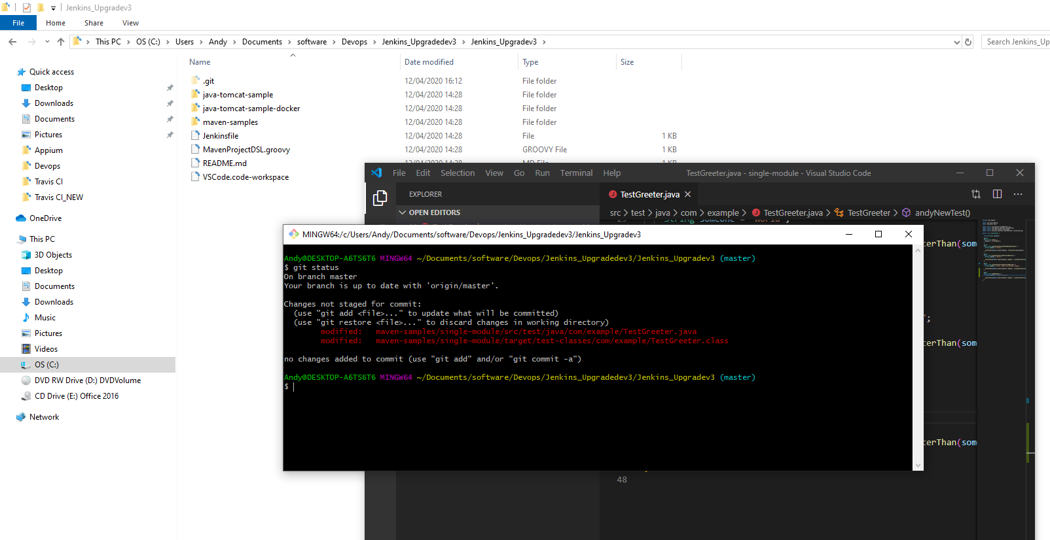

See that there are modified files that need adding to the staging area (see highlighted above in red).

Add files to staging area and commit changes to local repo, then push to remote repo:-

git add .

git commit -am “Added new test case”

git pull origin master

git push origin master

Now go to Jenkins and notice that after a minute a new build will automatically start:-

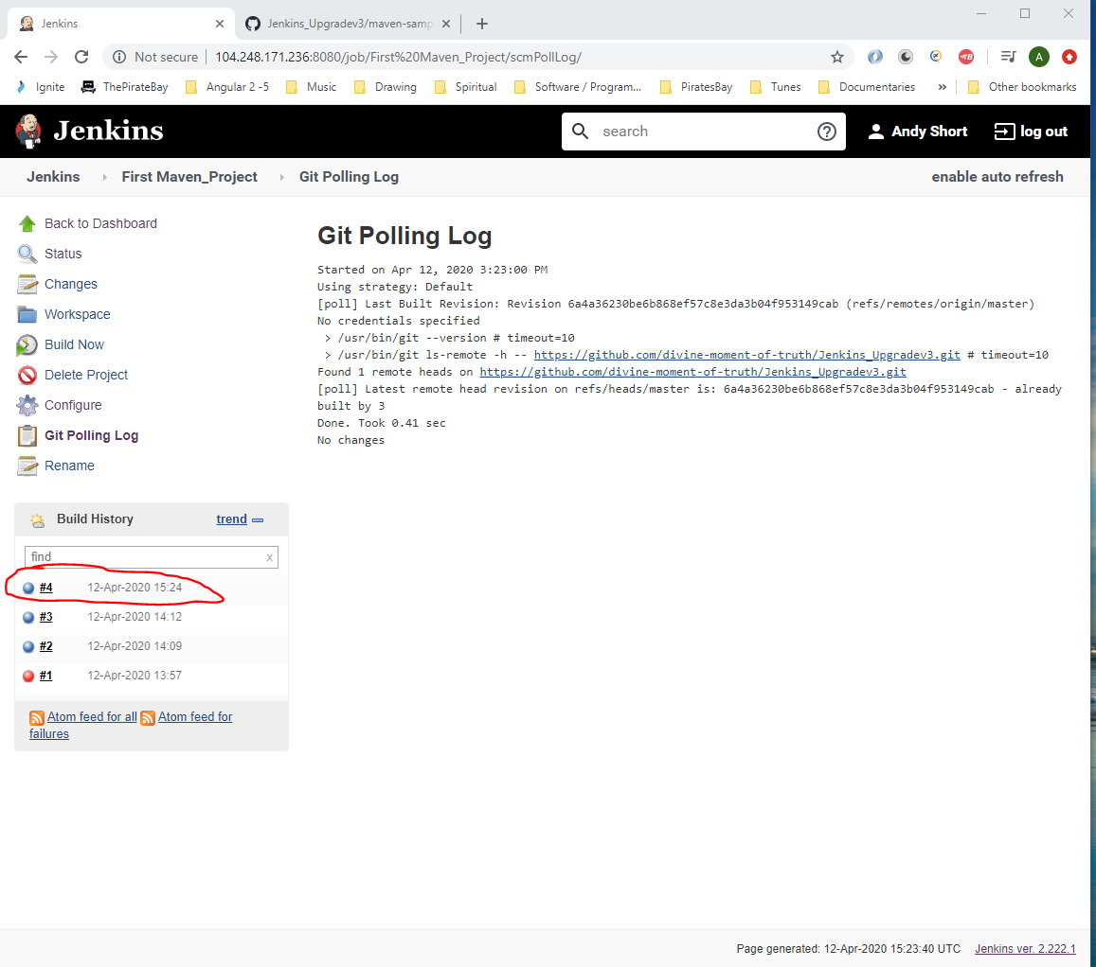7

See the ‘Polling Log’ comment below:-

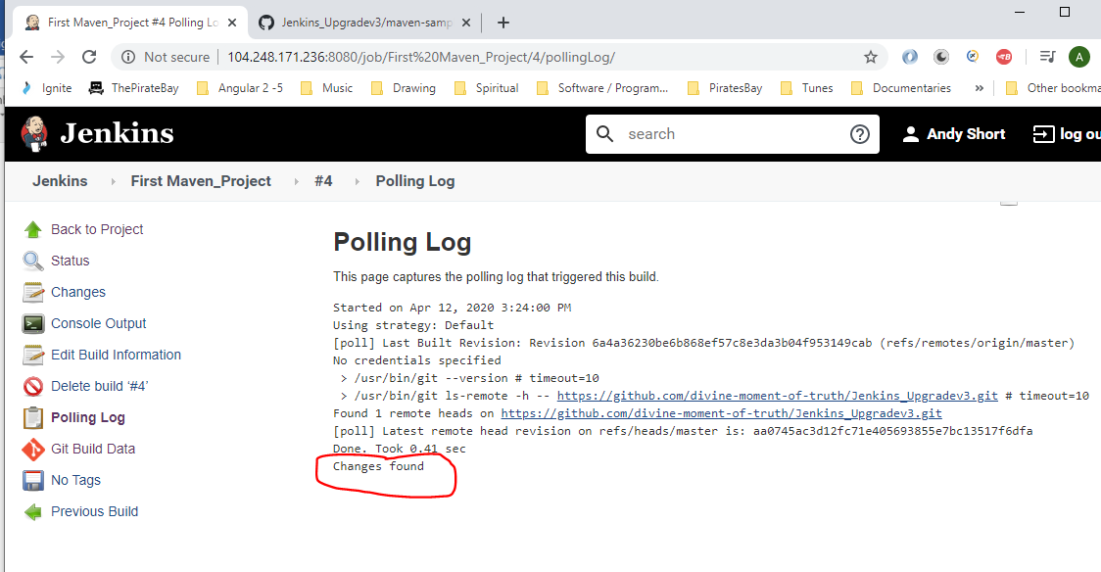

Also, see the commit id:-

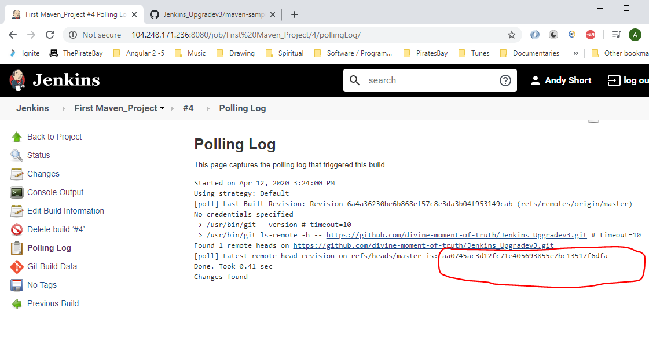

This will match the commit id in GitHub:-

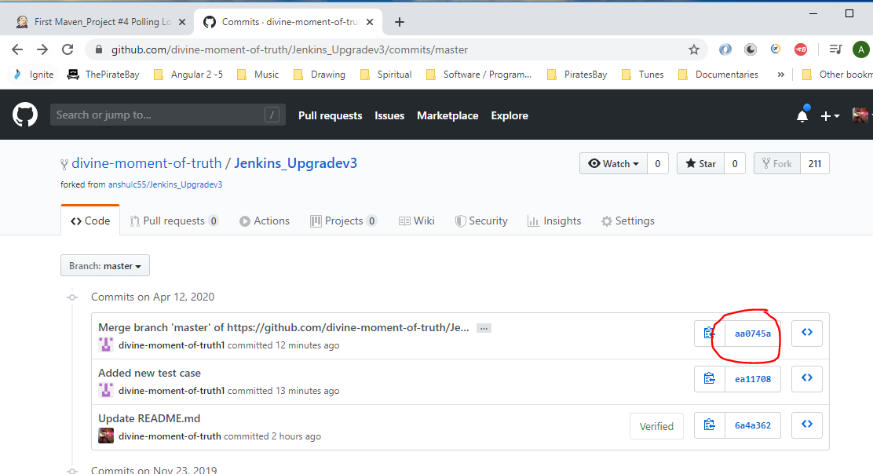

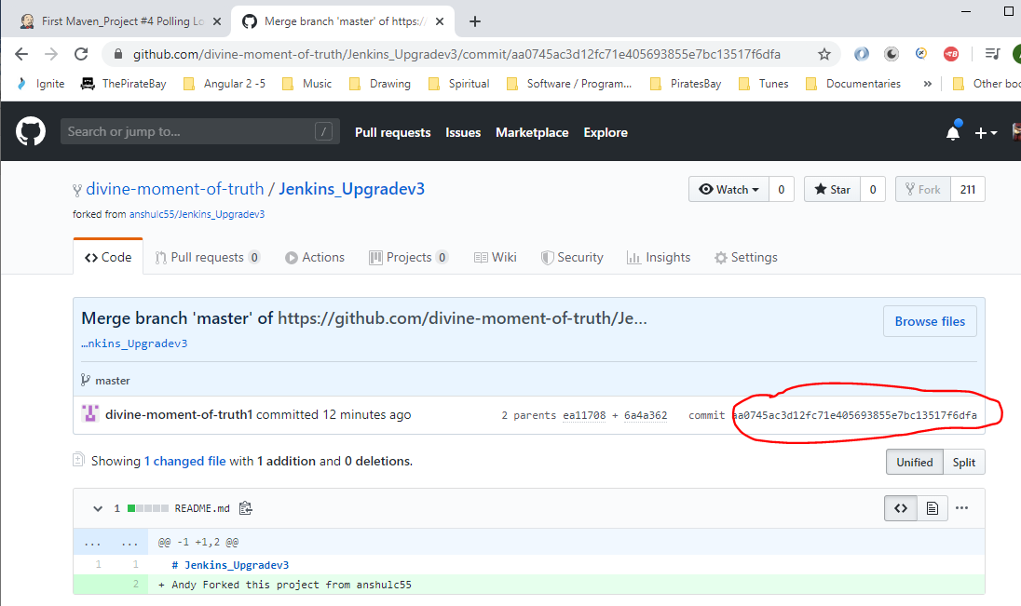

Also, clicking on build log:-

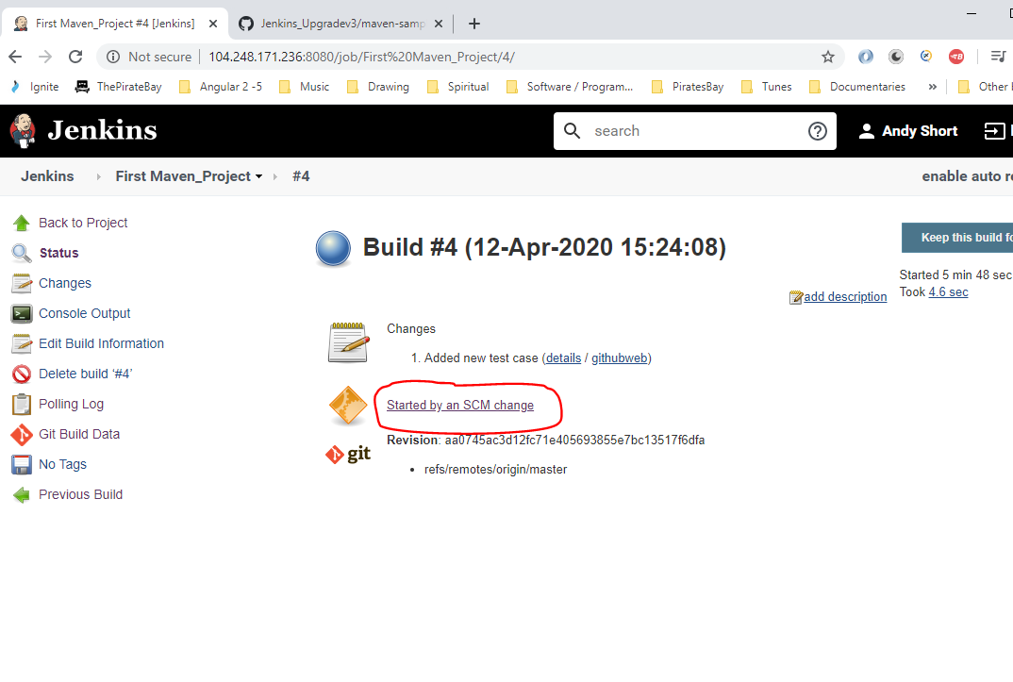

**Remote trigger in Jenkins**

Go to the ‘Build Triggers’ section in Jenkins configuration:-

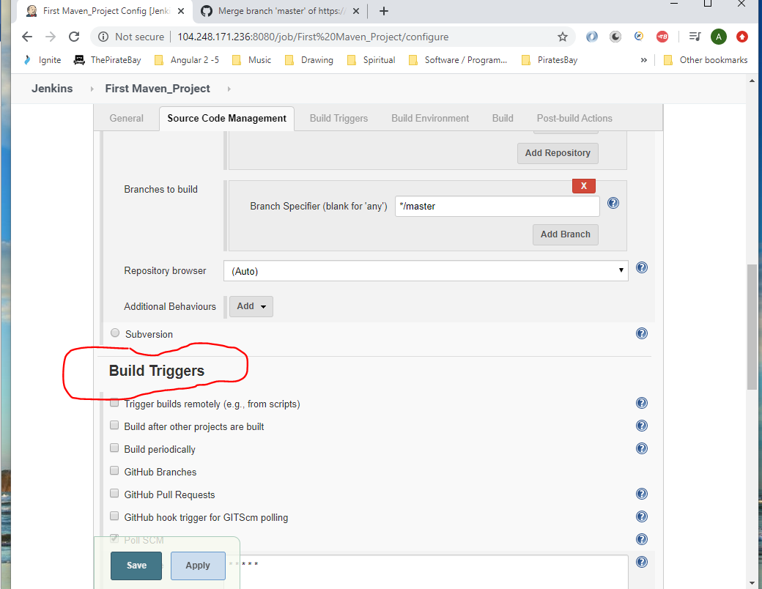

Tick the ‘Tigger builds remotely’ check box and enter ‘TESTAUTH’ into box, then copy the highlighted (below) text then click ‘Save’:-

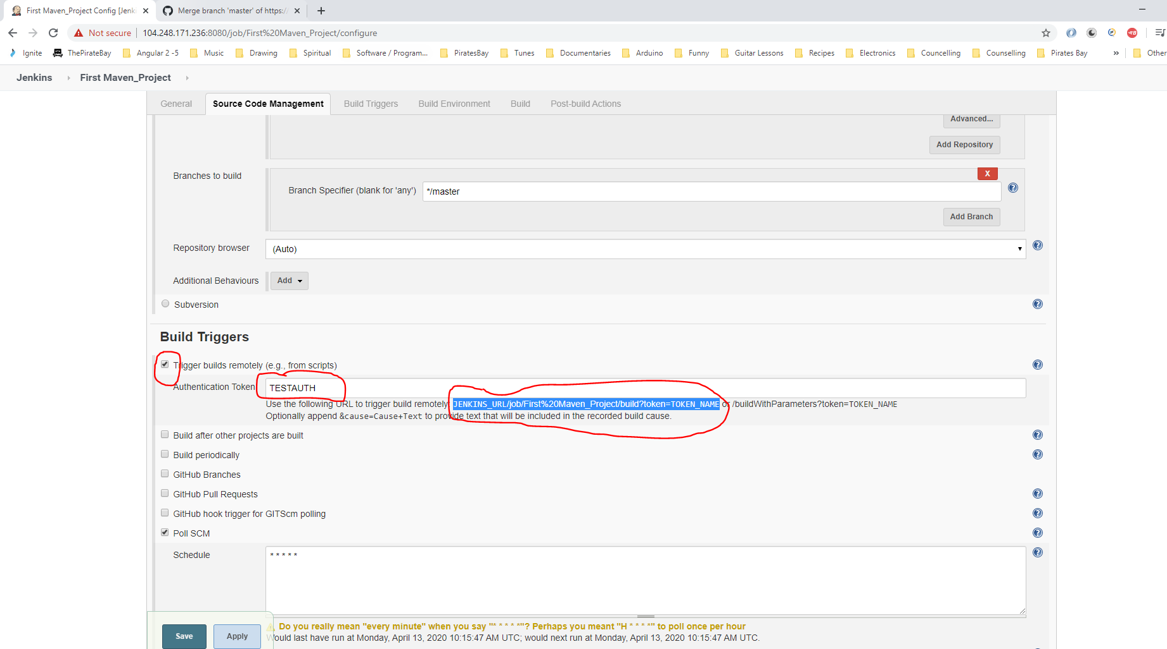

JENKINS_URL/job/First%20Maven_Project/build?token=TOKEN_NAME

Paste the above add dress into a browser and change the:-

[1] ‘JENKINS_URL‘ part with the Jenkins server url - <http://104.248.171.236:8080/>

[2] ‘TOKEN_NAME‘ part with the authentication Token - TESTAUTH

[http://104.248.171.236:8080//job/First%20Maven_Project/build?token=TESTAUTH](http://104.248.171.236:8080/job/First%20Maven_Project/build?token=TESTAUTH)

<http://104.248.171.236:8080/job/First%20Maven_Project/build?token=TESTAUTH>

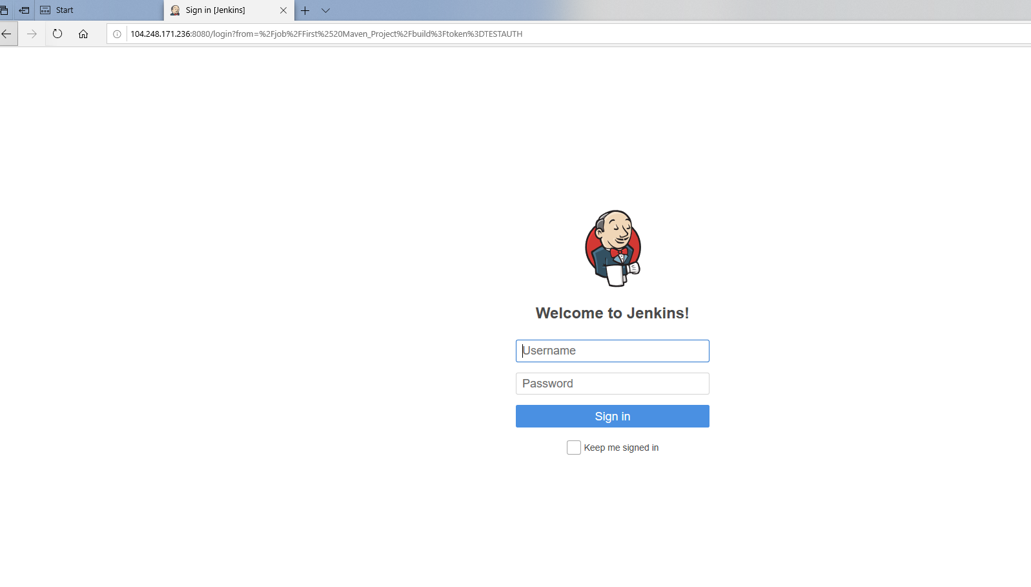

Log in:-

Username - Test_king77, password - dudeegg1977

If you go back to your Jenkins session you will see that doing the above triggers a new build job:-

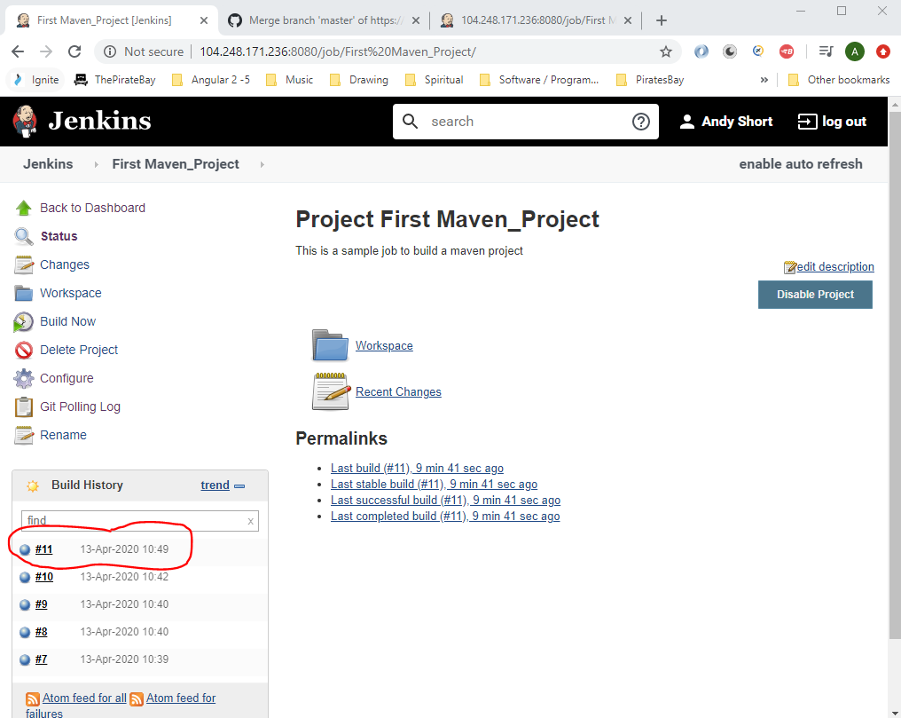

Setting the following will trigger a new build every minute:-

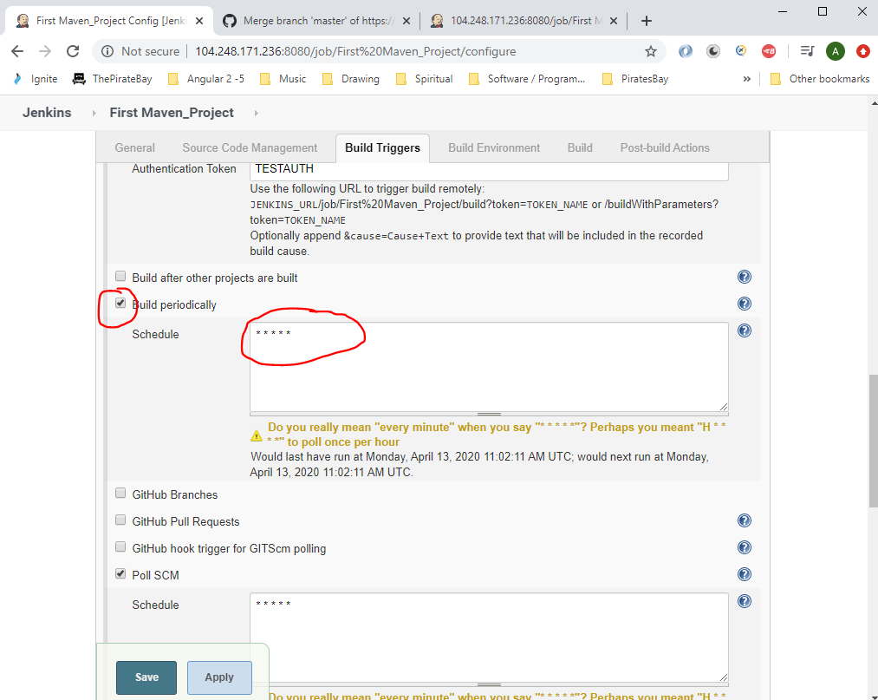

**Archive Jenkins Job Artifacts**

Click on the jobs ‘Configure’ link:-

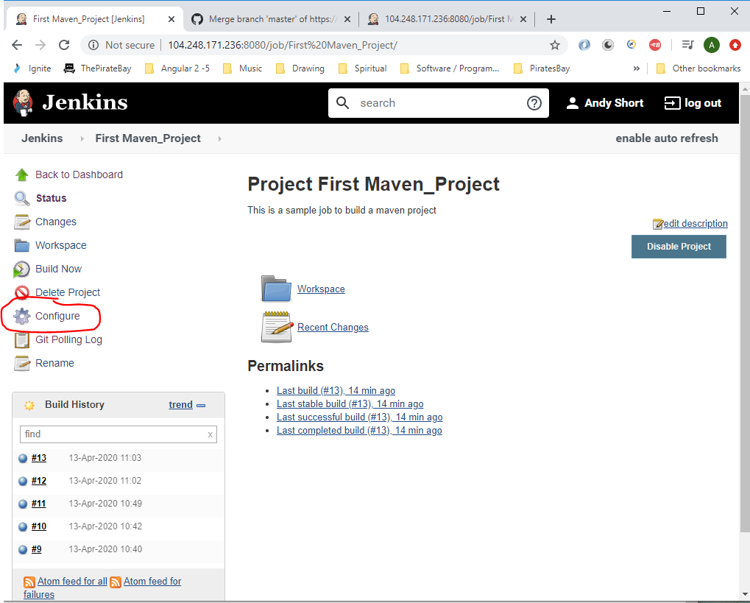

Go down to ‘Post-build Actions’ and select ‘Archive the artifacts’:-

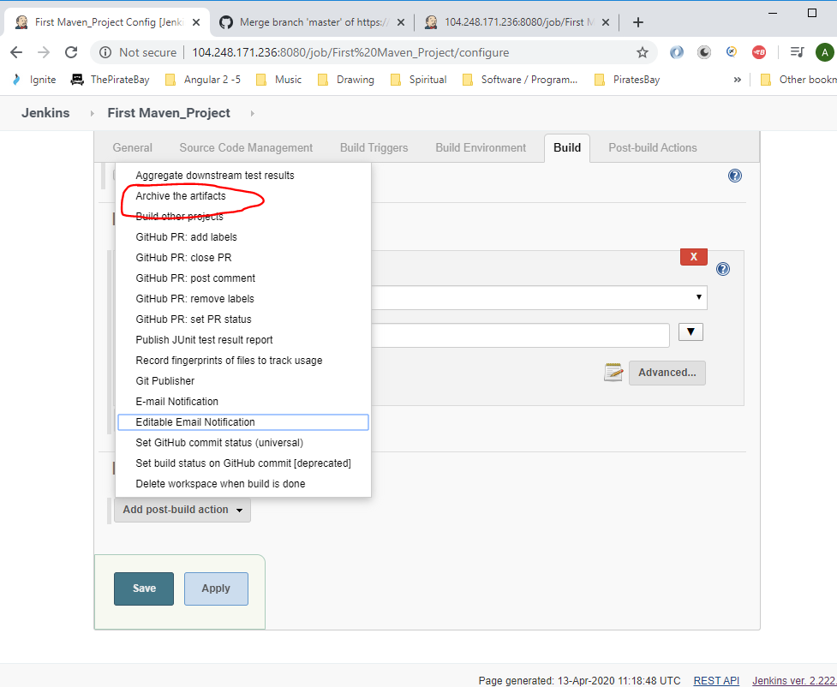

To archive all jar files enter the following regular expressions:-

**/*.jar

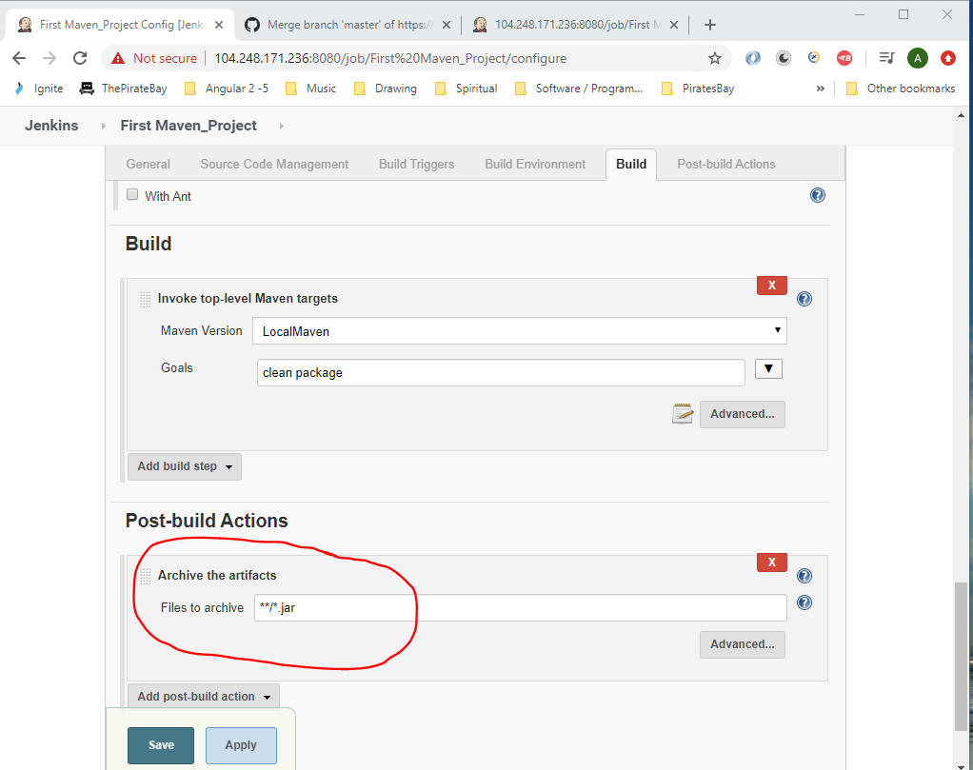

Then click ‘Save’.

Trigger a new build by entering the following into a browser:-

<http://104.248.171.236:8080/job/First%20Maven_Project/build?token=TESTAUTH>

A new build will start, click on the below:-

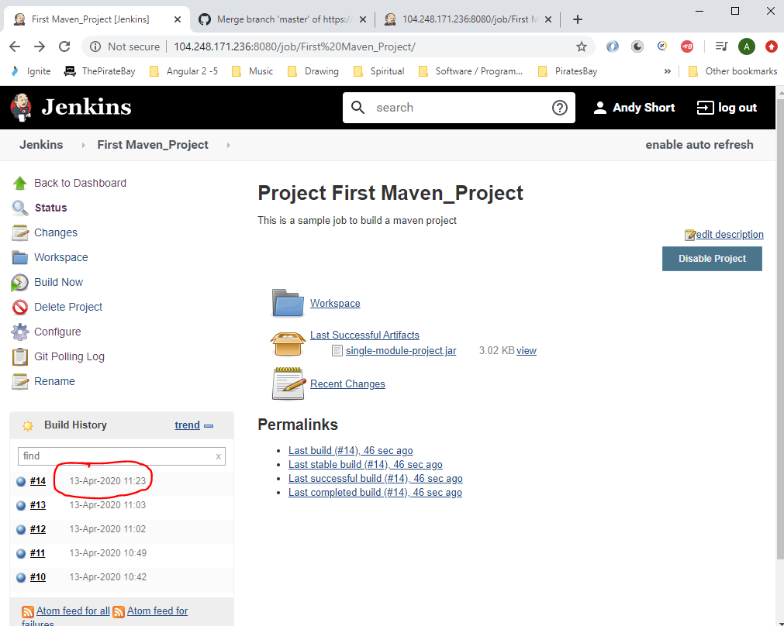

Then click the ‘Console Output’:-

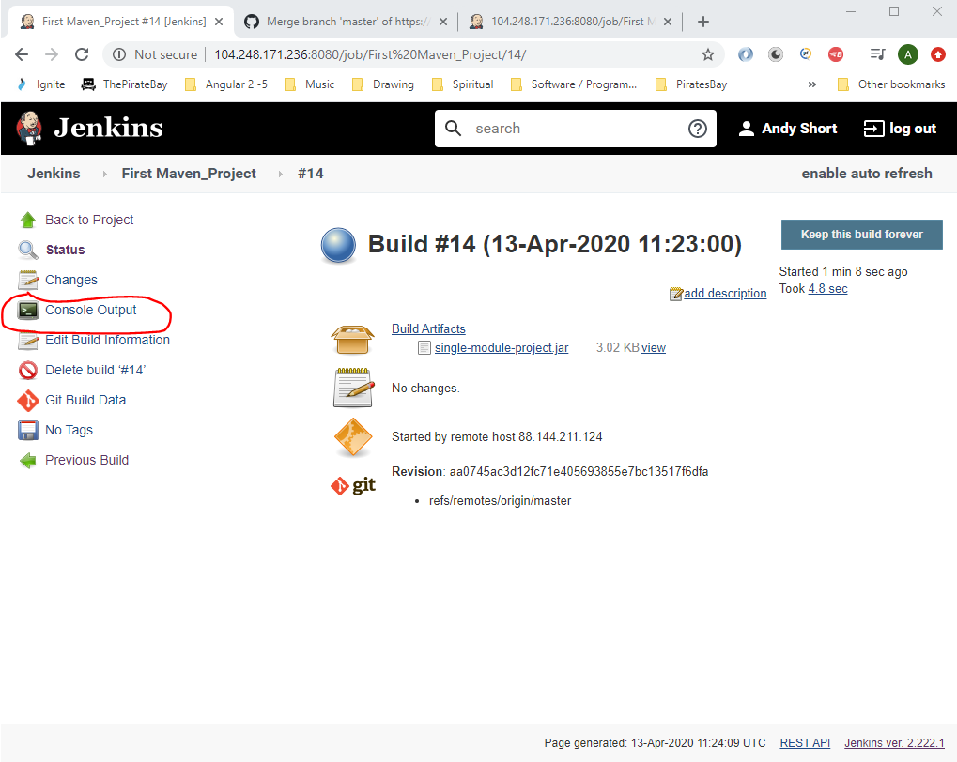

See statement at the bottom:-

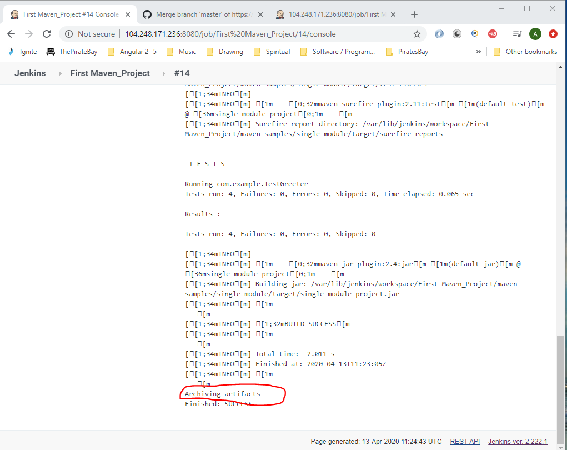

Clicking the build number i.e. 14 in the below you will see a new section called ‘Build Artifacts’:-

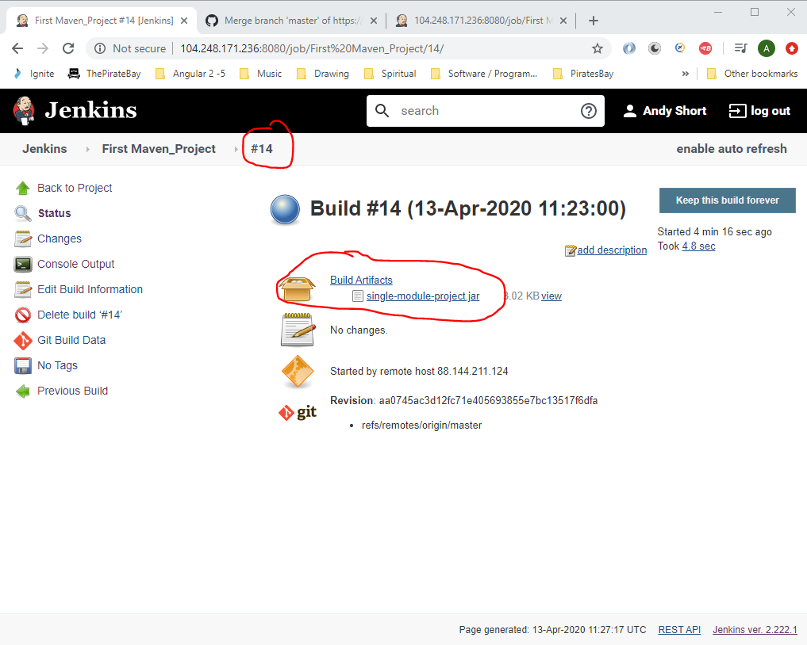

To archive all files go to the ‘Configure’:-

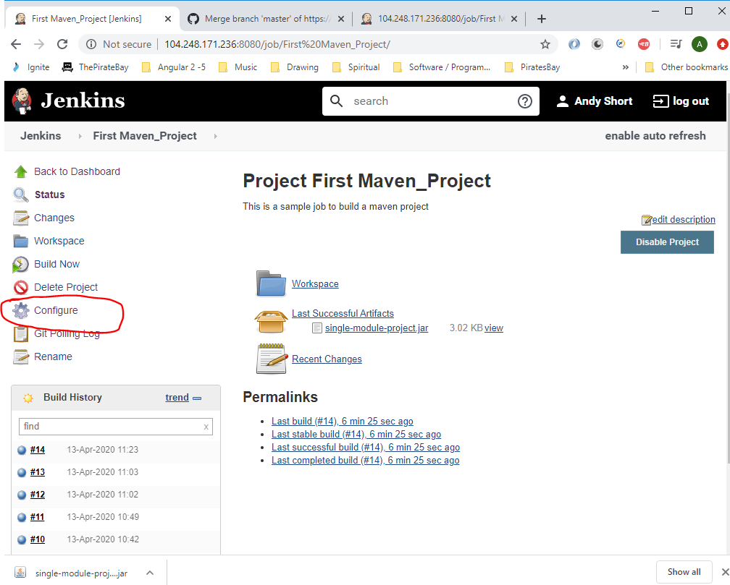

Remove the ‘.jar’ section in the Post-build Actions section:-

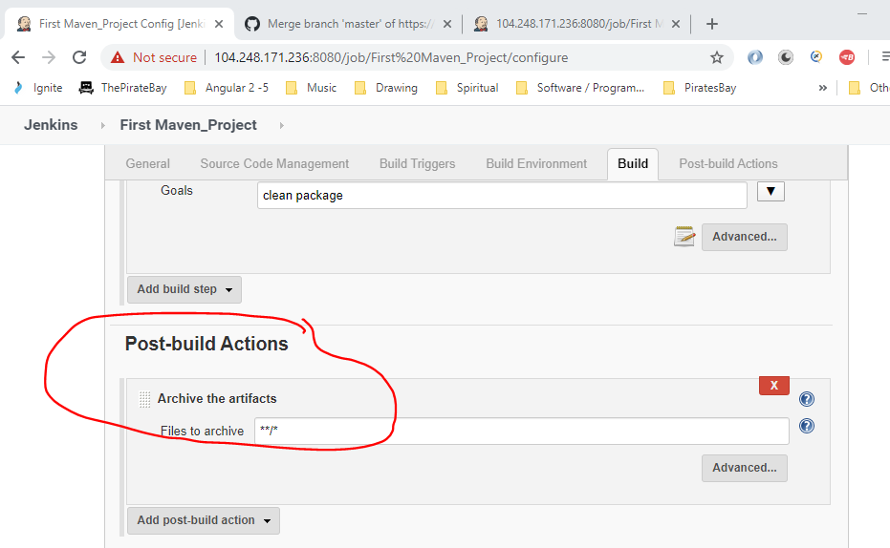

Click save.

Trigger build again by going to the following link in a new browser:-

<http://104.248.171.236:8080/job/First%20Maven_Project/build?token=TESTAUTH>

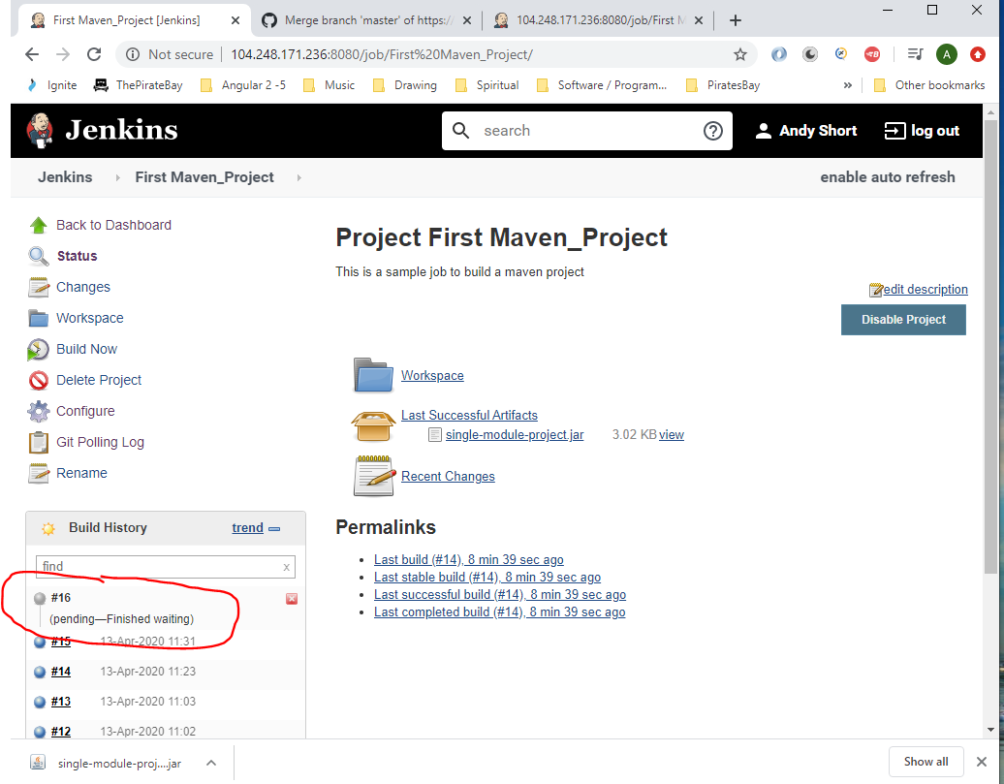

Now see all the artifacts being archived:-

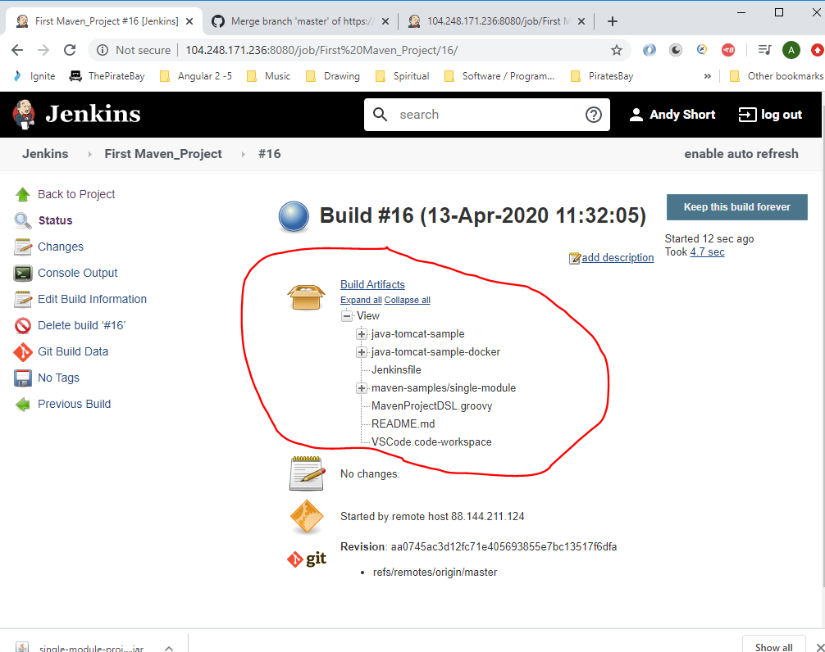

**Continuous Delivery**

Install and configure Tomcat (staging environment):-

Tomecat is a web-server from Apache that executes Java servlet and renders web pages.

Go to GitHub repo to see code for Tomcat server:-

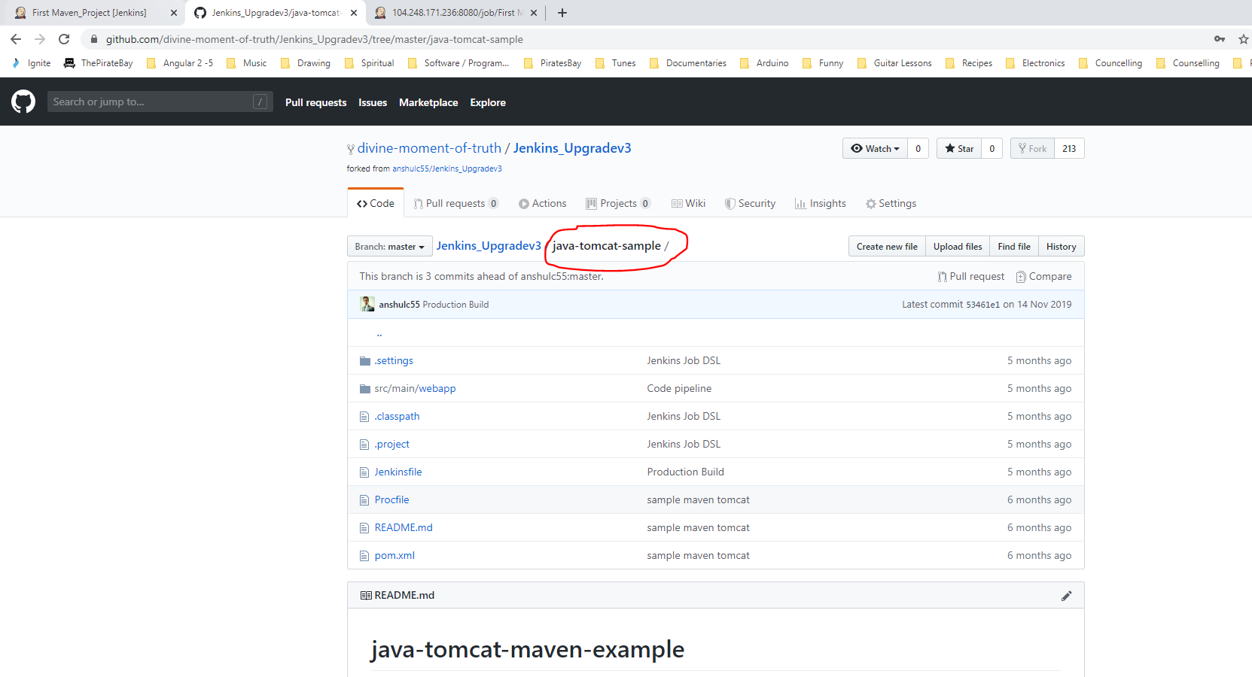

<https://github.com/divine-moment-of-truth/Jenkins_Upgradev3/tree/master/java-tomcat-sample>

To install Tomcat on the Linux cloud based machine you will need to open Putty and perform the following steps:-

**[1] Install Java (This step will not be required because Java 8 has already been installed on the cloud based Ubuntu server in previous steps)**

sudo apt-get update

sudo apt-get install default-jdk

**[2] Install Tomcat Server**

*sudo apt install unzip wget*

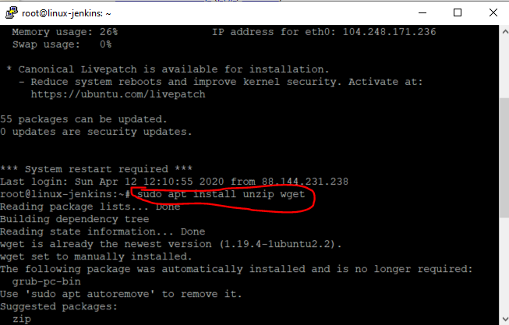

Change to the ‘tmp’ folder in Putty:-

*cd /tmp*

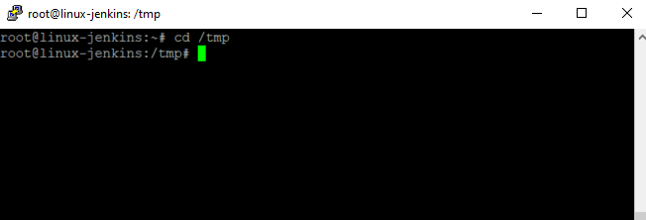

Then copy the url of the following link (this can be done by right clicking the link):-

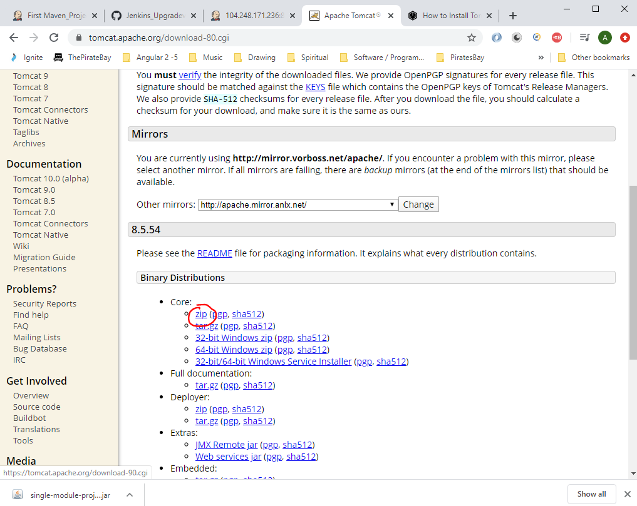

Type the following into Putty:-

wget <http://mirror.vorboss.net/apache/tomcat/tomcat-8/v8.5.54/bin/apache-tomcat-8.5.54.zip>

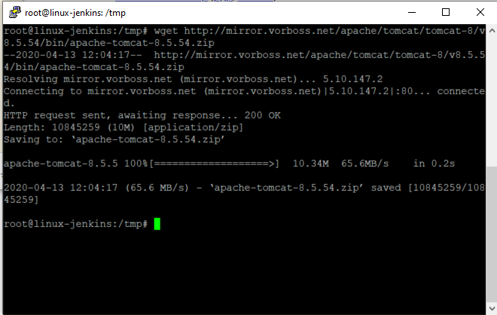

Now unzip this file:-

*unzip apache-tomcat-8.5.54.zip*

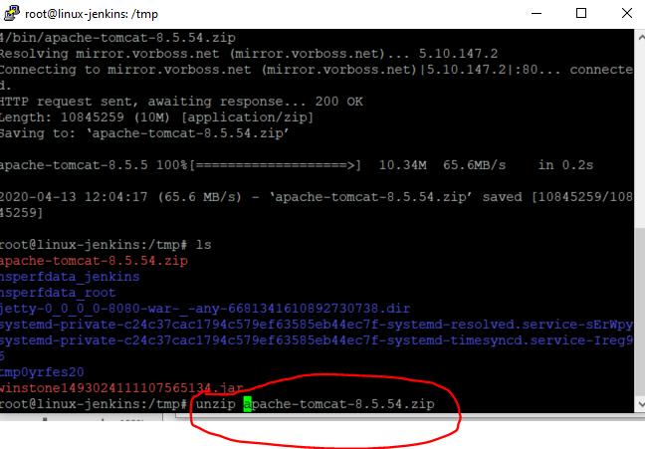

Now create a new folder in the ‘opt’ folder called ‘tomcat’:-

*sudo mkdir -p /opt/tomcat*

Now move all files previously unzipped and place them in the new ‘tomcat’ folder:-

*sudo mv apache-tomcat-8.5.54 /opt/tomcat/*

**[3] Change the Tomcat port**

Need to change the port because tomcats default port number is 8080 (which is already been used by the Jenkins server). So change port to 9090

Change directory into new tomcat folder:-

*cd /opt/tomcat/*

Then, change directory into here:-

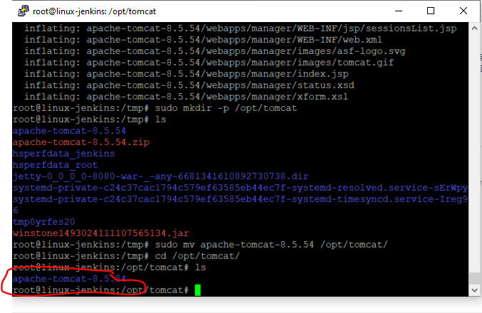

Then cd into the ‘conf’ folder:-

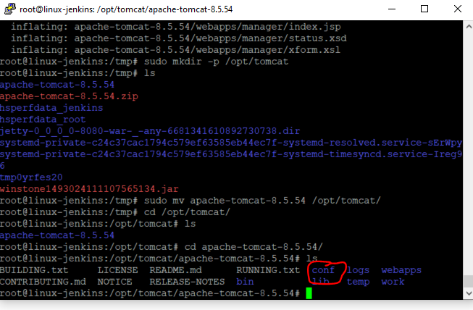

Now, edit the ‘server.xml’ file:-

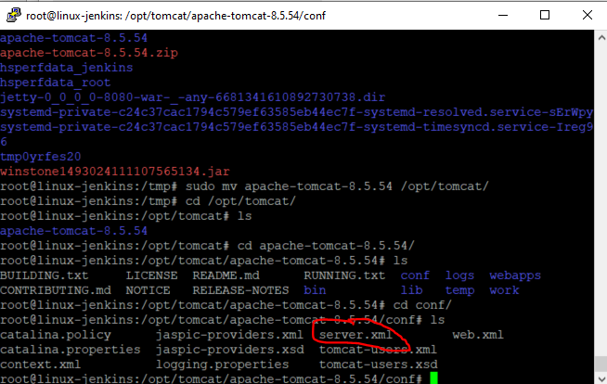

Type:-

*vi server.xml*

Search for ‘connector’. Keep pressing [Enter] until you find this section:-

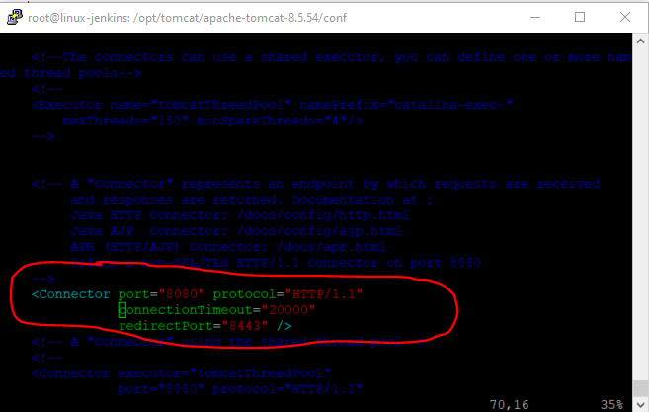

Move the cursor down to the ‘8080’ text then press ‘I’ to insert:-

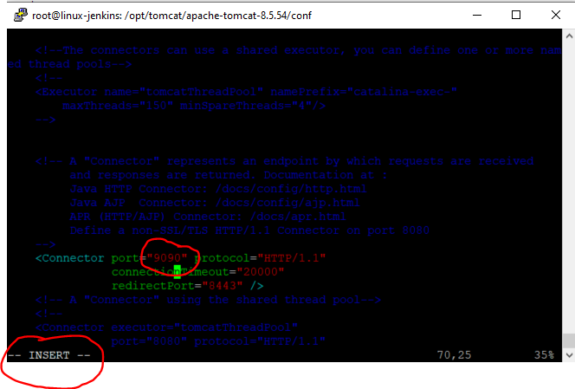

Then press [Esc] then press ‘:’, then ‘w’, then press ‘q’:-

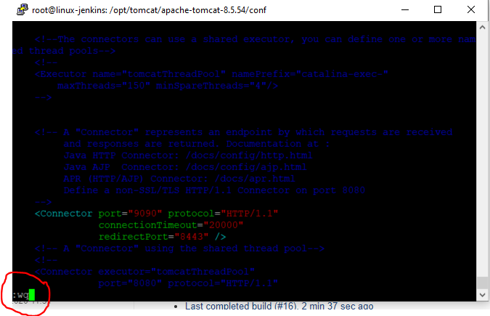

Then press [Enter].

To see saved version of ‘server.xml’ type this:-

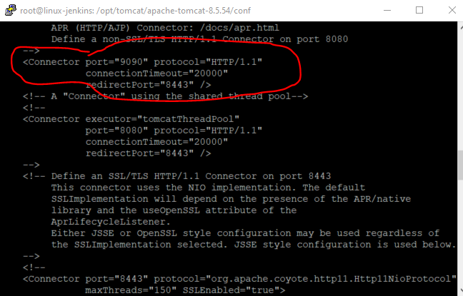

**[4] Change permission of scripts in /bin folder**

Now, navigate to the ‘bin’ folder to do this:-

cd ..

cd bin

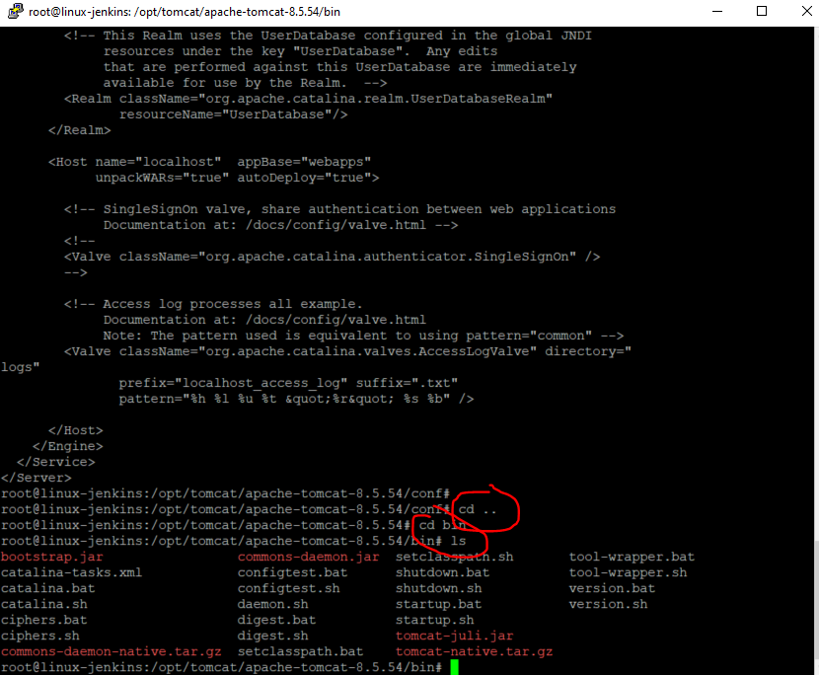

Type the following to get a list of the read/write permissions of the files within this folder:-

ls -la

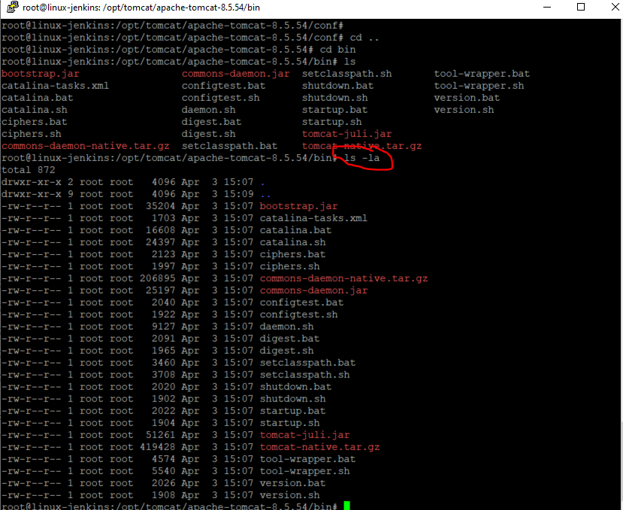

Change the permissions of all files within the current directory to be executable:-

*sudo chmod +x \**

Then type the following command again:-

ls -la:-

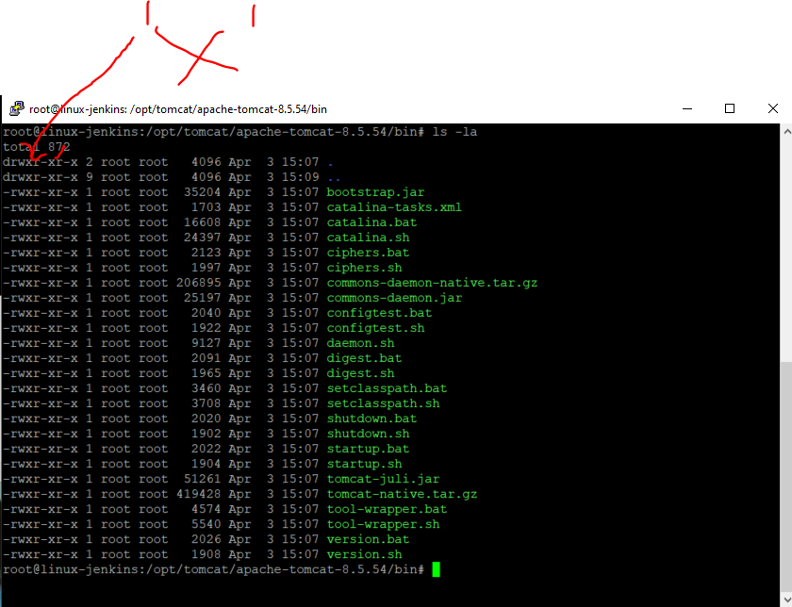

All files have changed to green meaning that they have executable permissions.

**[5] Start tomcat server and access via browser on port 9090**

Start the following file:-

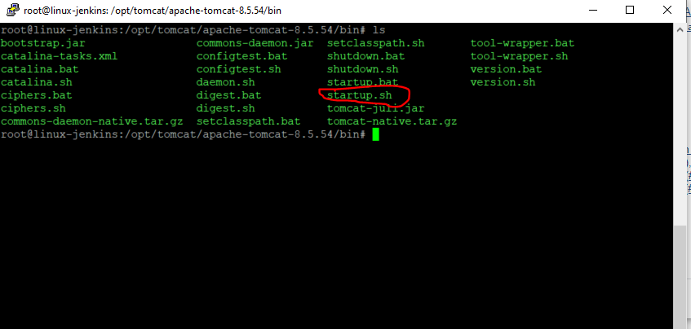

Type:-

./startup.sh

See message saying that tomcat has started:-

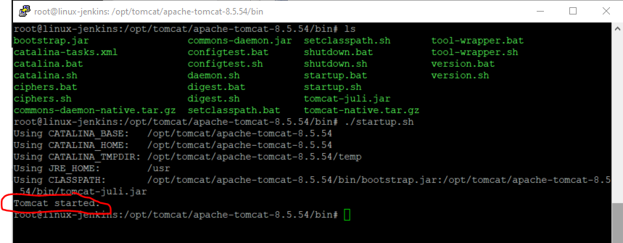

Now open a browser and navigate to:-

<http://104.248.171.236:9090>

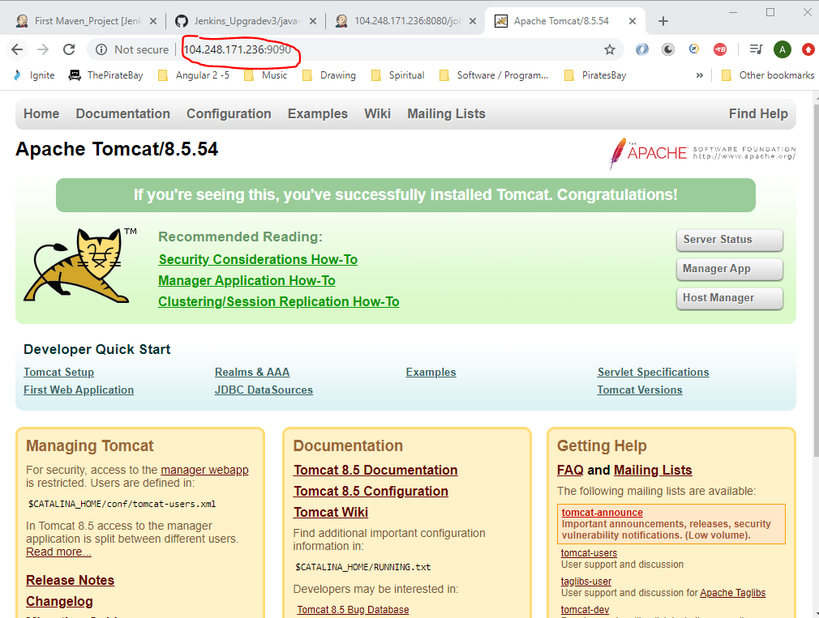

**[6] Configure Jenkins with Tomcat for automatic deployment of artifacts**

In Putty:-

cd ..

ls

cd conf

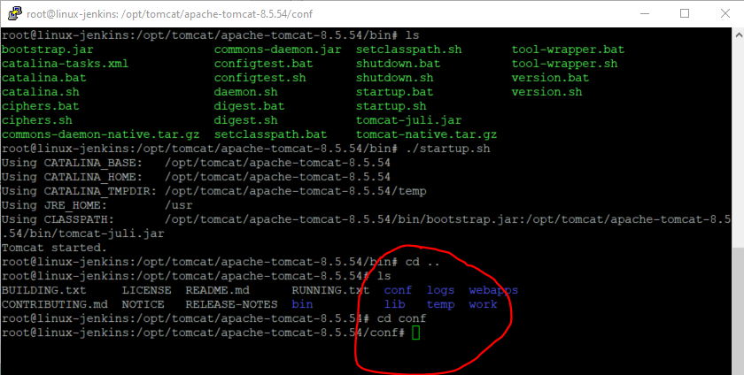

Edit this file:-

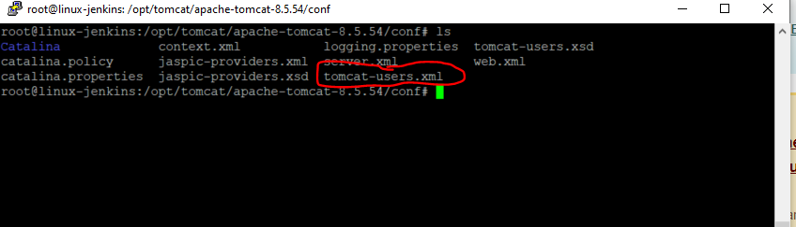

Enter:-

vi tomcat-users.xml

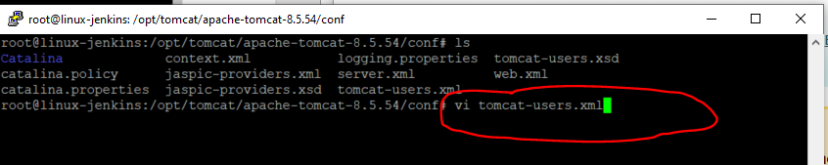

Press ‘I’ to go into insert mode. Then uncomment out the following section:-

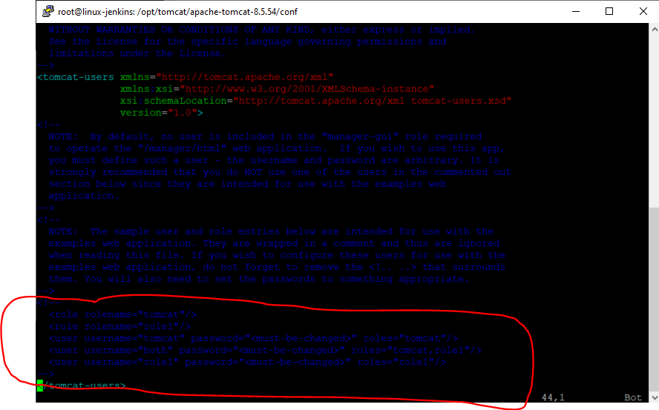

Add the following data:-

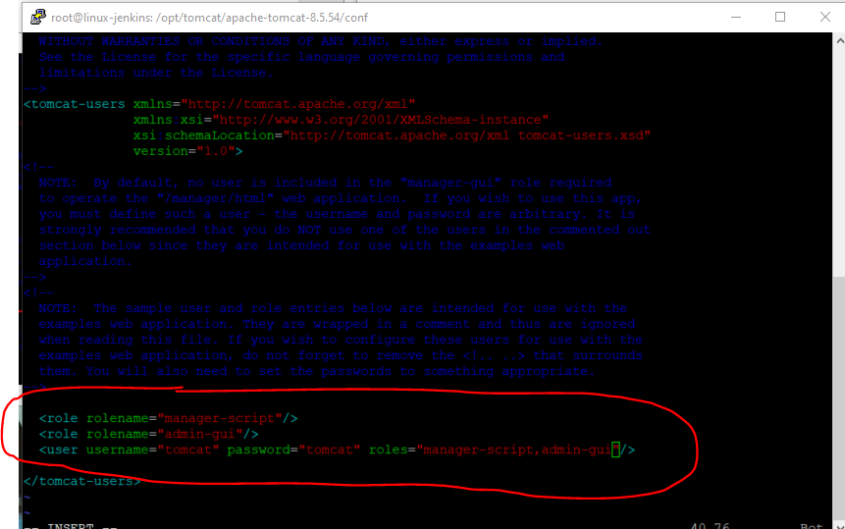

Then press - [esc]

Then type - :wq

Now shutdown Tomcat server by navigating to:-

cd ..

cd bin/

./shutdown.sh

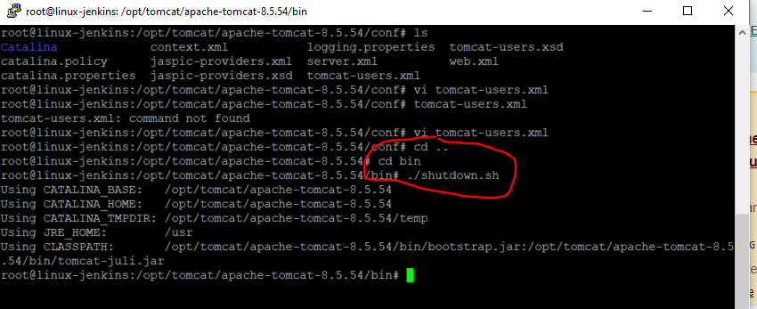

Now start Tomcat server by:-

./startup.sh

**Deploying Staging Environment**

Log into Jenkins (cloud based Ubuntu machine):-

<http://104.248.171.236:8080/>

On the list of jobs page create a new customised view by clicking the ‘+’ sign:-

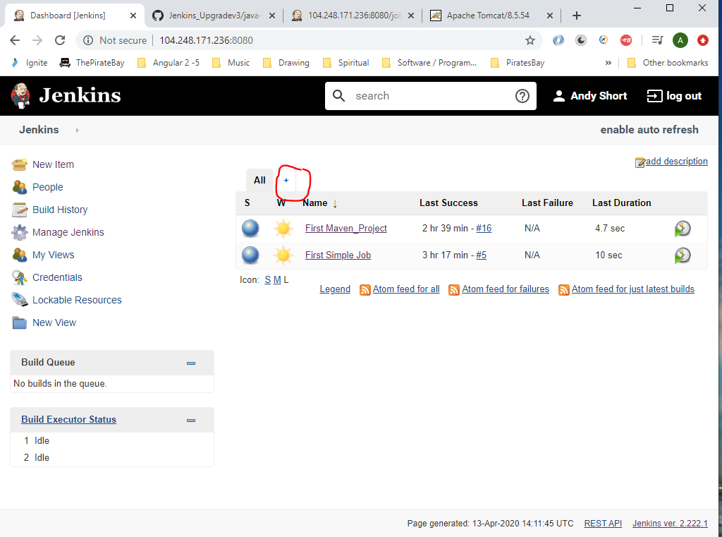

Enter a name and select the ;List View’ radio button:-

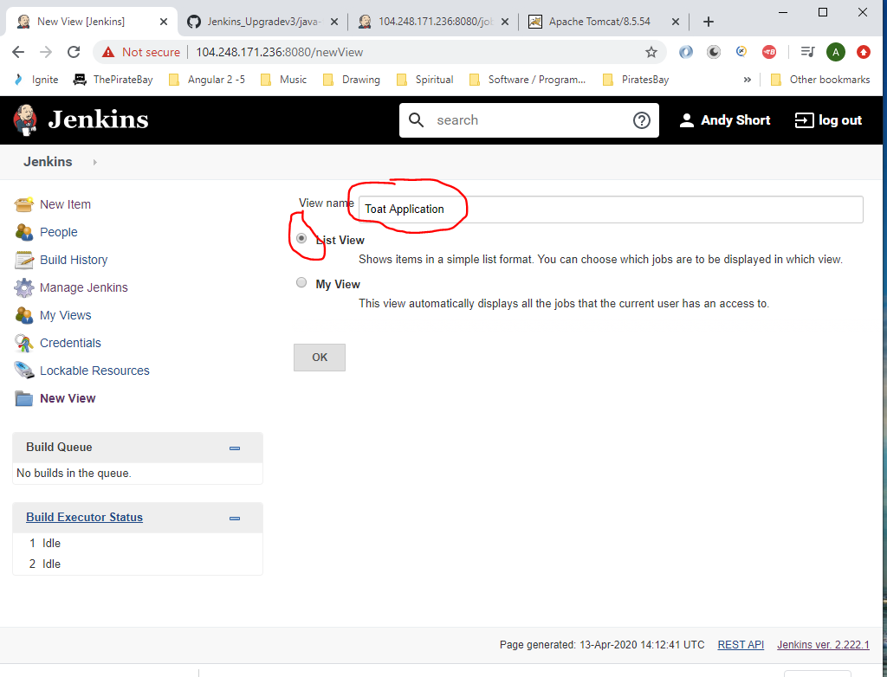

Click ‘OK’.

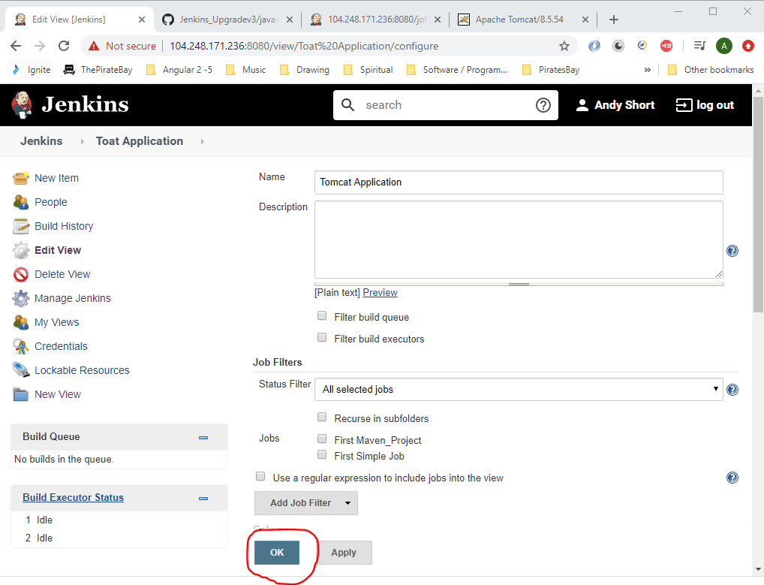

Click ‘OK’.

You will now have a new job view tab:-

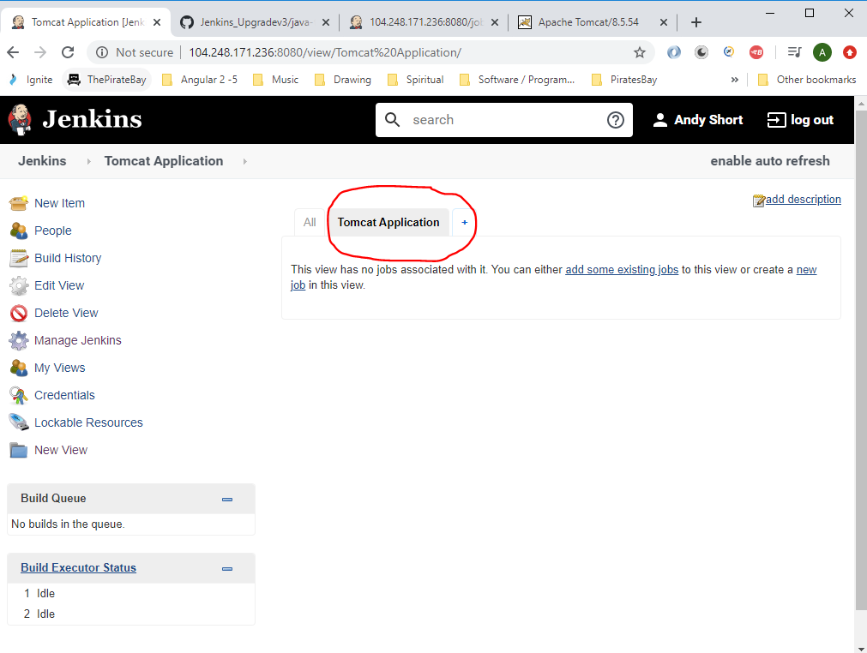

Now create a new job by clicking ‘New Item’:-

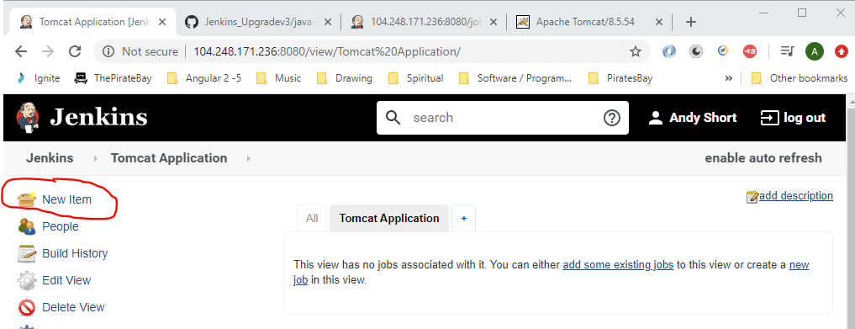

Enter a name and click ‘Freestyle project:-

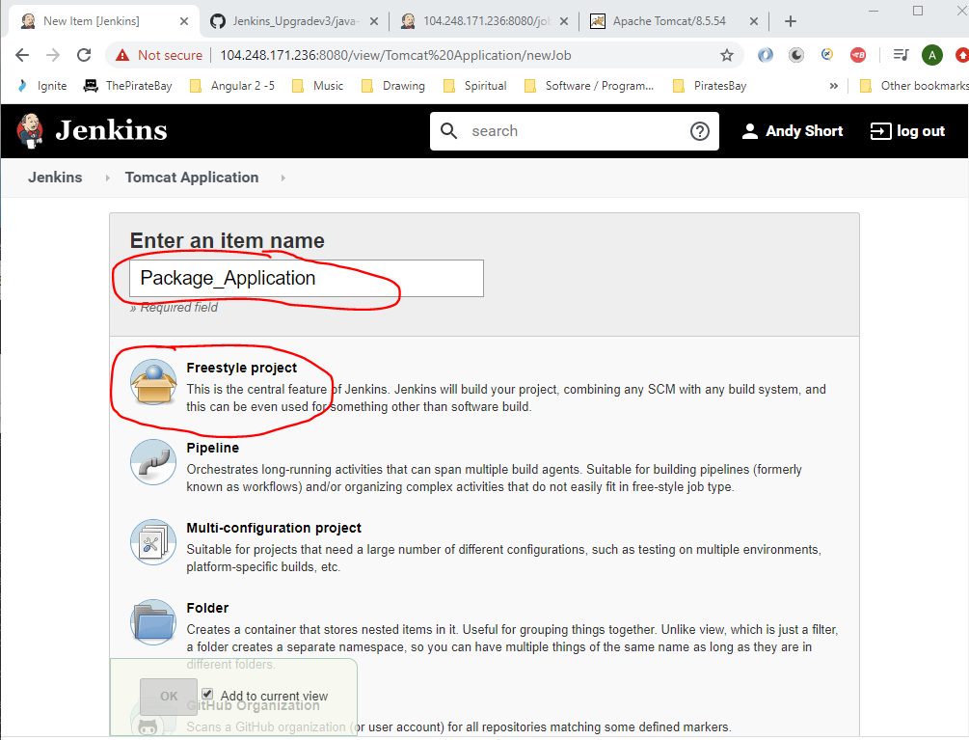

Enter the following:-

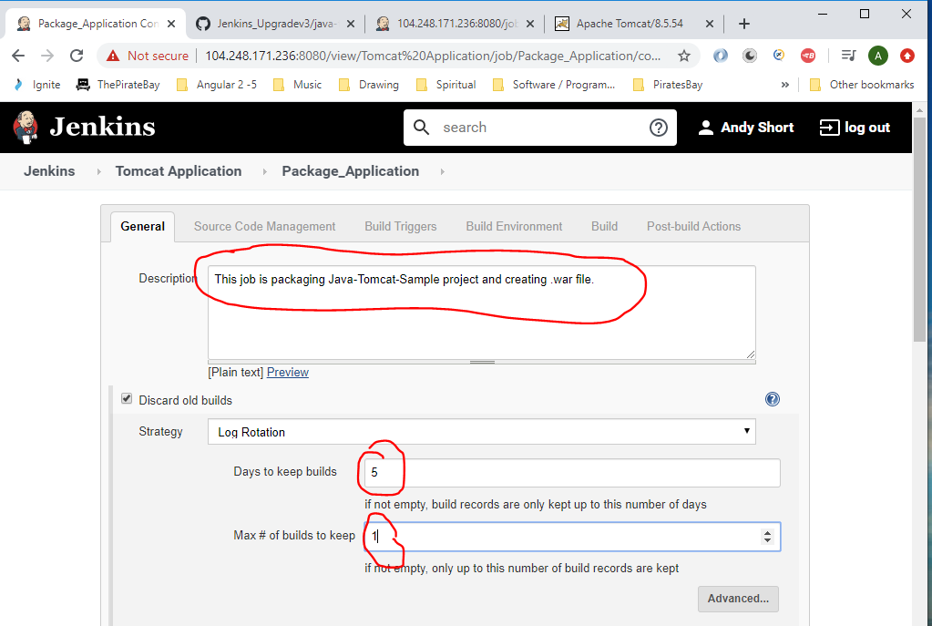

Enter the following:-

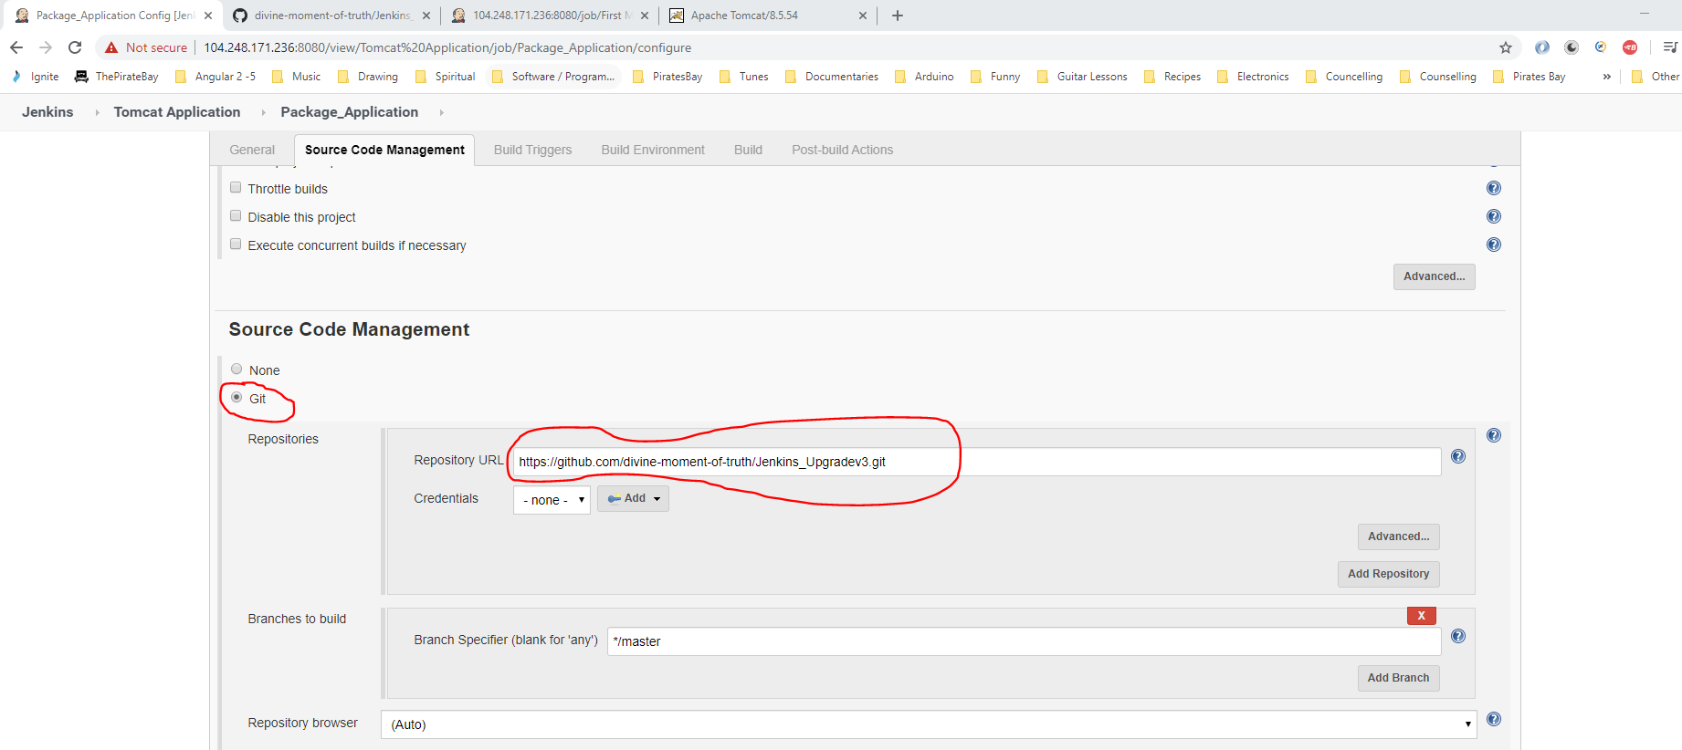

The above Git repo address is taken from here:-

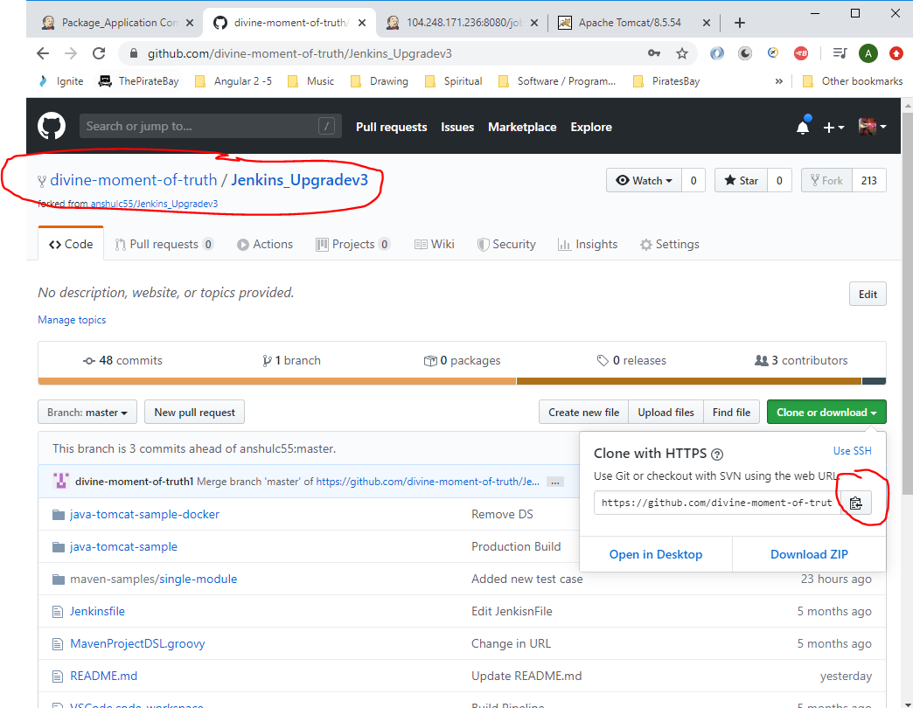

Set the following ‘Build Environment’ options:-

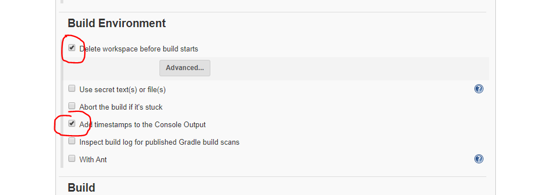

Under ‘Build’ select ‘Invoke top-level Maven targets’:-

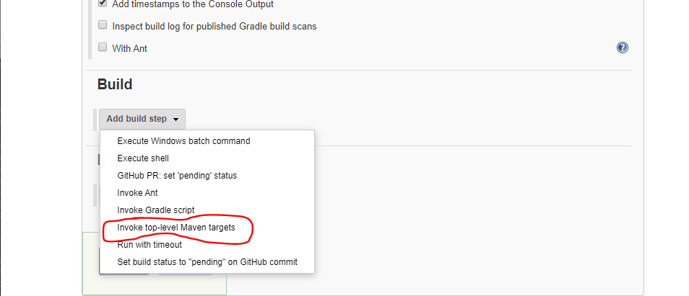

Enter the following:-

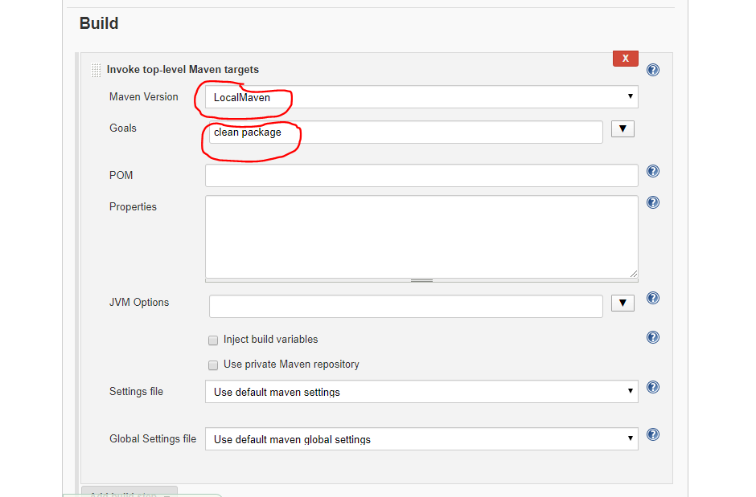

Get the ‘POM’ path from Git:-

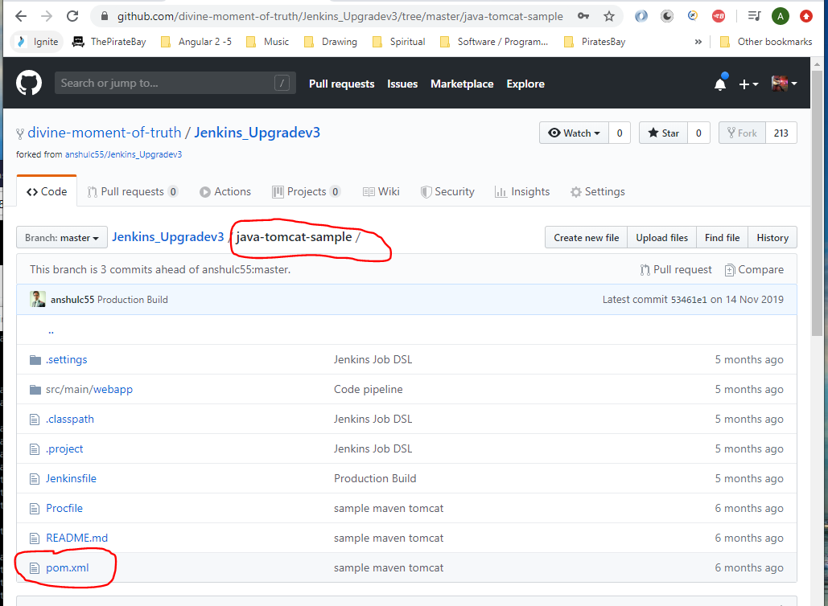

So, enter:-

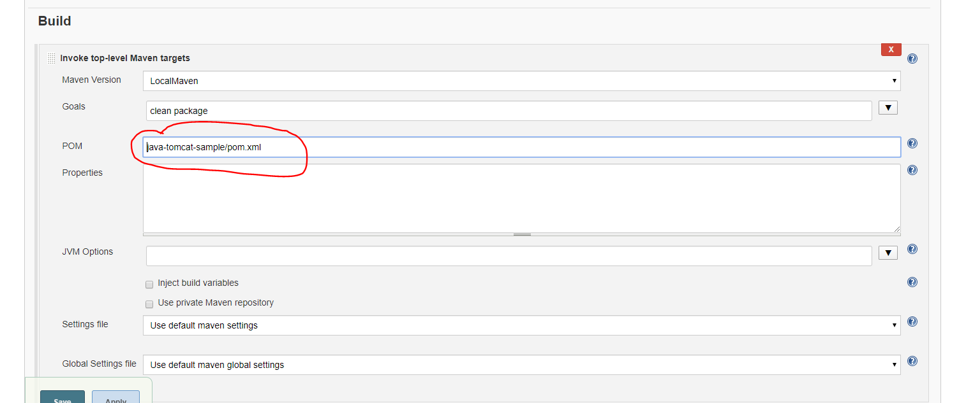

Under ‘Post-build Actions’ select:-

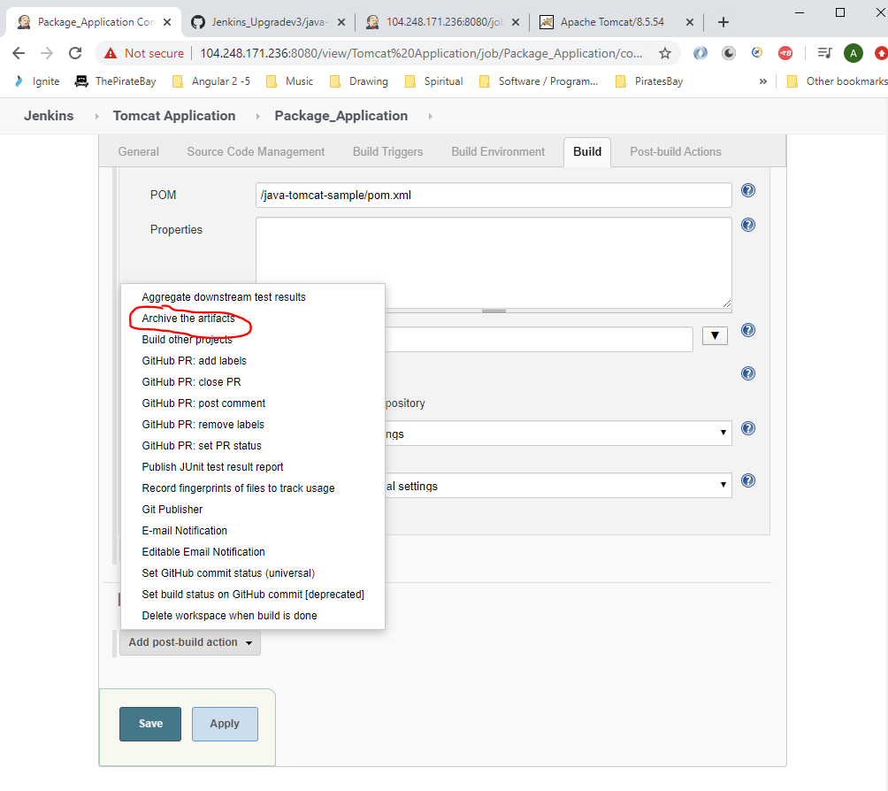

Then enter the following:-

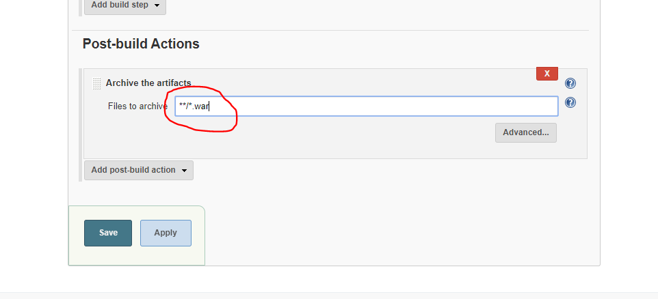

Then click ‘Save’.

See your new job:-

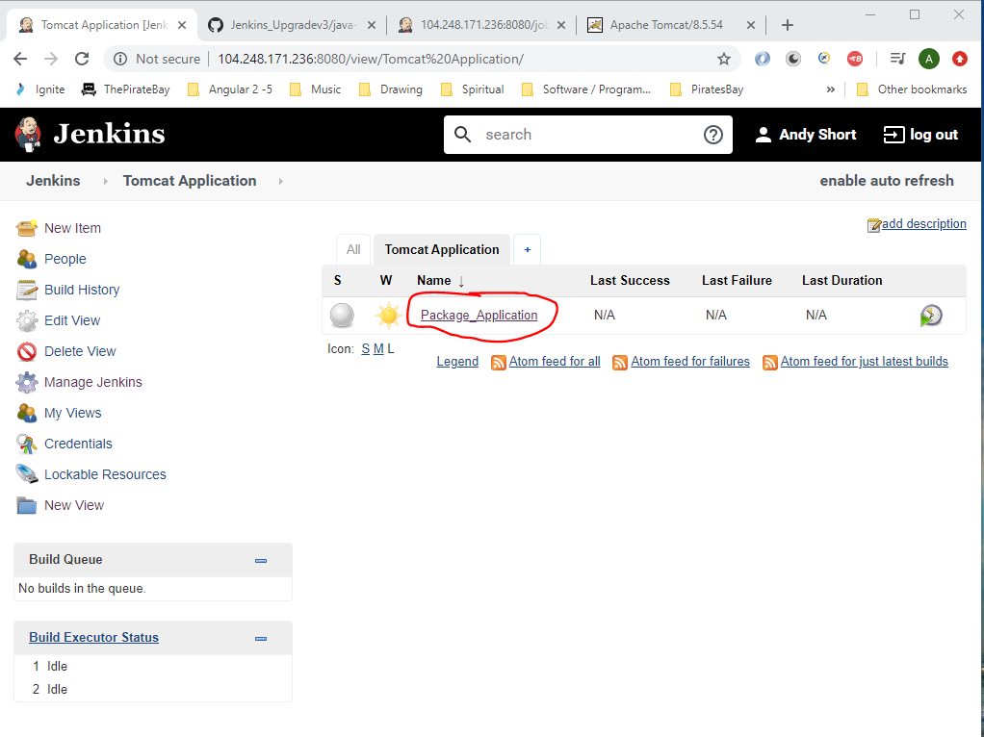

Click on the above then click ‘Build Now’:-

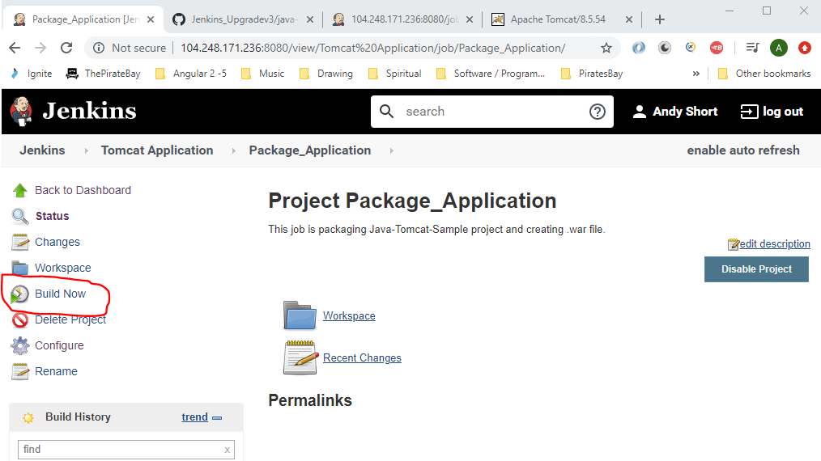

Go to ‘Console Output’ and view output:-

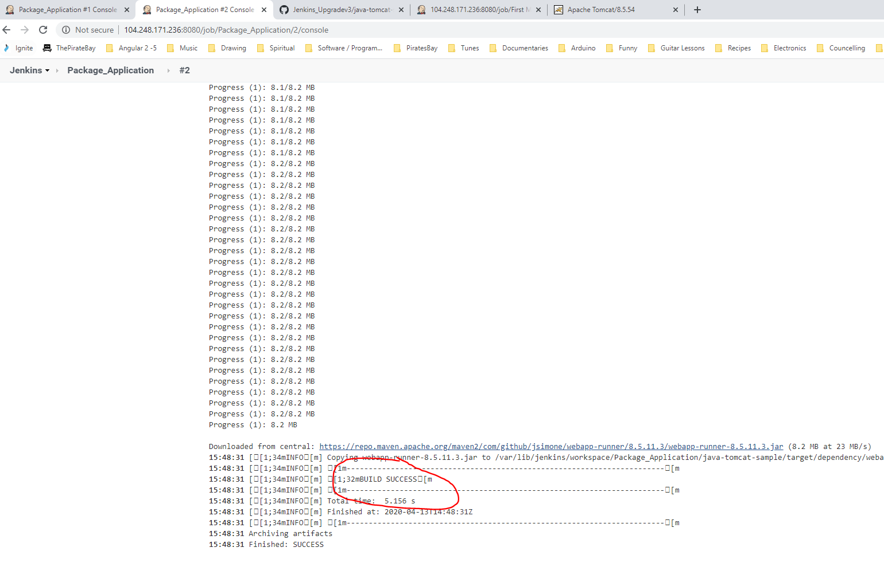

Also, see the .war artifact file:-

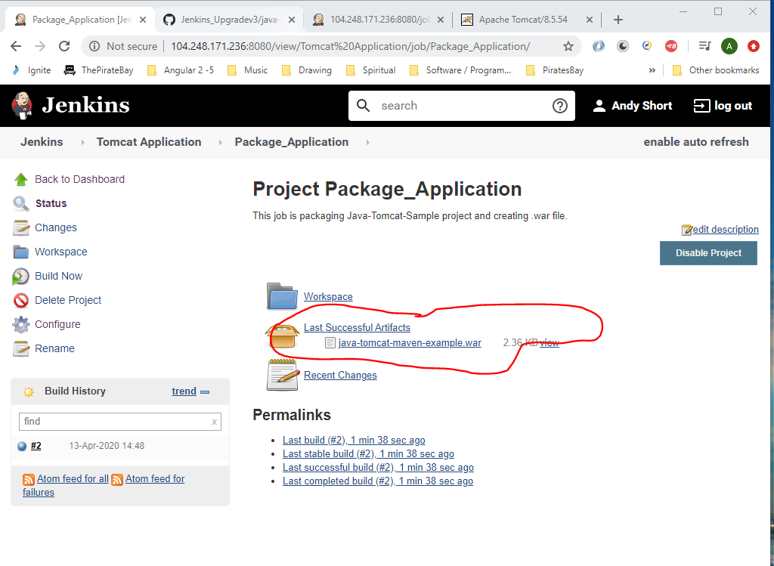

Now install some new Plugins into Jenkins:-

Click on the following:-

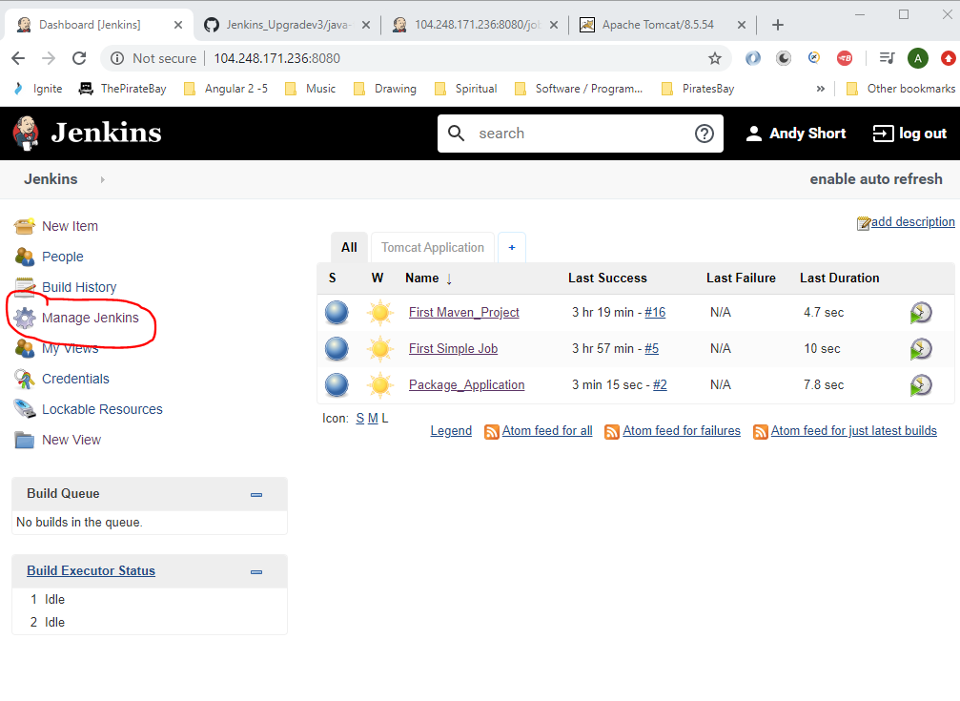

Then, click on this:-

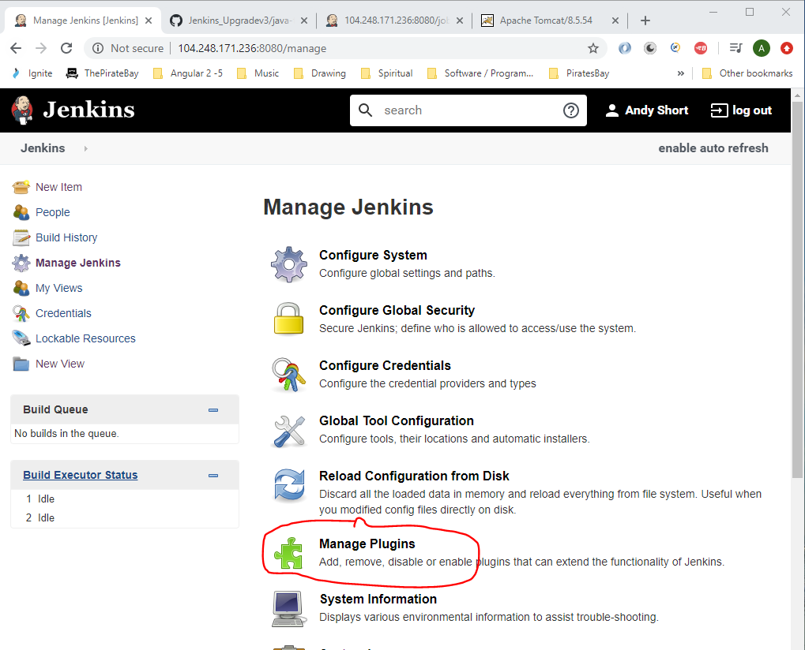

Click on ‘Available’ tab and search for ‘copy art’:-

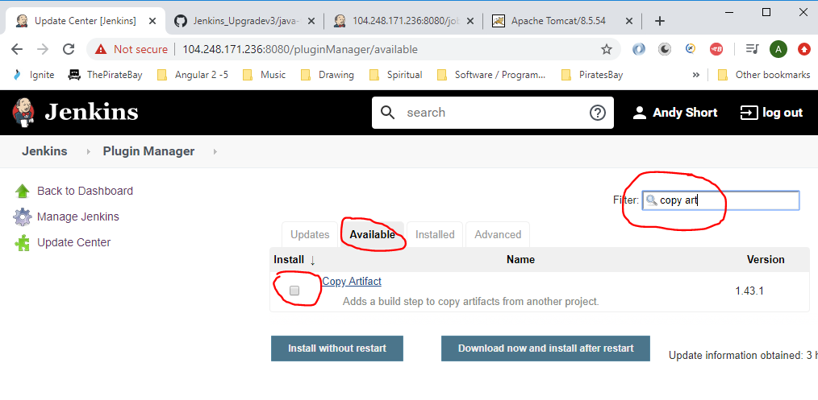

Select checkbox and click the ‘Install without restart’ button.

Now search for ‘Deploy to container’:-

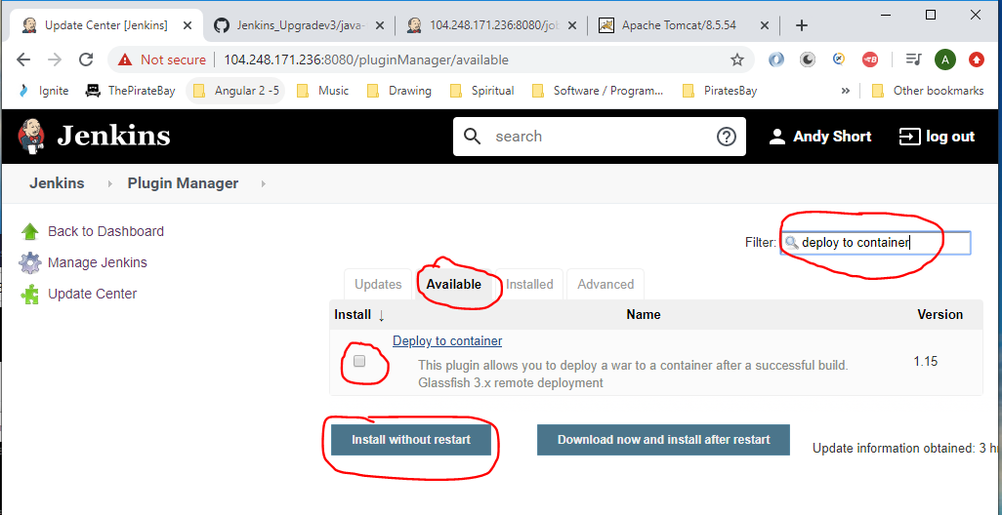

Select checkbox and click ‘Install without restart’ button.

Now go to the go to the following area and create a new job for deploying the app to the staging environment:-

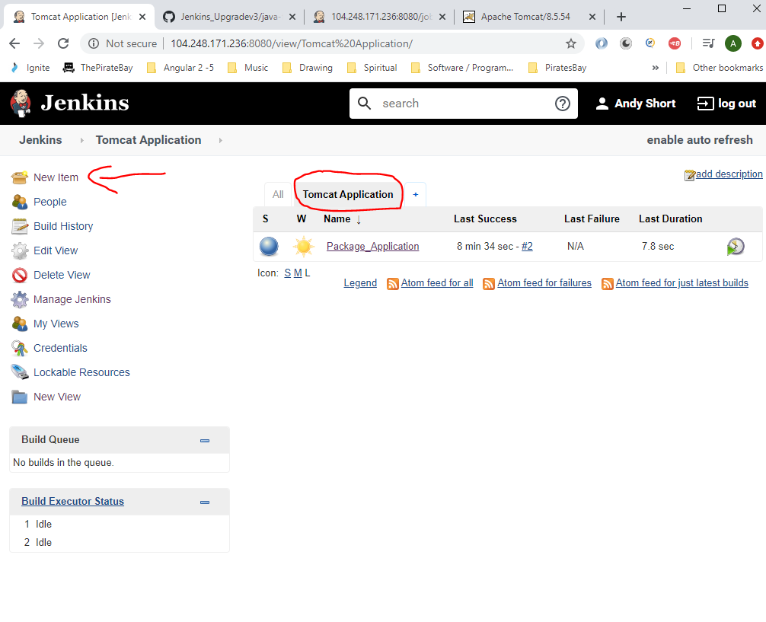

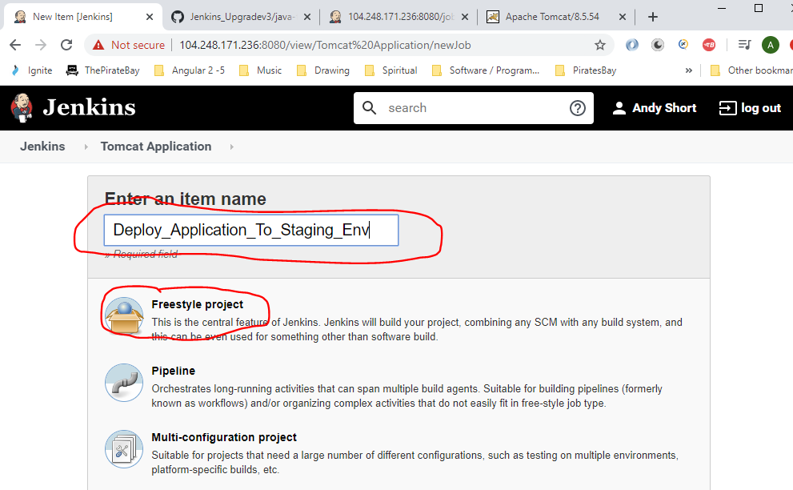

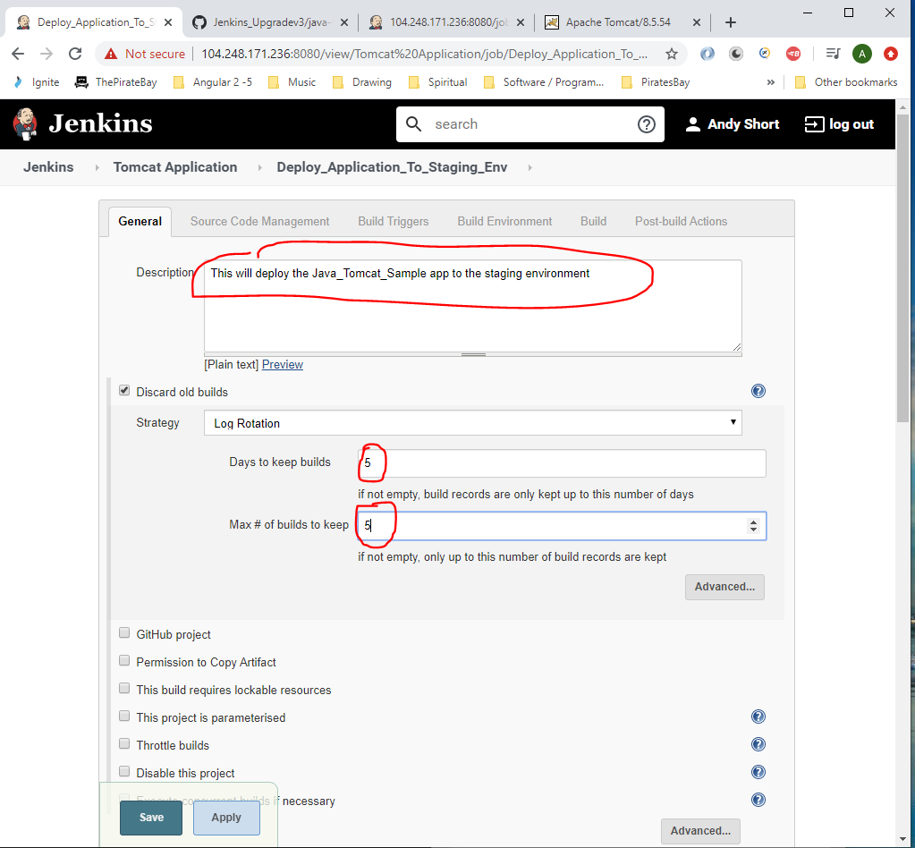

Set the ‘Build Environment’ options:-

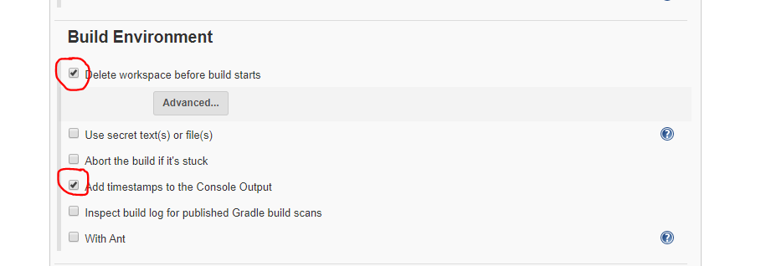

Under ‘Build’ select:-

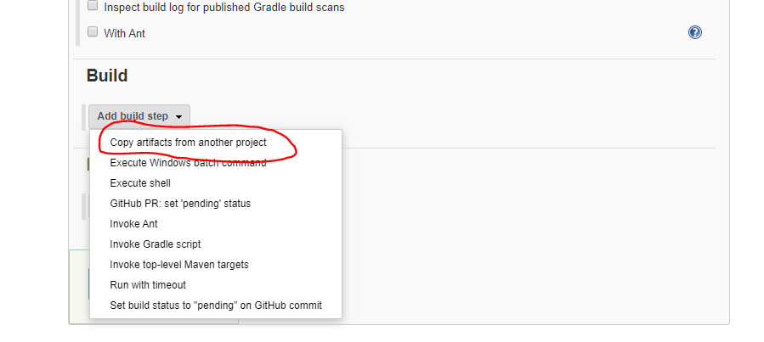

Set the following fields:-

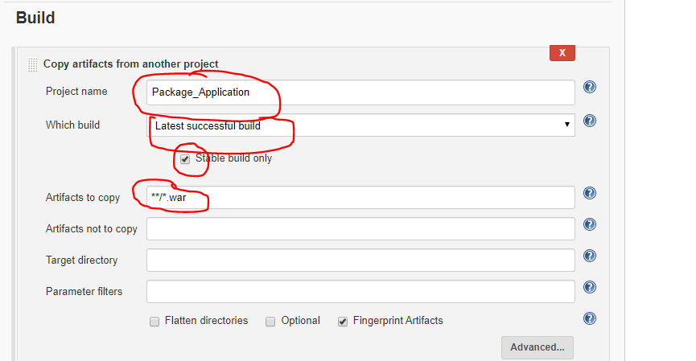

‘Project Name’ comes from here:-

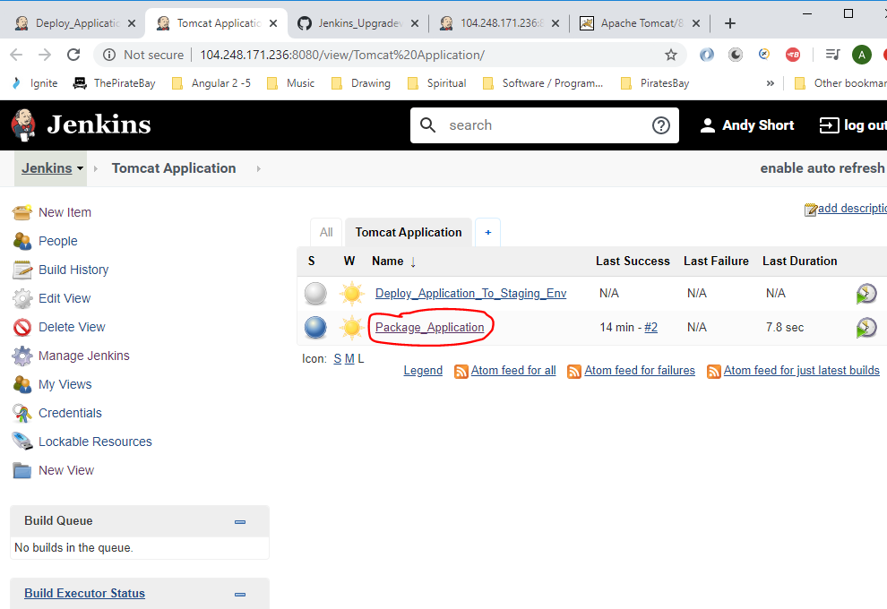

Under ‘Post-build Action’ select the following:-

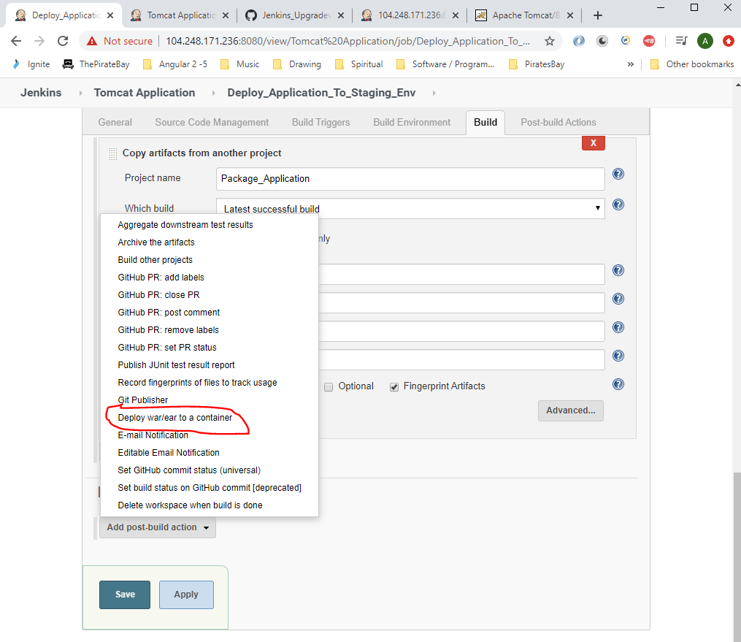

Enter the following:-

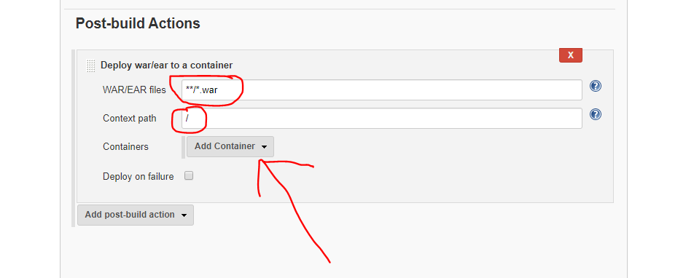

Click ‘Containers’ drop down and select the version of Tomcat installed (we installed version 8 earlier).

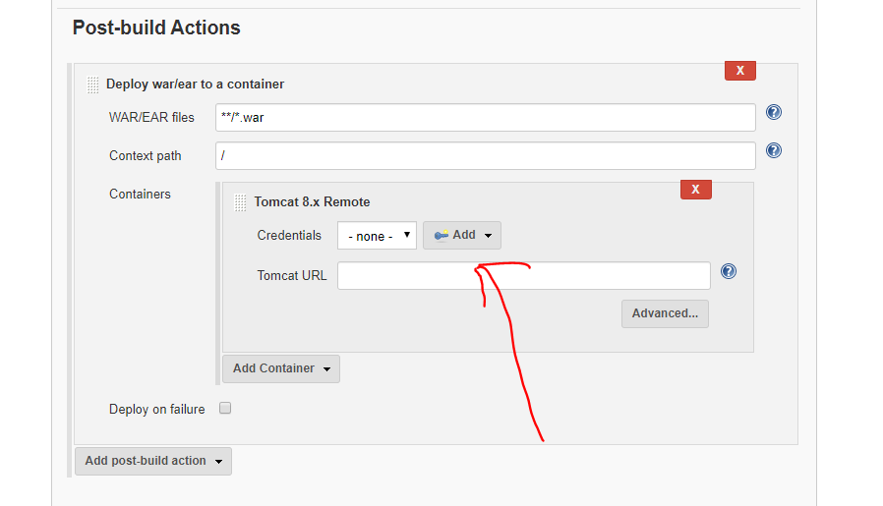

Click the ‘Add’ button and select ‘Jenkins’.

Enter username and password (remember we set them in the config file earlier as – tomcat and tomcat):-

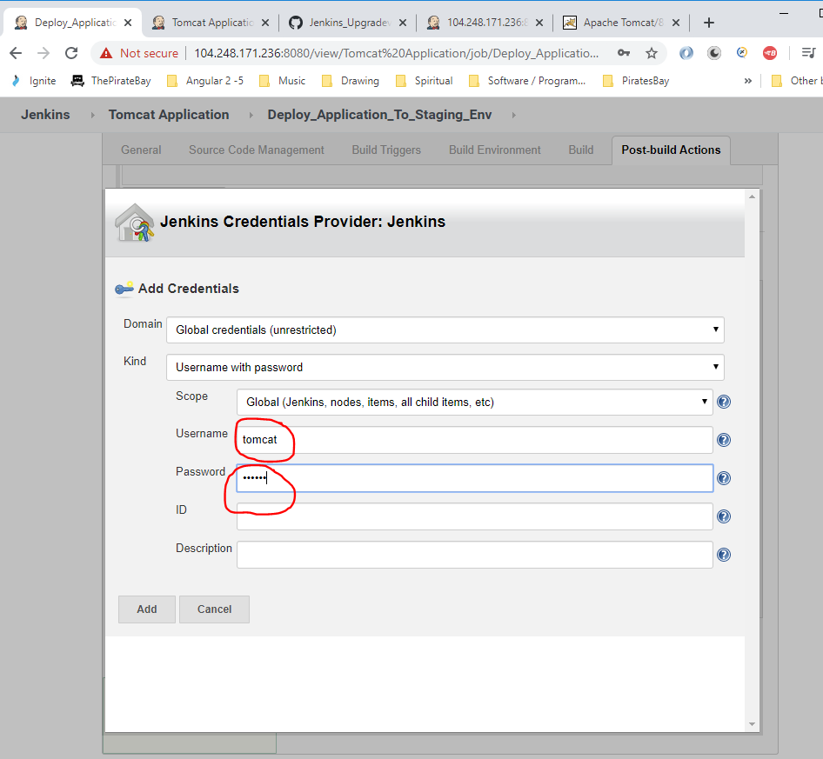

Then click ‘Add’.

Click the following:-

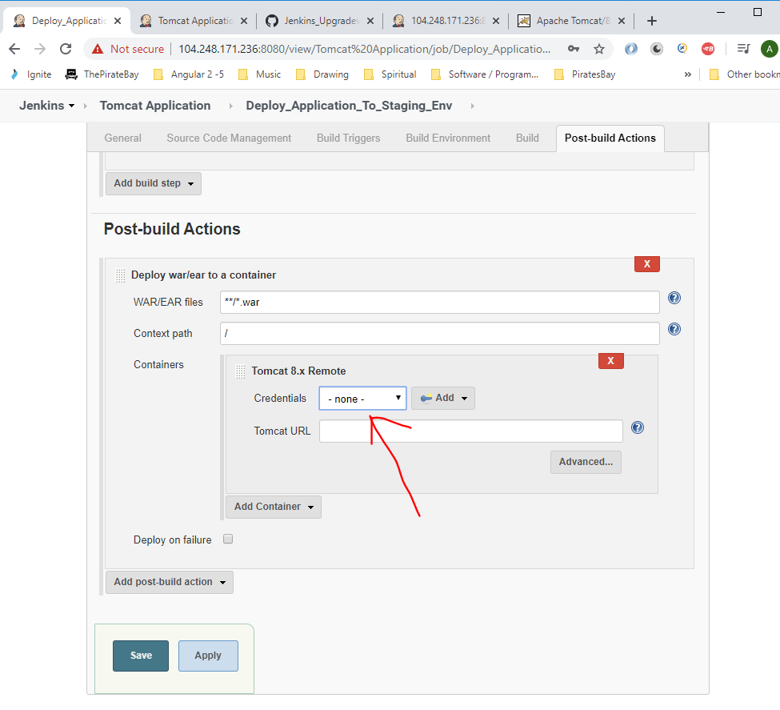

And select ‘tomcat/*****’:-

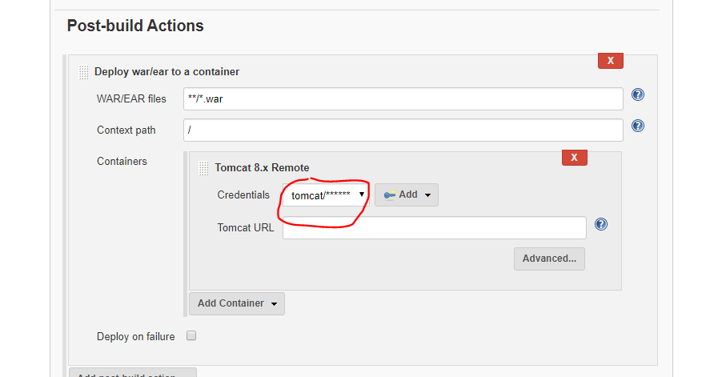

Enter the tomcat server <url:->

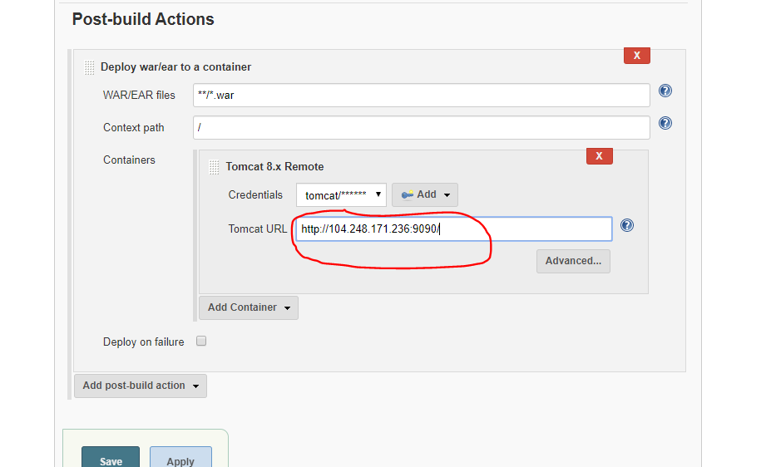

Then click ‘Save’ button.

Now run this job. The job should copy the application artefact package and deploy it to the Tomcat server.

Click ‘Build Now’. You will see that the job fails:-

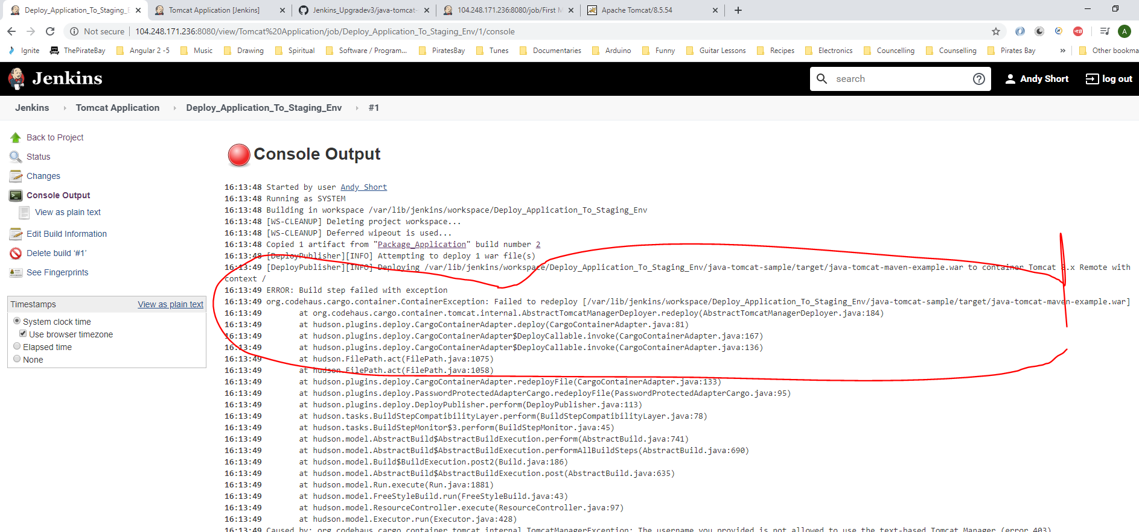

Unable to deploy .war file.

Also, see this error:-

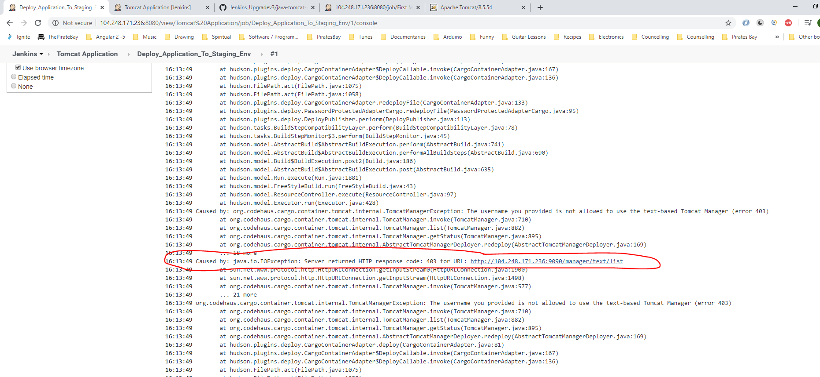

Copy the above url () and paste into a browser:-

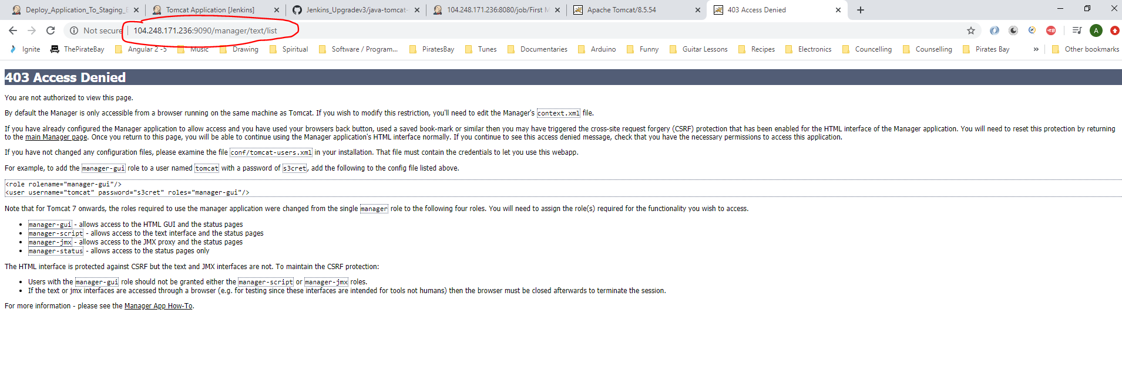

The below user (manager-gui) needs adding to the ‘tomcat-users.xml’ file:-

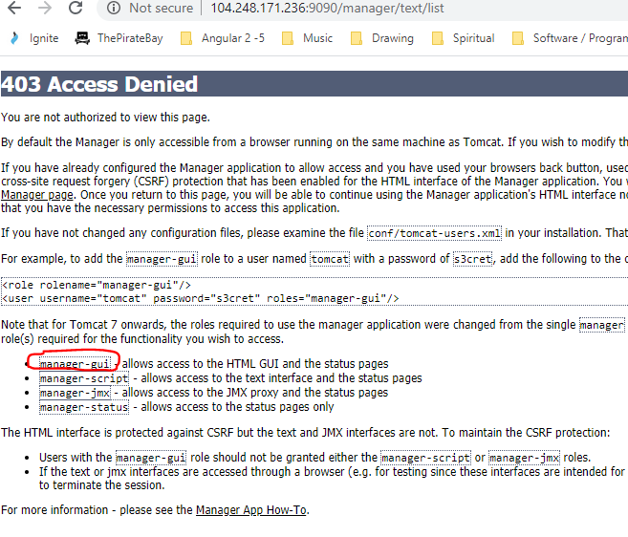

Go to Putty and edit the ‘tomcat-users.xml’ file:-

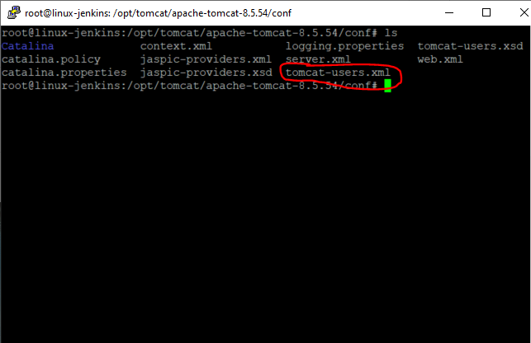

*vi tomcat-users.xml*

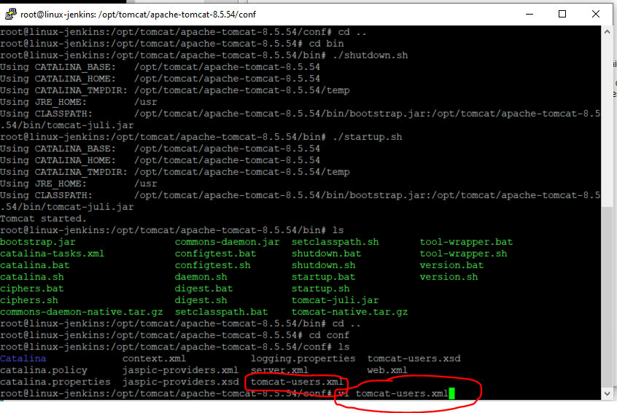

Add the below:-

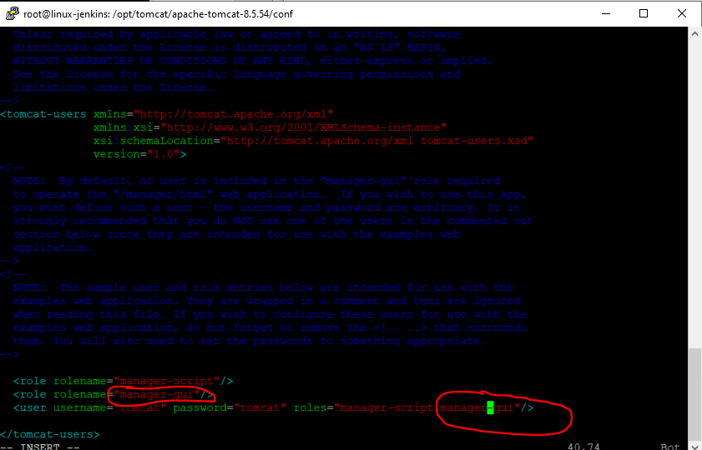

[esc]

:wq

Now restart the tomcat server by:-

cd ..

cd bin

ls

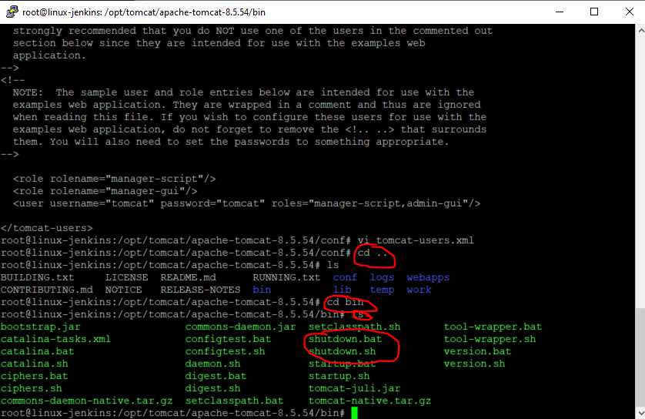

*./shutdown.sh*

*./startup.sh*

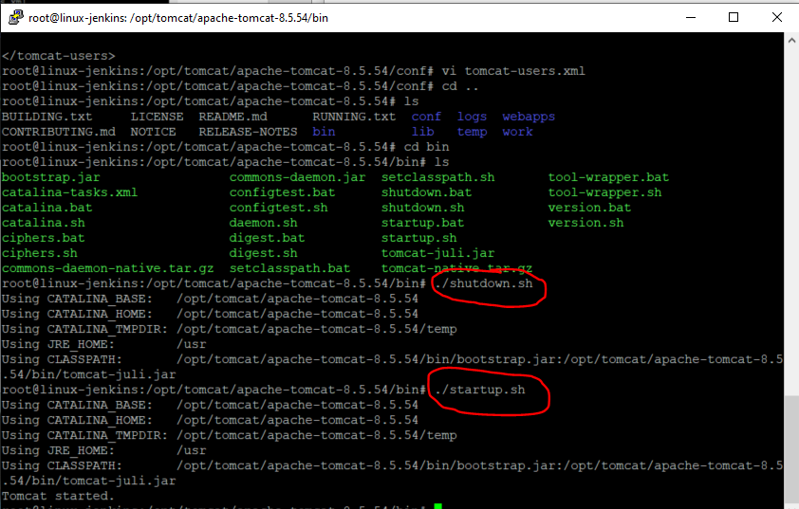

Now, retrigger your job in Jenkins. Click ‘Build Now’.

Build fails again:-

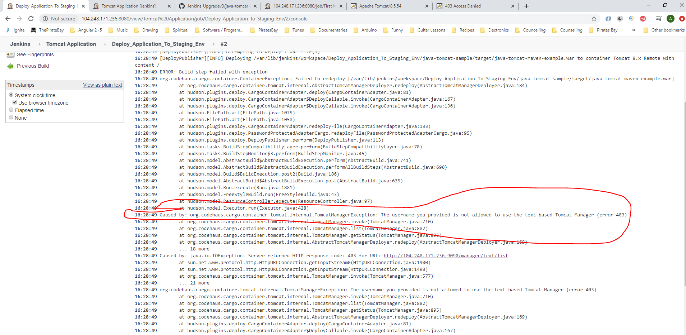

Go to Putty again and navigate here:-

*cd ..*

*cd webapps*

*cd manager*

*cd META-INF*

*ls*

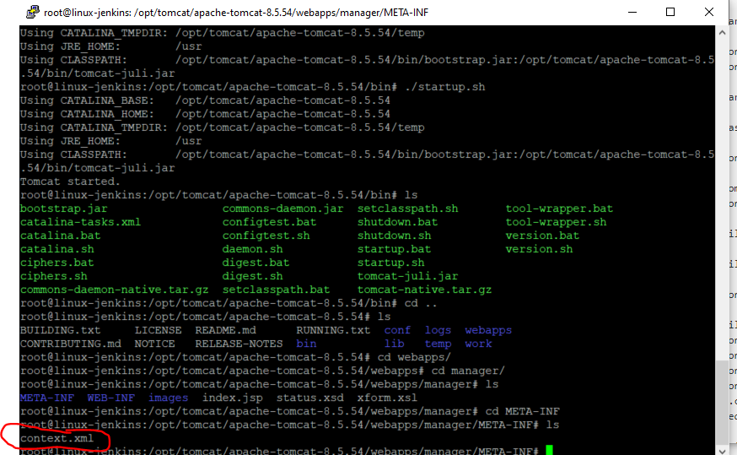

Edit the ‘context.xml’ file:-

*vi context.xml*

Now, comment the following line by adding these:-

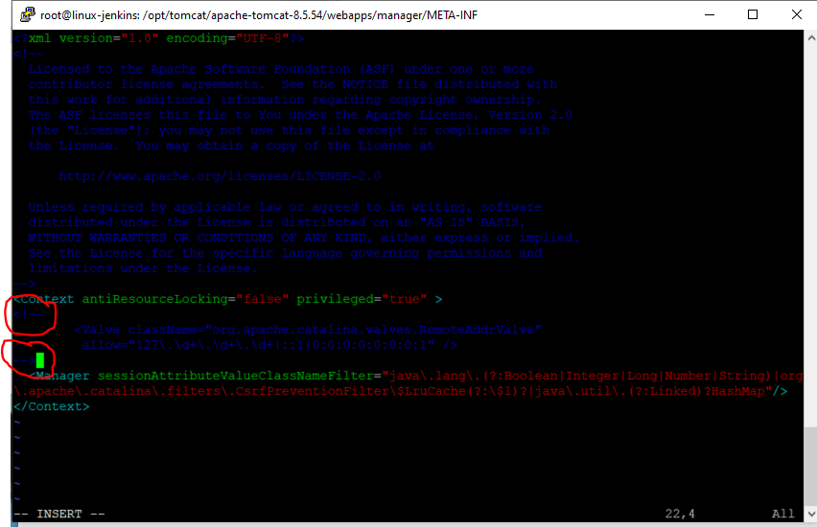

Then save.

*[esc]*

*:wq*

Then restart tomcat server again using Putty:-

*cd /opt/tomcat/apache-tomcat-8.5.54//bin*

*./shutdown.sh*

*./startup.sh*

Now, try to run the Jenkins job again by clicking ‘Build Now’.

This time job runs successfully:-

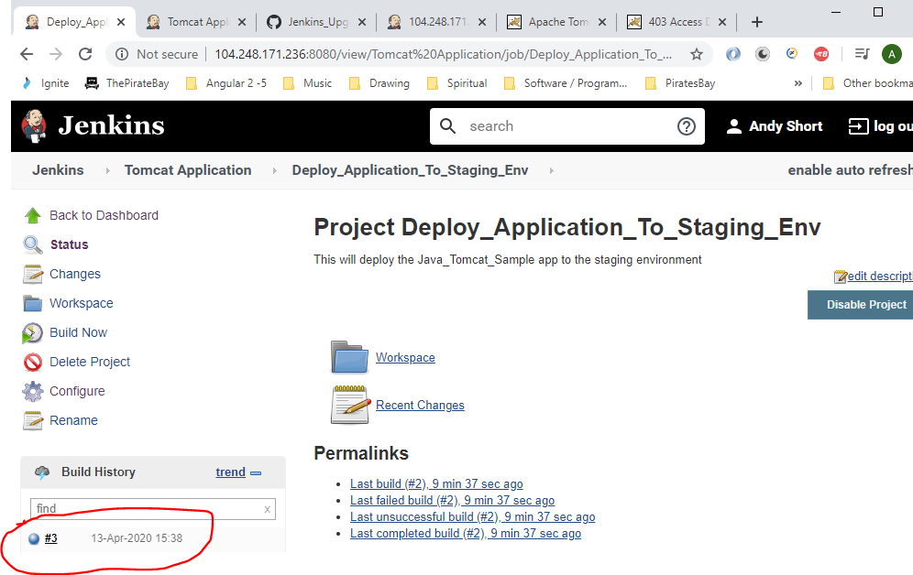

Type the following into a new browser and see that the app is running on the Tomcat server:-

<http://104.248.171.236:9090/>

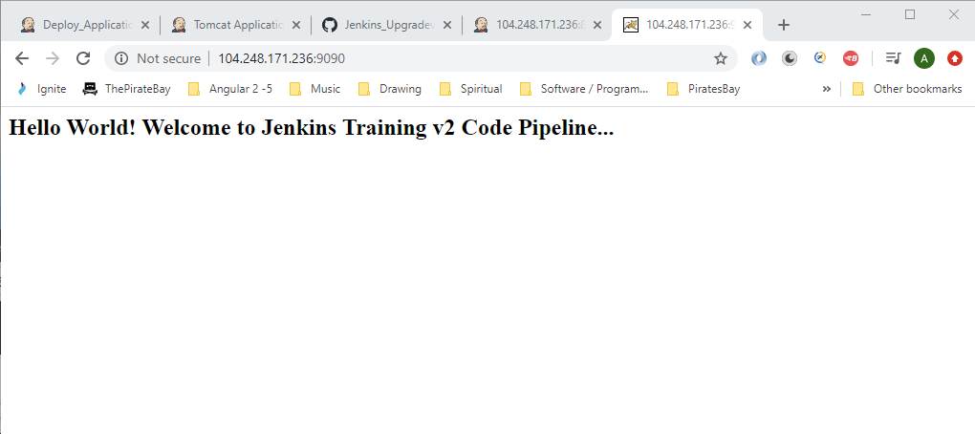

Now in Jenkins you need to make the two jobs below dependant on each other i.e. when the first job finishes then the seconds job needs to run to deploy the application.

So, click on the ‘Package_Application’ job in Jenkins as this needs to run first:-

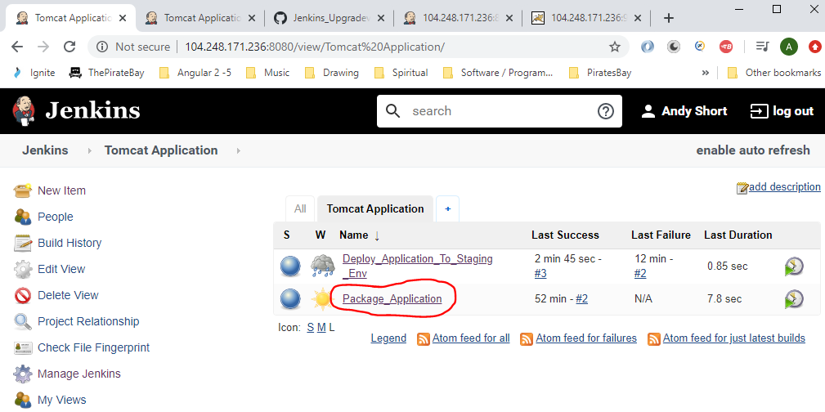

Click ‘Configure’:-

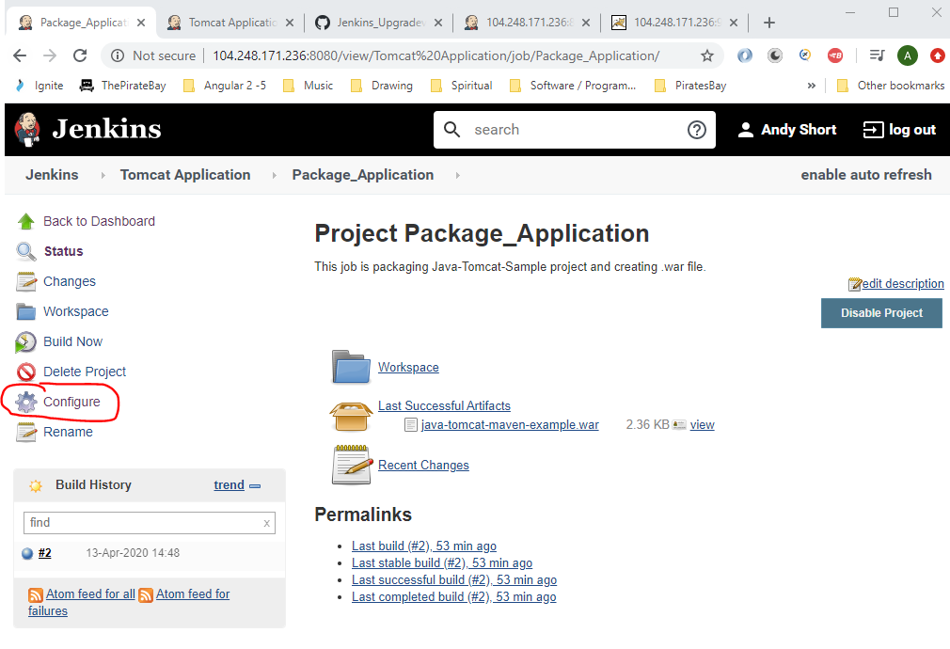

Click on the ‘Post-build Actions’ tab:-

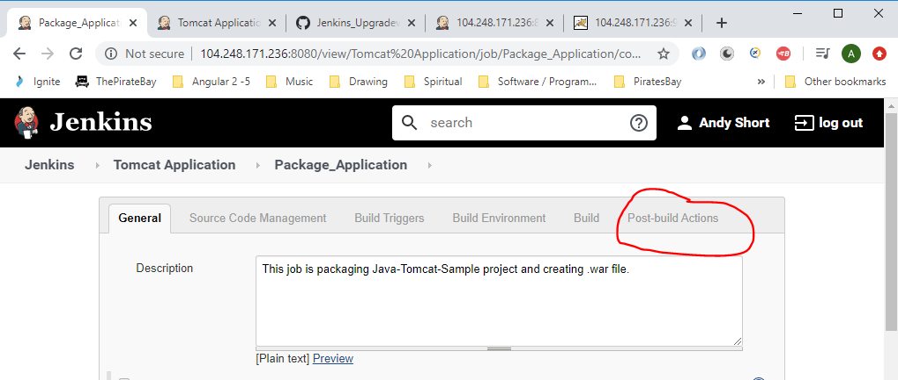

Then click the below button:-

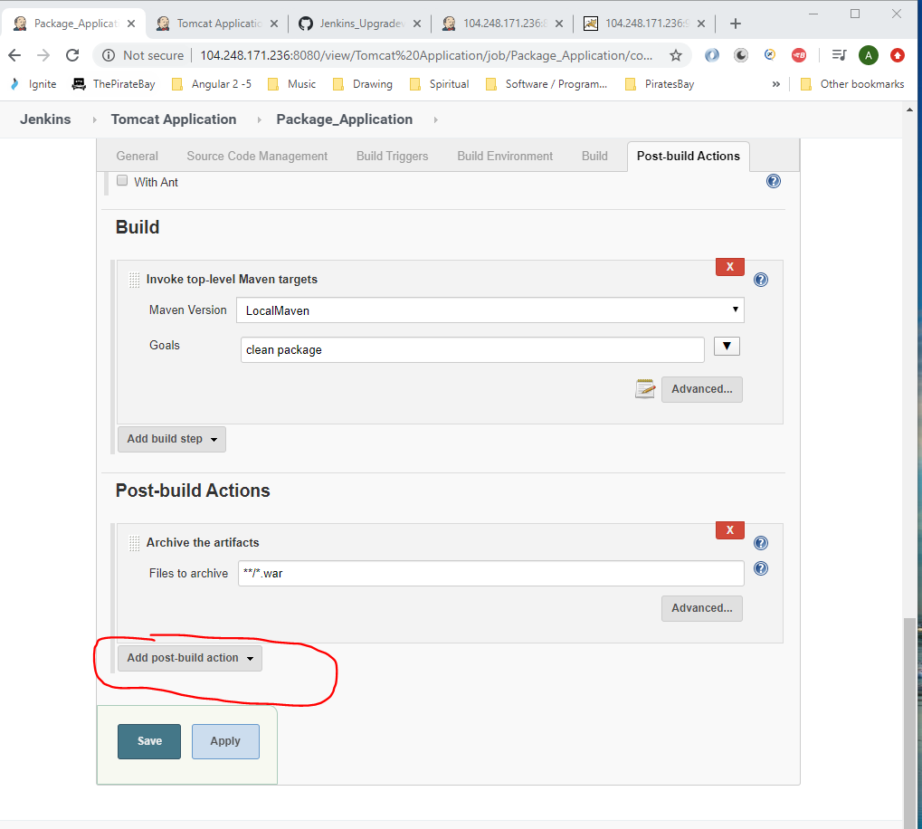

Select the following from the drop down menu:-

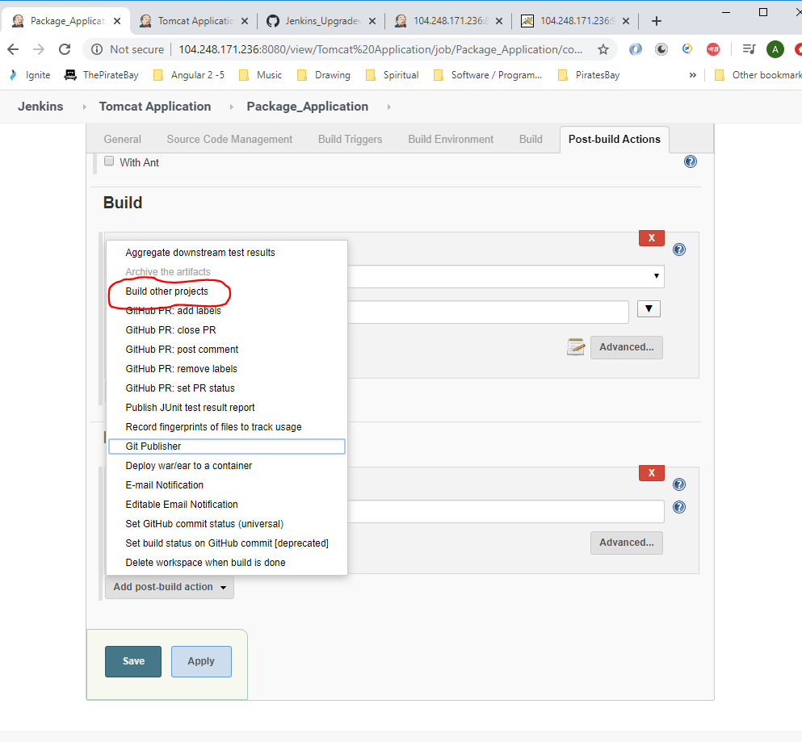

Add the job name:-

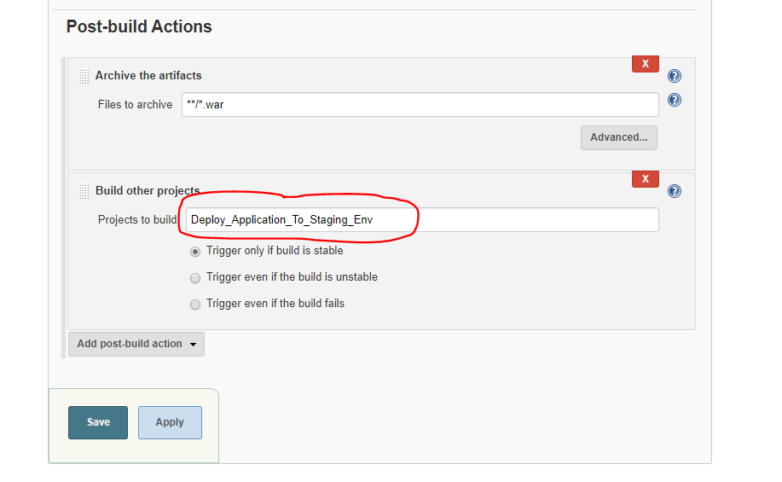

Which is this job:-

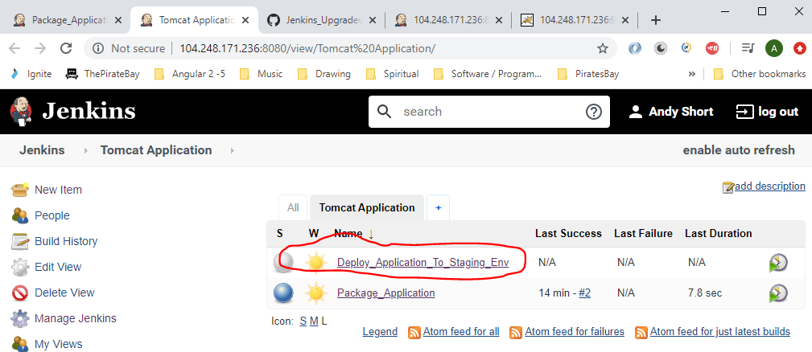

Ensure this radio button is selected:-

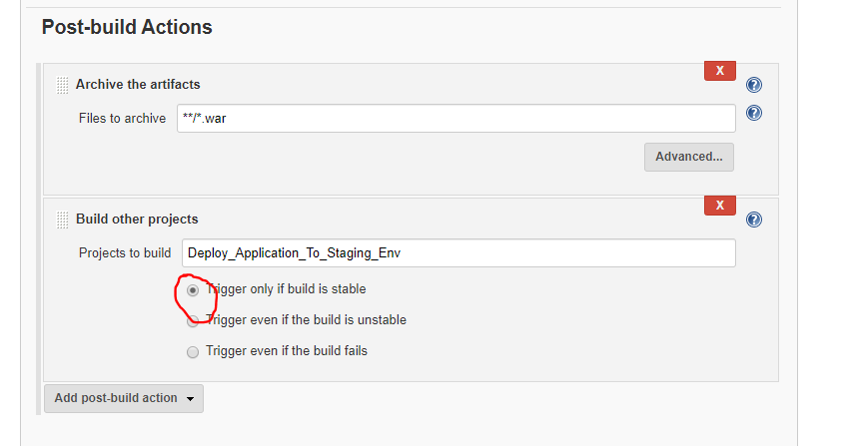

Also, set the ‘Build Triggers’ to trigger every minute:-

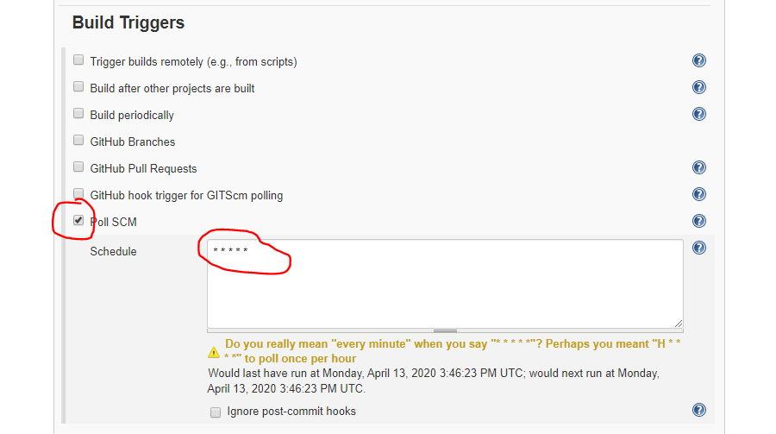

Then click ‘Save’.

You will now see this added to your job:-

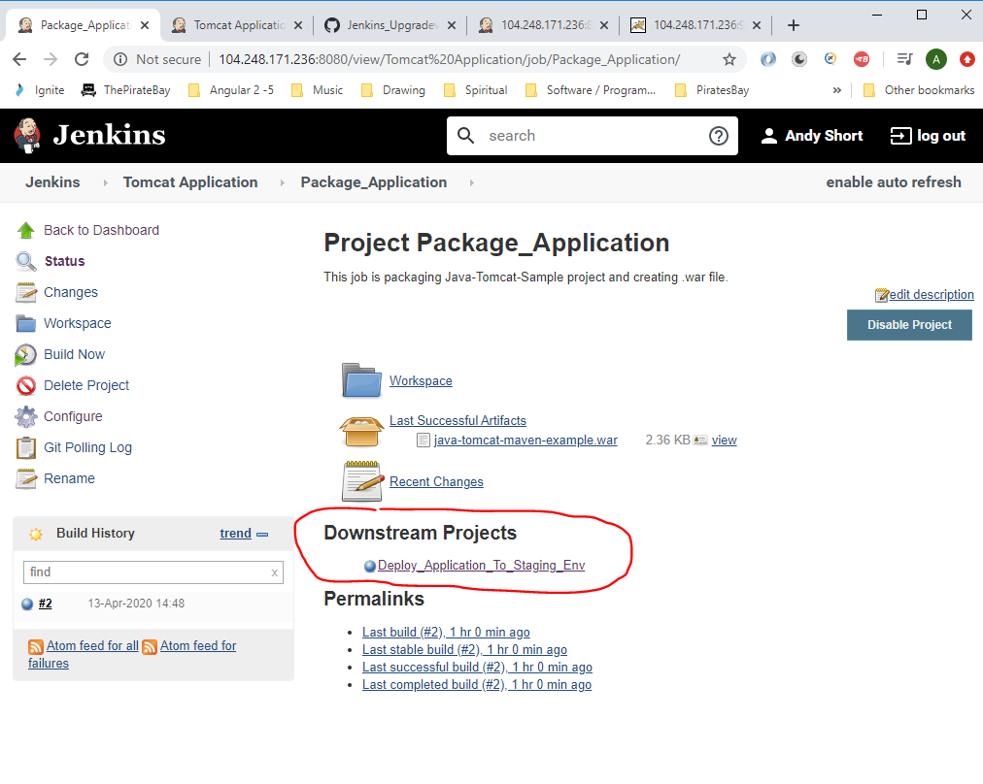

Now go to your local version of your application and make some modification’s to it then commit changes to the remote repo in GitHub:-

So, first open the ‘JAVA-TOMCAT-SAMPLE’ project in Visual Studio Code and modify this file:-

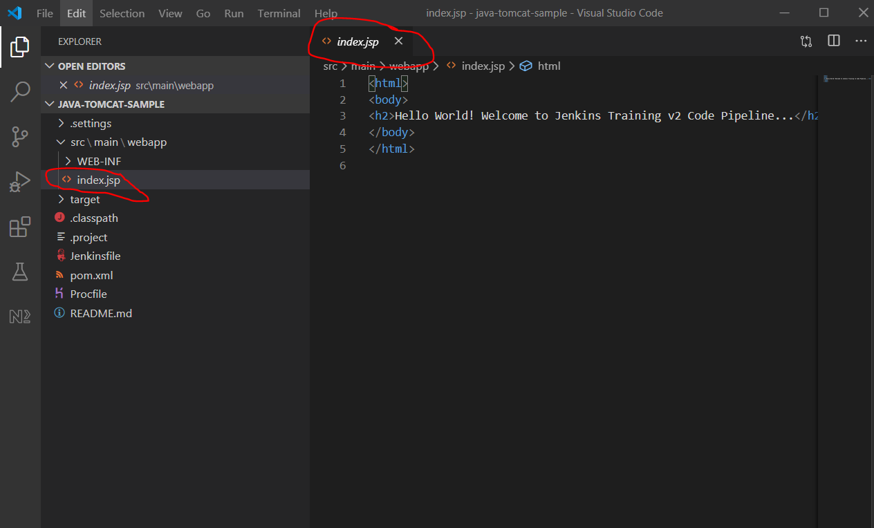

Add the following to it:-

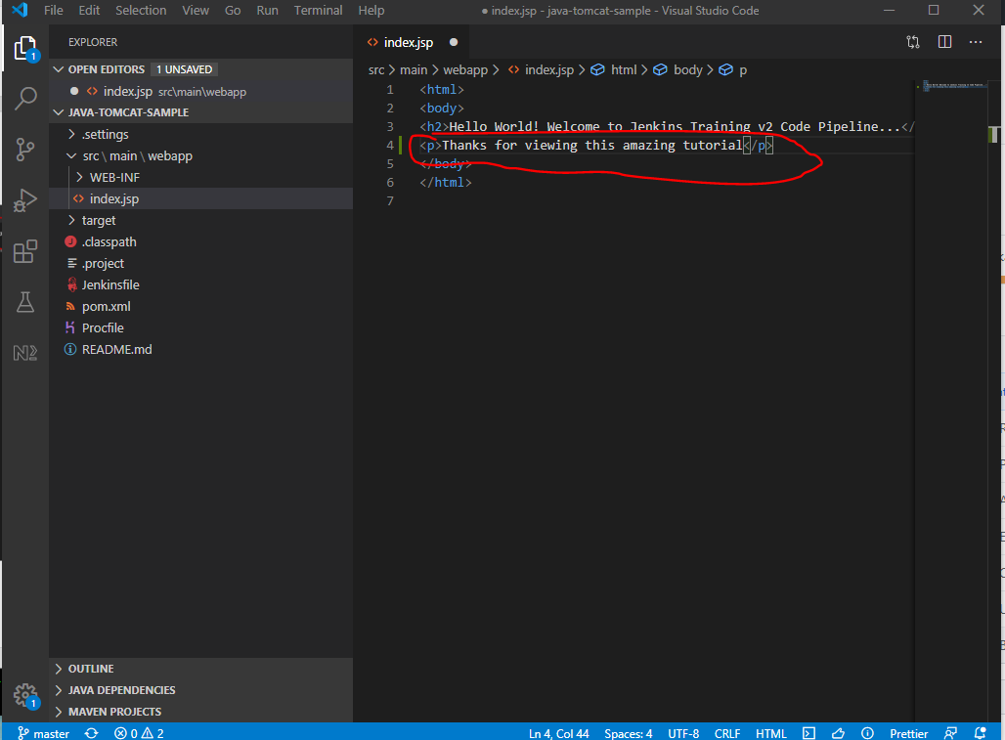

Save the file.

In Git Bash type ‘git statsu’:-

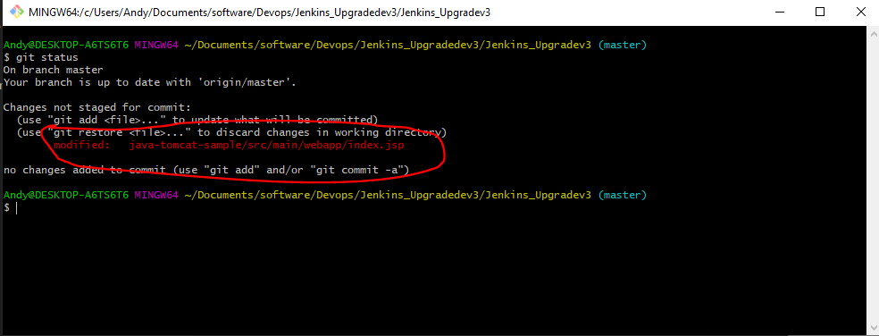

See there is one file that needs adding to the staging area:-

*git add .*

*git commit –am “Tomcat project file modified*

*git push*

In Jenkins see that this new job has started due to the update in GitHub:-

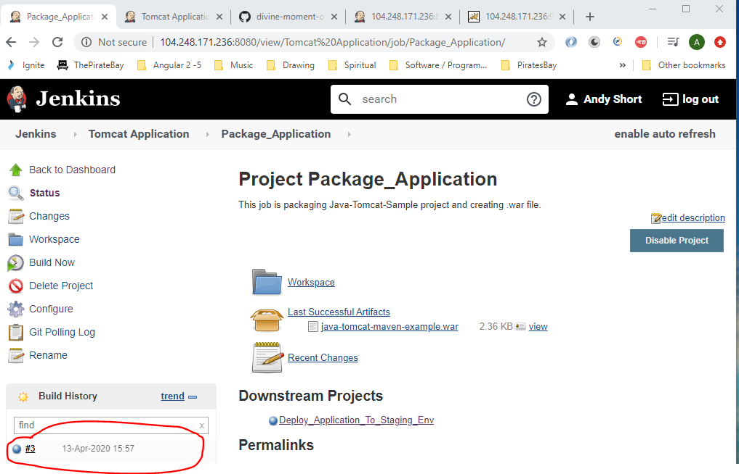

Also, see that the ‘Project Deploy_Application_To_Staging_Env’ job was automically triggered when the previous one finished:-

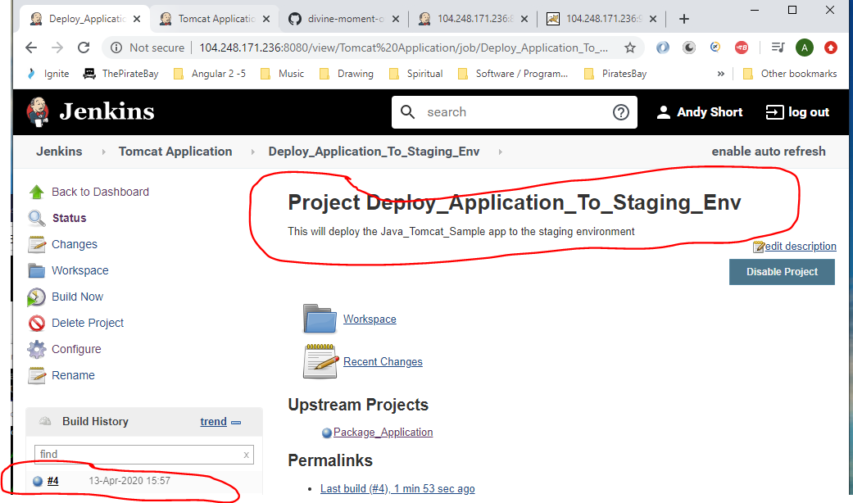

See that the job was started by “upstream project Package_Application”:-

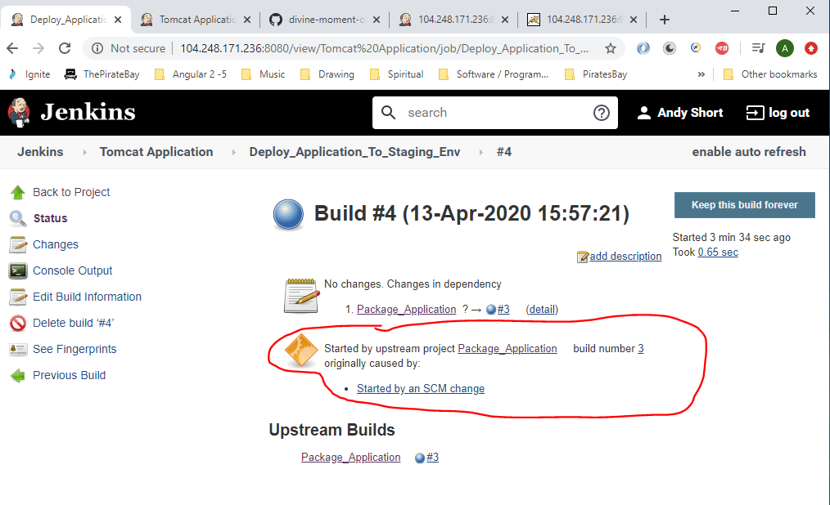

Now go to the tomcat web address and see the updated line of text:-

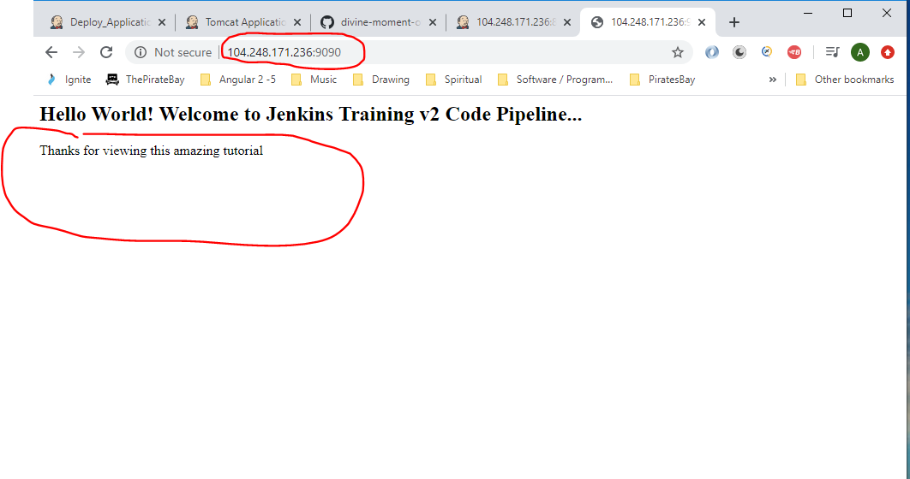

**Build Pipeline Plugin**

Go to ‘Manage Jenkins’:-

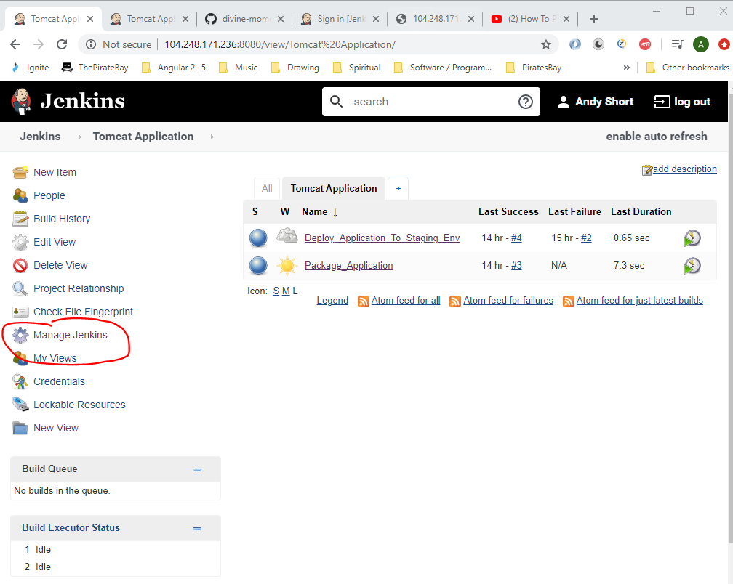

Go to ‘Manage Plugins’:-

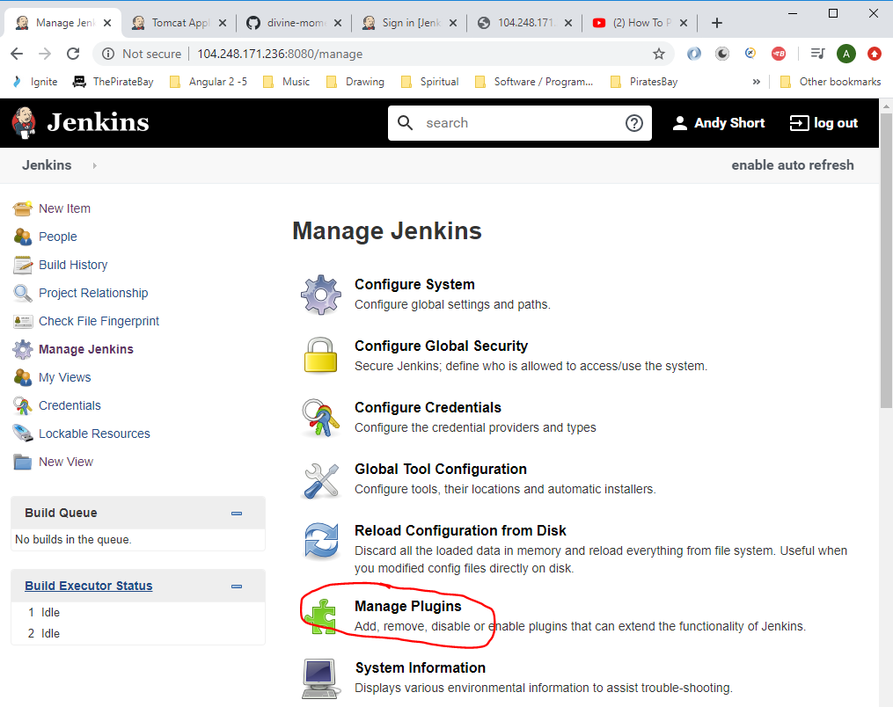

Search for ‘build pipeline’:-

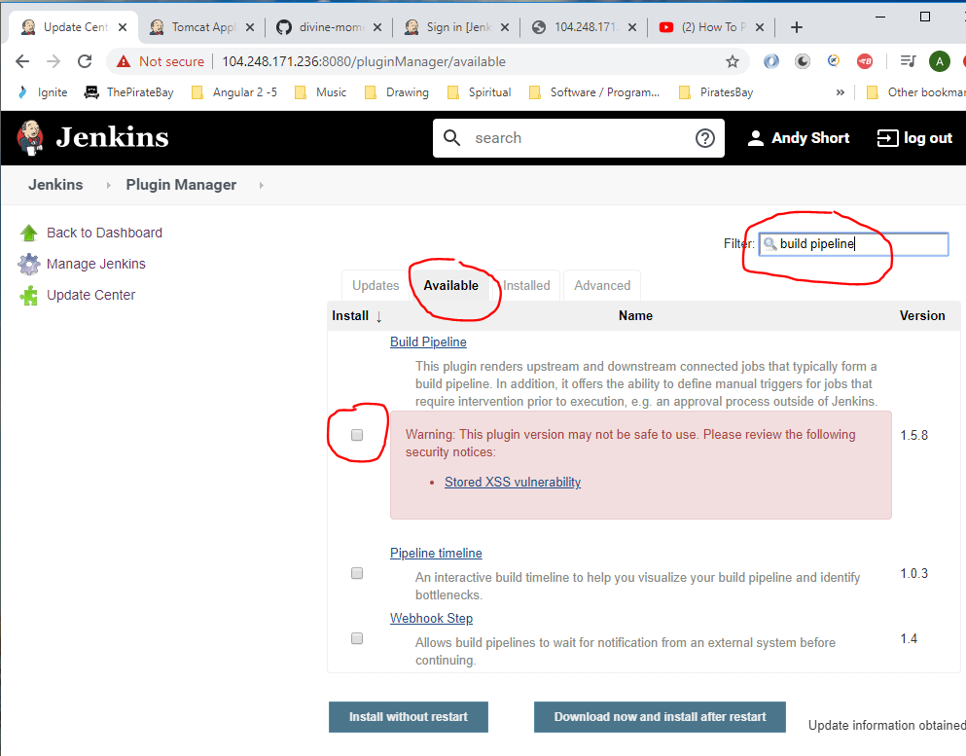

Select checkbox and click ‘Install without restart’.

When downloaded go here and click the ‘+’:-

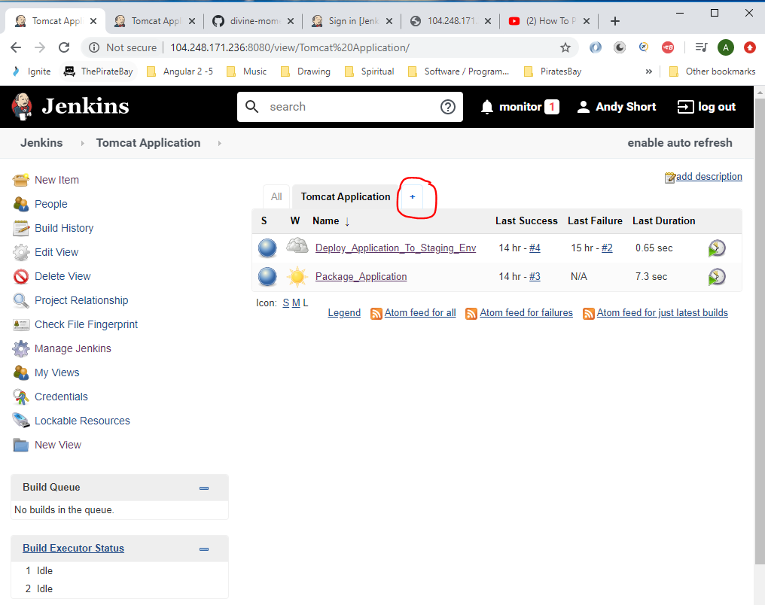

Select the following:-

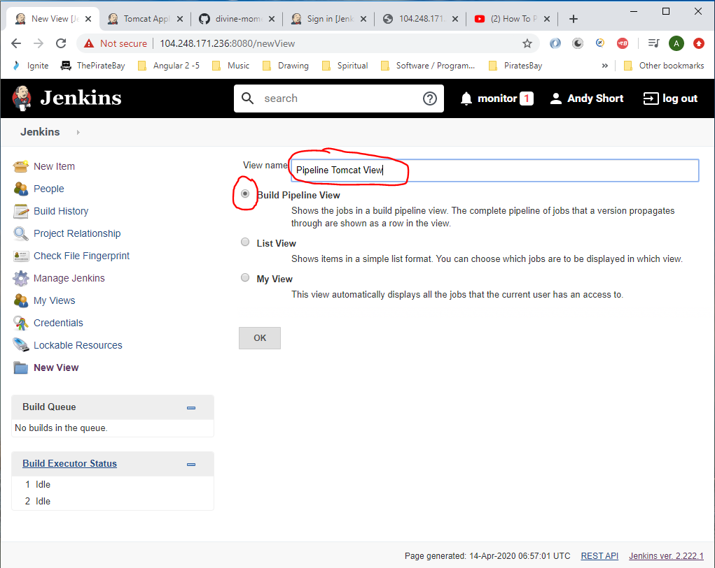

Click ‘OK’.

Enter the following:-

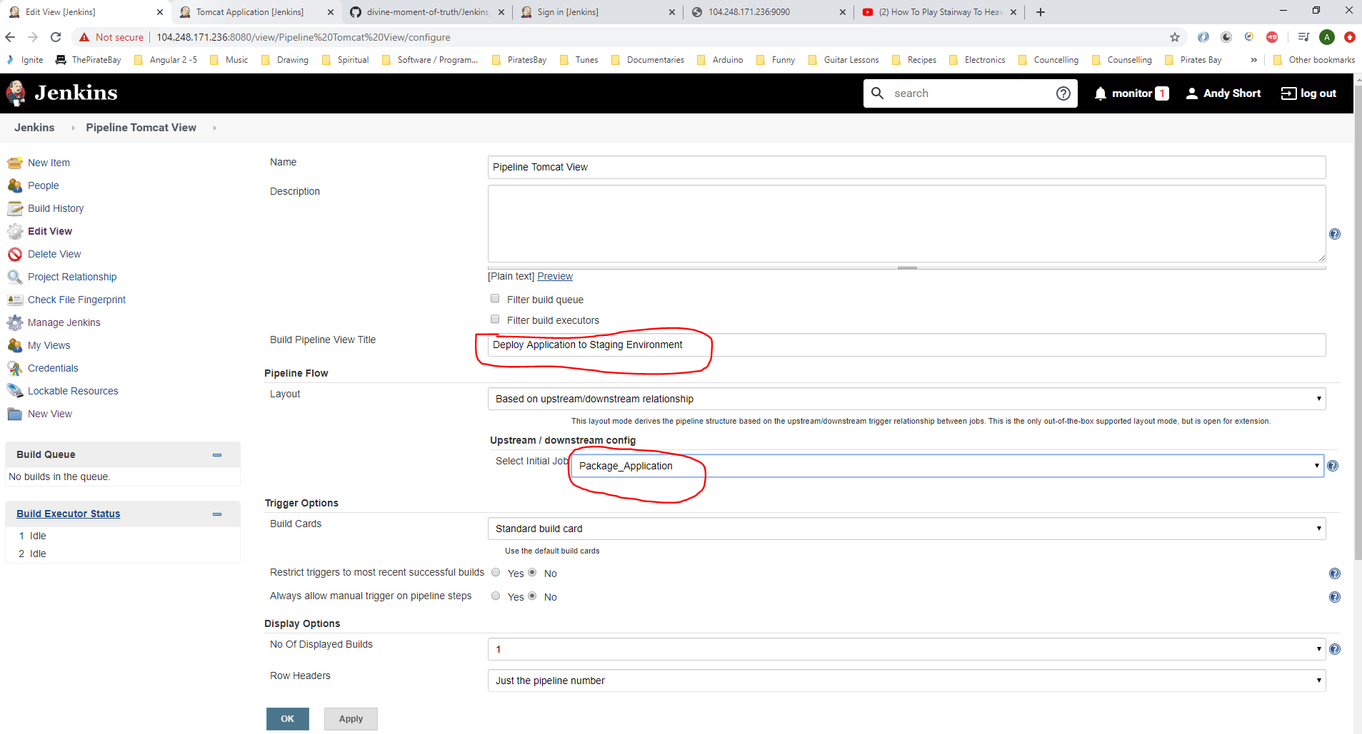

Click ‘OK’.

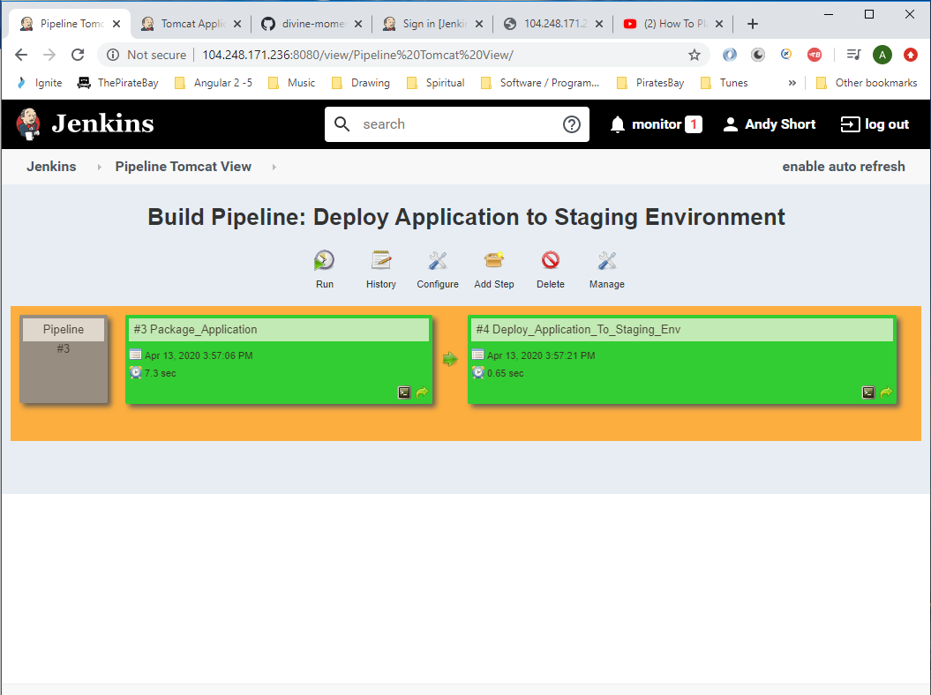

To run pipeline click the ‘Run’ button:-

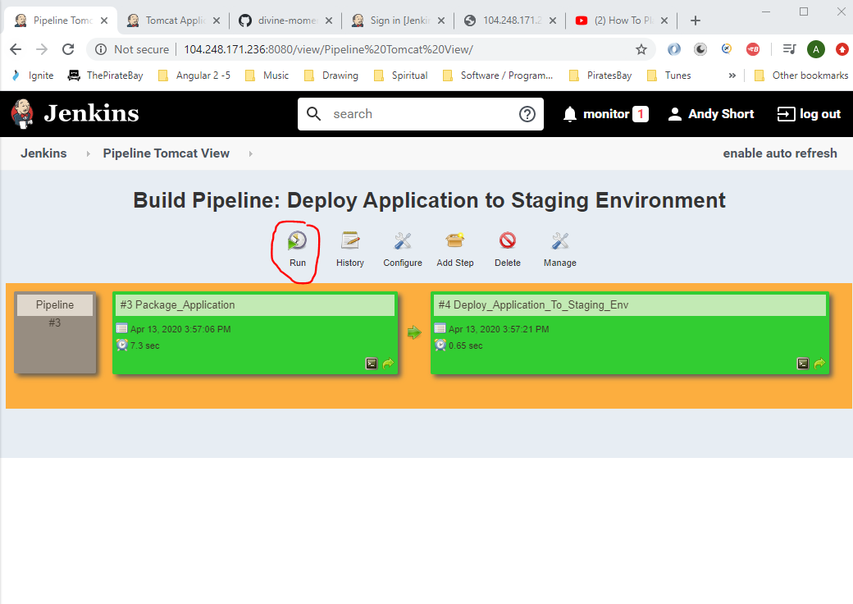

**Deploy in Production**

Create Tomcat server to be running on port 9091 for the production environment. Go to Putty:-

Navigate to the following location:-

*cd /opt/tomcat/apache-tomcat-8.5.54/bin*

Stop Tomcat server:-

*./shutdown.sh*

Now navigate to:-

*cd /opt/tomcat*

Copy this folder – ‘ apache-tomcat-8.5.54’ and create a new folder:-

*cp -r apache-tomcat-8.5.54/ apache-tomcat-8.5.54-prod*

Now, navigate into:-

*cd apache-tomcat-8.5.54-prod/conf*

Open server.xml:-

*vi server.xml*

Search for ‘connector’ and change port number to 9091:-

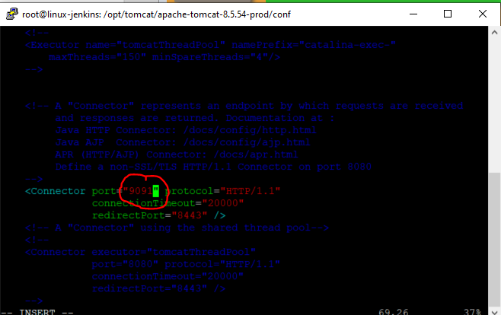

[Esc]

:wq

Start Tomcat server for the prod server:-

*cd ..*

*cd ..*

*cd apache-tomcat-8.5.54-prod*

*cd bin*

*./startup.sh*

Now go to Jenkins and create a new job:-

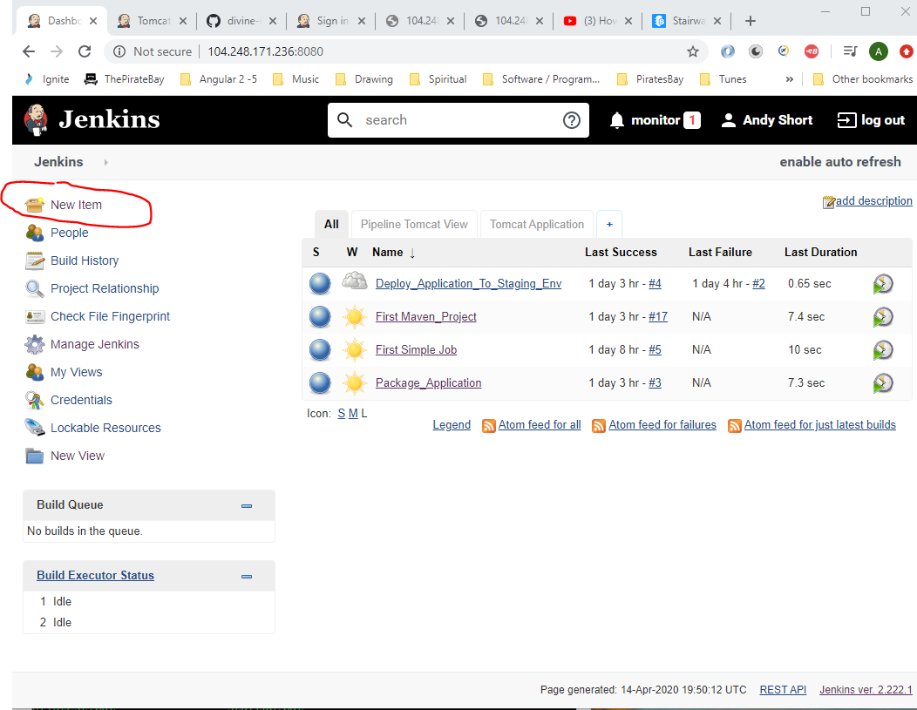

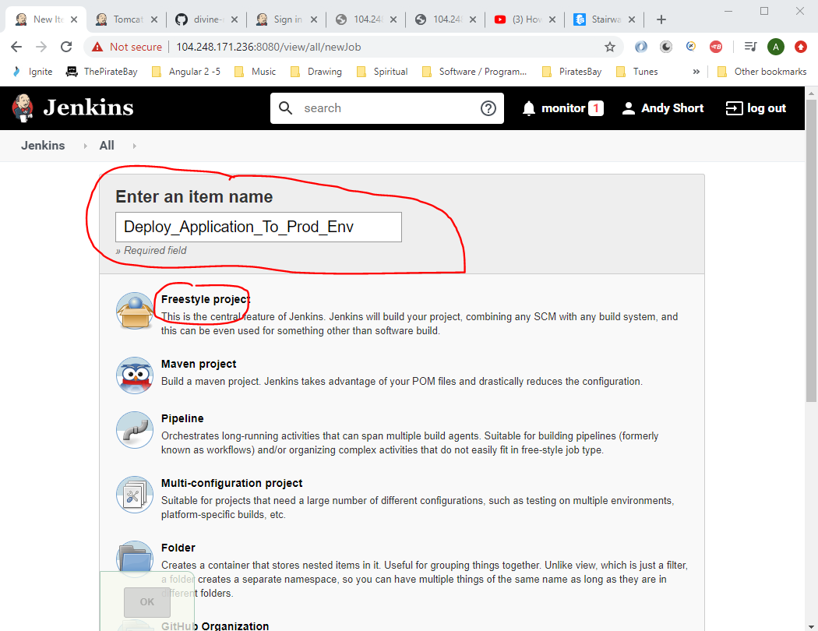

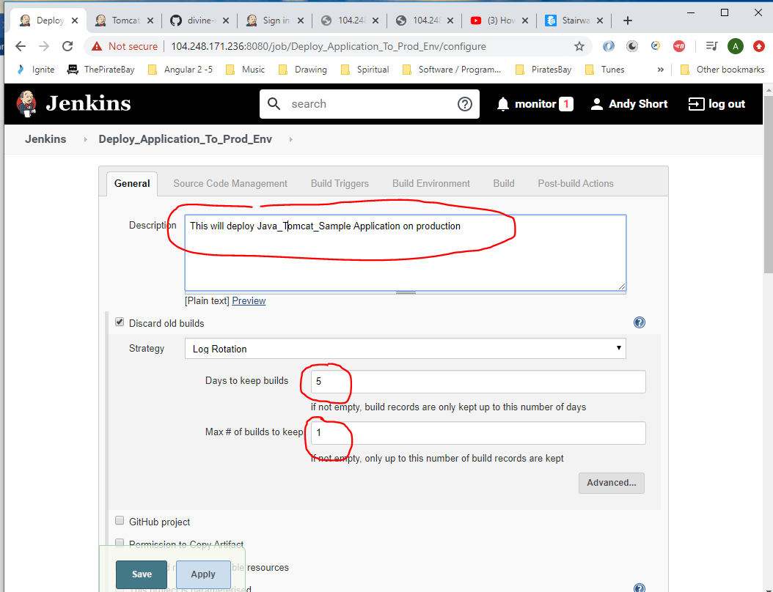

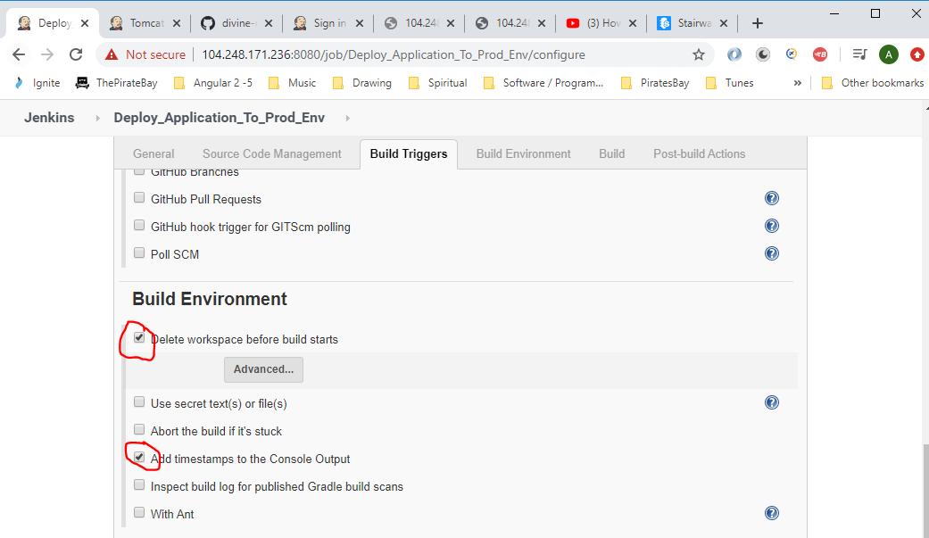

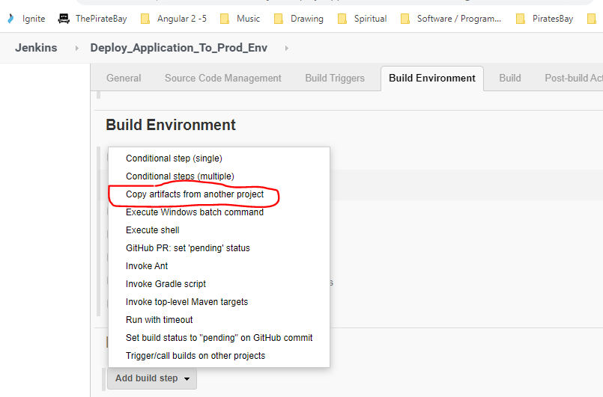

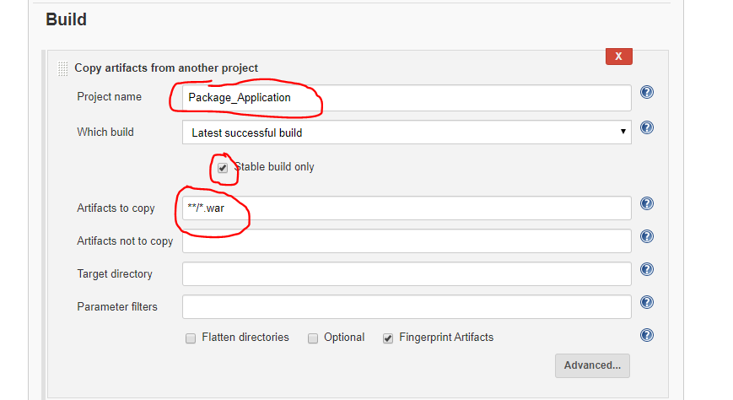

Click ‘Save’.

Now you need to go to the – ‘Deploy_Application_To_Staging_Env’ and add a post-build step, so that when this job is complete it starts the ‘Deploy_Application_To_Prod_Env’ job:-

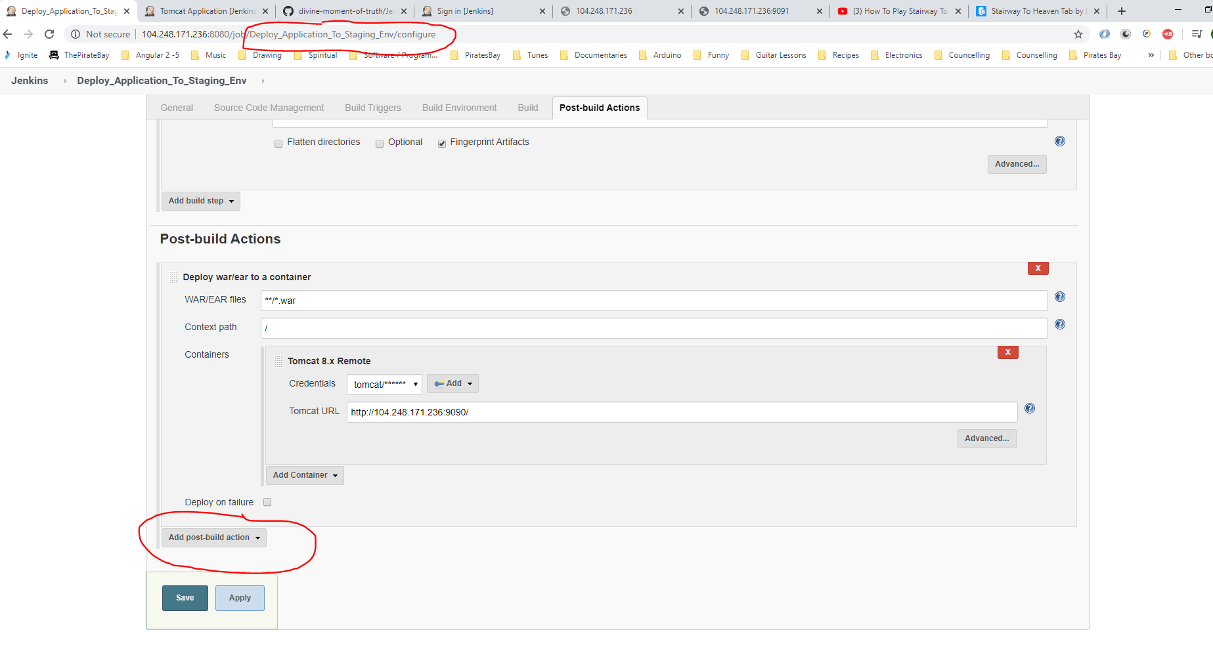

This time choose ‘Build other projects (manual step) because we do not want a build deploying to production without it being checked first with the stakeholders.

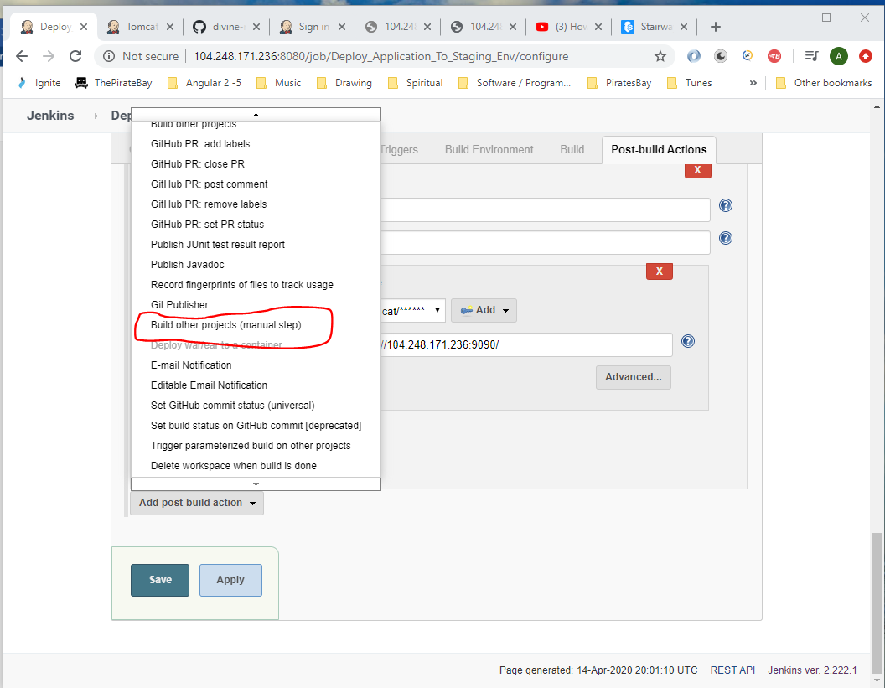

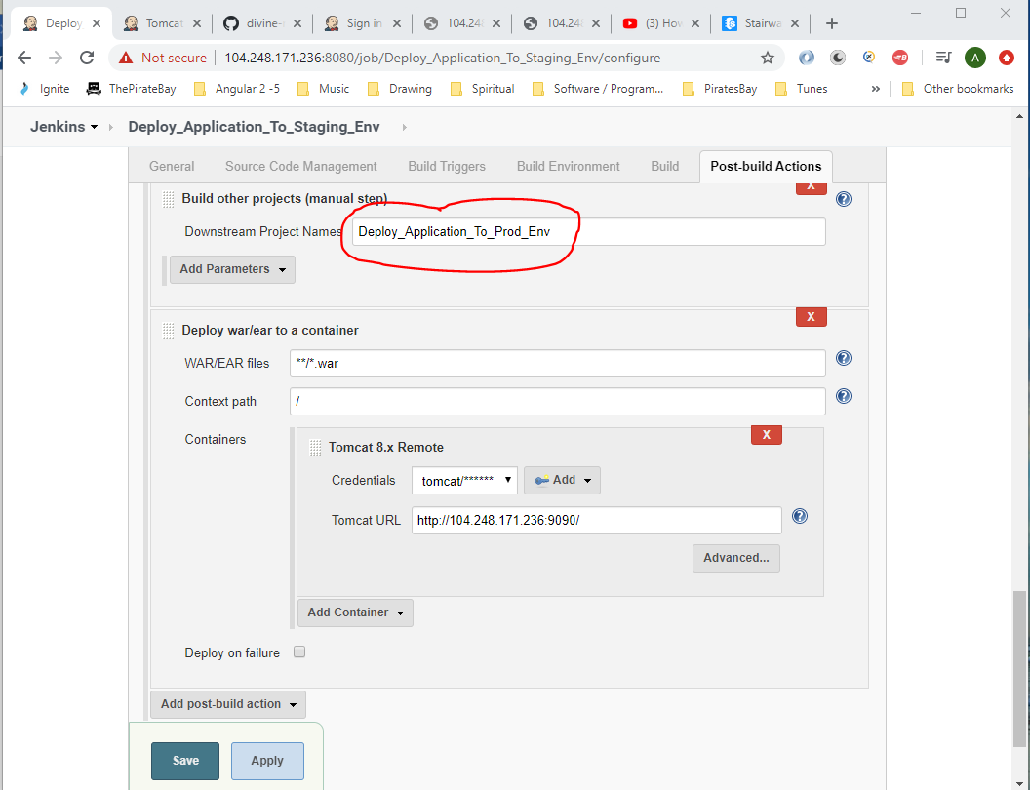

Then click @Save’.

Go back to the Deploy_Application_To_Prod_Env job and go to the ‘Post-build Actions’ and select ‘Deploy war/ear to a container’:-

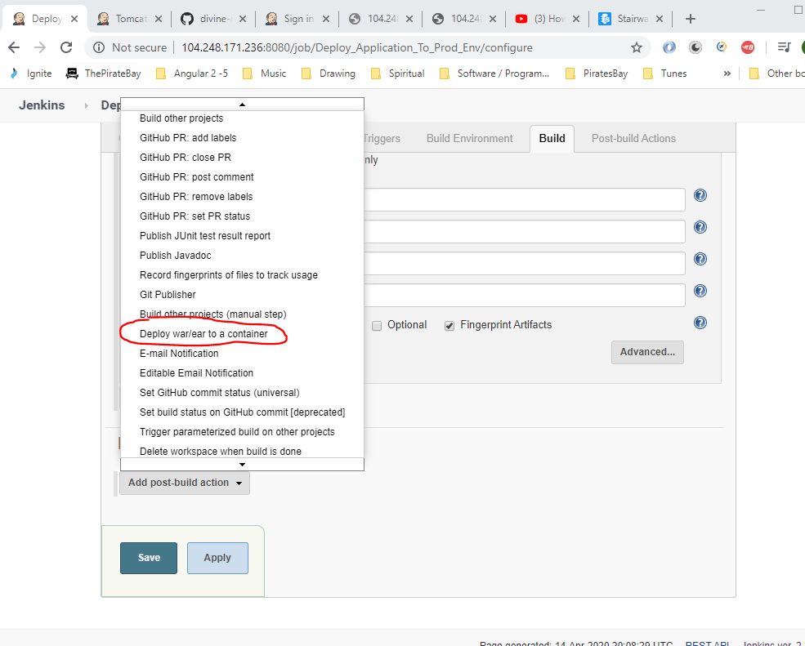

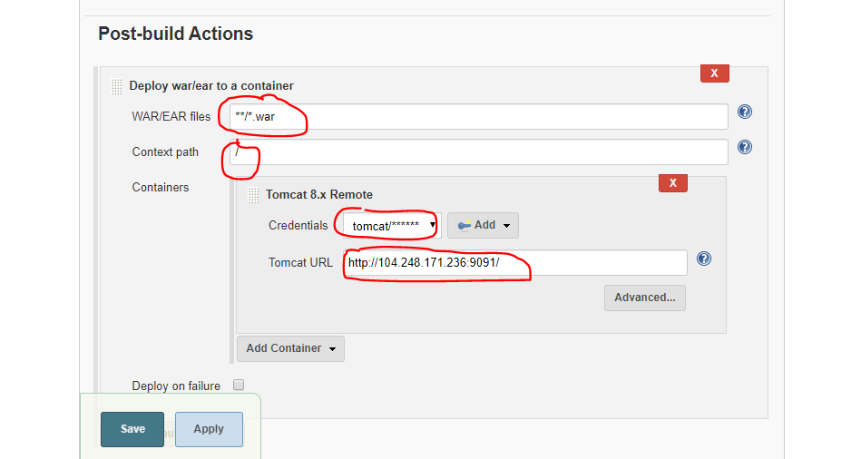

Then click ‘Save’.

Now, click on ‘Pipeline Tomcat View’ tab:-

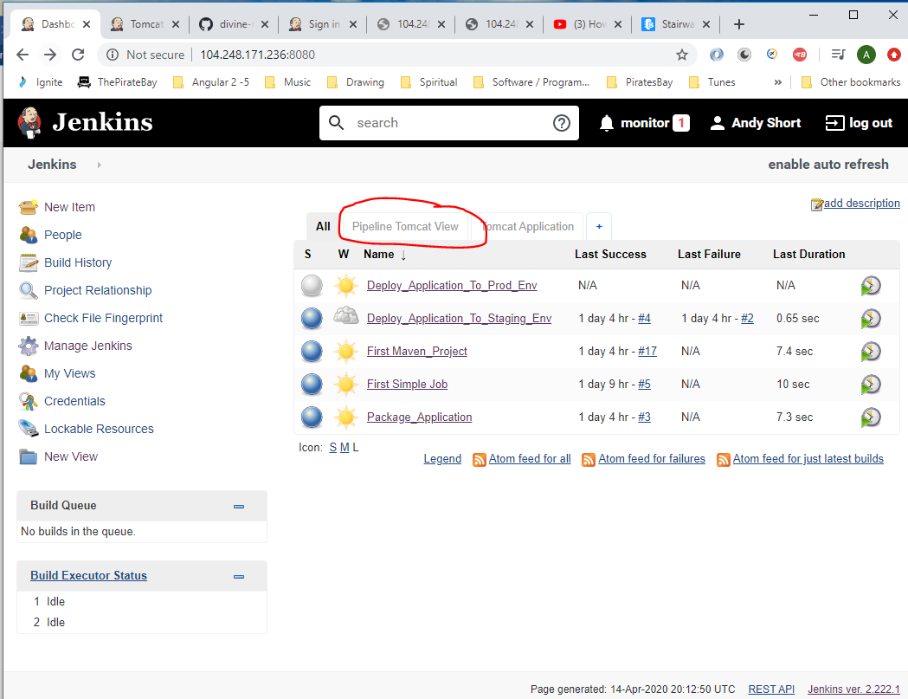

See new item added to end (in blue):-

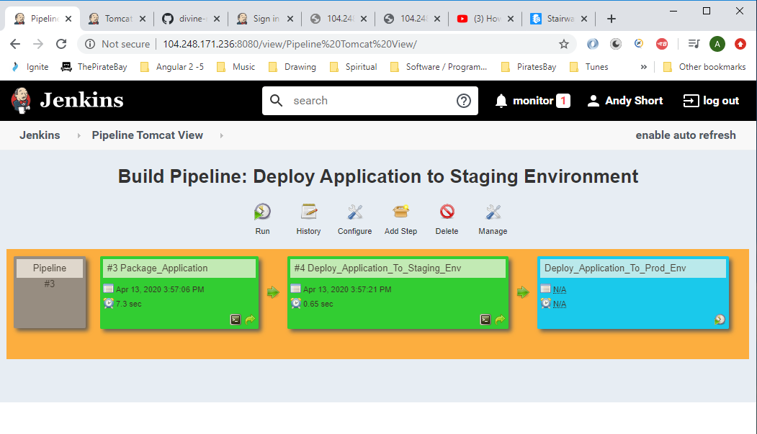

Now edited the following project file in Visual code and then commit changes to remote GitHub repo:-

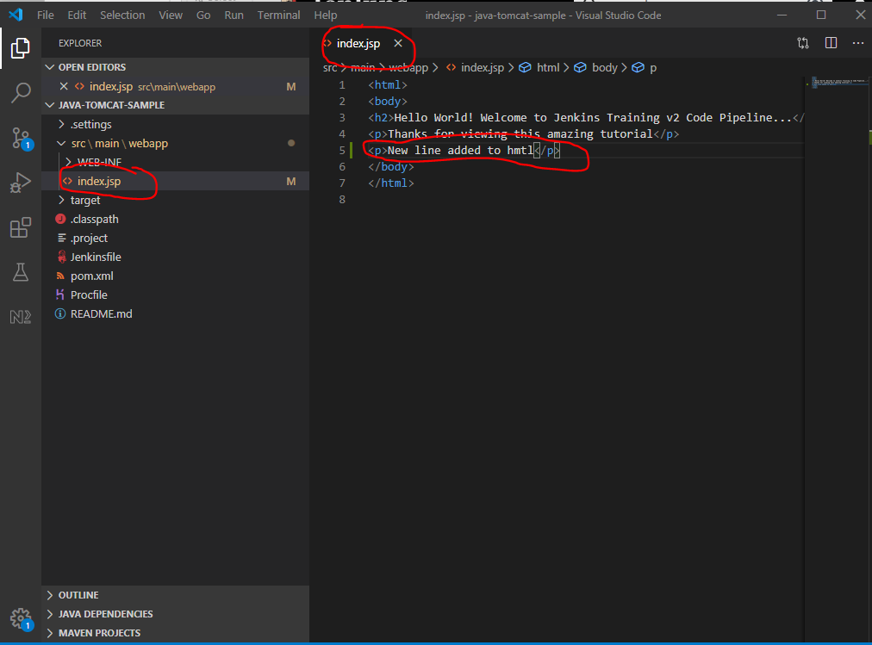

**Infrastructure as Code**

Install Jenkins DSL plugin:-

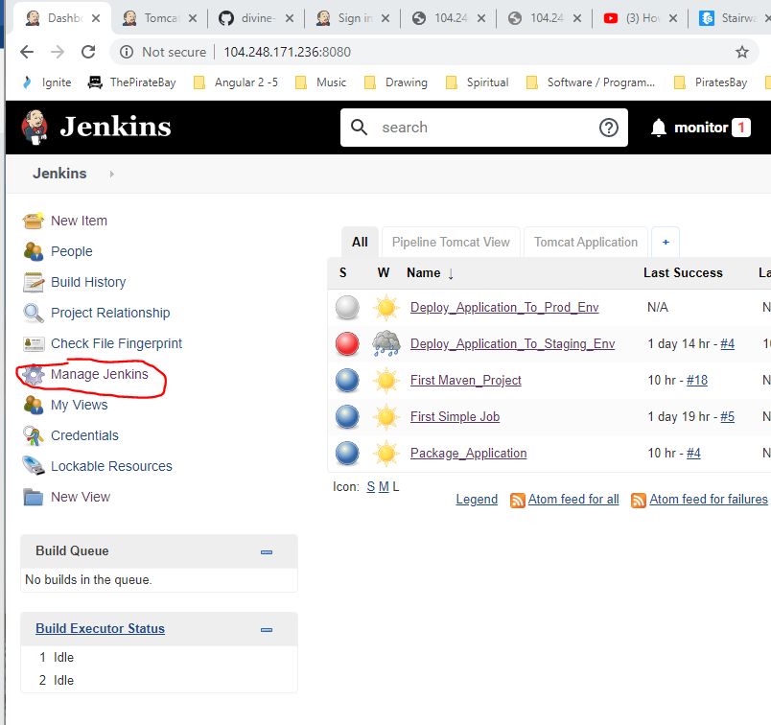

Then,

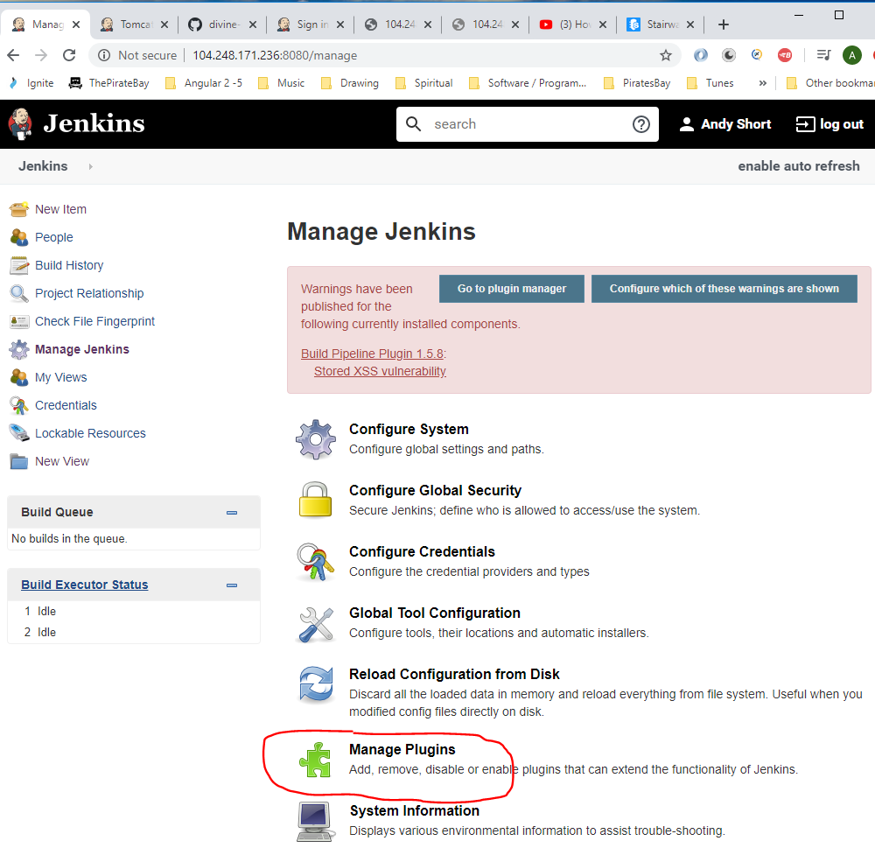

Search for – ‘job DSL’:-

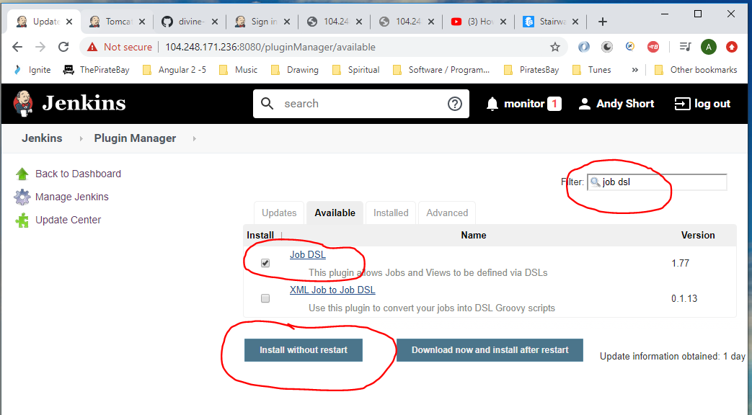

Now click this:-

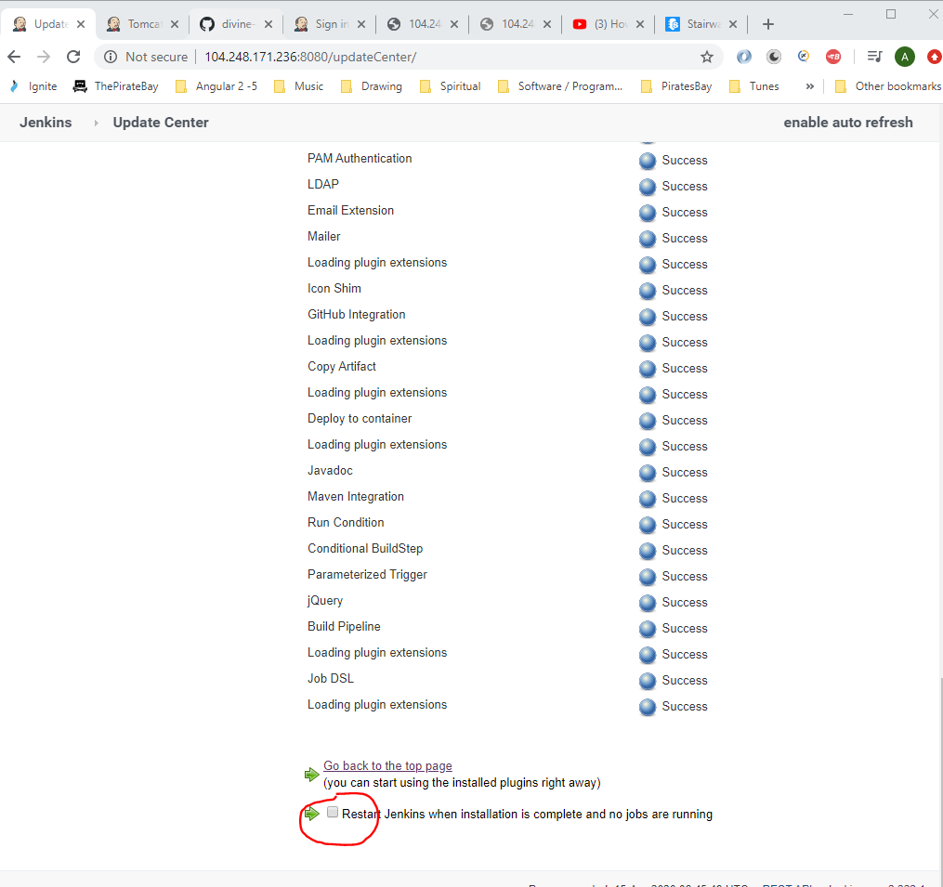

First, create a seed job. The seed job runs a DSL script and this generates a new job.

See the following Groovy script in Visual Code:-

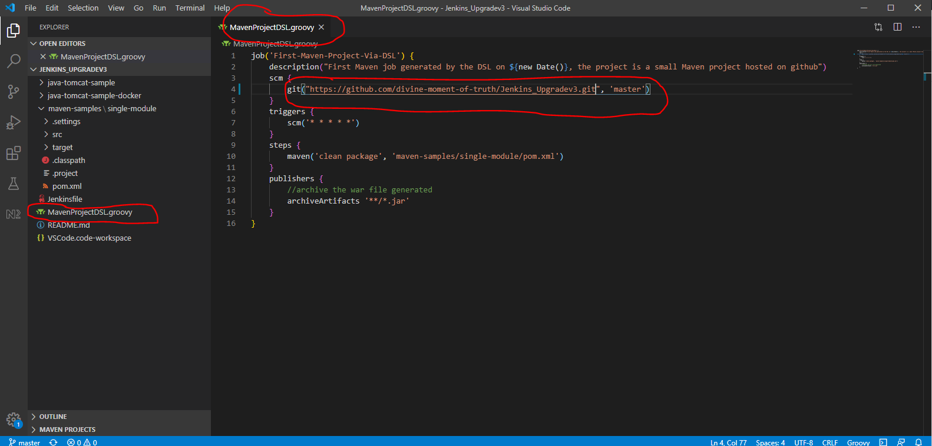

Now, create the seed job in Jenkins:-

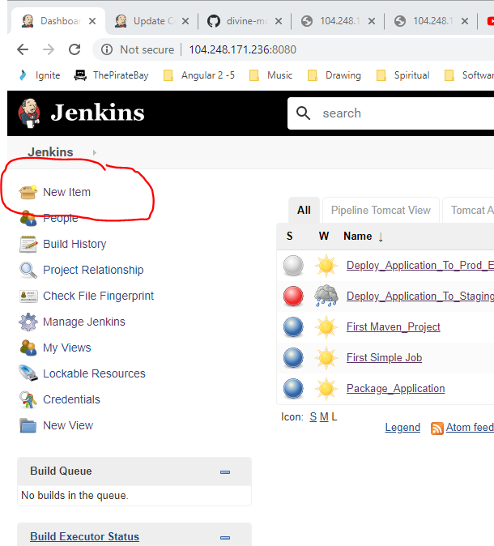

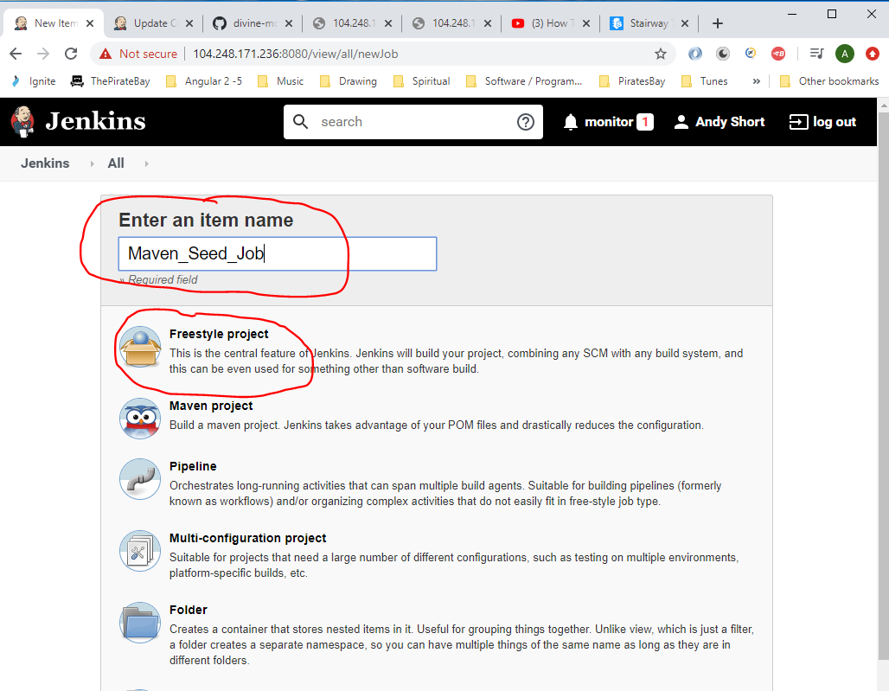

Go to ‘Source Code Management’ section and add GitHub address:-

Take address from here in GitHub:-

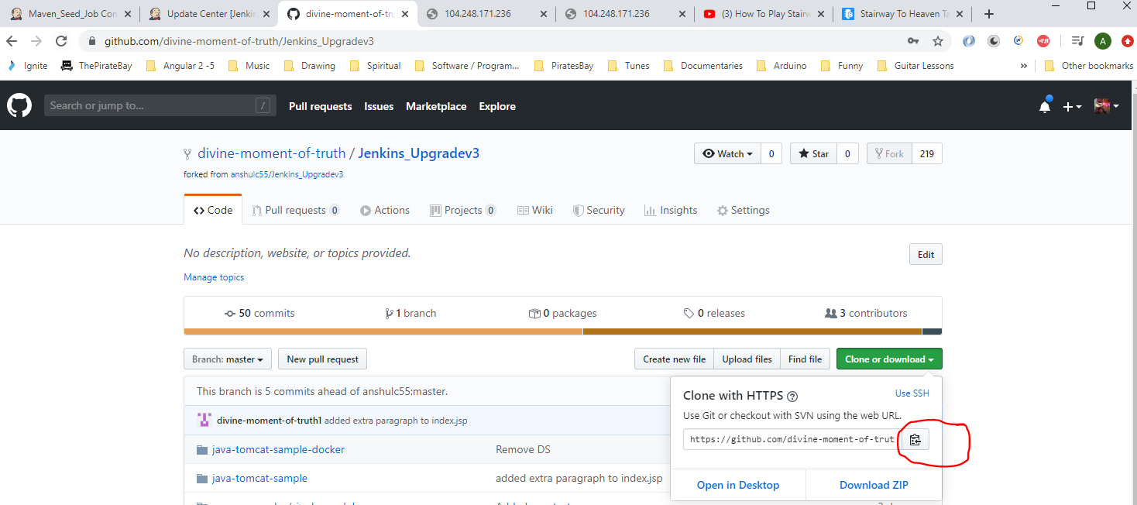

Paste into Jenkins:-

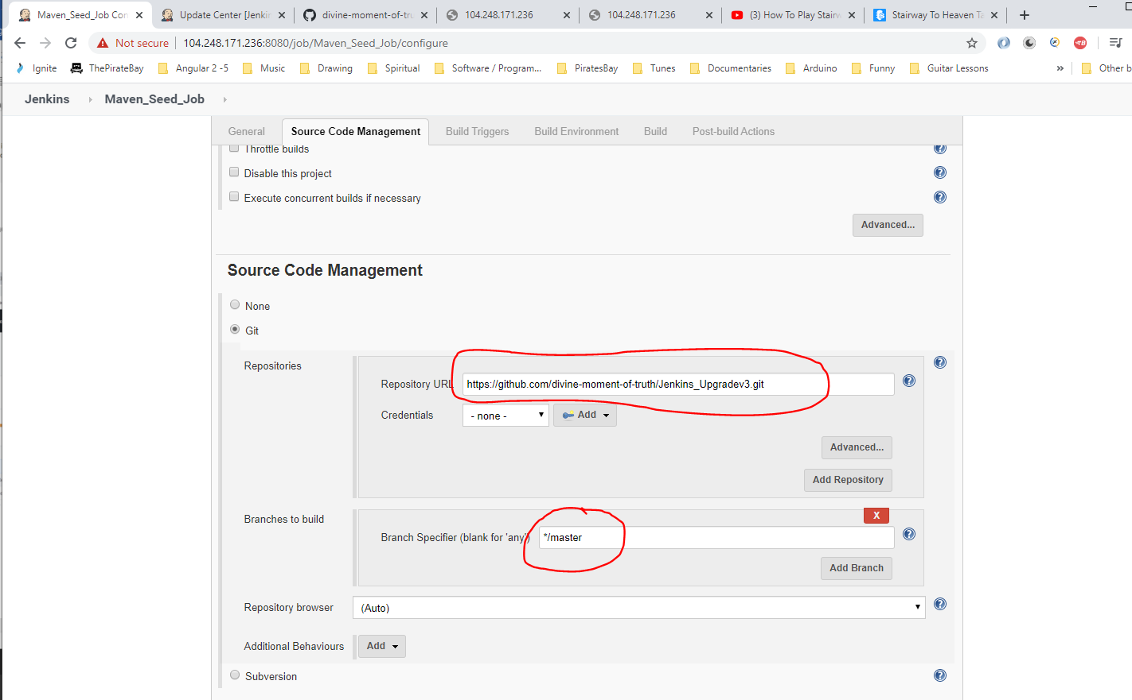

Under the ‘Build’ section select this:-

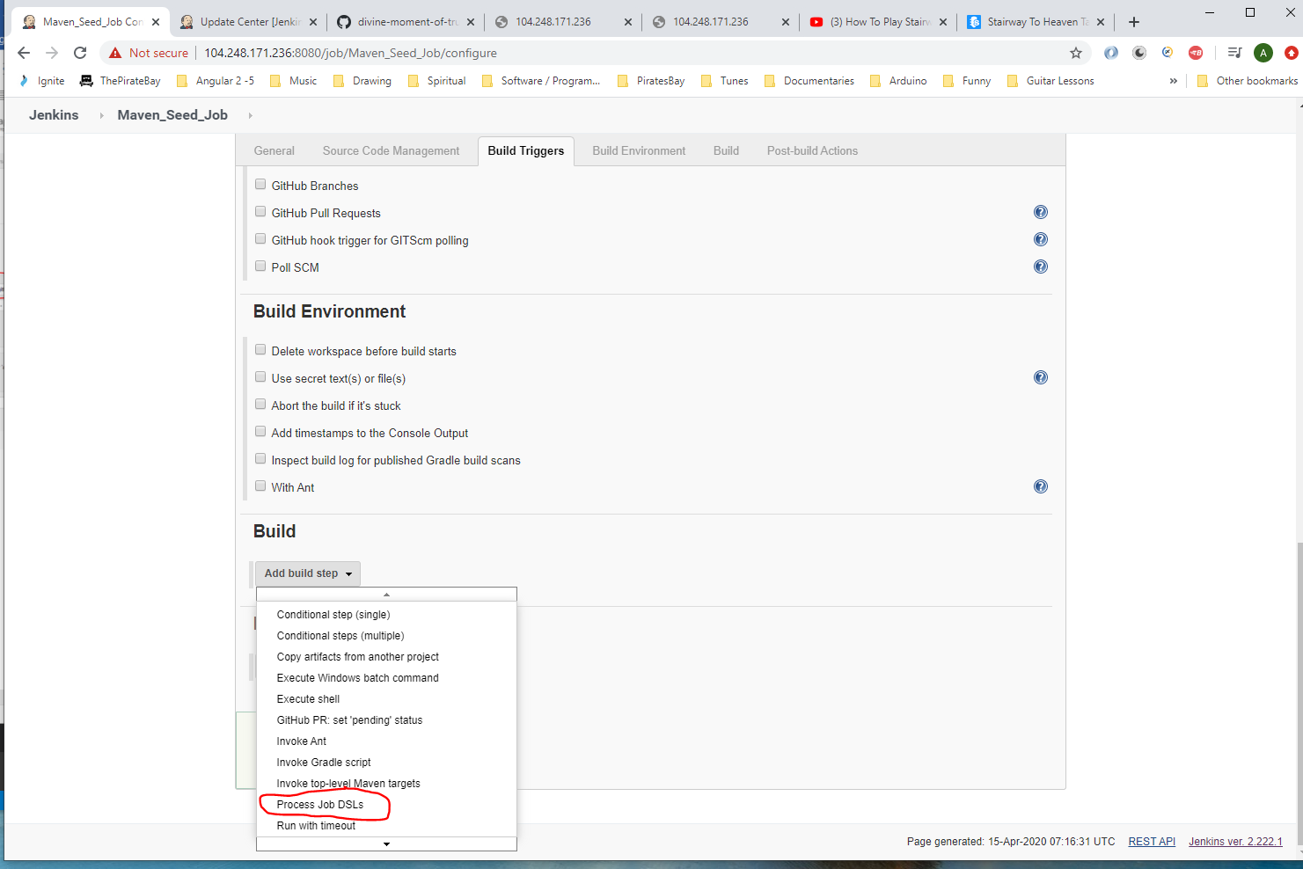

Copy name from here:-

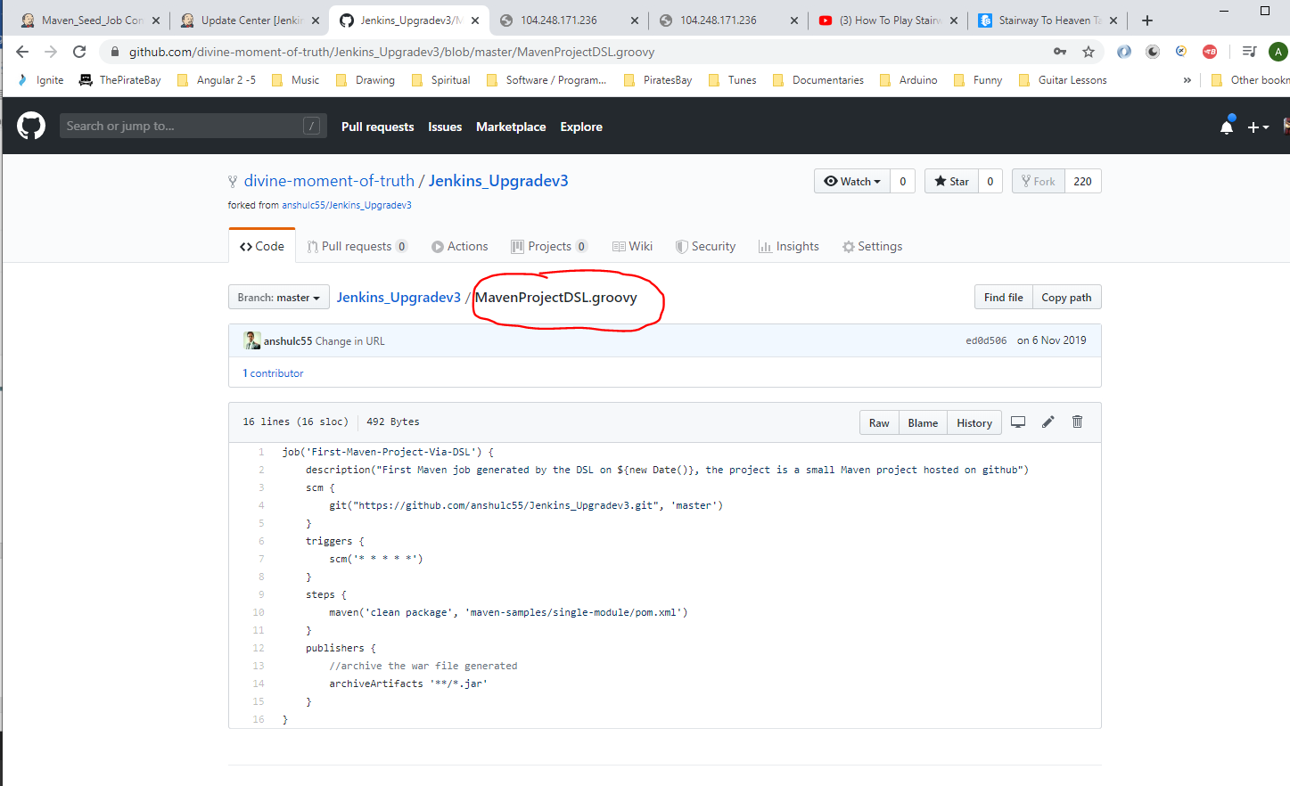

Paste here:-

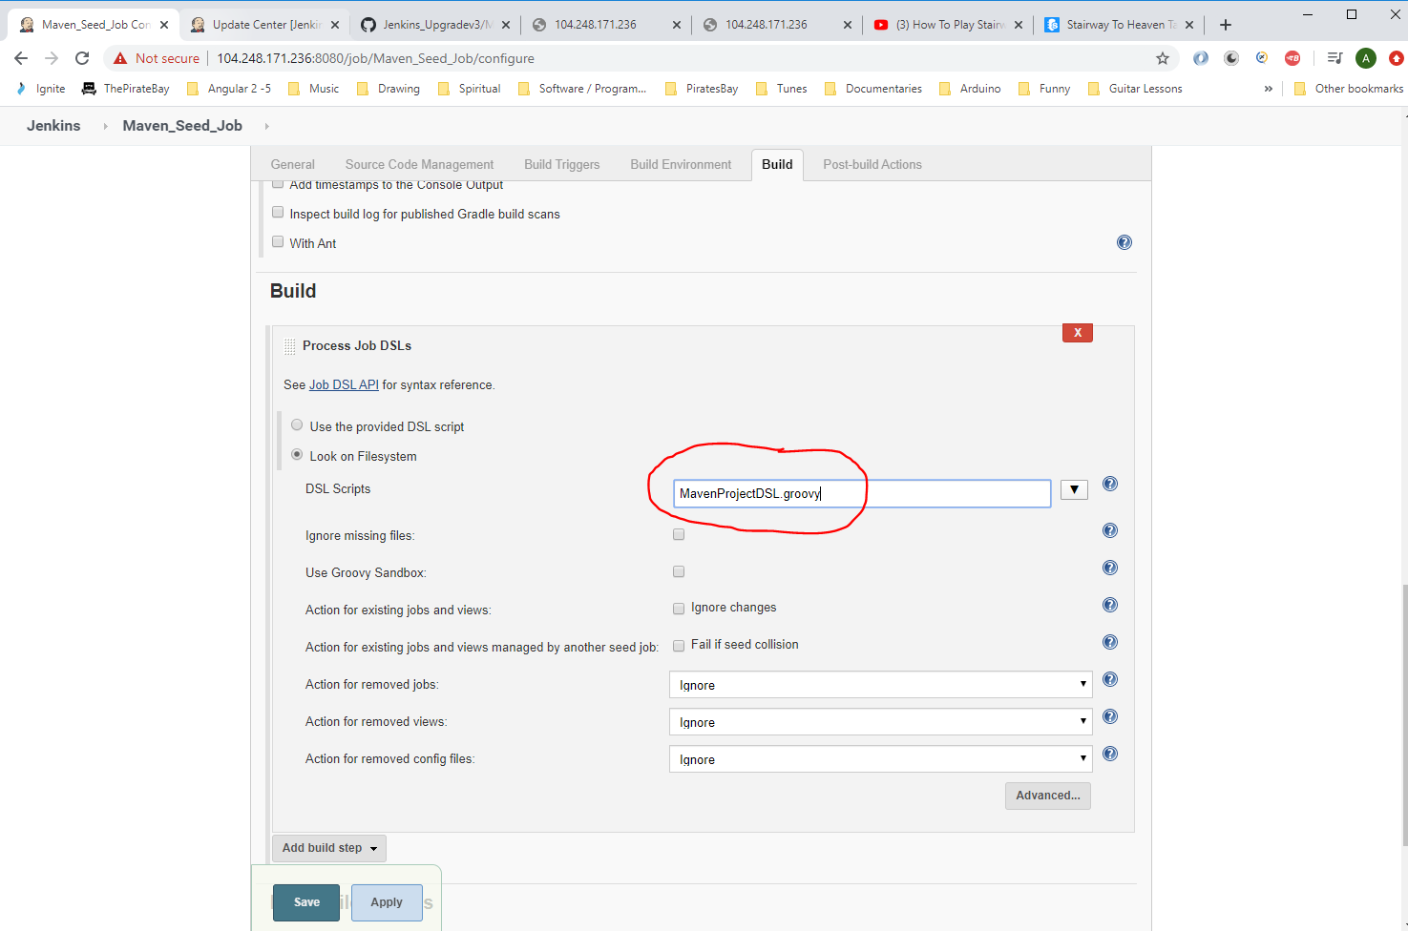

Then click ‘Save’.

Now try and run Jenkins job (it will fail though).

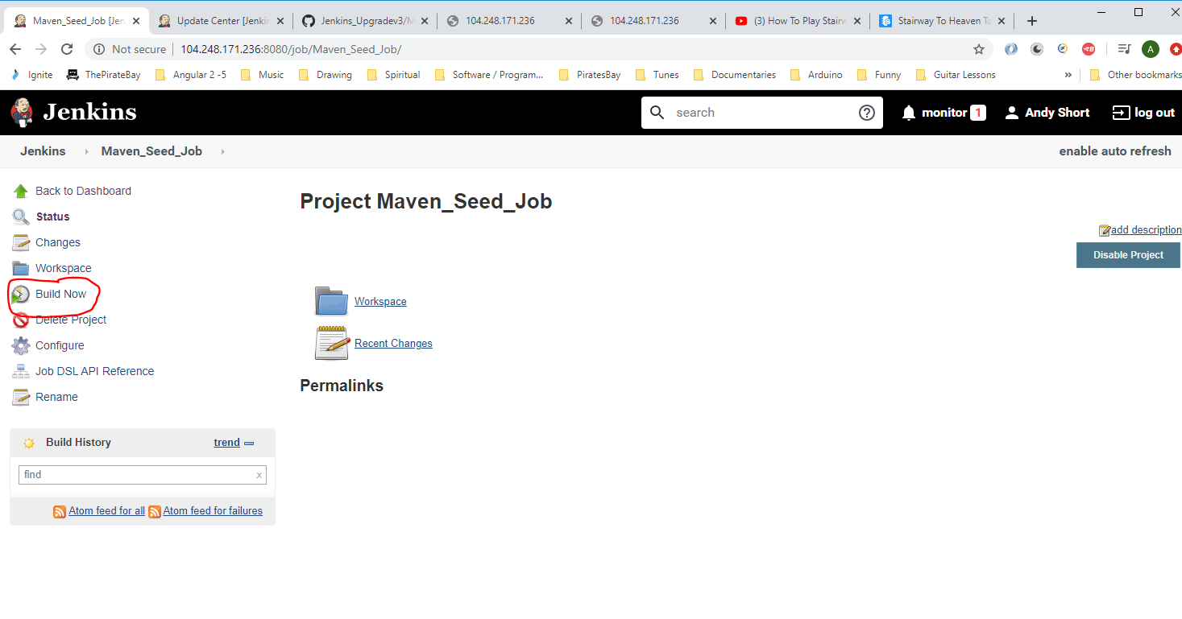

See error:-

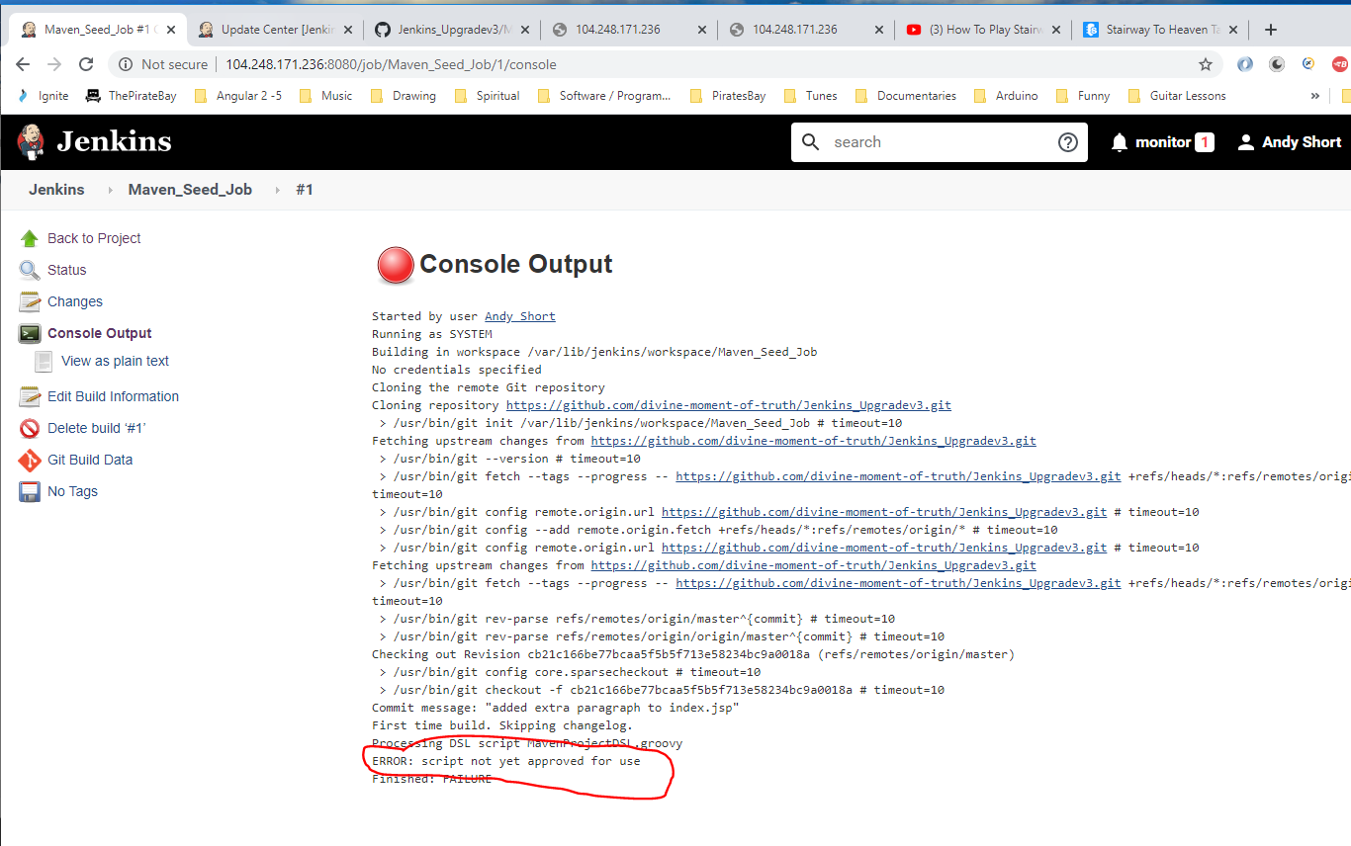

The problem is that the script is not approved. To Approve it go ‘Manage Jenkins’ here:-

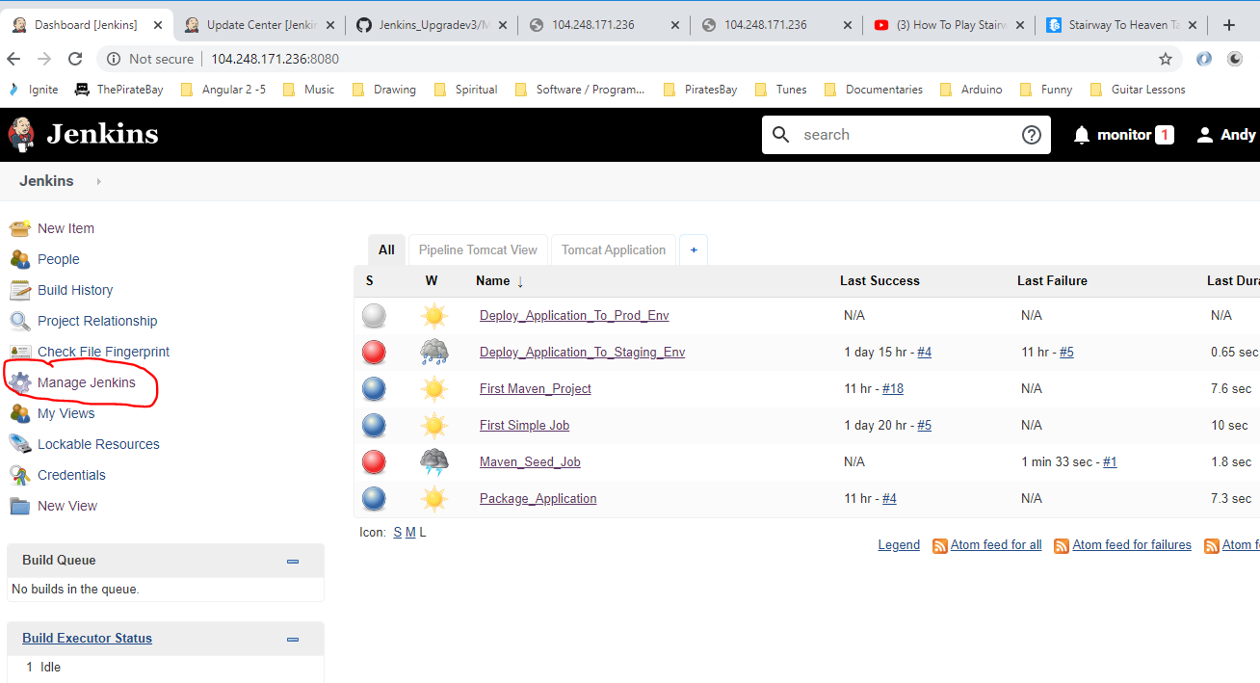

Click this option:-

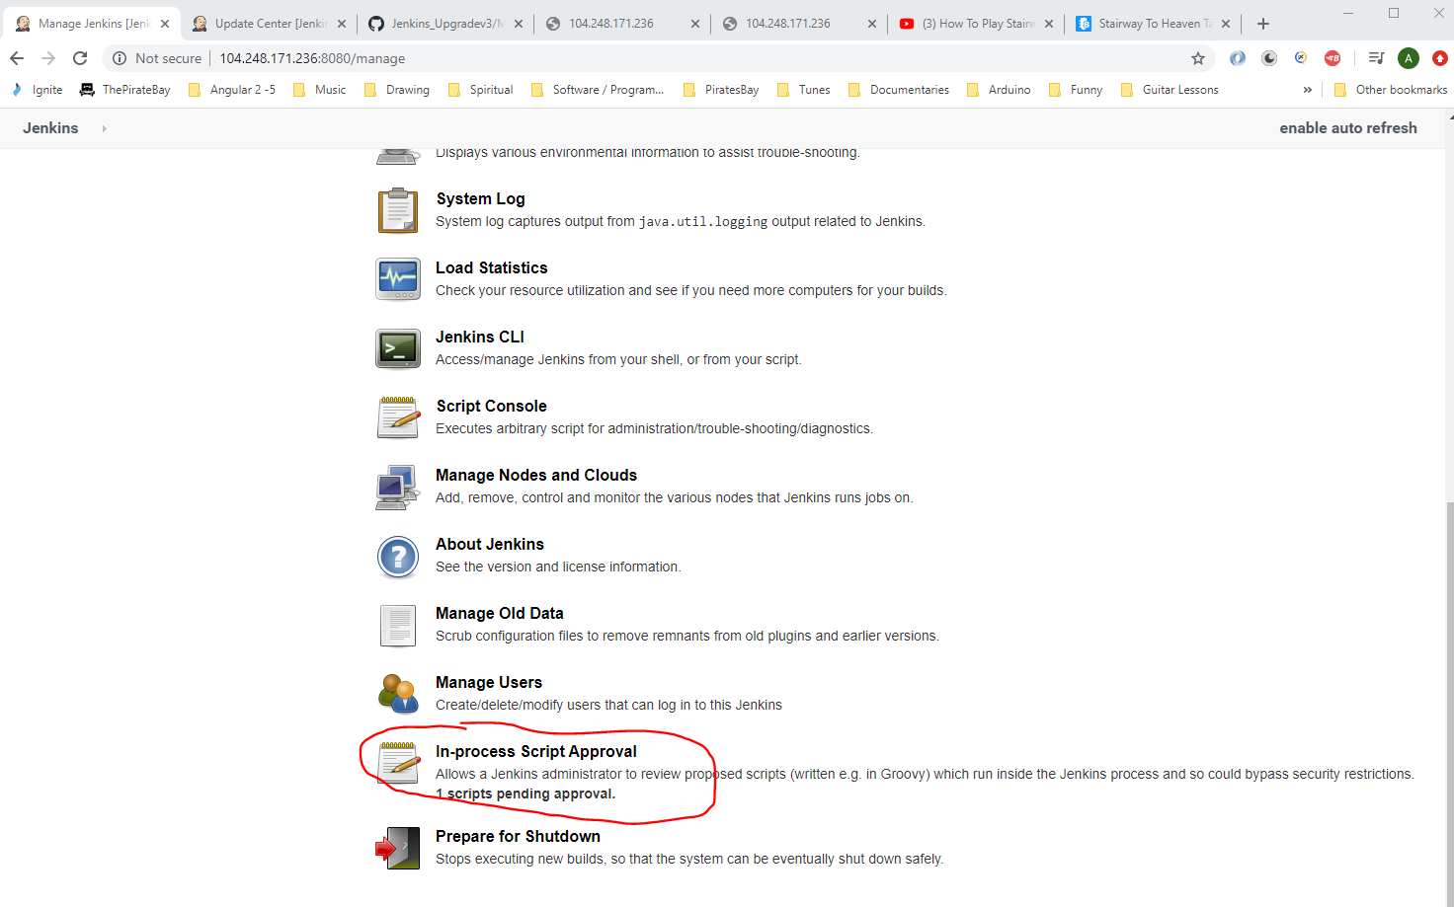

See script. Click the ‘Approve’ button:-

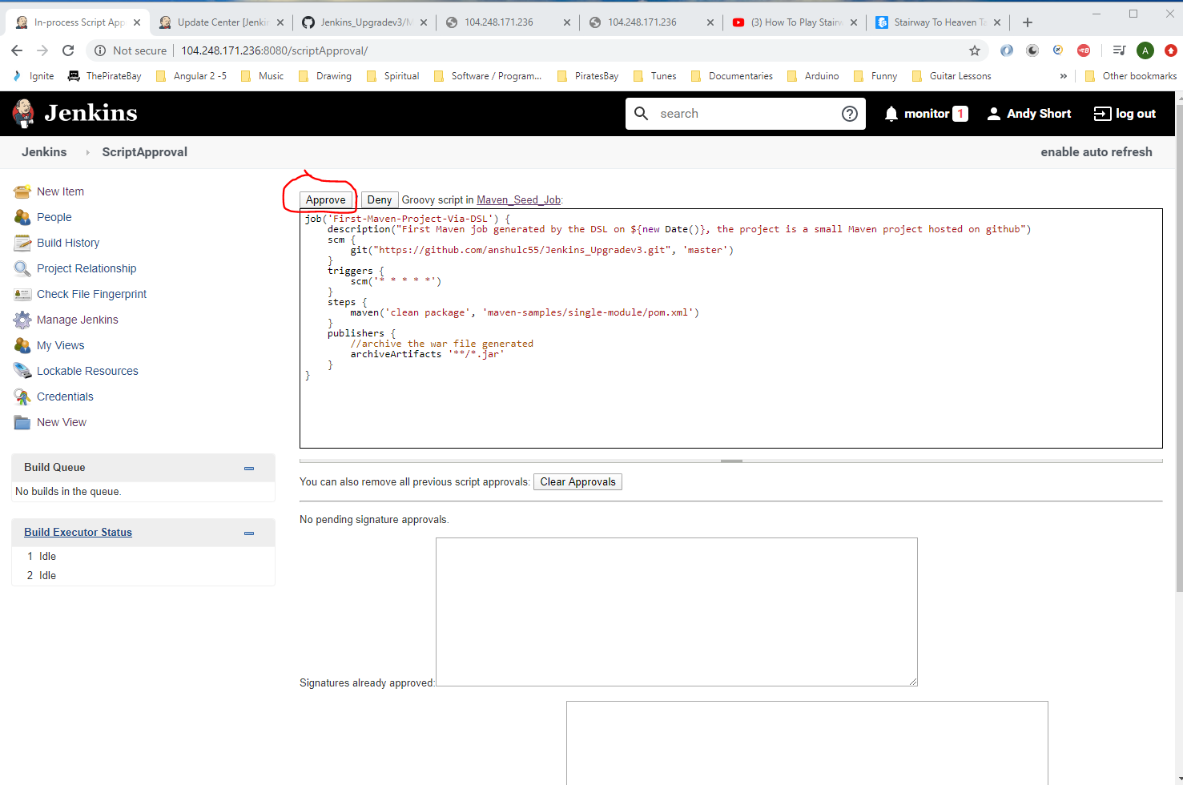

Then re-run job:-

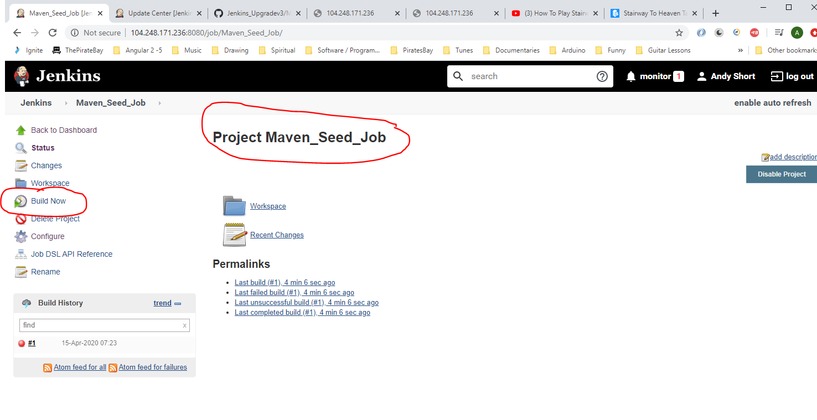

This creates this new job:-

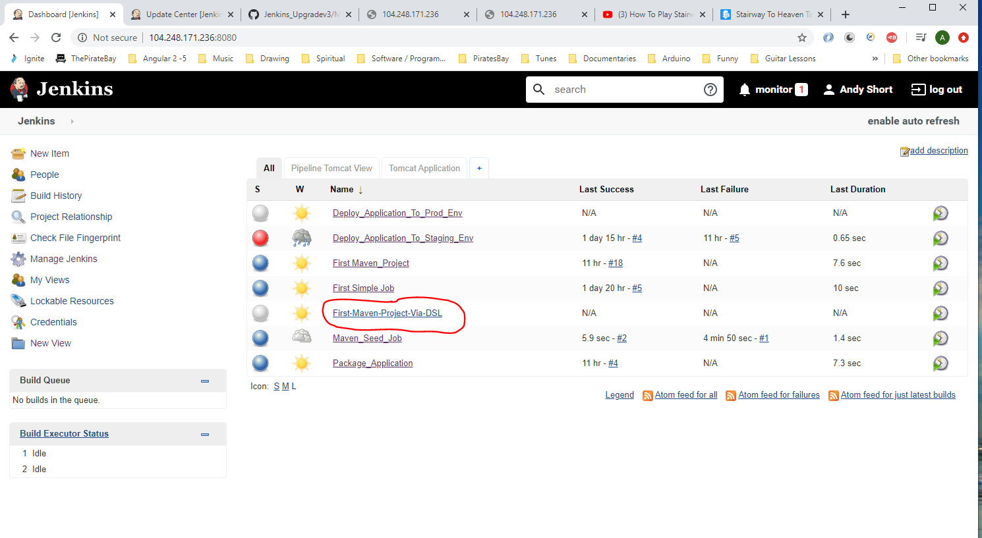

See name is the name mentioned in the Groovy script:-

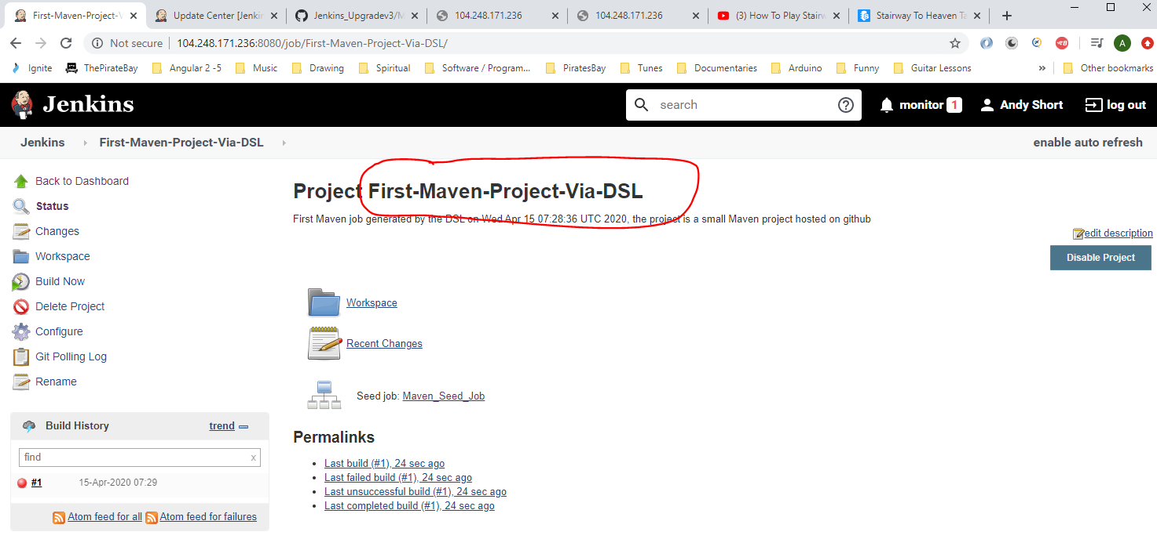

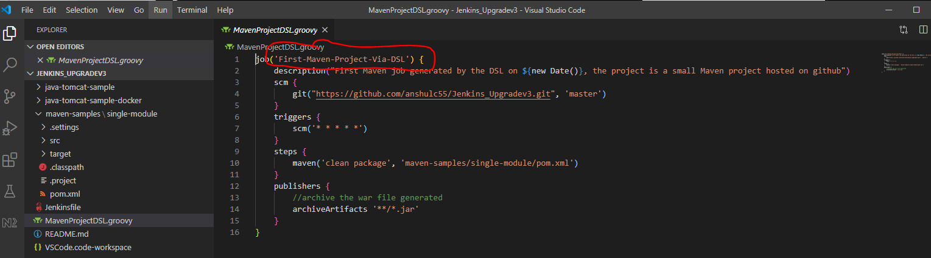

In Jenkins click on ‘Configure’ and see how the script has data in it that was in the groovy script:-

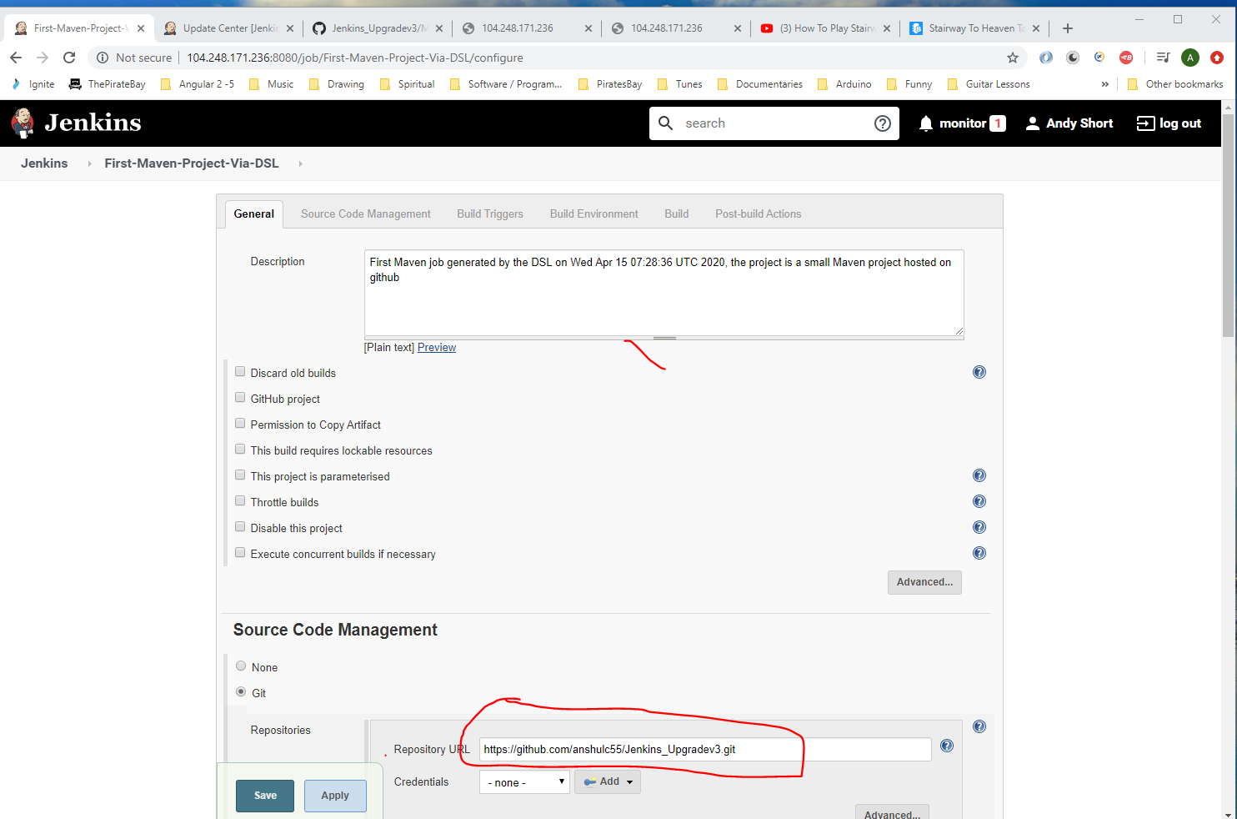

Now run the new job by clicking ‘Build Now’.

Below is where Jenkins places the built packages on the cloud based Jenkins Ubuntu machine:-

*/var/lib/jenkins/jobs/Package_Application/builds/8/archive/java-tomcat-sample/target*

To restart a Digital Ocean Ubuntu machine do the following:-

Putty onto machine

Type – reboot

If you see this error appearing when you try to run job – ‘First-Maven-Project-Via-DSL‘ then you will need to remove the ‘Additional Behaviours’ section in the job.

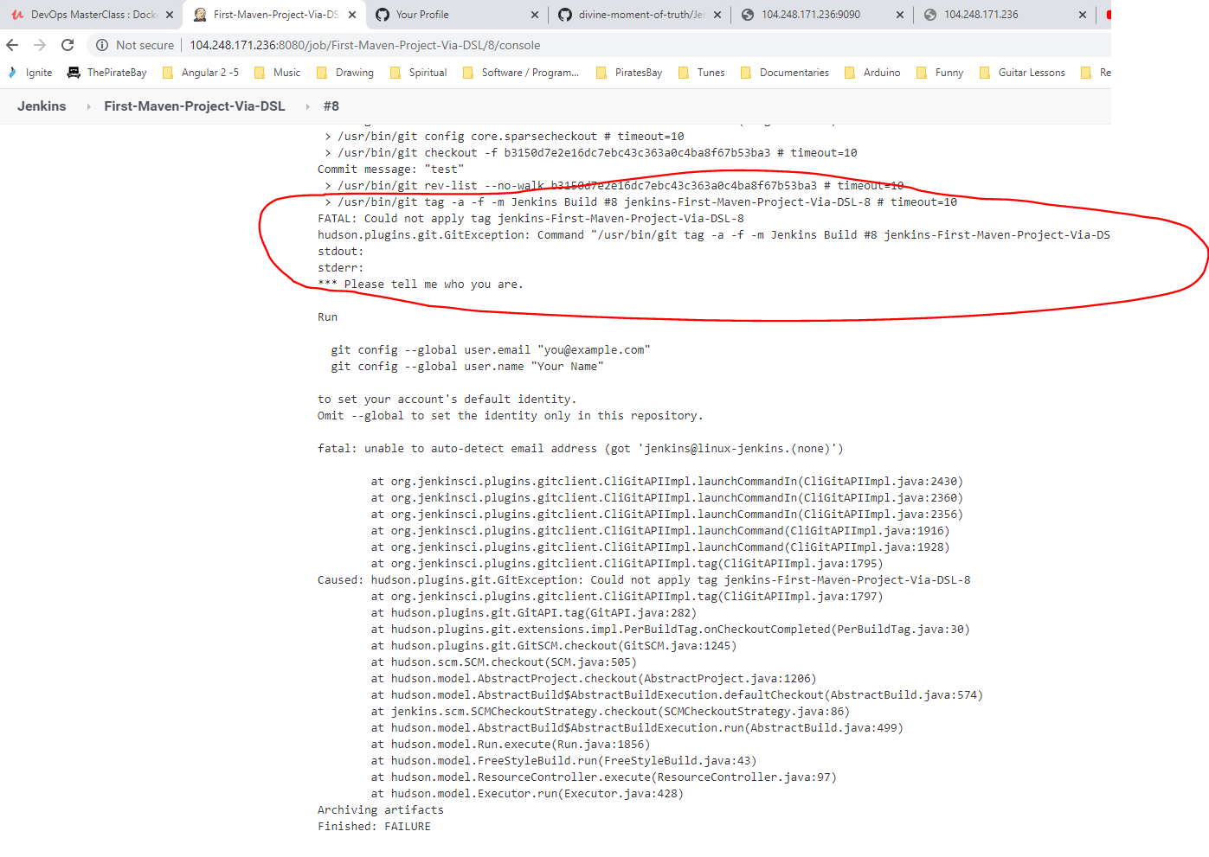

Remove this section from the job:-

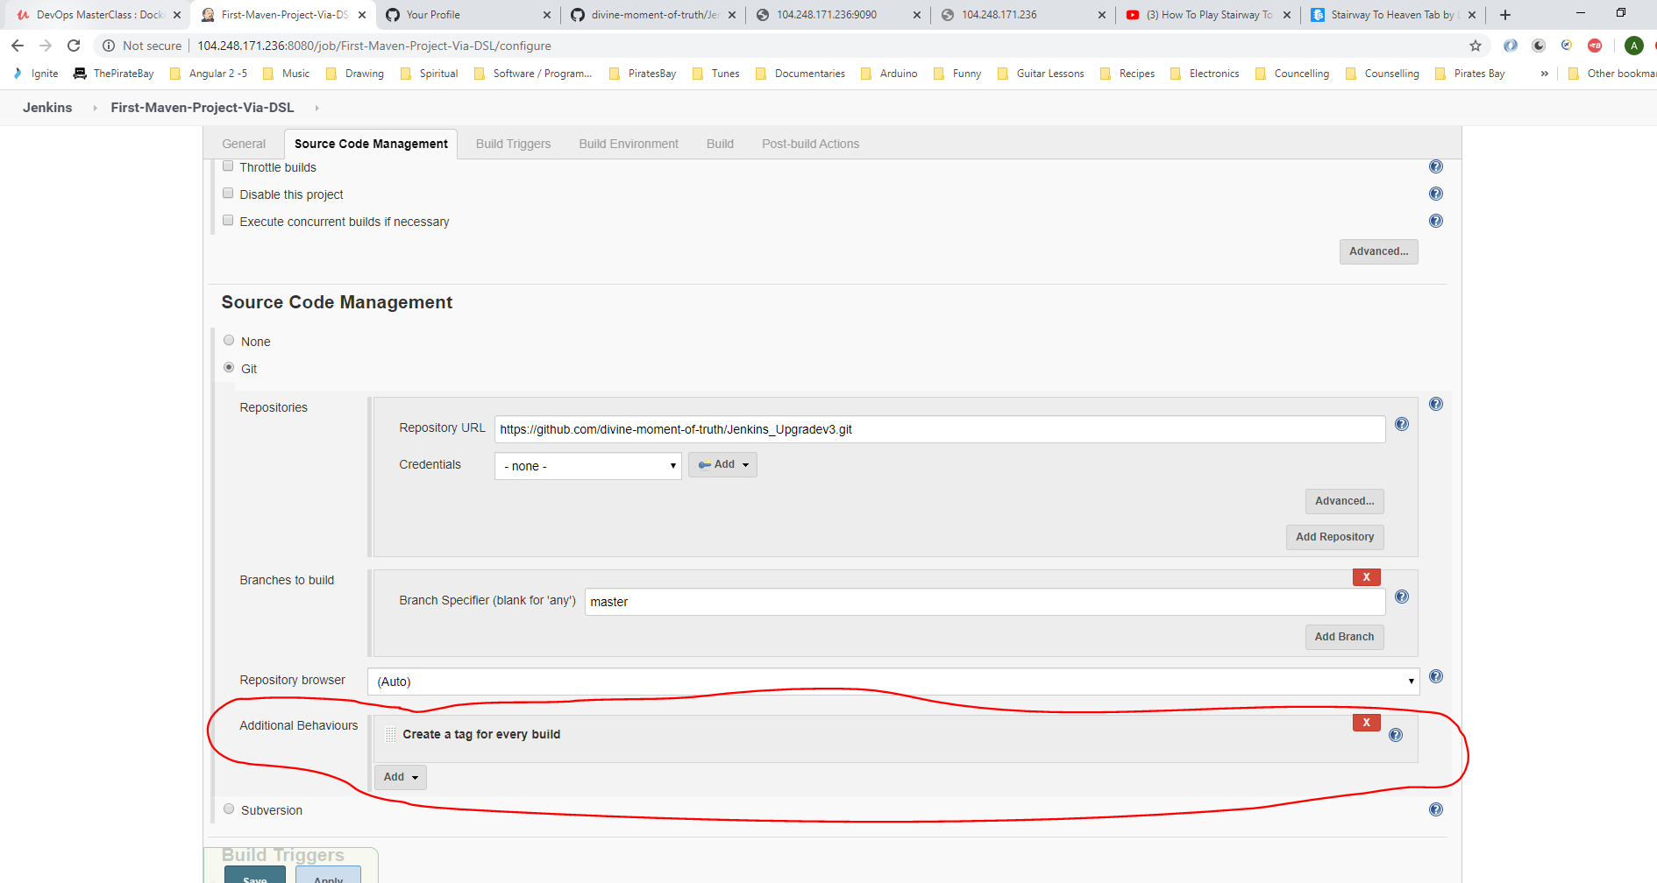

**Jenkinsfile**

First, ensure you have this installed:-

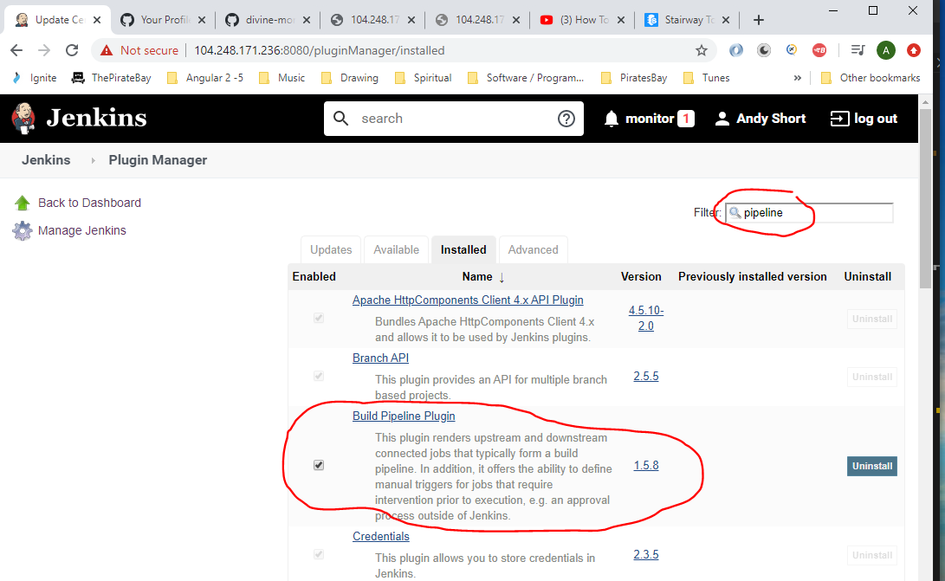

**See Jenkinsfile in project:-**

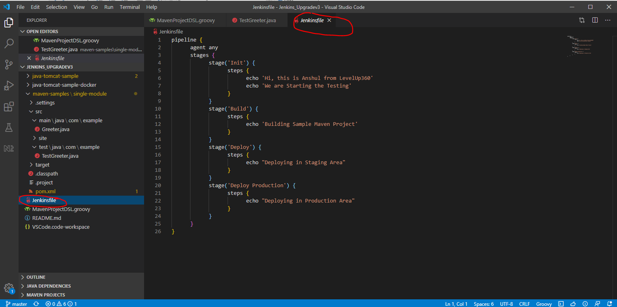

Ensure file is checked into GitHub:-

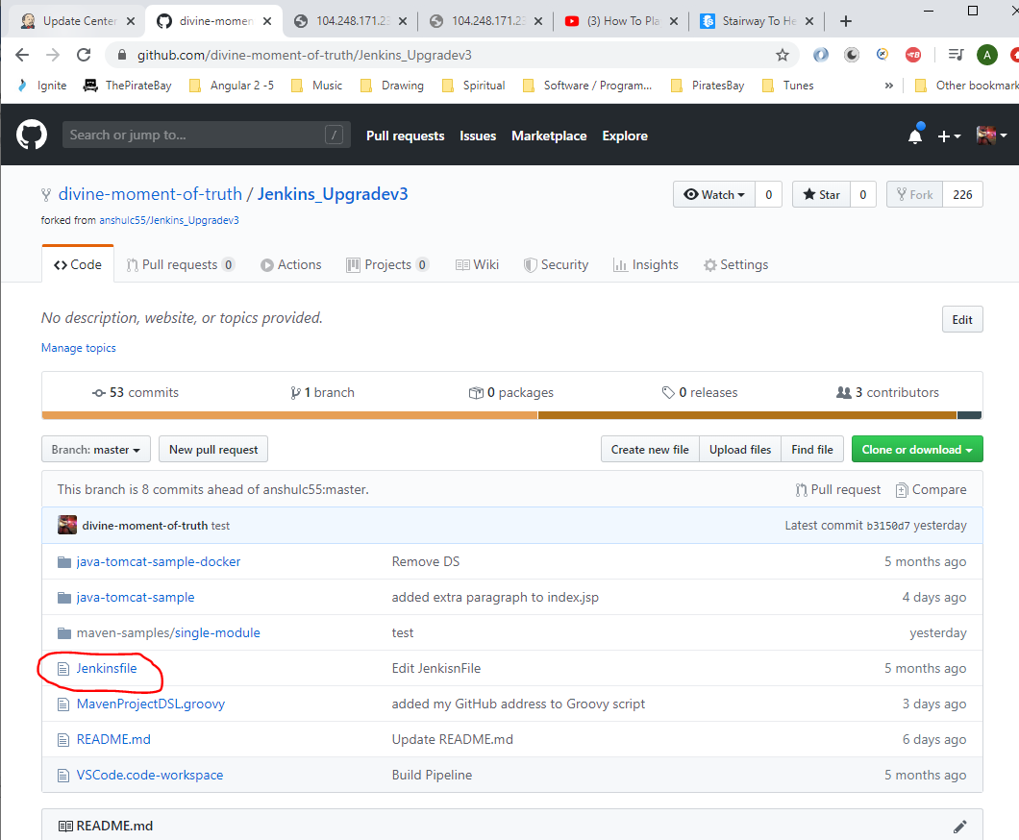

Create a new build Pipeline job. First create a new view by clicking on here:-

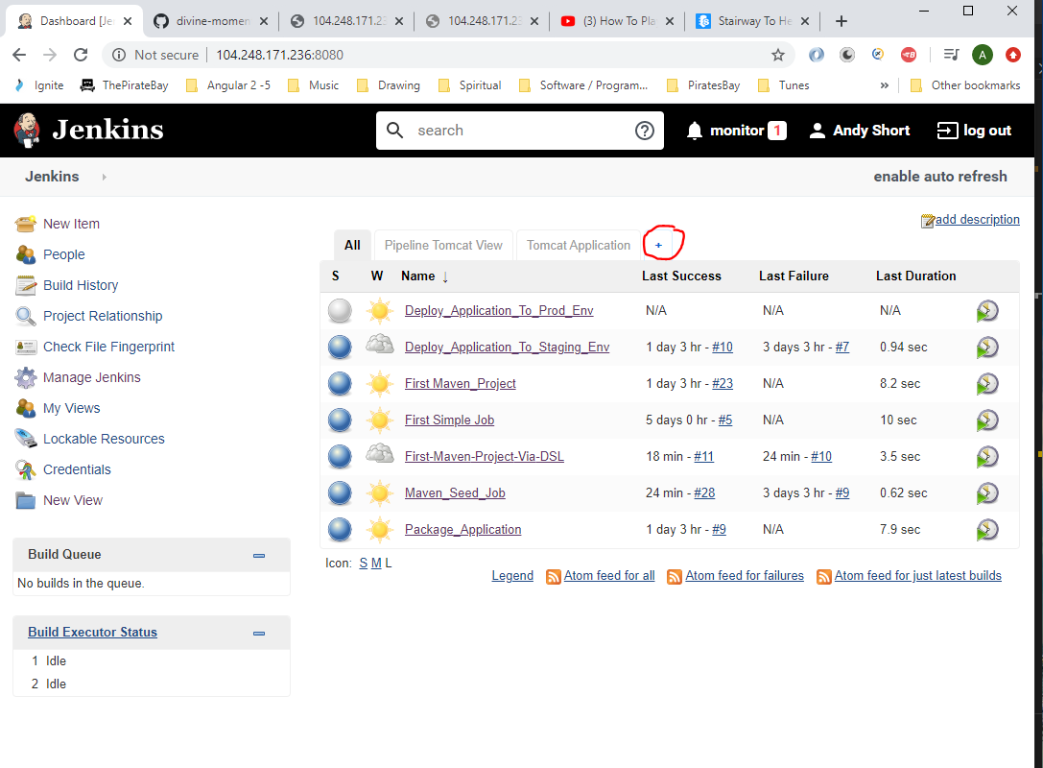

Then:-

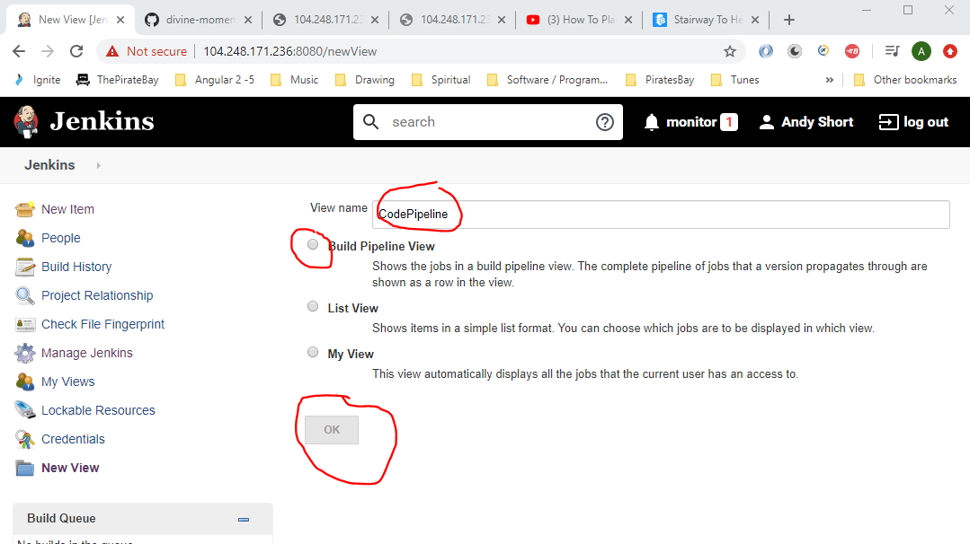

Create a new Jenkins job:-

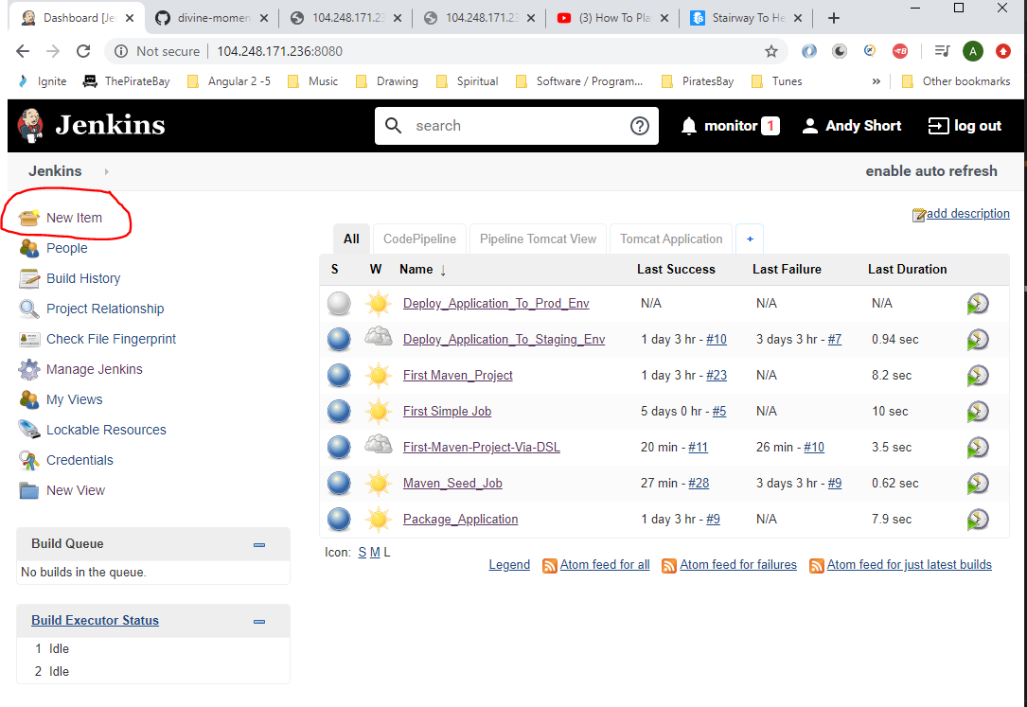

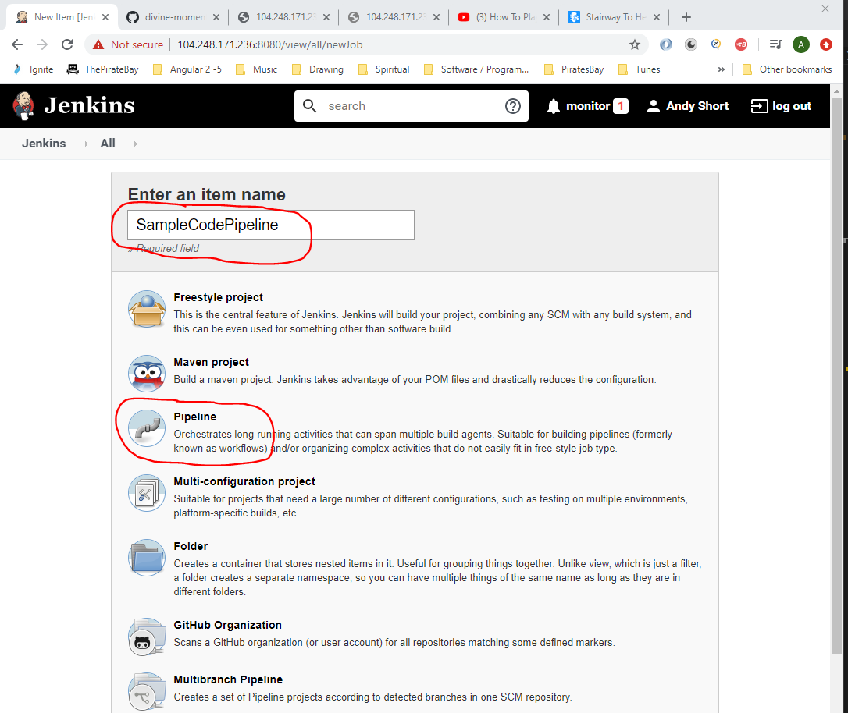

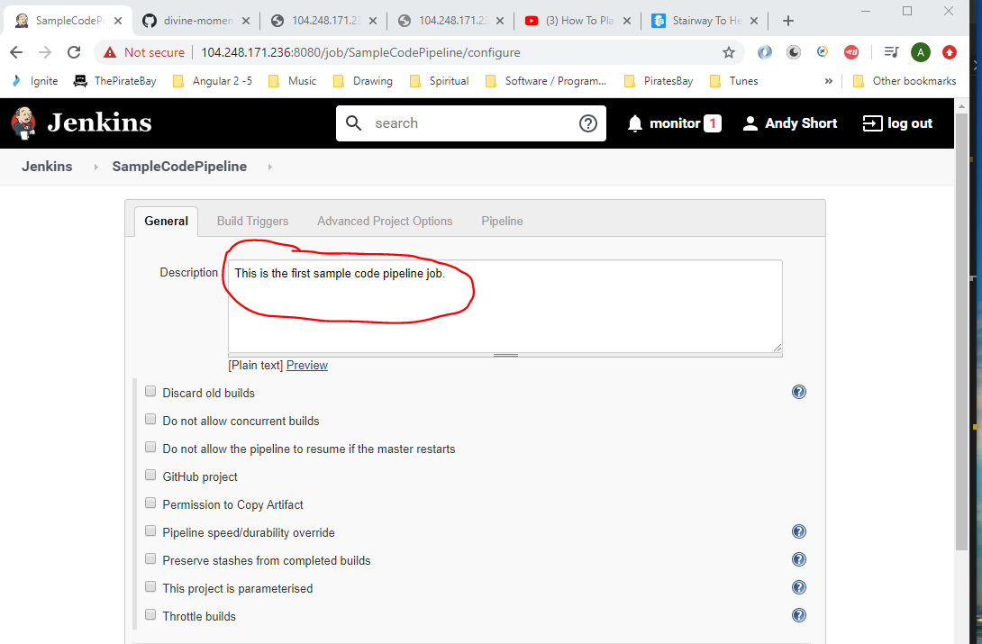

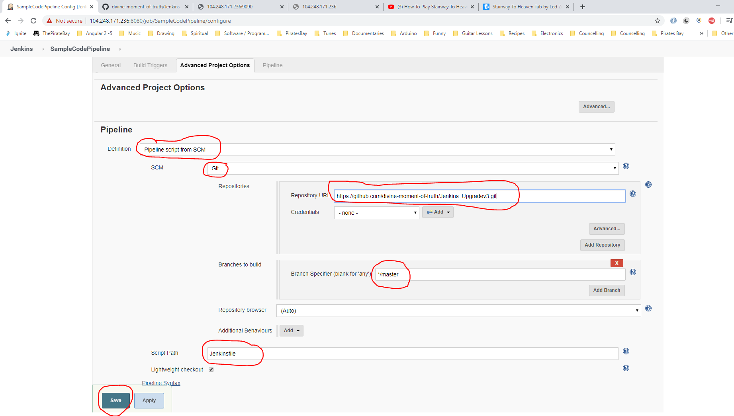

See new job here:-

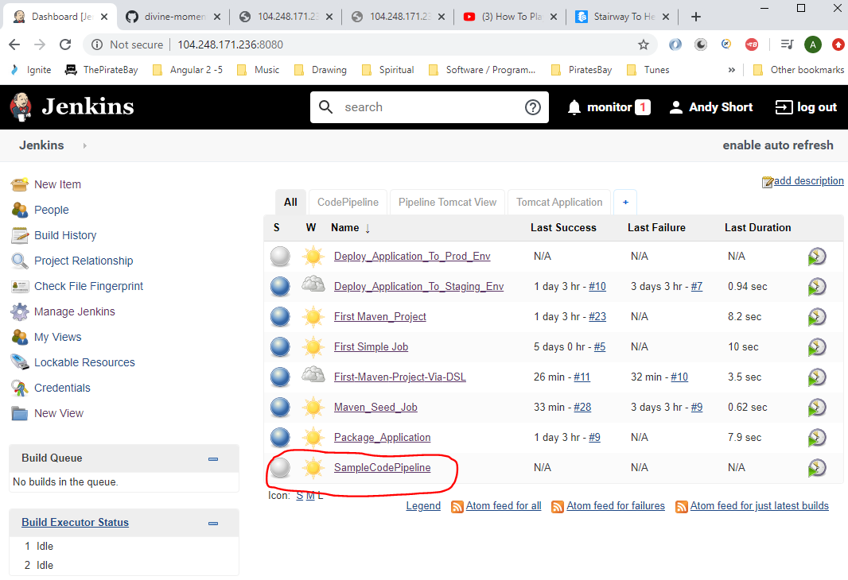

Now build it:-

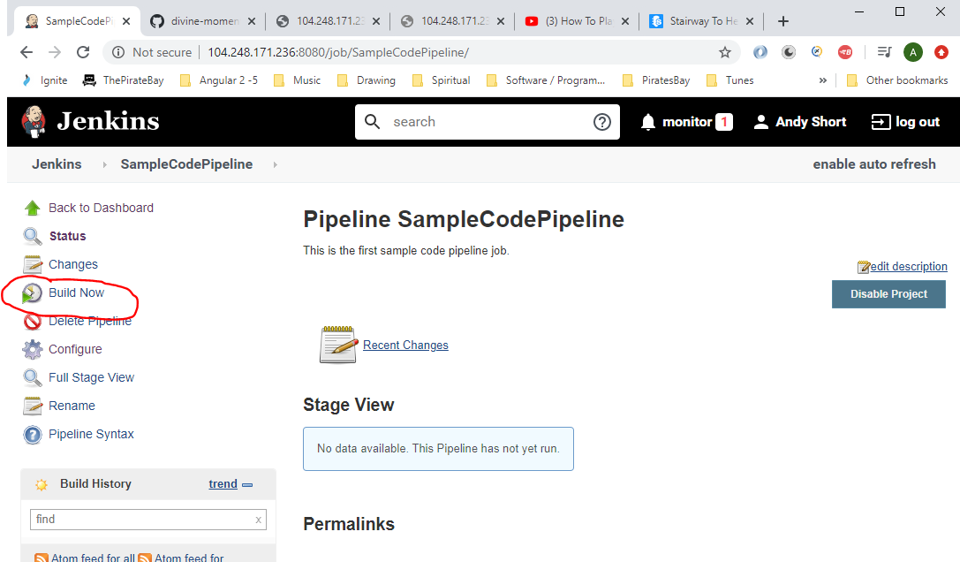

See result:-

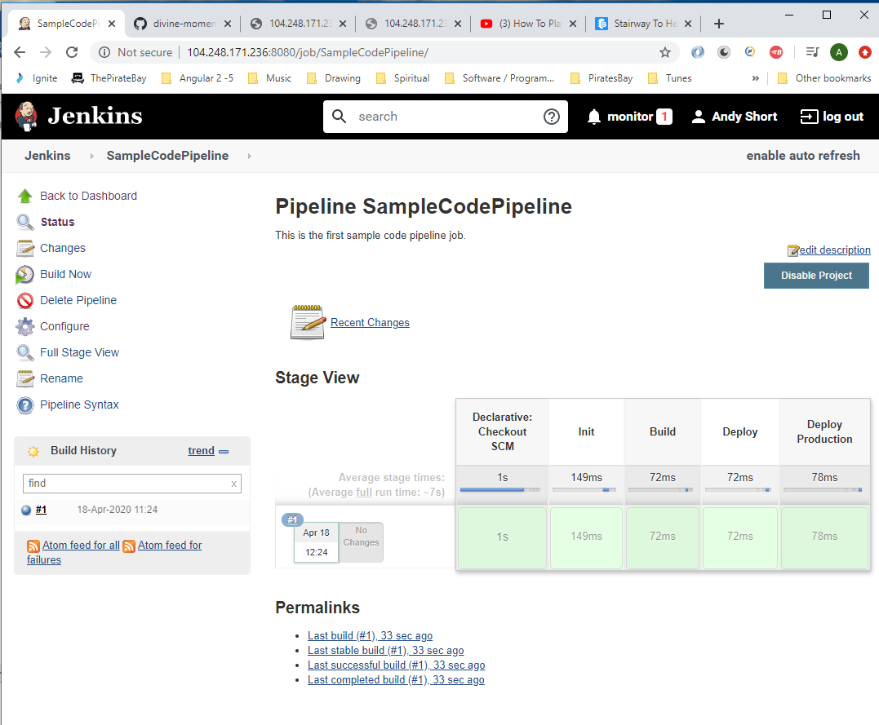

See the stages:-

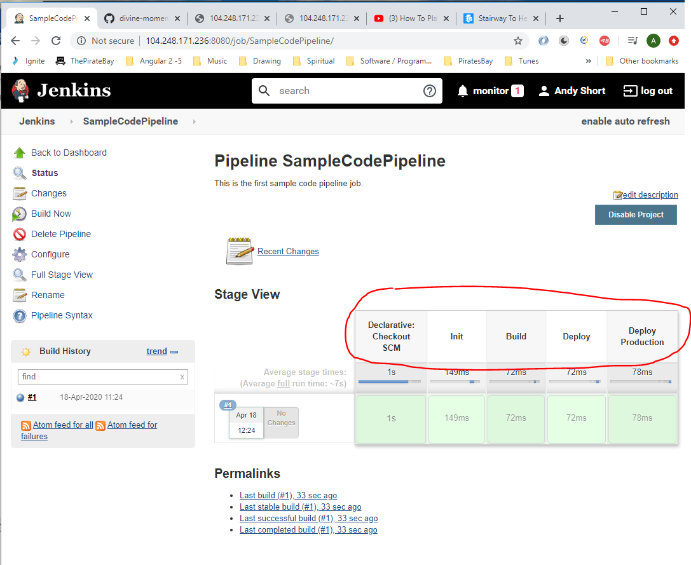

These stages were defined in the ‘Jenkinsfile’:-

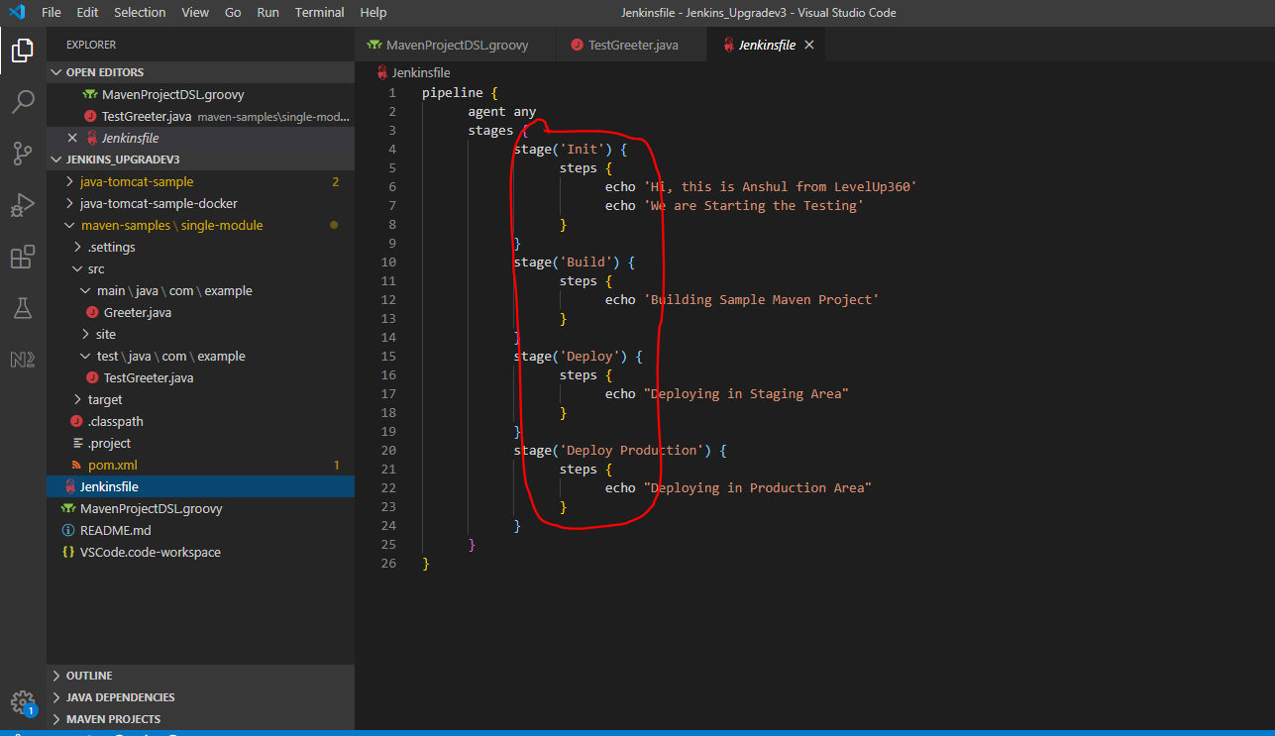

Now configure the job:-

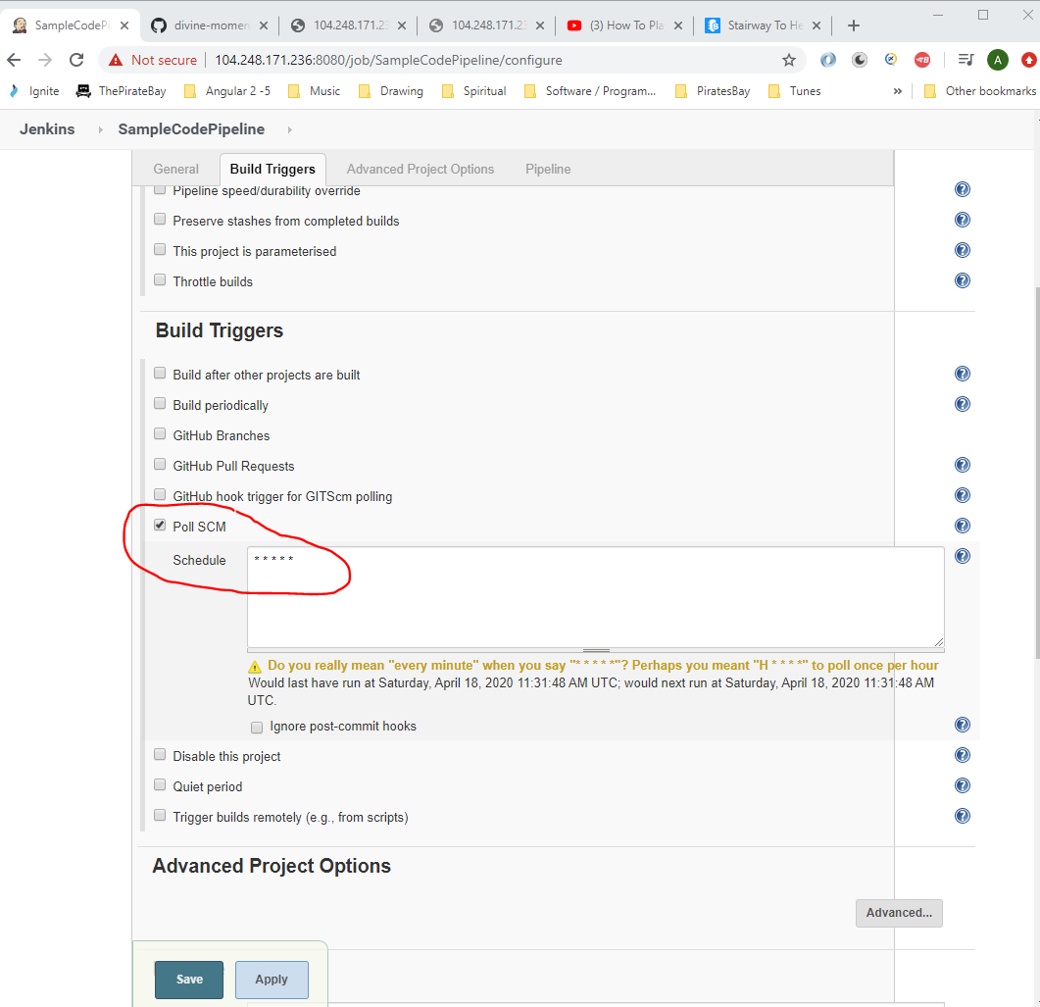

Click save.

Now add a new stage to the Jenkinsfile:-

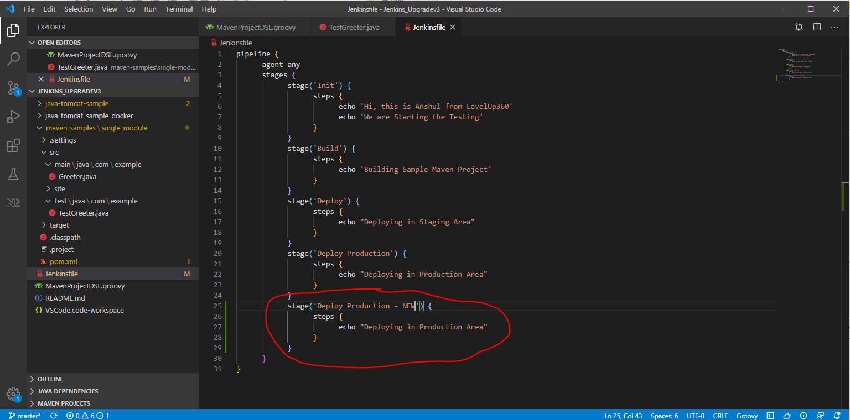

Now check in code:-

Go to GitBash and type:-

*git add .*

*git commit –am “Jenkinsfile update”*

*git push*

Now go to Jenkins and observe the new Pipeline job starting:-

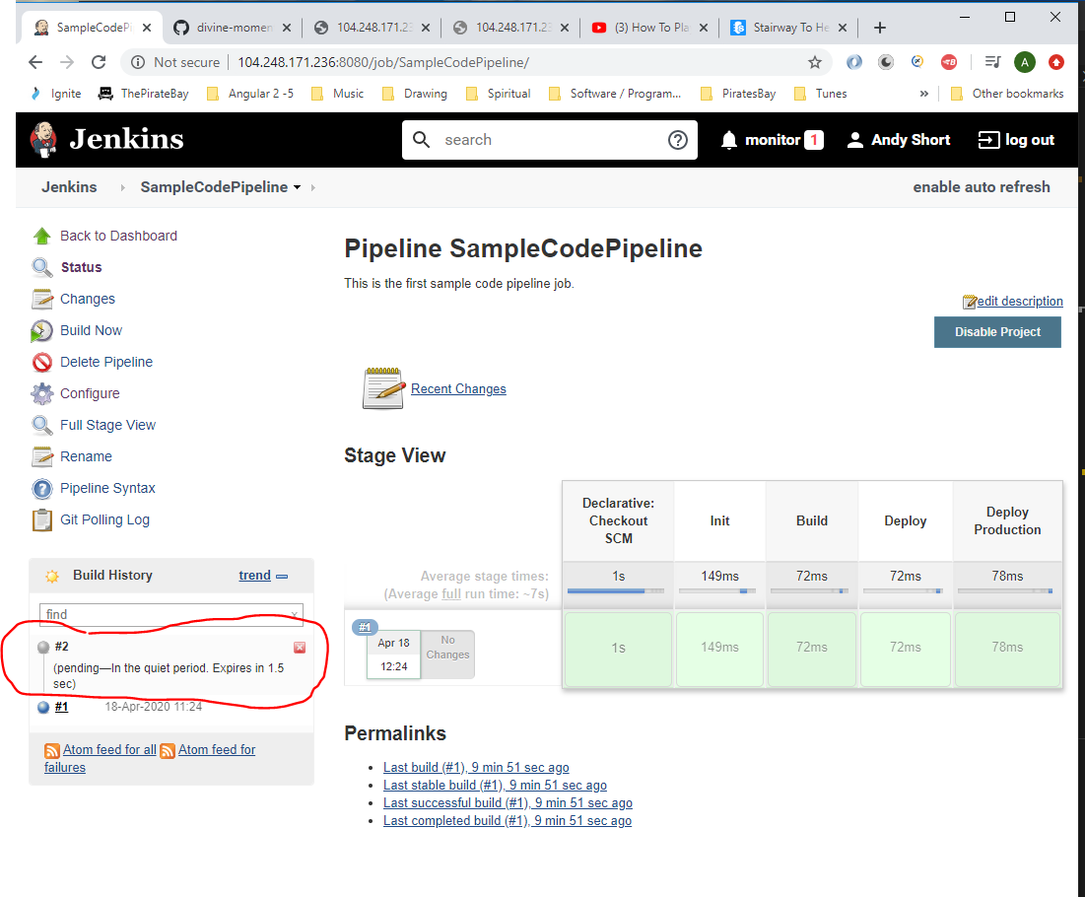

Create a new Jenkinsfile that will package and deploy an application to a staging and production environment:-

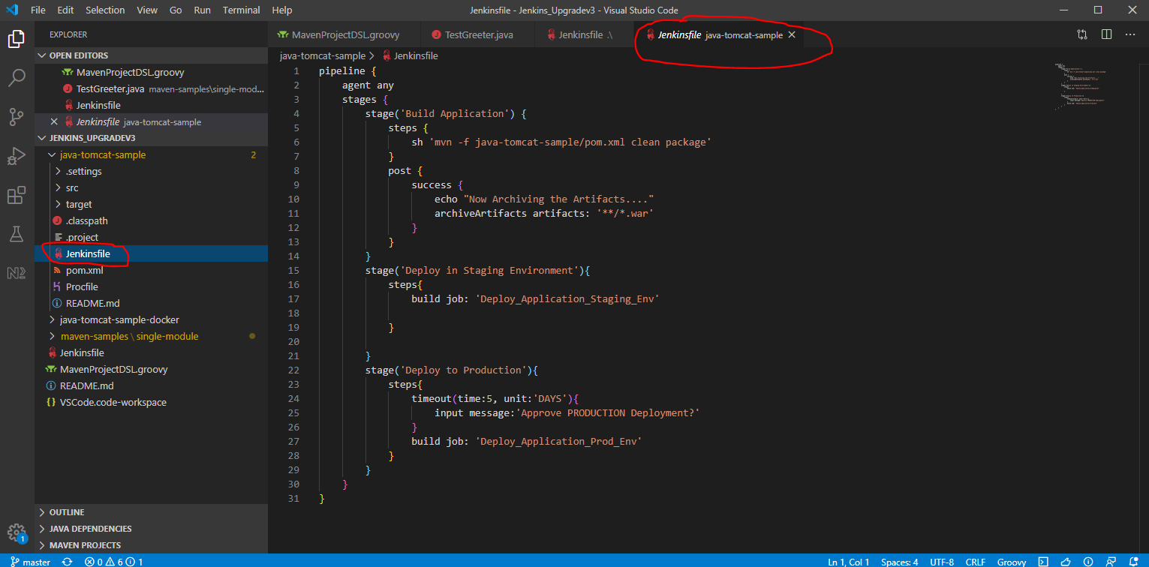

Now go to Jenkins and create a new job:-

Go to ‘Tomcat Application’ tab then click ‘New job’:-

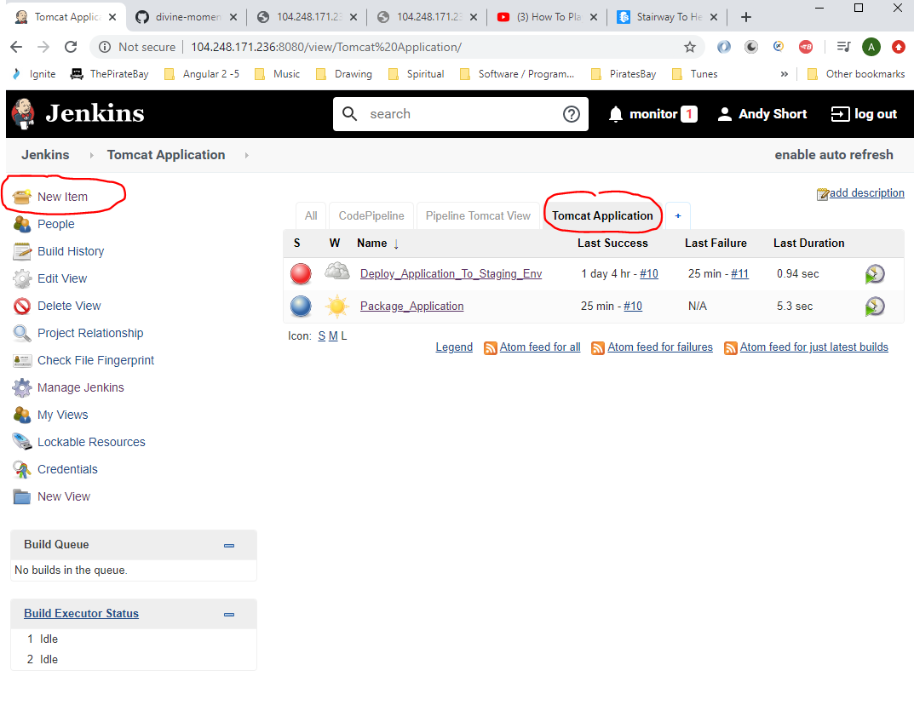

Enter the following:-

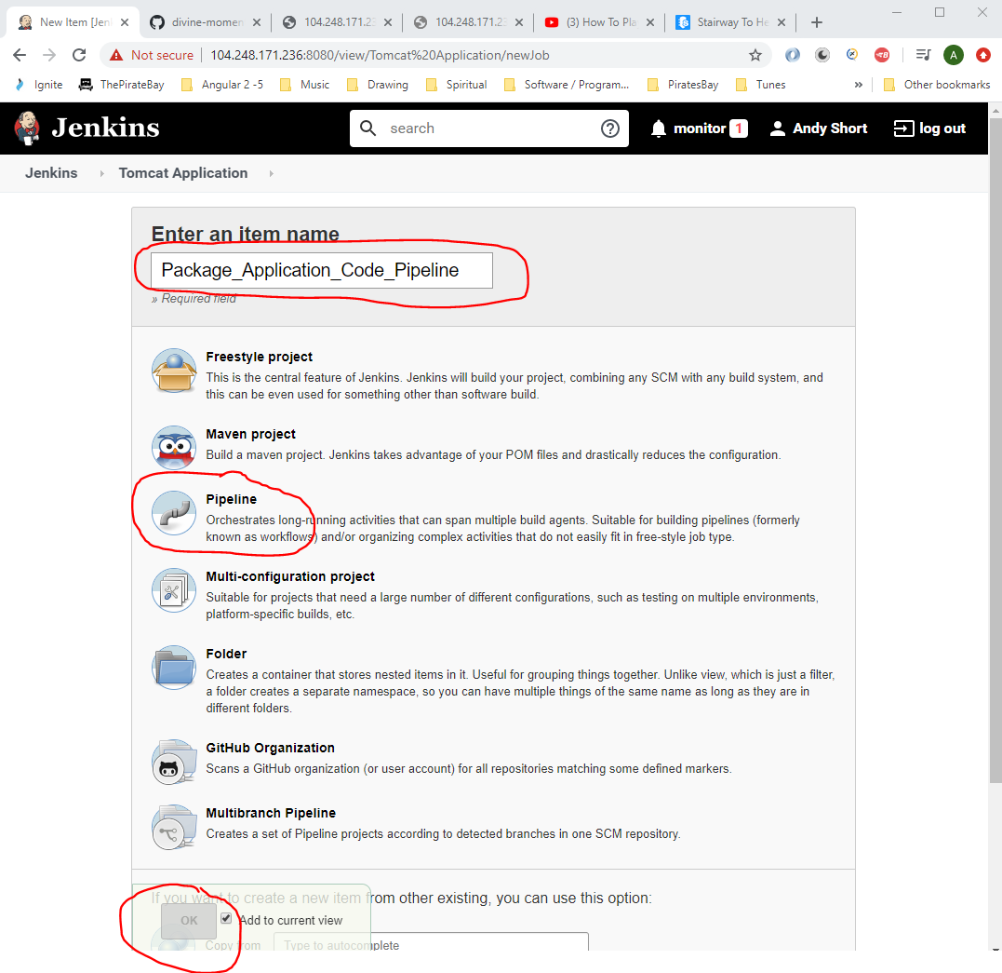

Add this:-

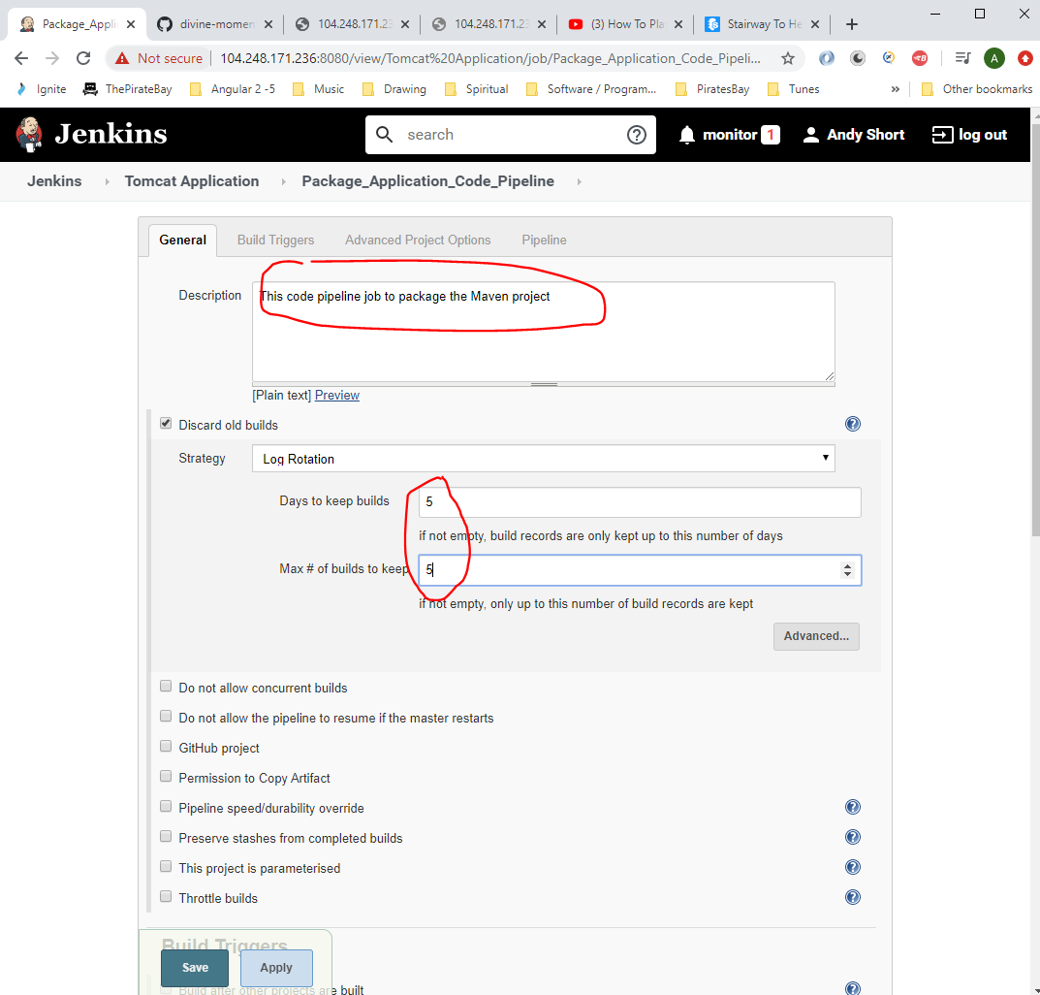

Enter the following:-

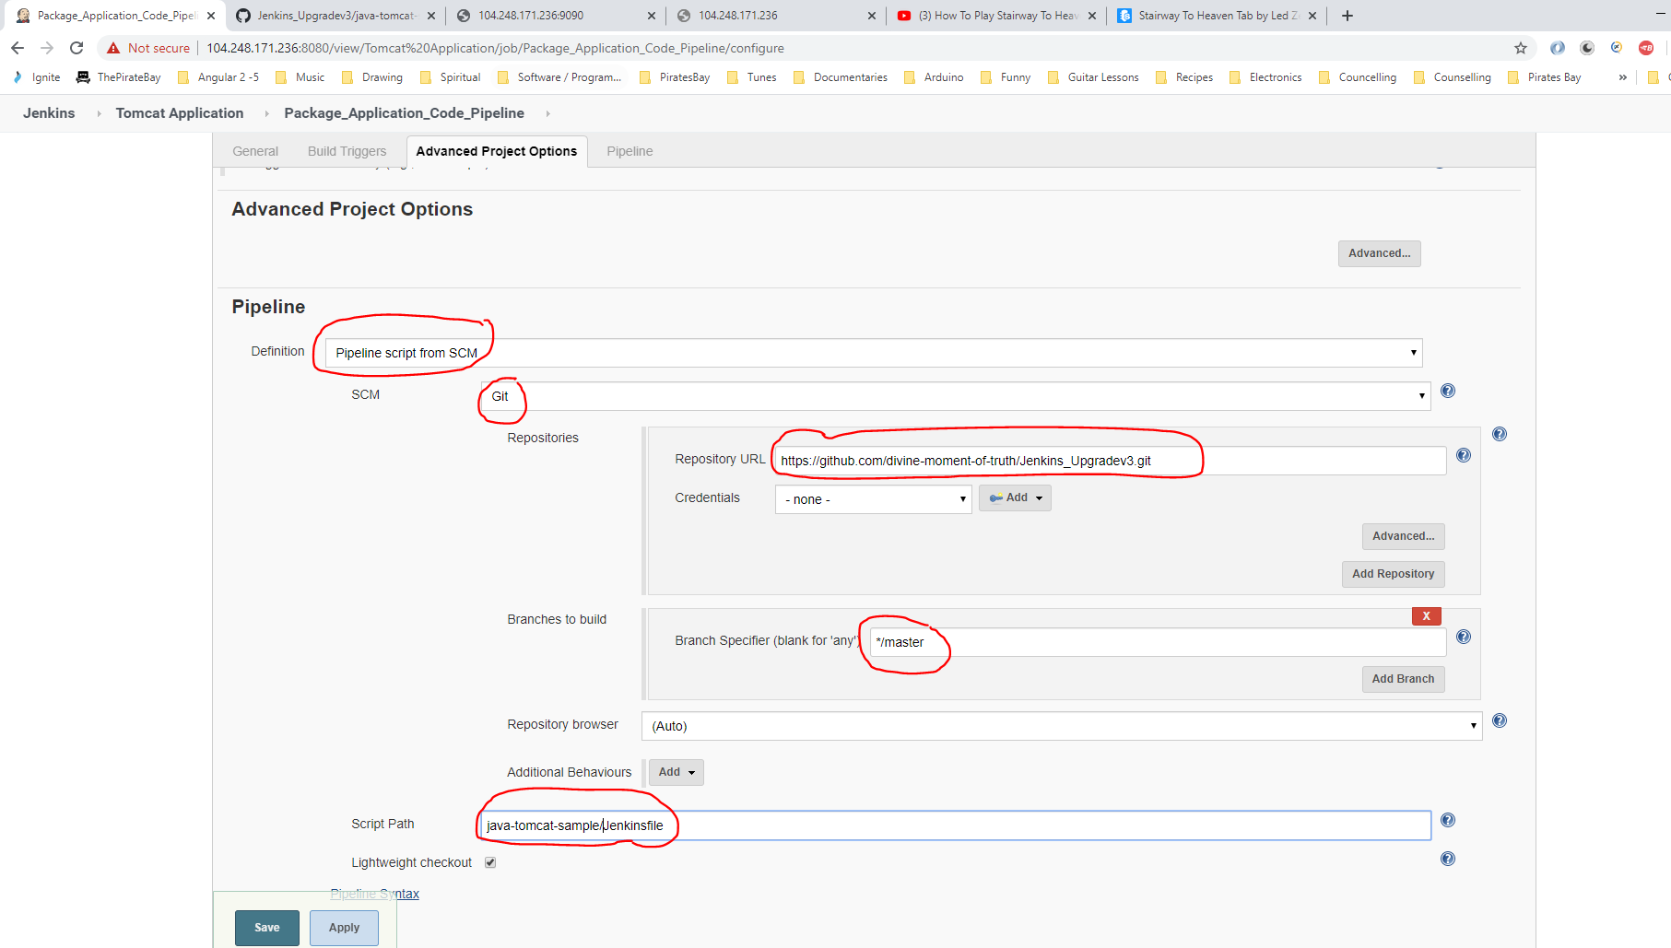

From above ‘Repository’ is taken from here:-

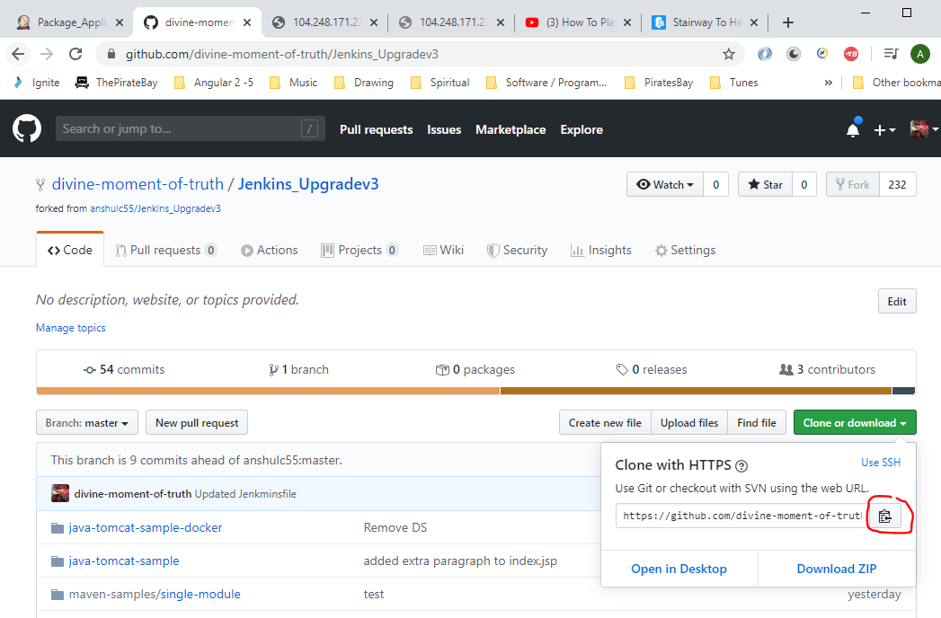

And ‘Script Path’ is from here:-

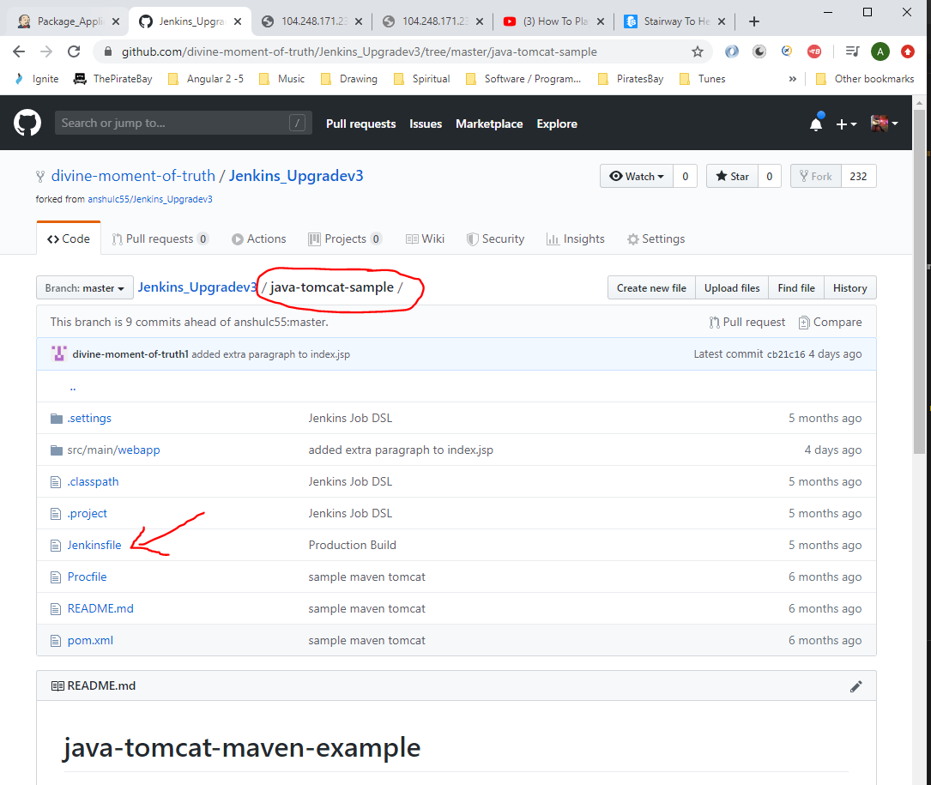

Click ‘Save’.

The click ‘Build Now’.

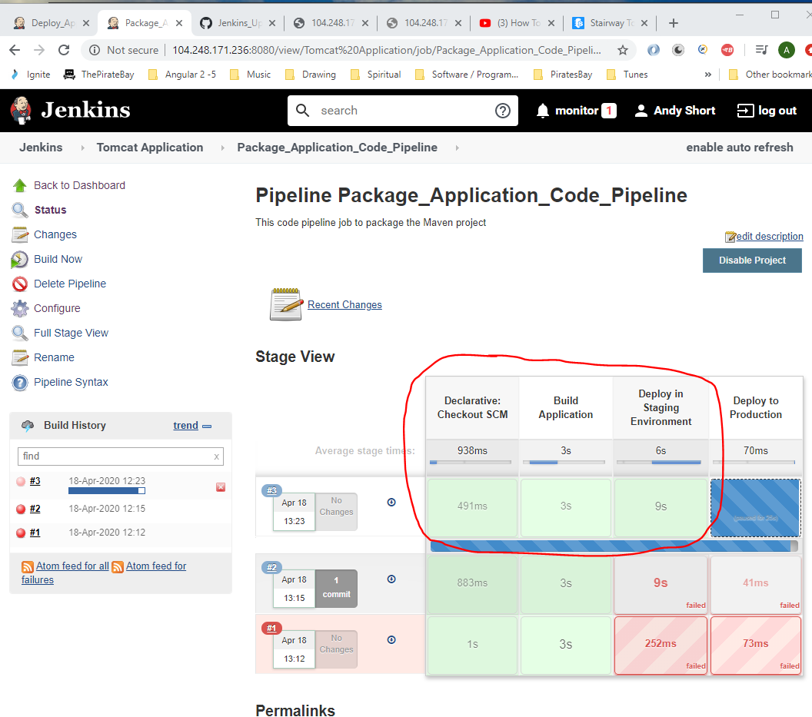

Note:- Look at Jenkinsfile, see location of pom.xml file:_

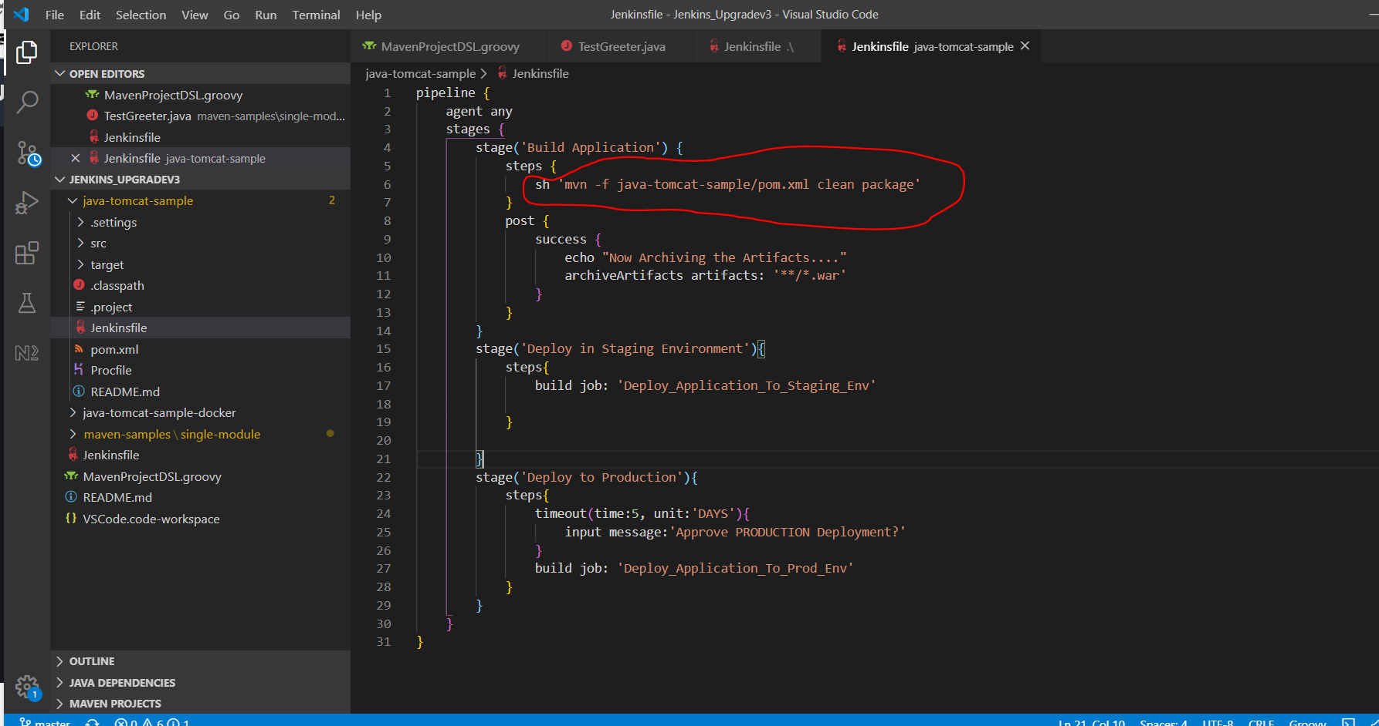

Modify the ‘Deploy_Application_to_Staging_Env’ job section = ‘Build’ -> ‘Project name’ section and change ‘Package_Application’ to the new ‘Package_Application_Code_Pipeline’ job:-

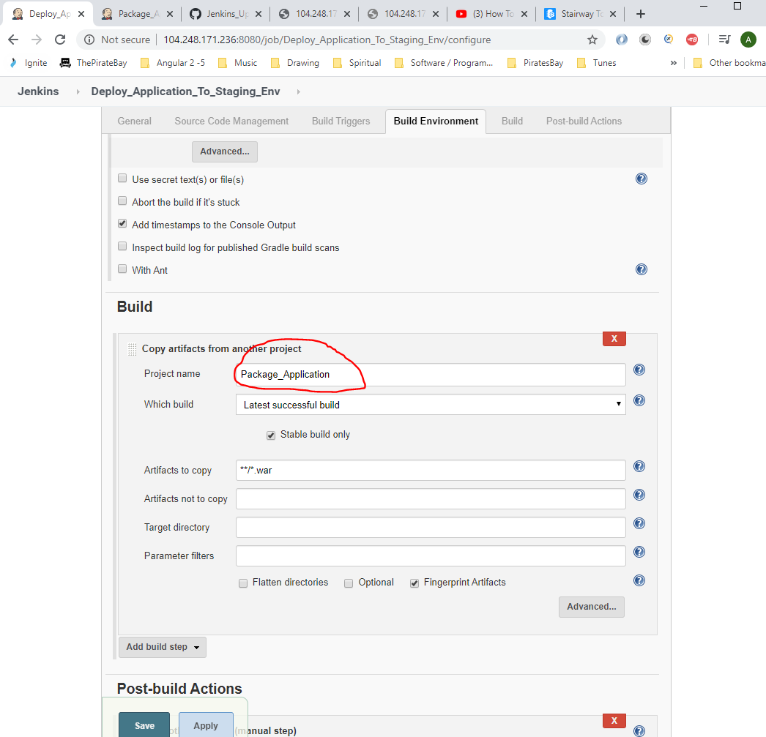

Change to (copy the following job name from here):-

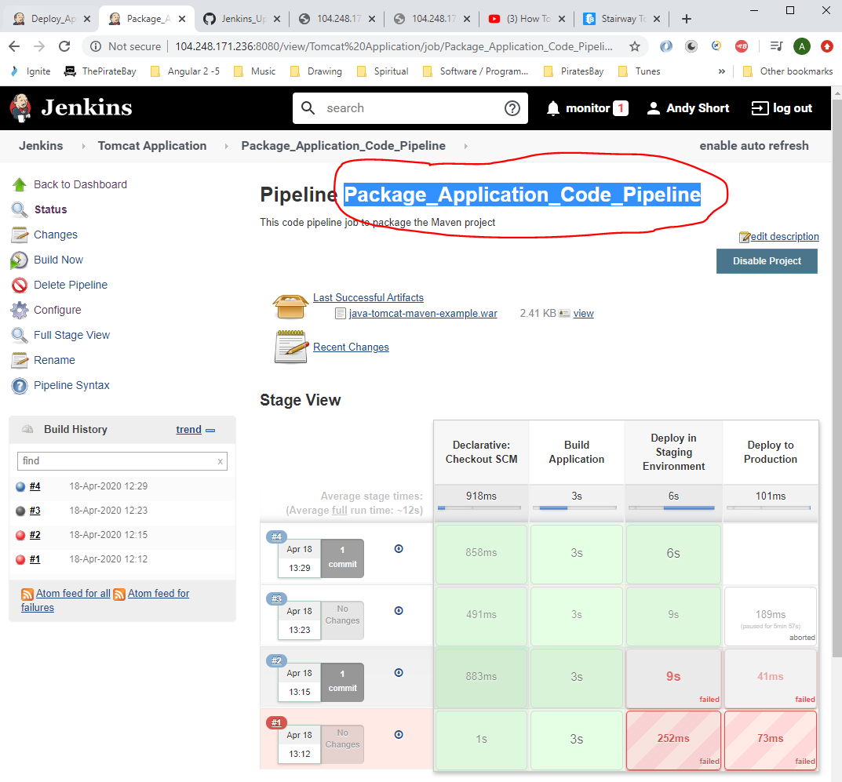

So change to:-

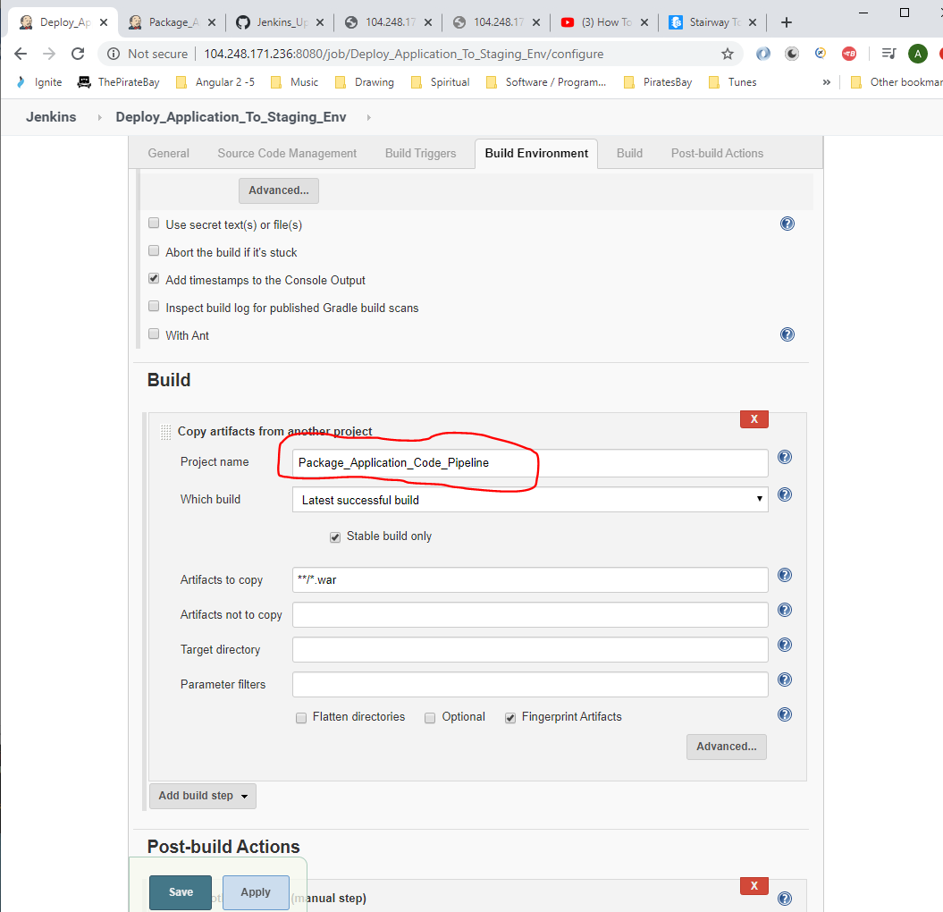

Also, then remove this section from the ‘Deploy_Application_To_Staging_Env’ because this job no longer needs to trigger the deploy to production environment job because the ‘Jenkinsfile’ does this now:-

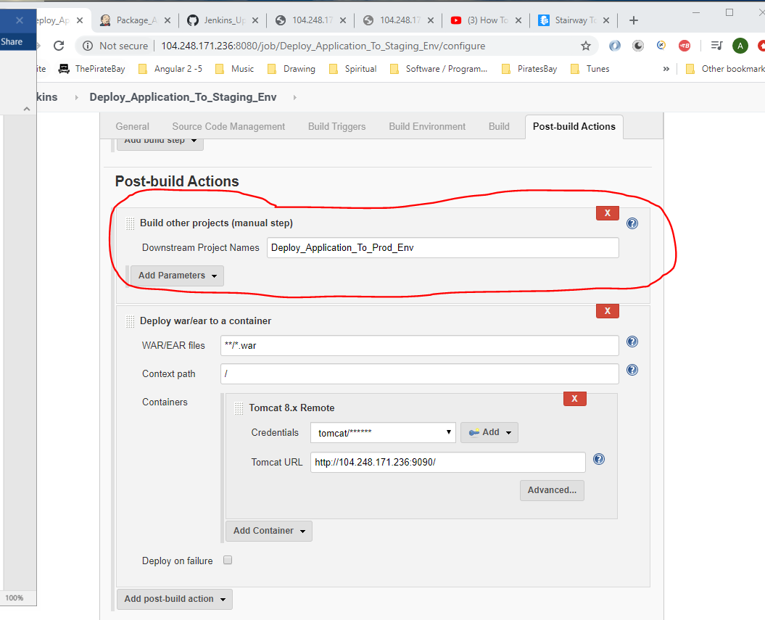

Then click ‘Save’

Also, change the ‘Project Deploy_Application_To_Prod_Env’ Build section. Change this:-

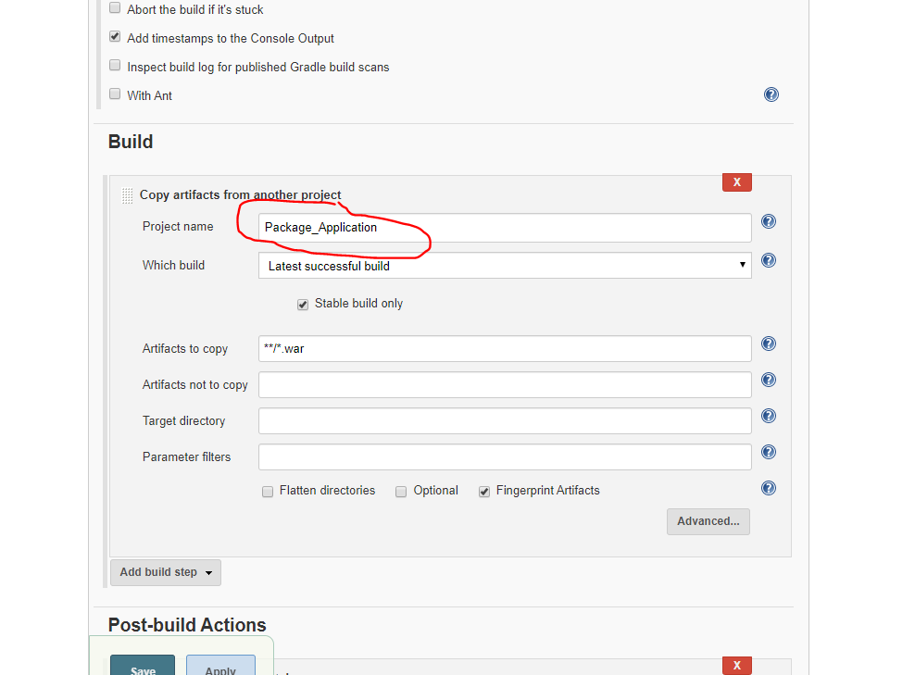

Change to:-

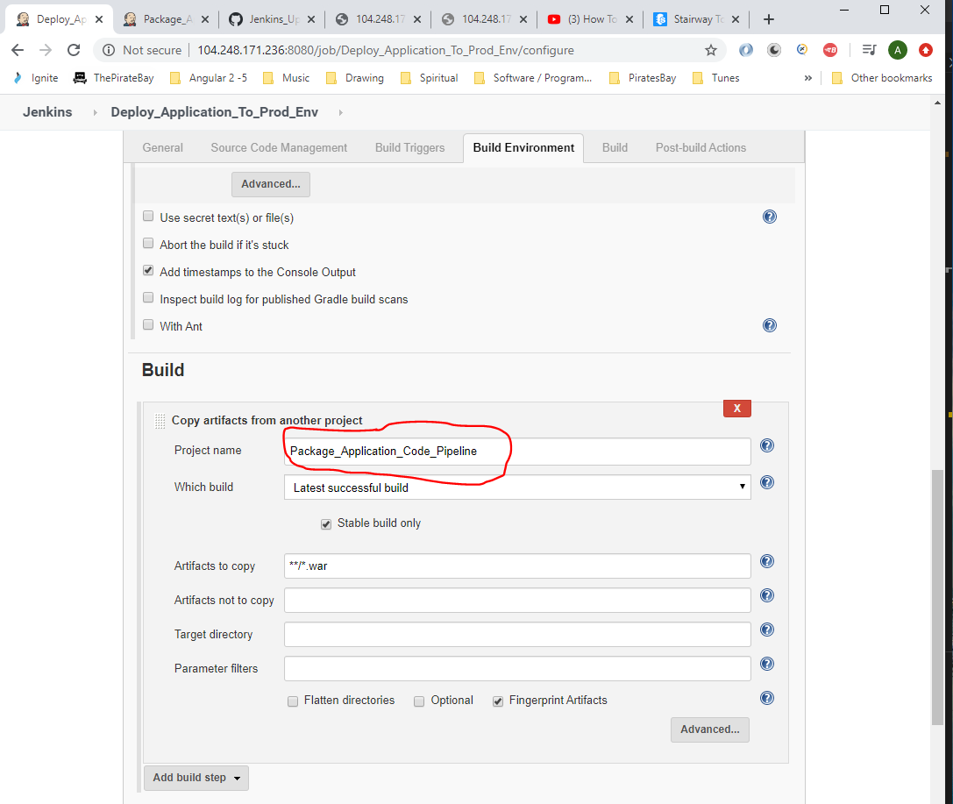

Then click ‘Save’.

Note: The following section in the ‘Jenkinfile’ means that if the job is not approved within 5 days then the prod job will be discarded.

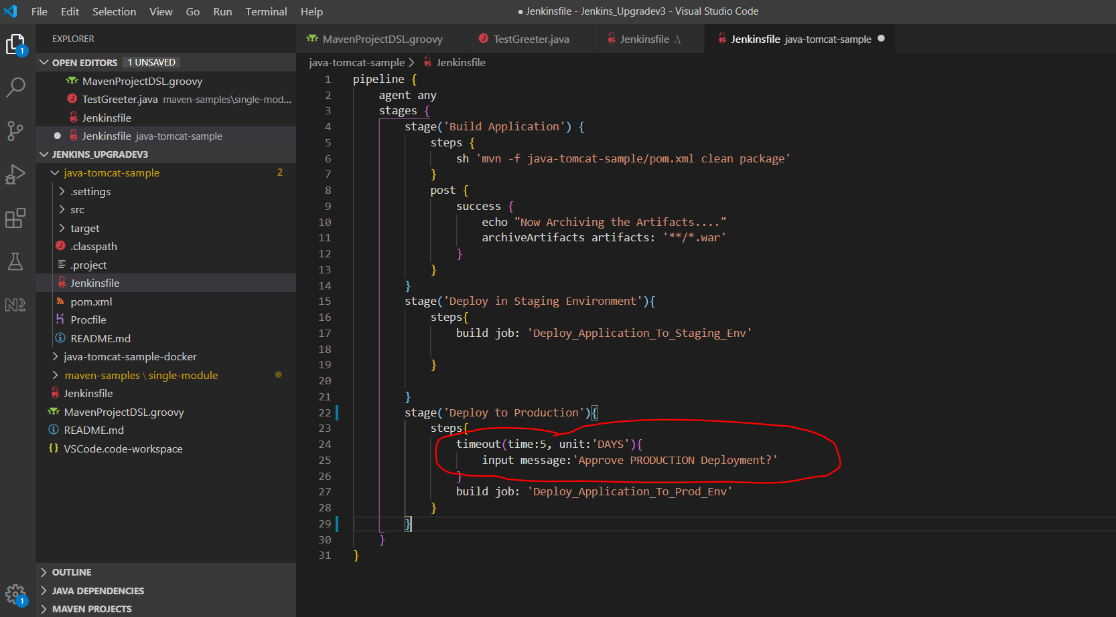

When running ‘Package_Application_Code_Pipeline’ job now see when you hover over the ‘Deploy to Production section’:-

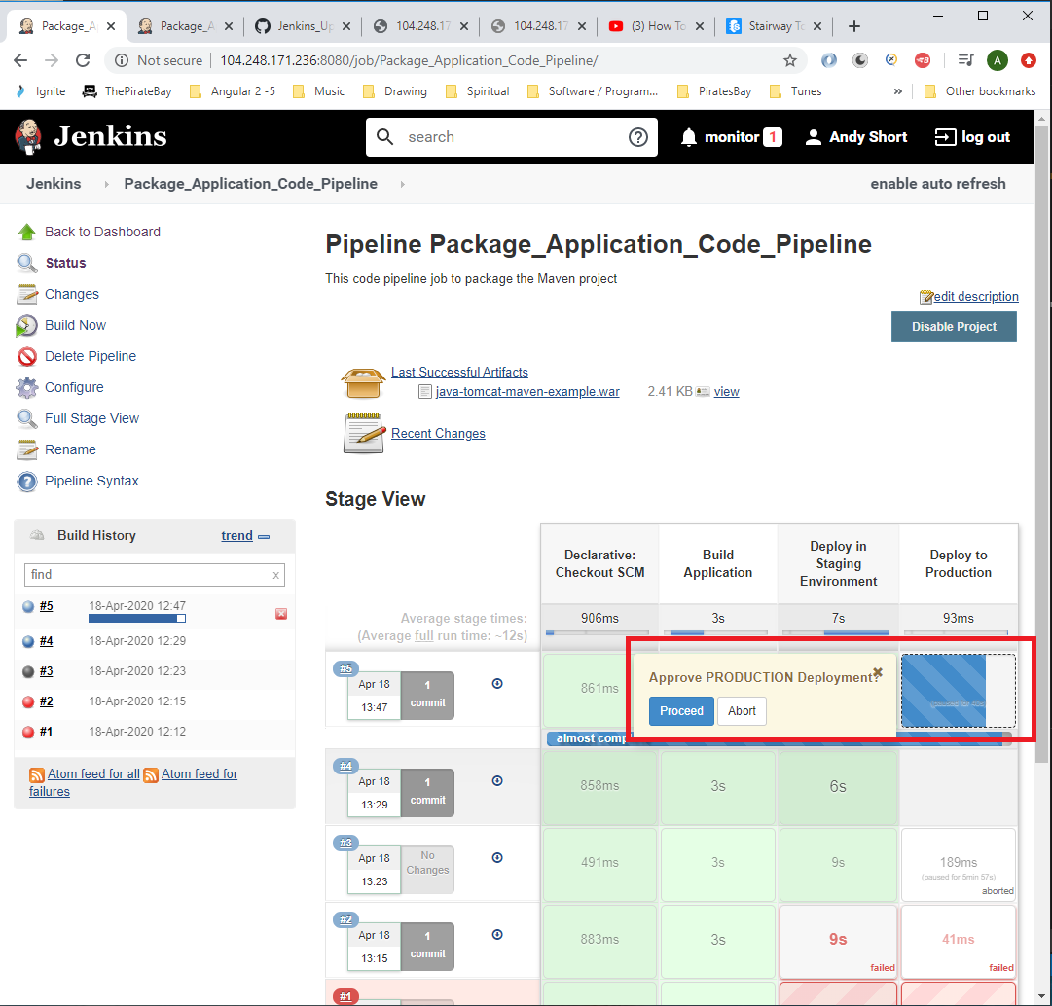

**Distributed Builds**

Master Node – this is where Jenkins is installed i.e. in this case the master node is the Digital Ocean ‘linux-jenkins’ Ubuntu machine.

To create a slave machine:-

[1] Go to Digital Ocean account (log in):-

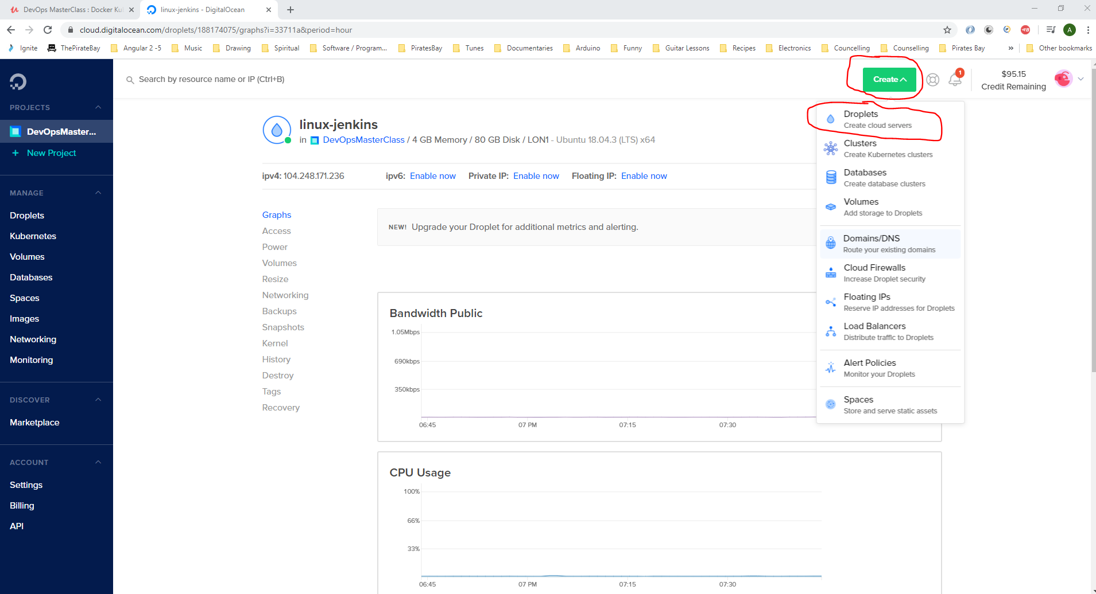

Click ‘Create’ then select ‘Droplet’.

Select a bare minimum machine:-

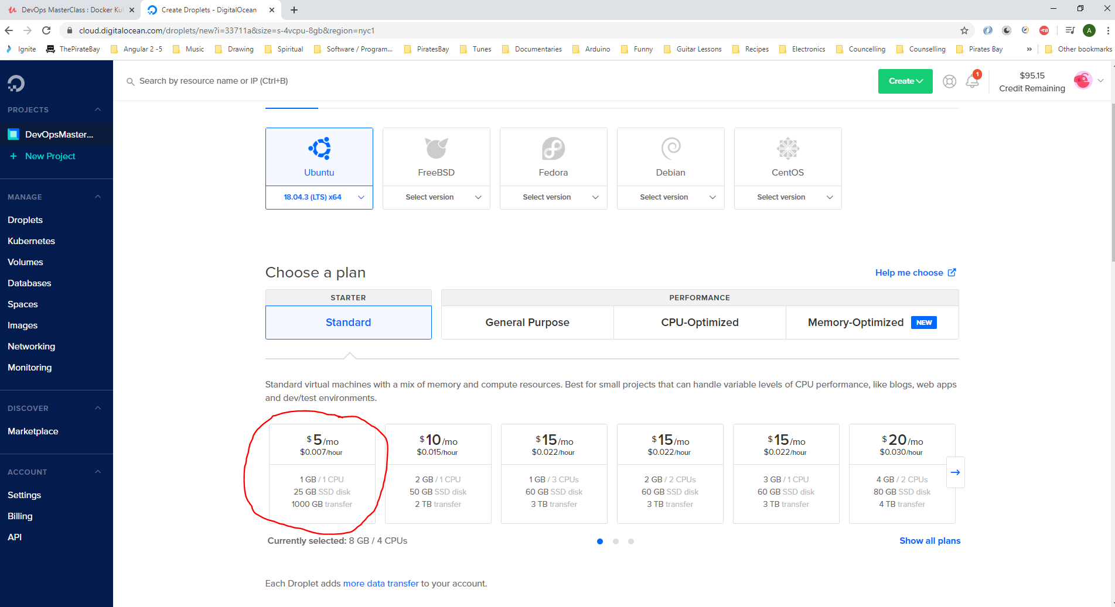

Slect UK:-

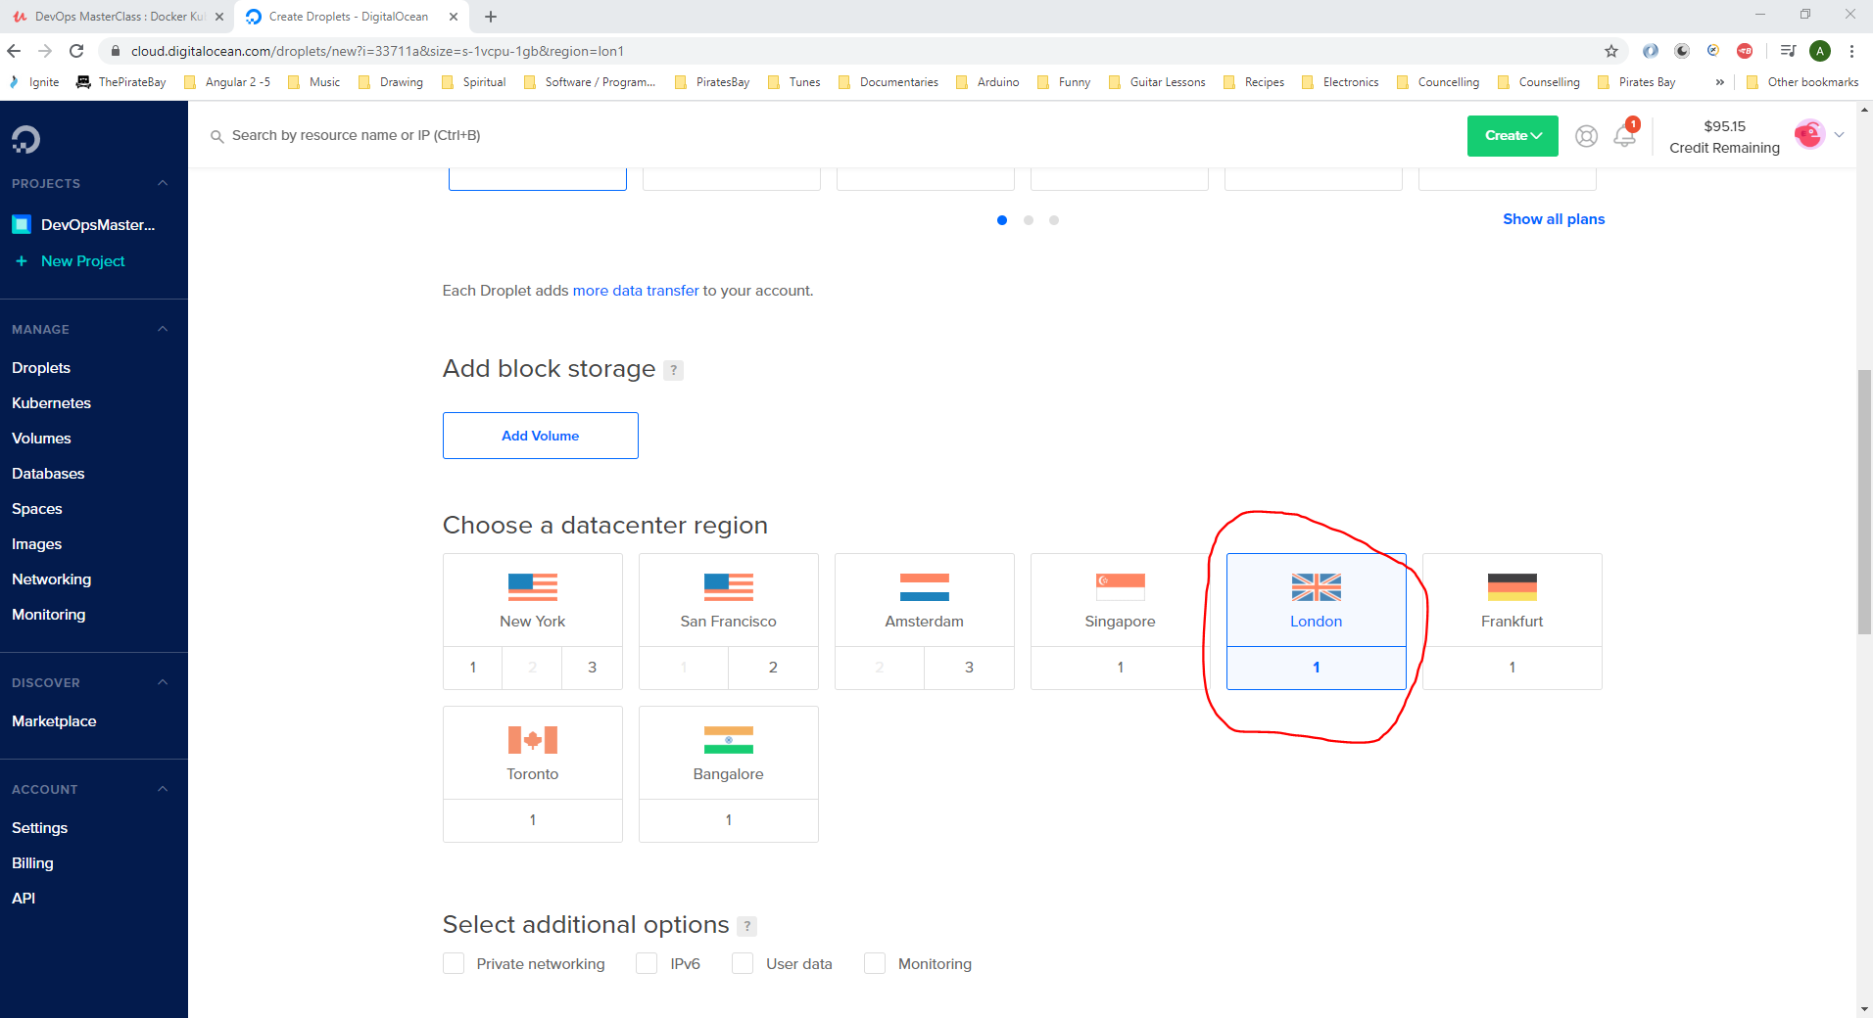

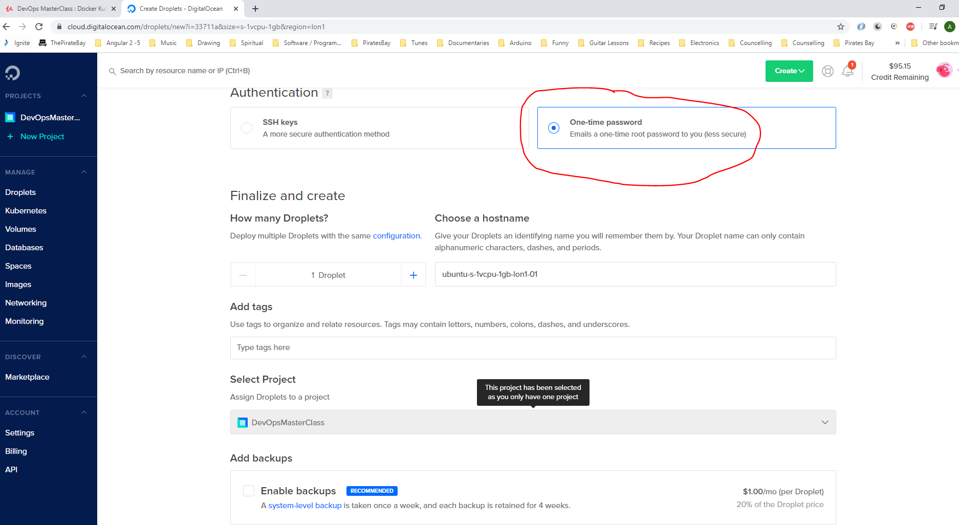

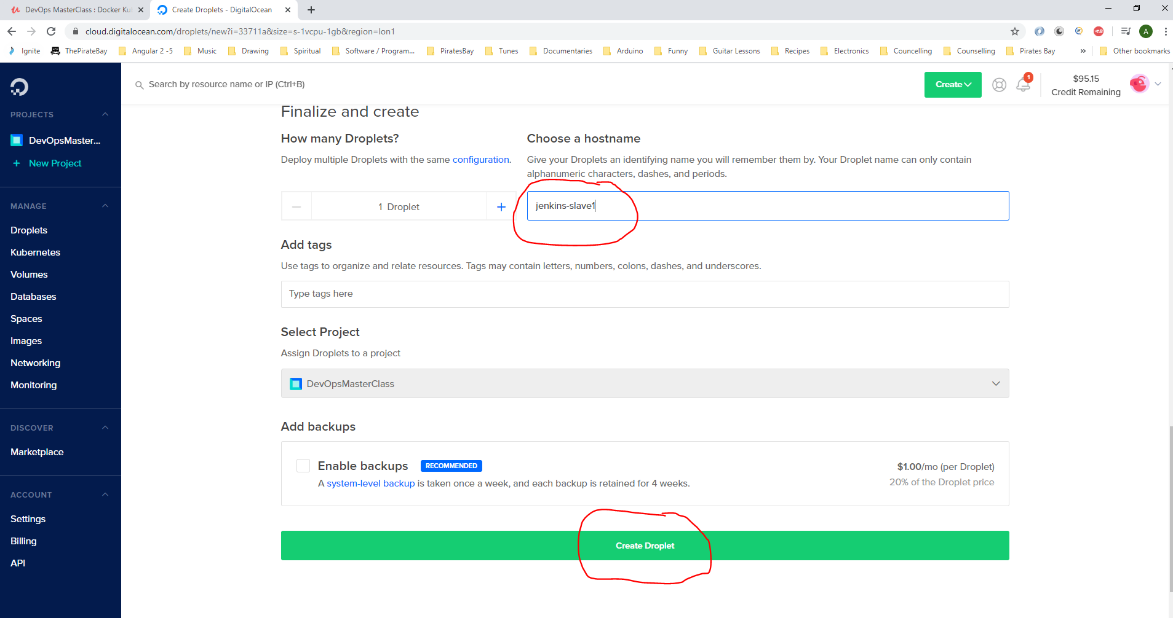

Go to email to get password to log onto new Jenkins-lave1 machine:-

Droplet Name: jenkinslave1  
IP Address: 142.93.34.163  
Username: root  
Password: **aNdyshort1F**

Use Putty to log into new slave machine:-

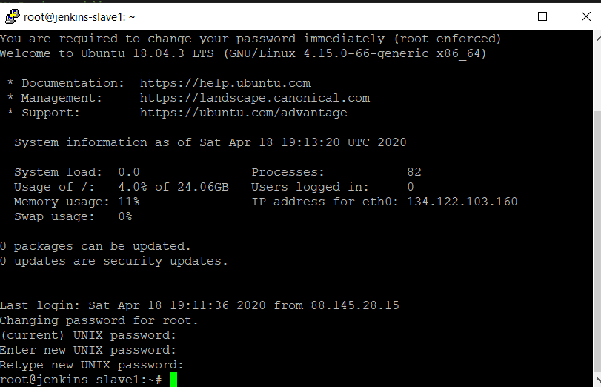

Open another Putty session for the Jenkins Master:-

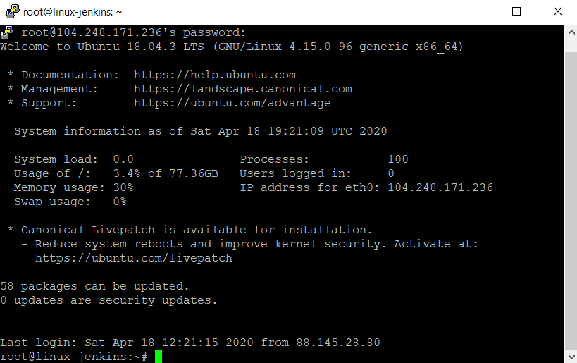

On the master putty session you need to switch users to the Jenkins user. Type this into Putty:-

*sudo -iu Jenkins*

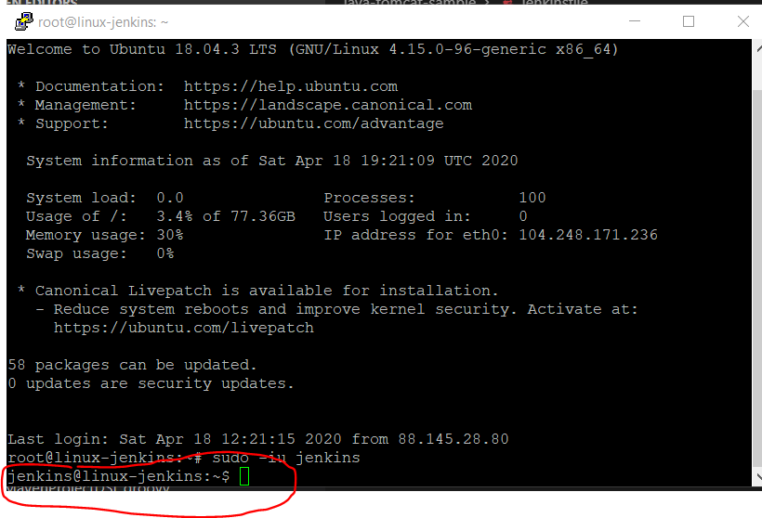

Now generate the rsa certificate by typing the following into the Master putty session:-

*ssh-keygen -t rsa*

*[Enter]*

*[Enter]*

*[Enter]*

*[Enter]*

Private key has been saved here:-

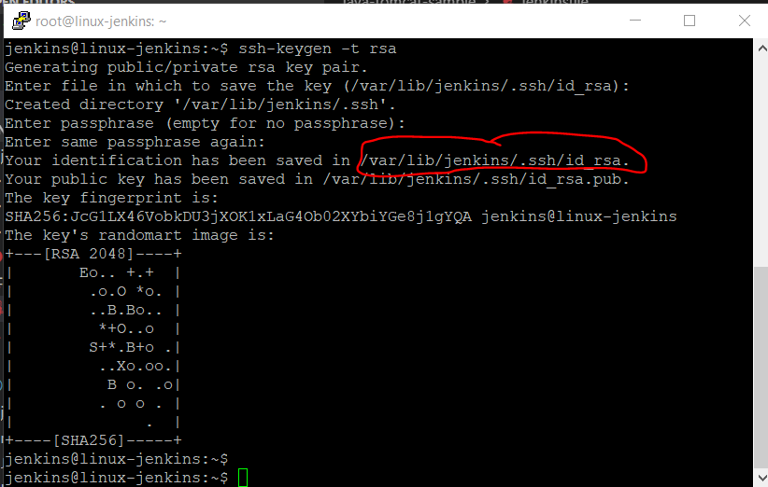

/var/lib/jenkins/.ssh/id_rsa

Public key is saved here:-

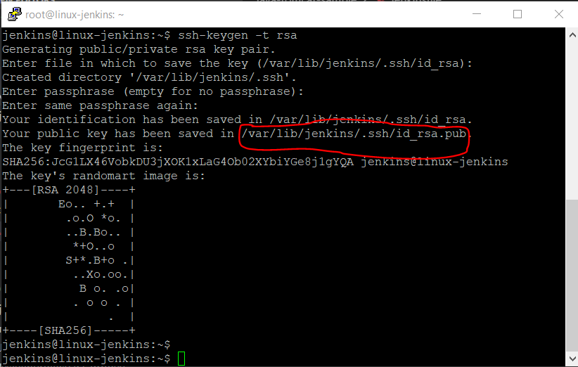

On the master Jenkins putty session type the following to setup a folder on the salve Jenkins machine:-

*ssh* [*root@*142.93.34.163](mailto:root@142.93.34.163) *mkdir -p .ssh*

*yes*

*Now enter the password of the save machine - dudeegg1977*

*Now open the file in this location:-*

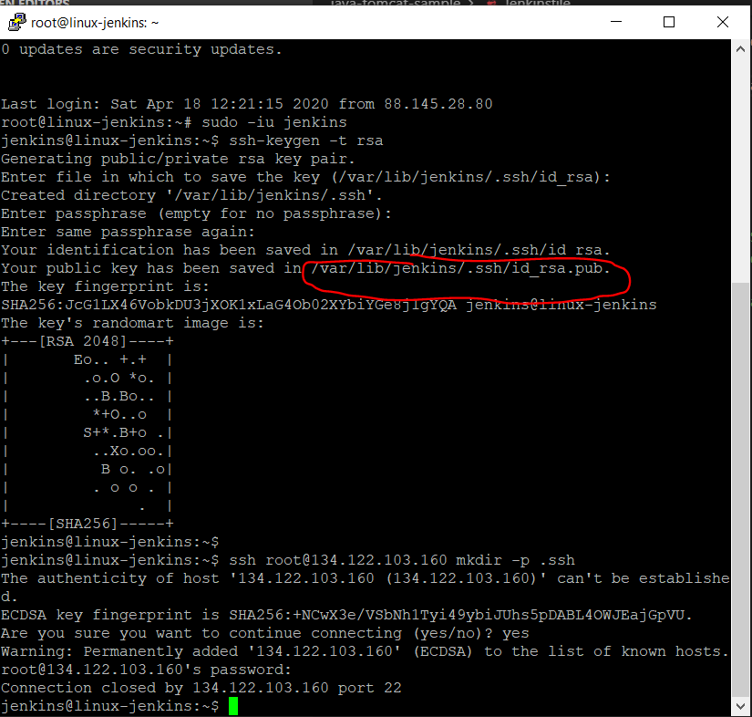

*Type the following to copy the pubic key and paste it into the slave machines folder::-*

***cat /var/lib/jenkins/.ssh/id_rsa.pub | ssh*** [*root@*142.93.34.163](mailto:root@142.93.34.163) ***'cat >> .ssh/authorized_keys'***

***{Enter]***

Then enter the password of the slave machine:-

***dudeegg1977***

**Note:- the above ip address is the Jenkins slave machine**

You can now ssh onto the slave machine from the master machine. See by typing the following below into the master putty session:-

*ssh root@142.93.34.163*

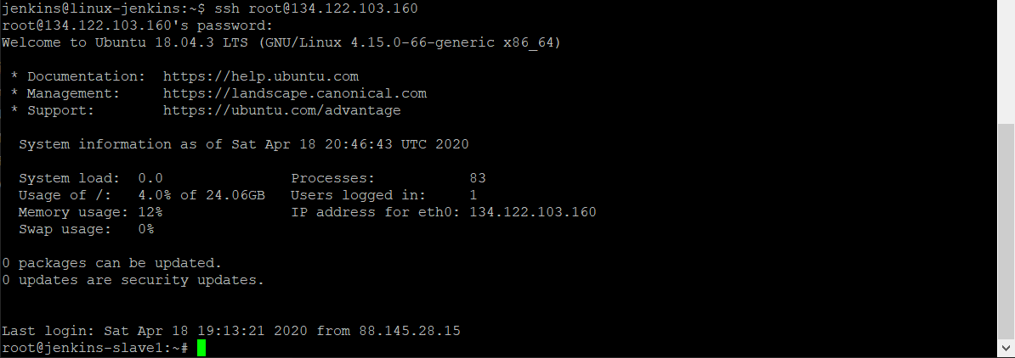

Go to Slave Jenkins Putty session and enter the following (this will download the slave.jar onto your slave machine):-

*mkdir bin*

*cd bin/*

*wget* [*http://master_ip_address*](http://master_ip_address)*:8080/jnlpJars/slave.jar*

**Replace ‘master_ip_address’ with ‘104.248.171.236’**

Now install java 8 onto slave machine enter:-

sudo add-apt-repository ppa:webupd8team/java

[enter]

sudo apt-get update

sudo apt install openjdk-8-jdk

Now open a browser session directed at the Jenkins Master:-

<http://104.248.171.236:8080/>

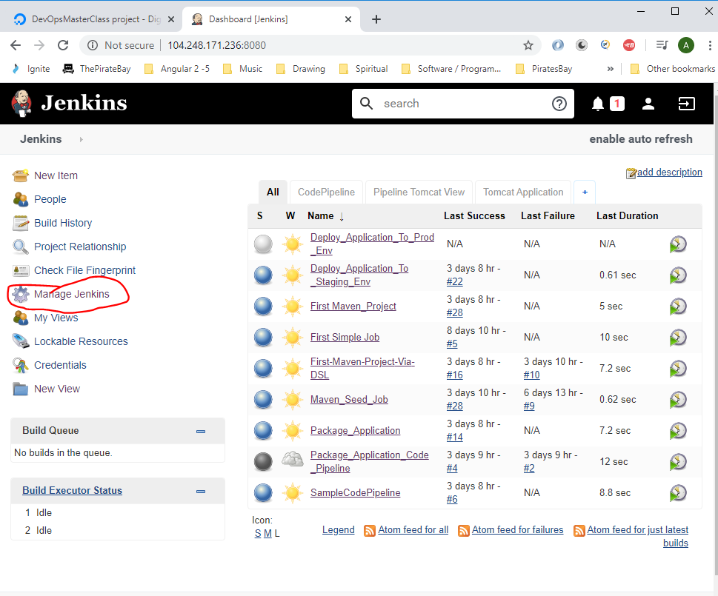

Click on ‘Manage Jenkins’.

Then click on ‘Manage Nodes and Clouds’:-

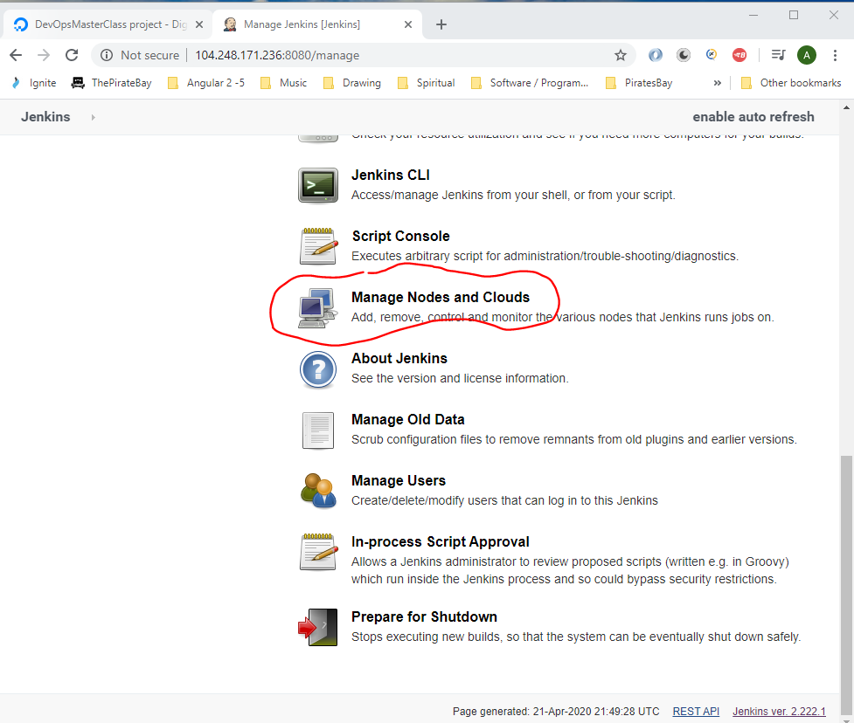

You will see at present there is only one node (master node):-

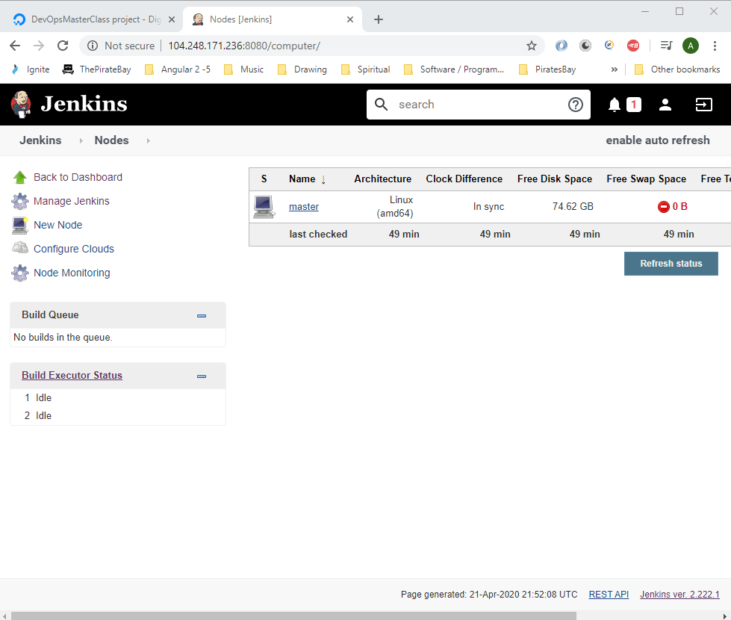

Click ‘New Node’.

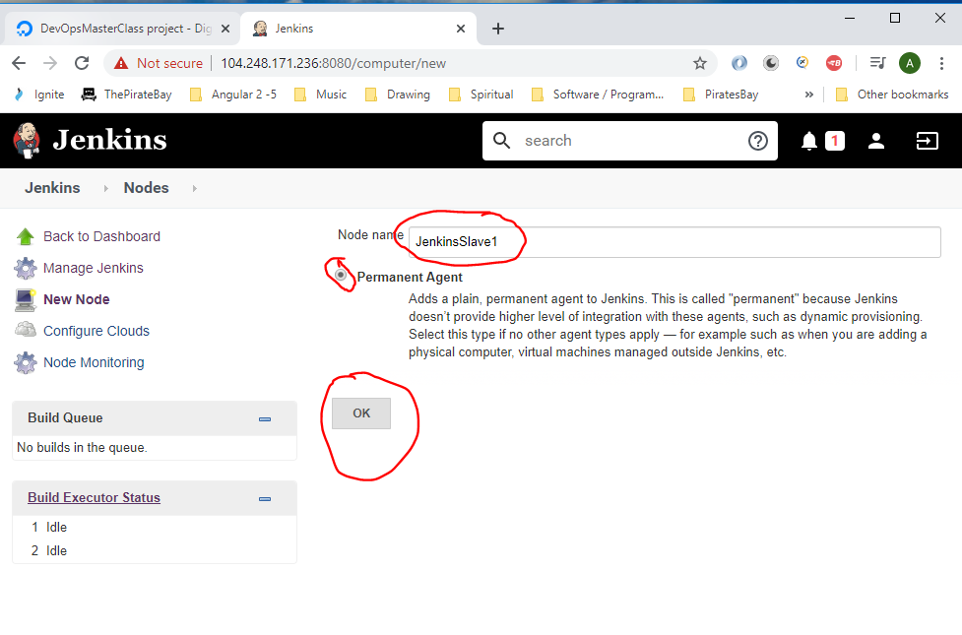

Set the below:-

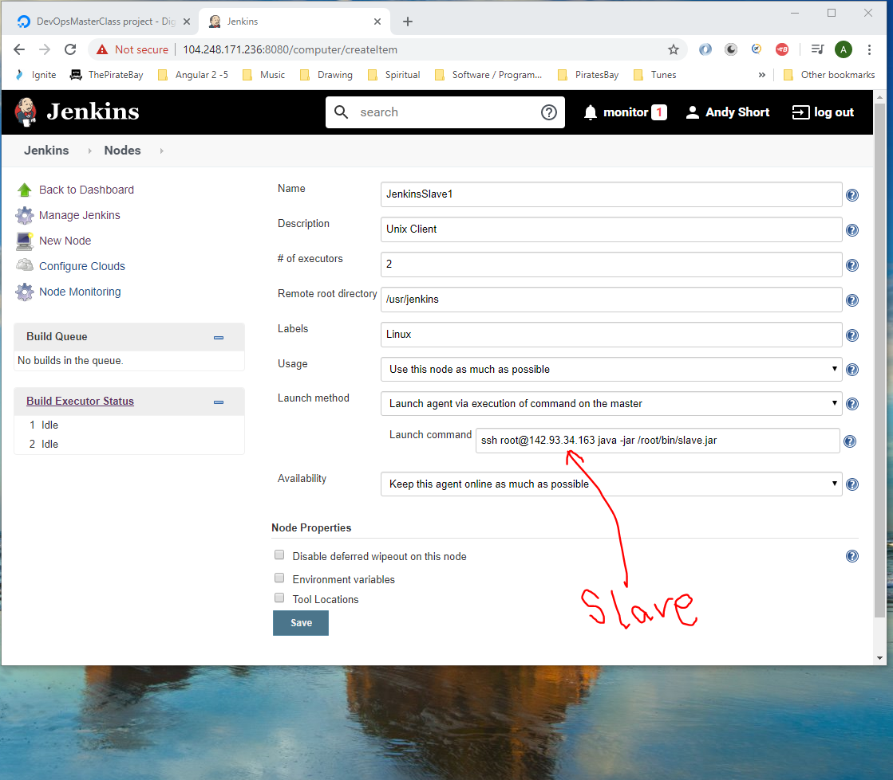

Note: It is recommended that the executor be 2 executors per 4 cores. So if a machine is 4 cores, then add 2 executors, it the machine has 8 cores then set executors to be 4.

Then click ‘Save’

Now refresh the webpage to show ‘JenkinsSlave1’ online:-

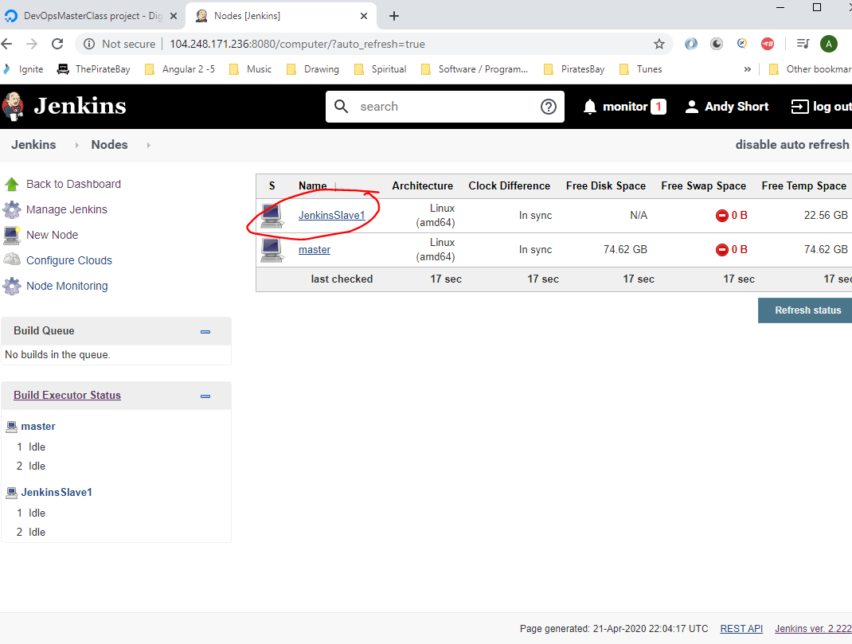

**Concurrent jobs**

Go to Jenkins and click on jobs ‘+’ sign on the tabs:-

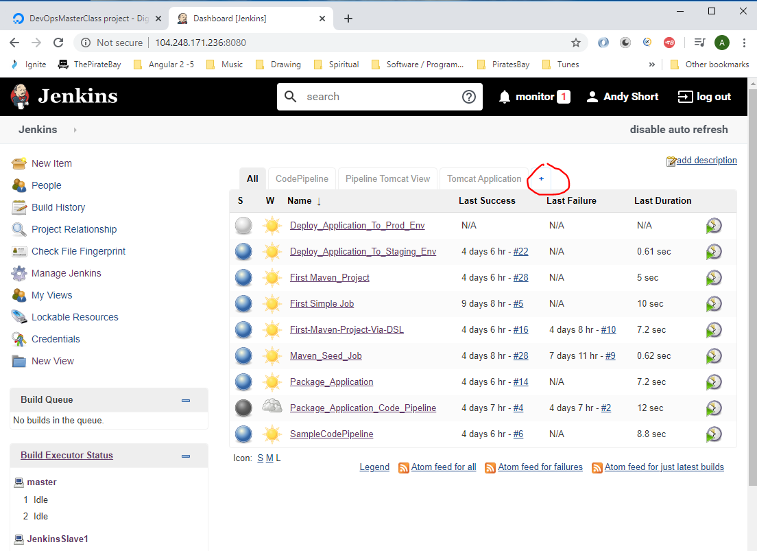

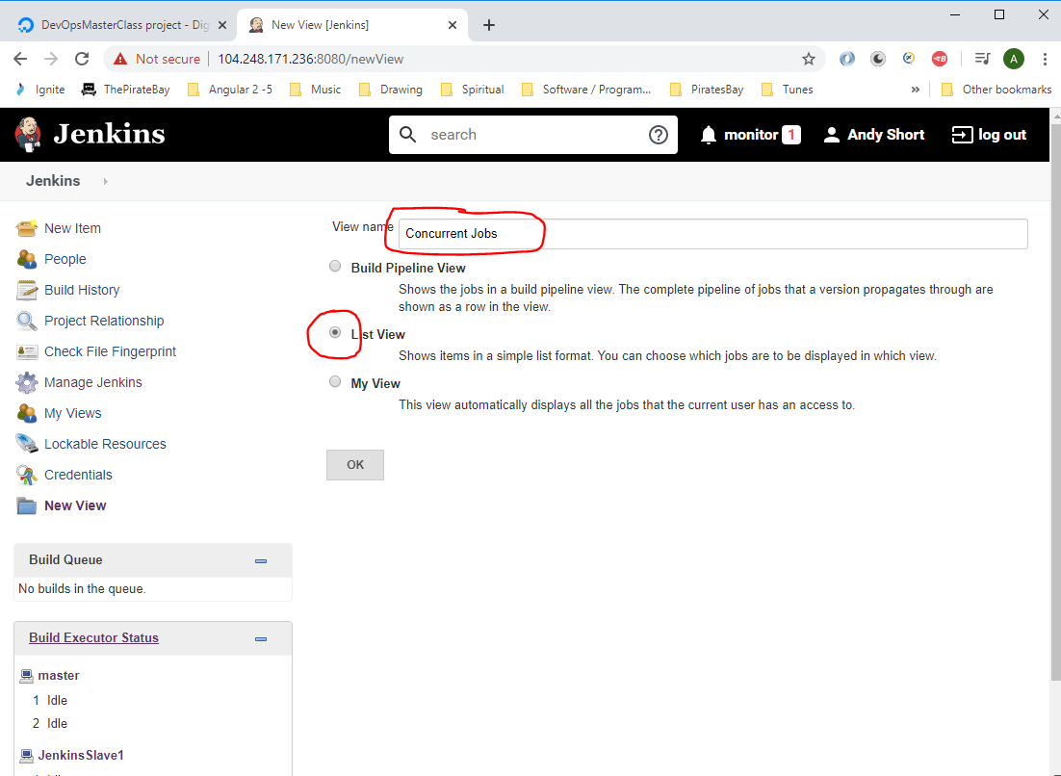

The just click ‘Ok’:-

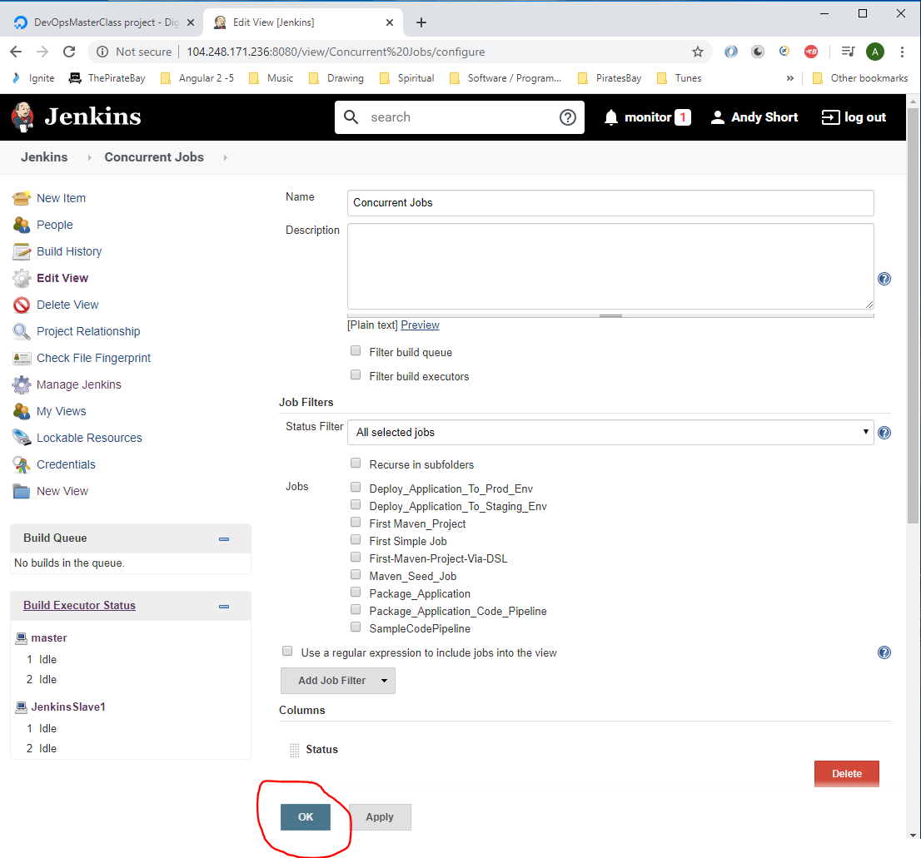

Under ‘Concurrent Jobs’ tab click ‘new job’:-

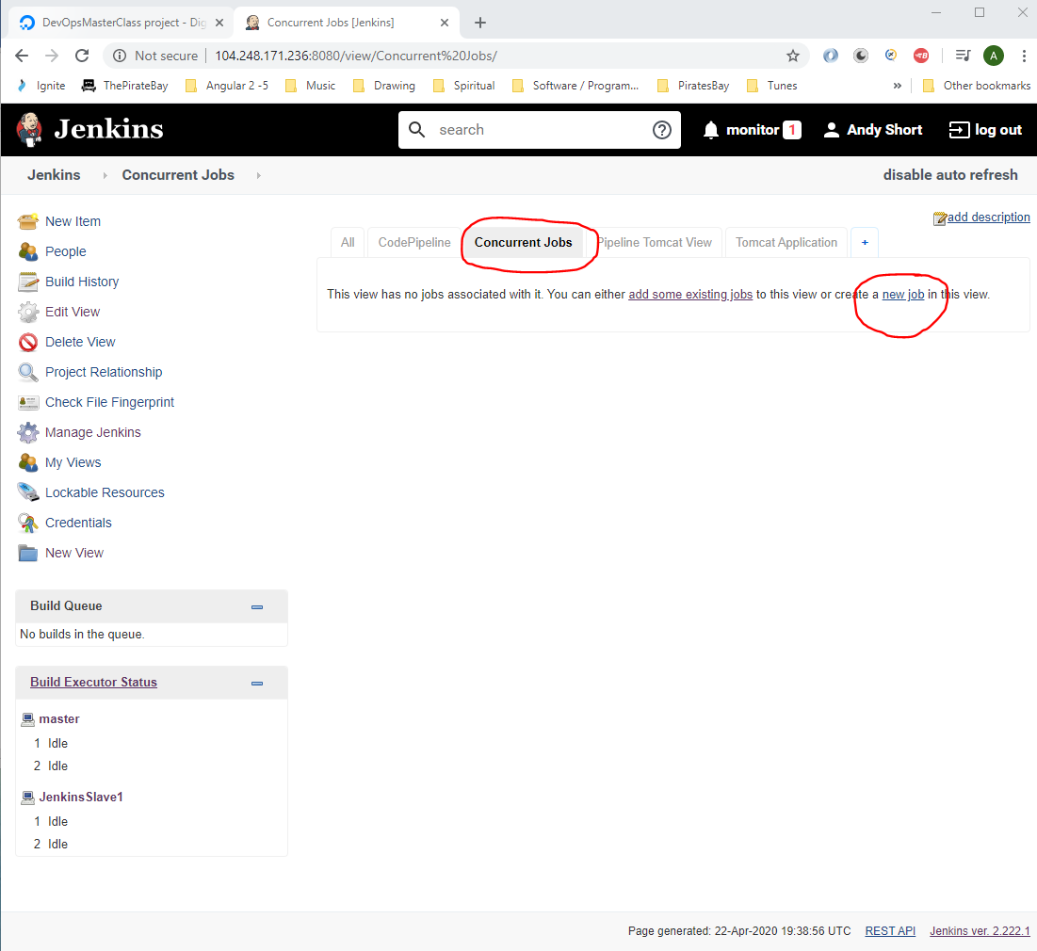

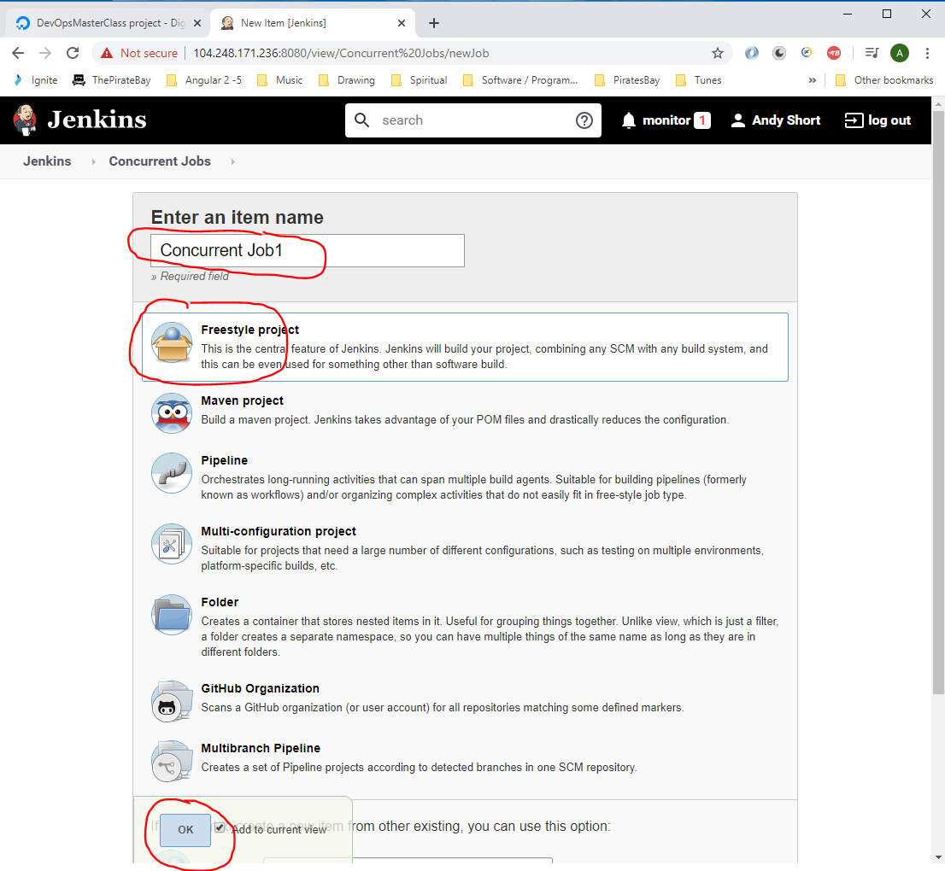

Add this:-

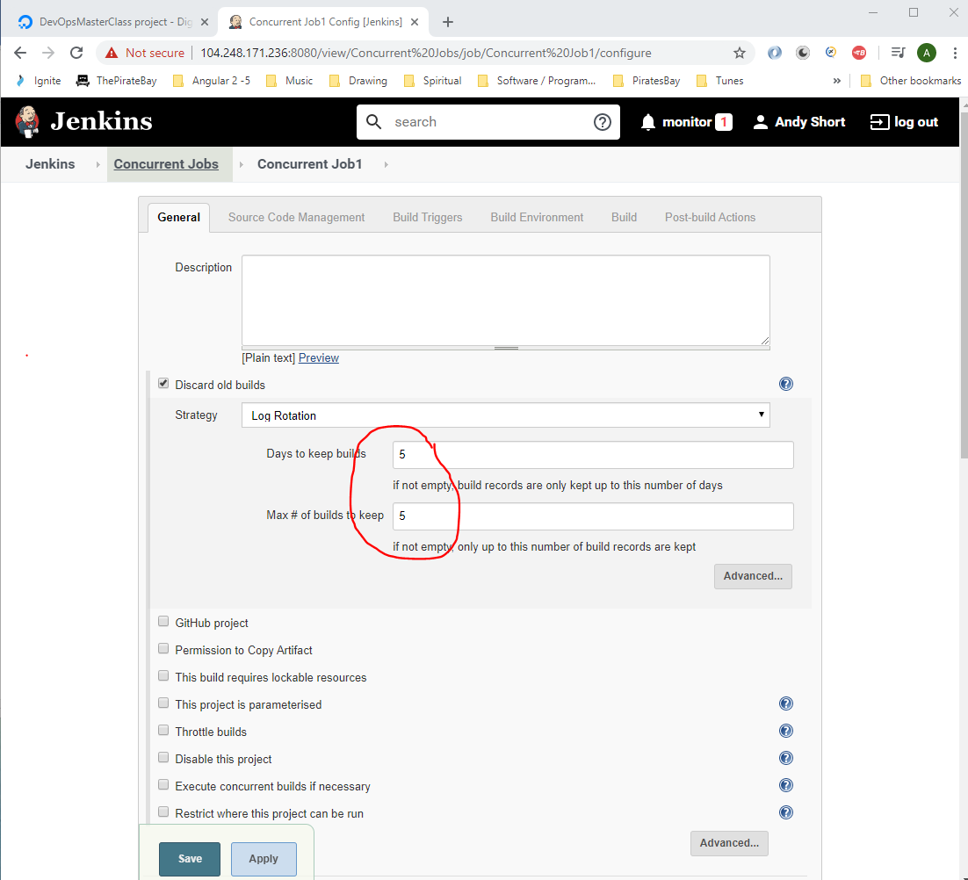

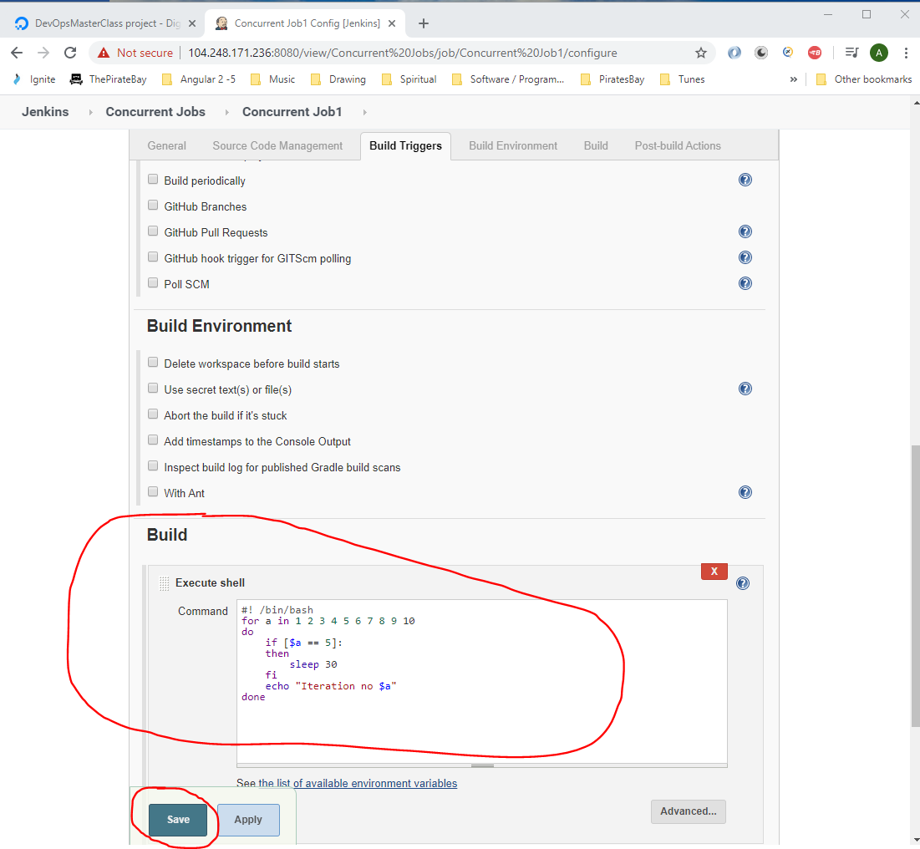

Then click ‘Save’.

Create two more jobs under the ‘Concurrent Job’ tab. Add the same Bash script to each job:-

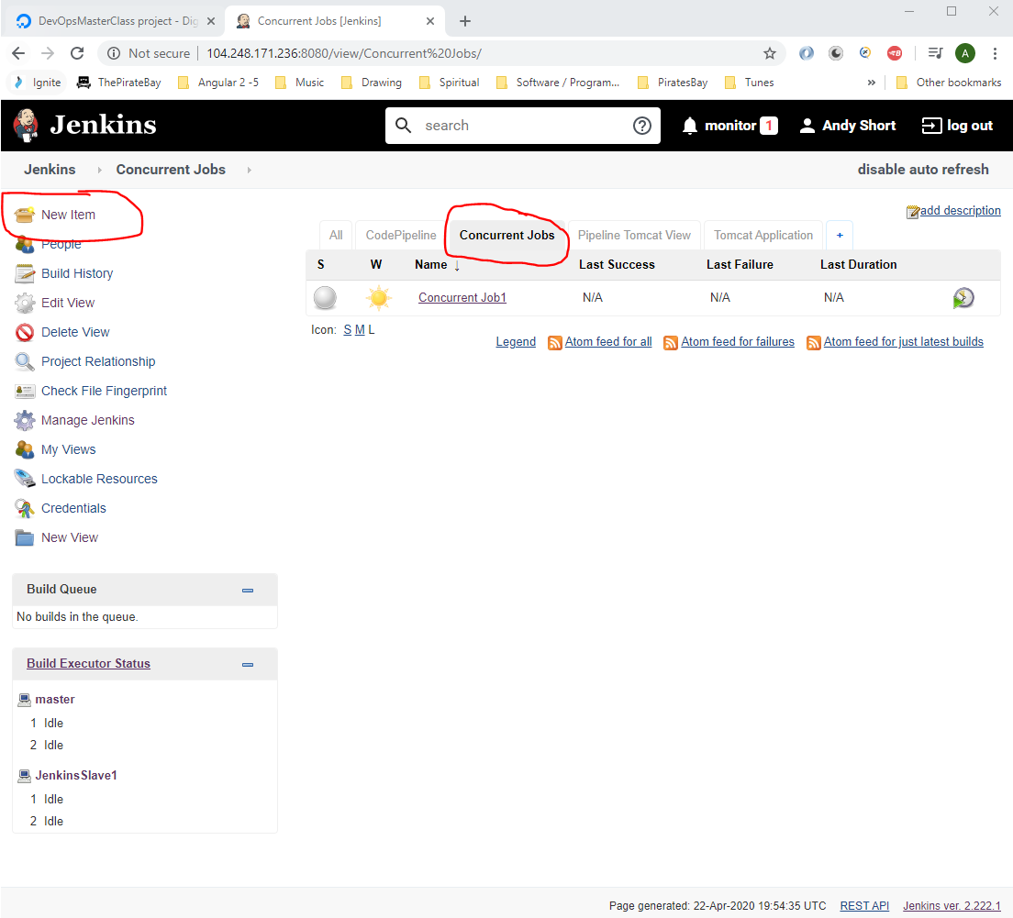

Giving this:-

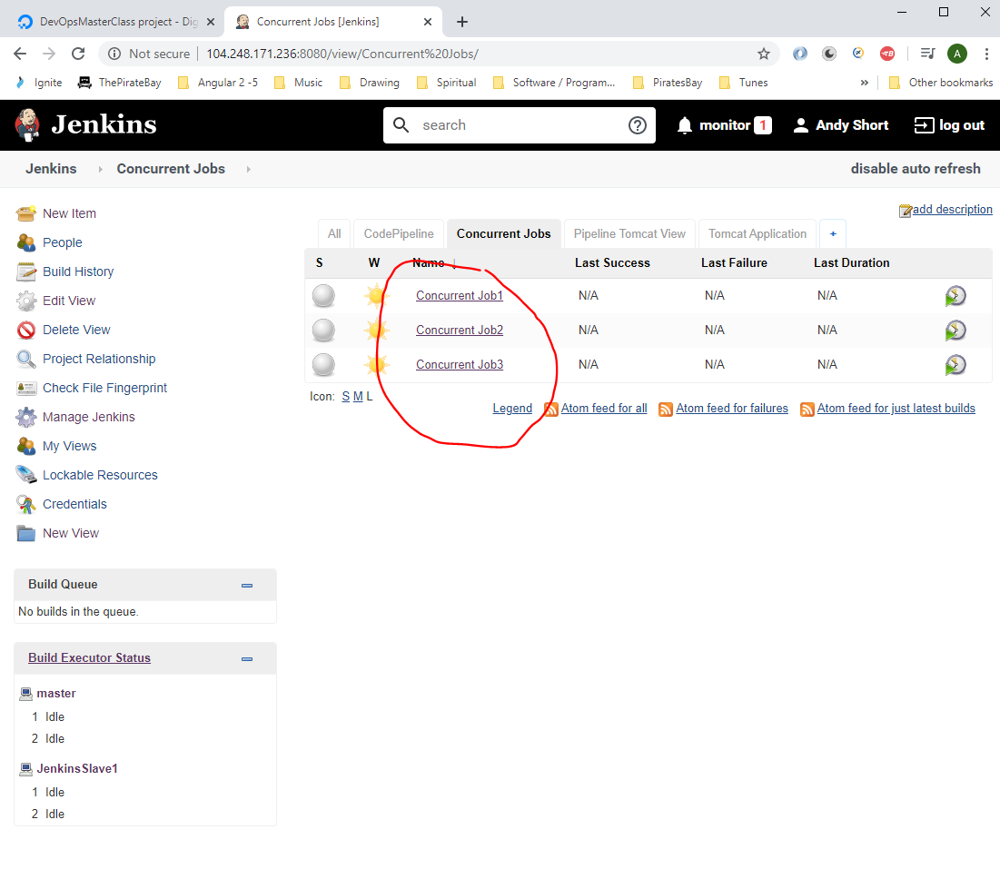

Set all jobs running by clicking each of these in turn:-

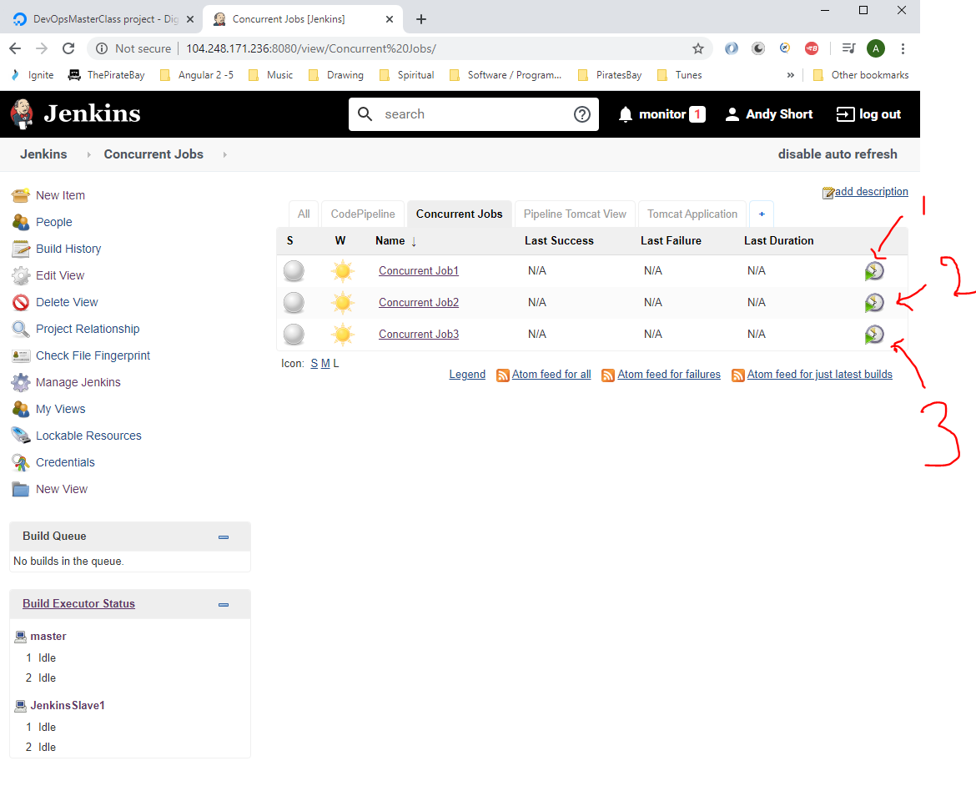

If you see starting them all off you get one running on the Master and the other two running on the slave:-

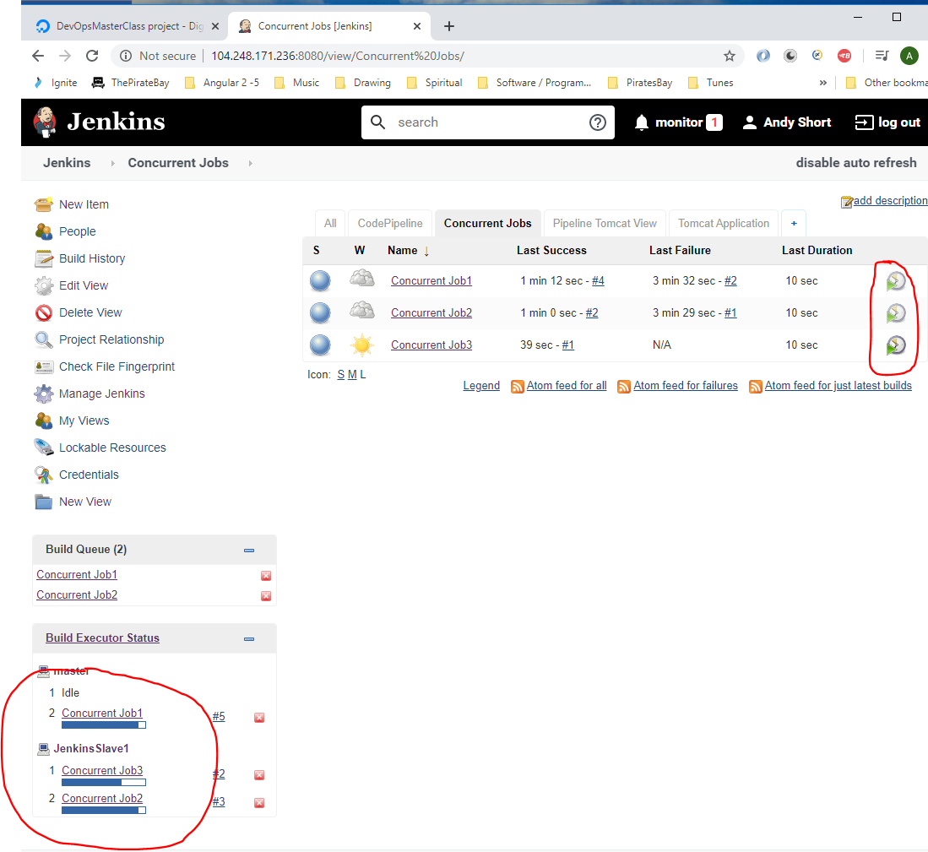

If you want to run specific jobs on specific nodes then go to ‘Manage Jenkins’:-

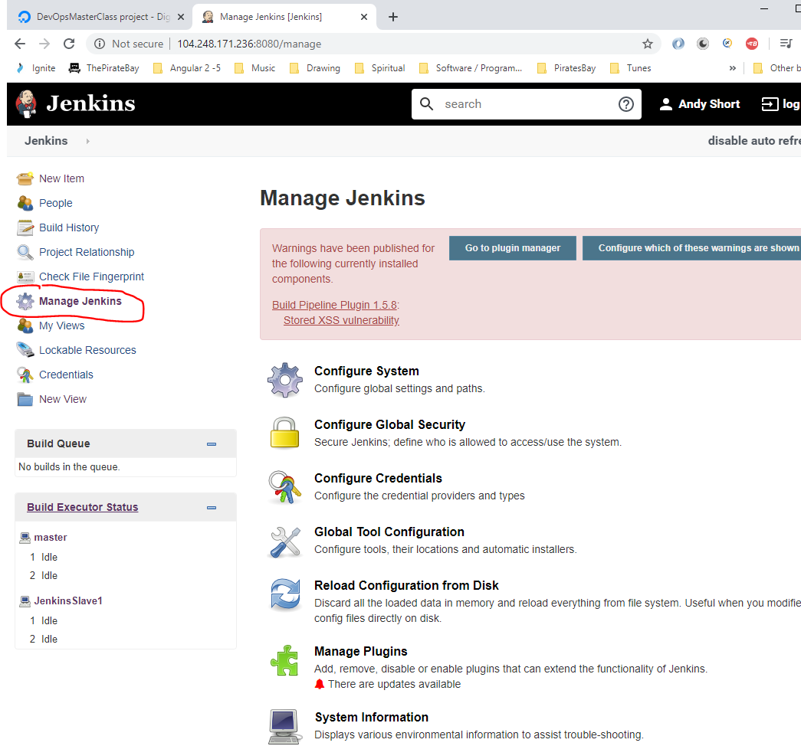

Then click on ‘Manage Nodes and Clouds’:-

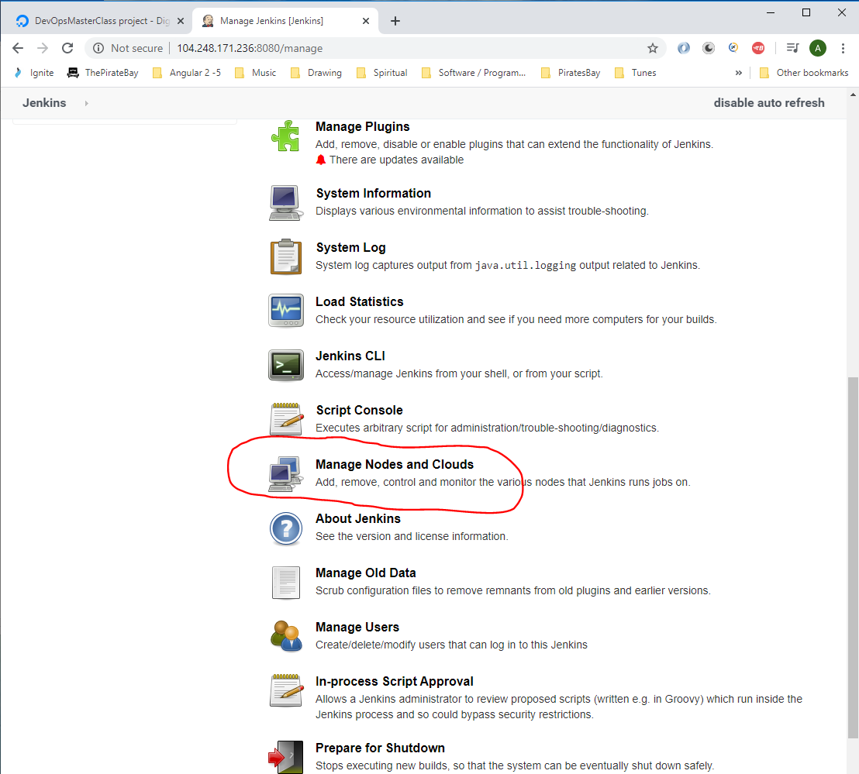

Then click on ‘JenkinsSlave1’:-

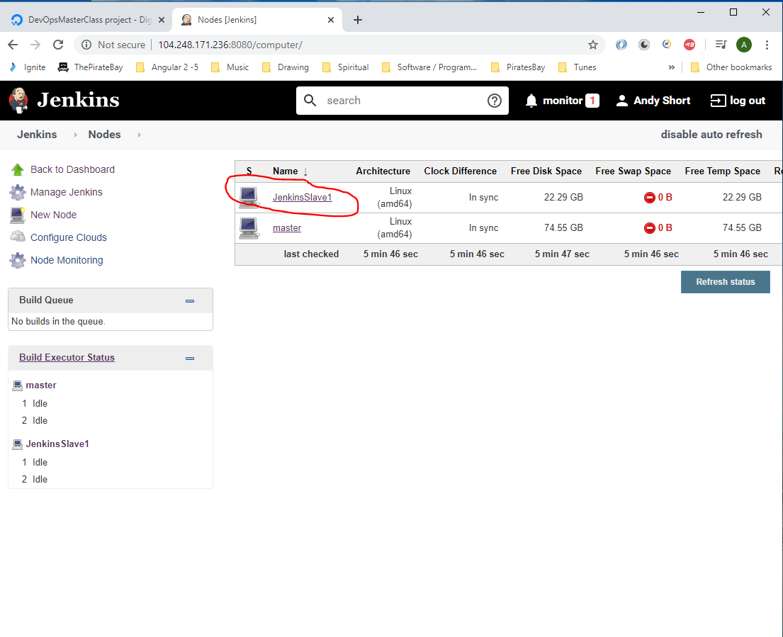

Then click on ‘Configuration’:-

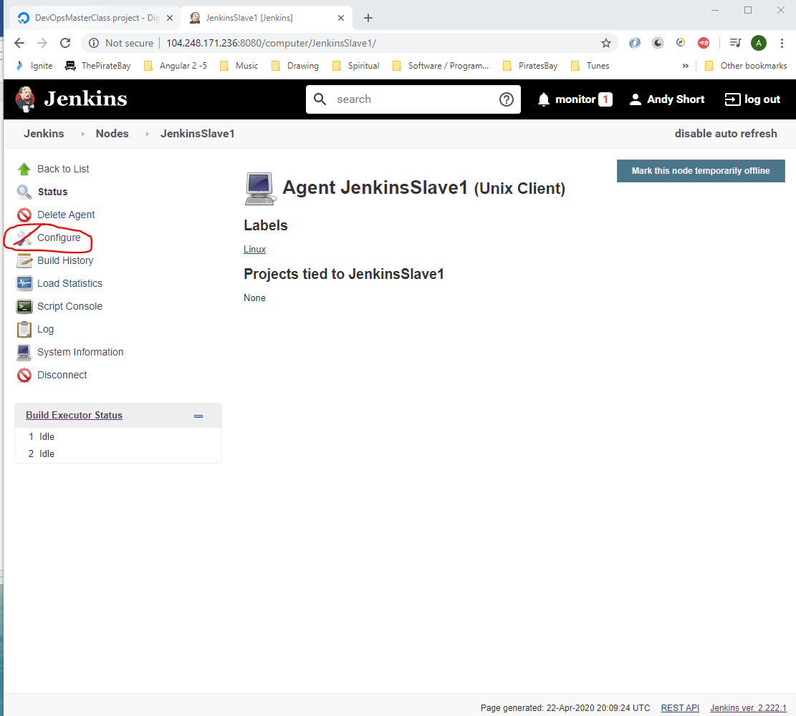

Now change the ‘Usage’ drop down to:-

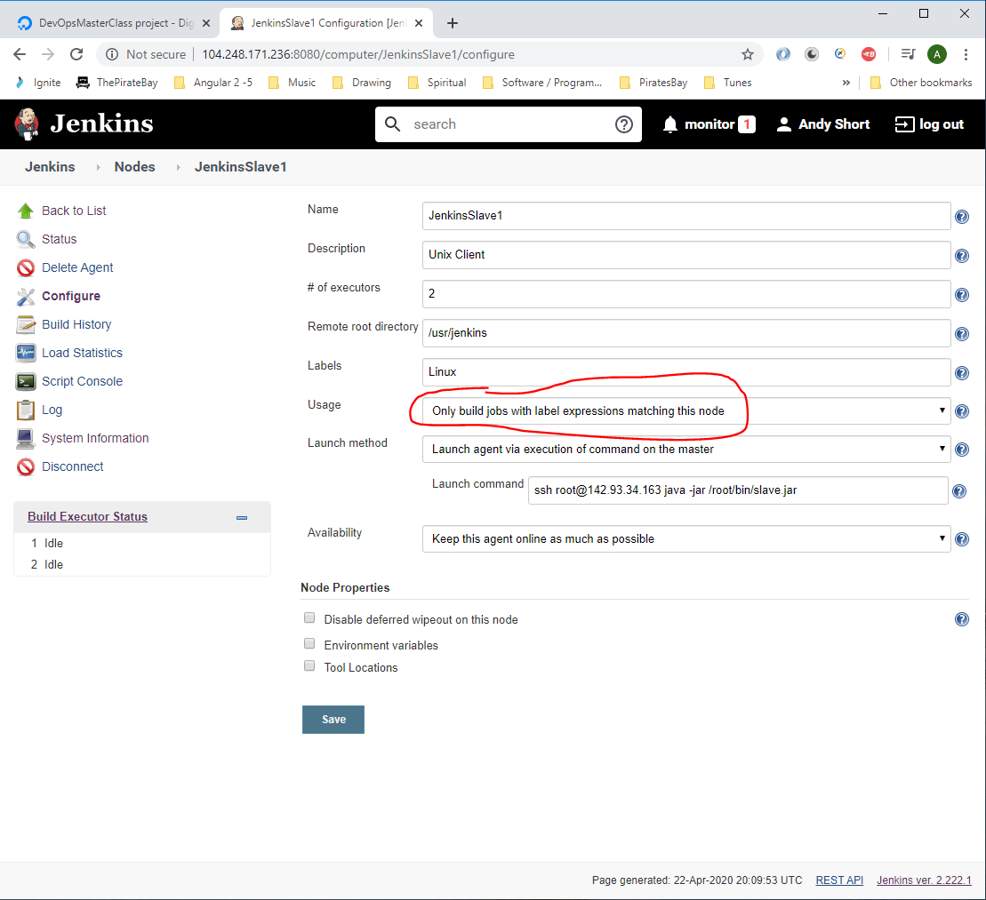

Then click ‘Save’

Now go to each of the jobs:-

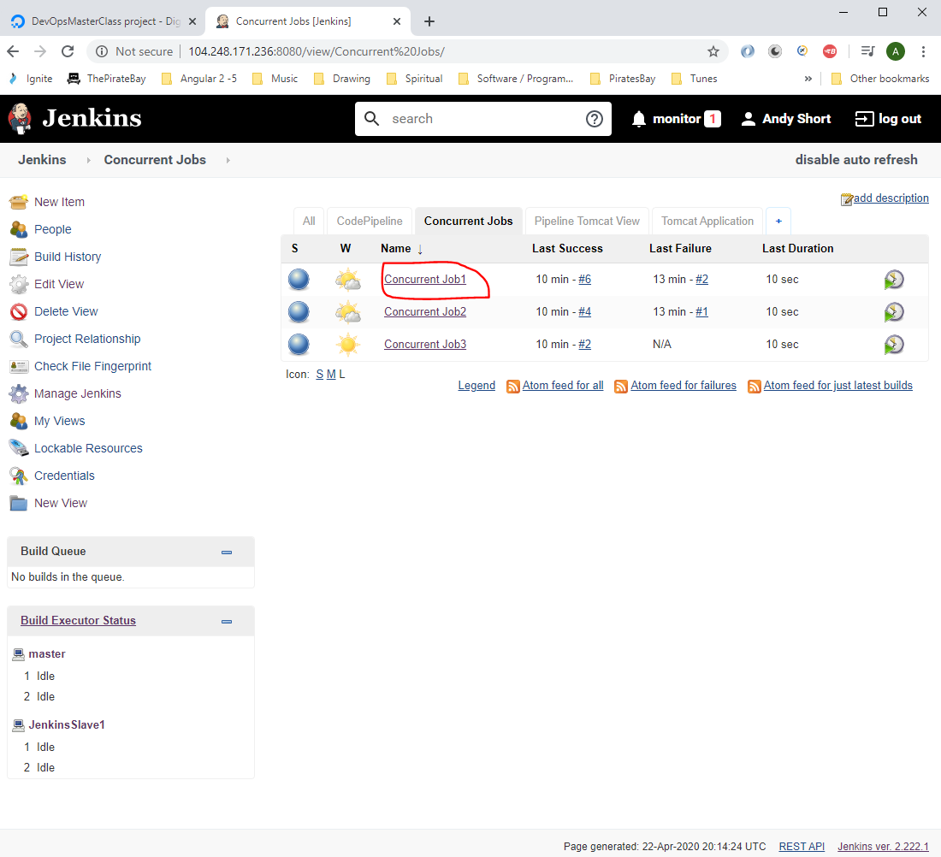

Click ‘Configure’:-

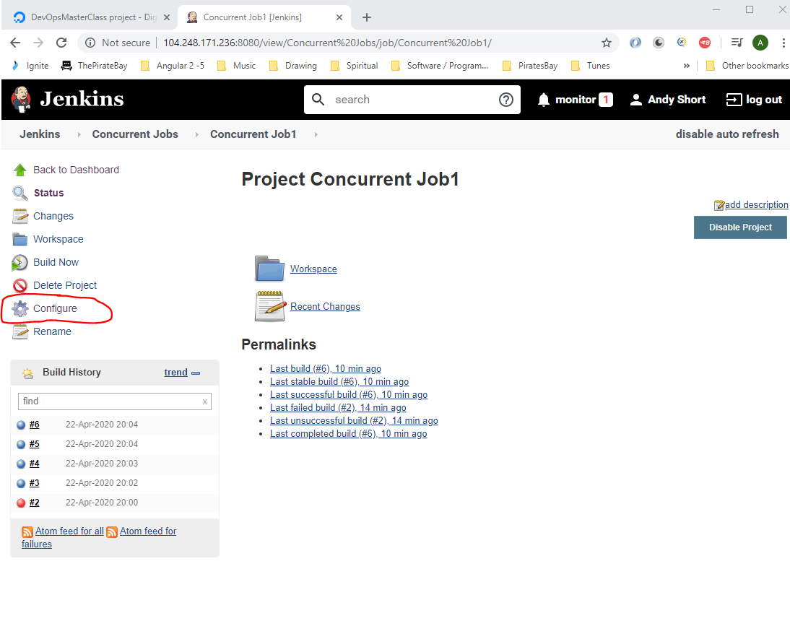

Then click the following checkbox:-

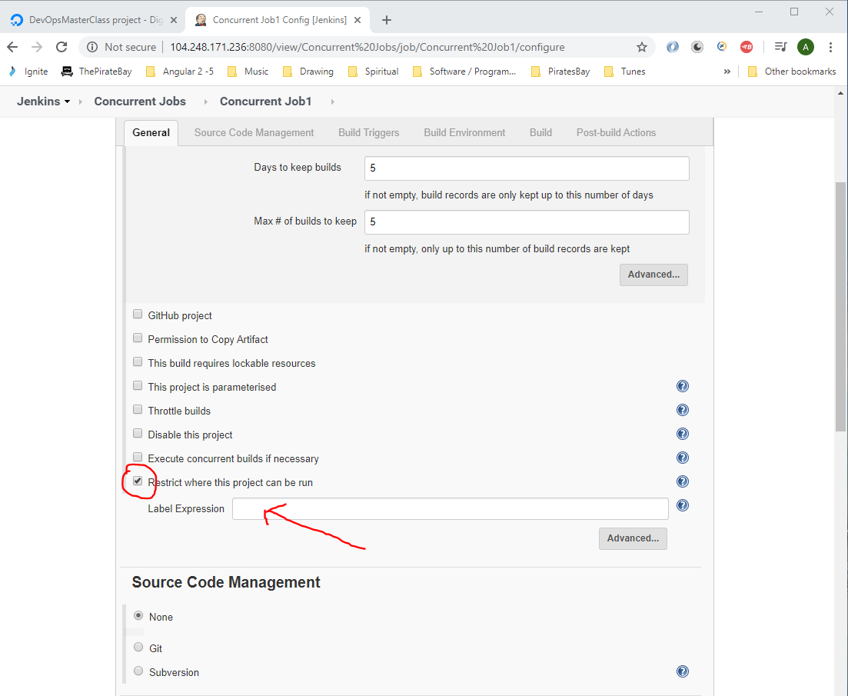

The ‘Label Expression’ is the label name of the node machine, see below for the slave Jenkins machine:-

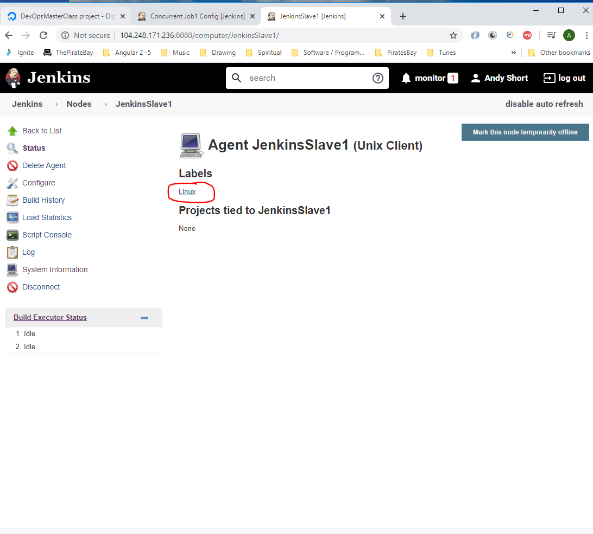

So add this here:-

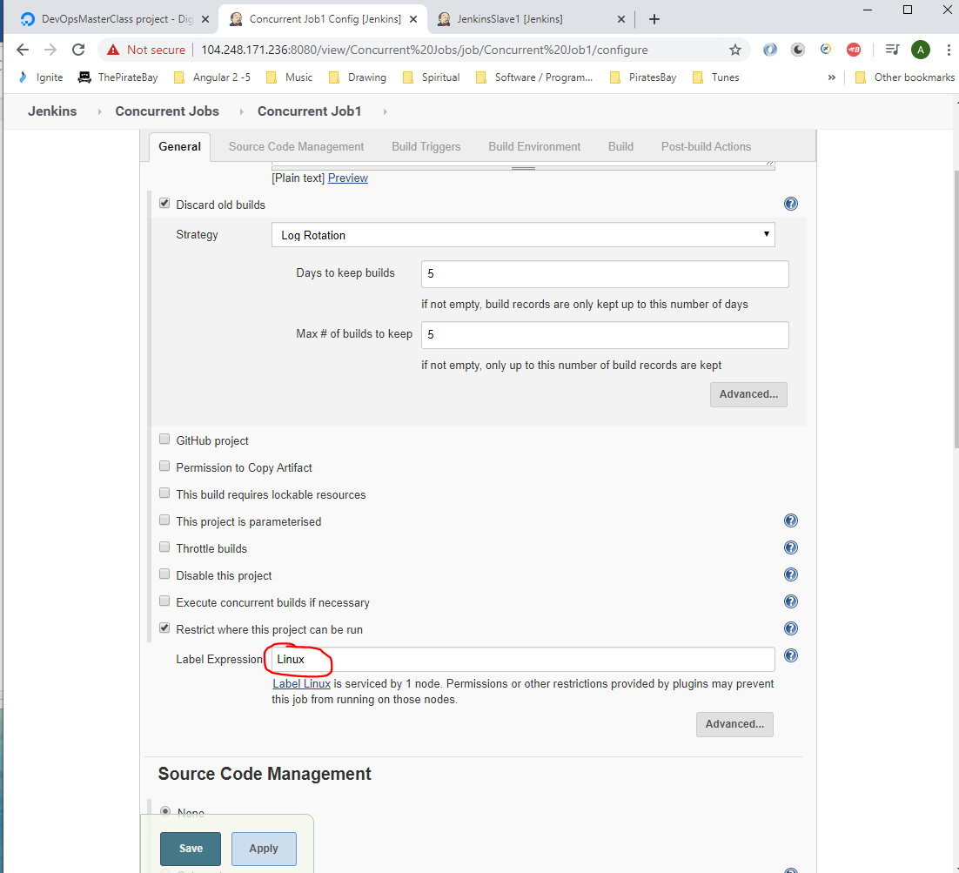

Click ‘Save’.

Now do the same for the other jobs. Then execute all jobs. Now all jobs will only run on the Salve Jenkins machine.

**Docker**

First SSH onto your cloud based Linux machine and check to see if Docker is installed:-

Type:-

*docker version*

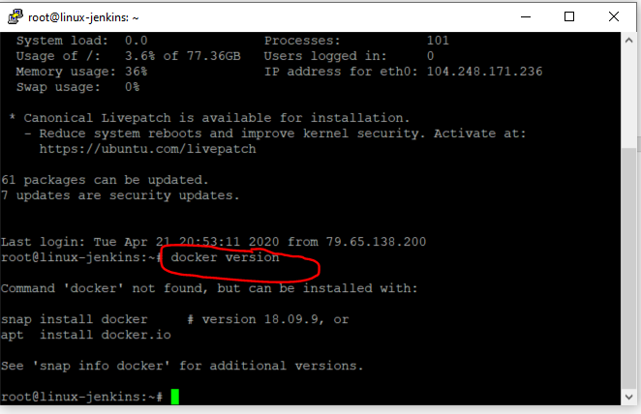

See that Docker is not installed.

To install Docker on the cloud based Ubuntu machine go here and read the instructions:-

<https://docs.docker.com/engine/install/ubuntu/>

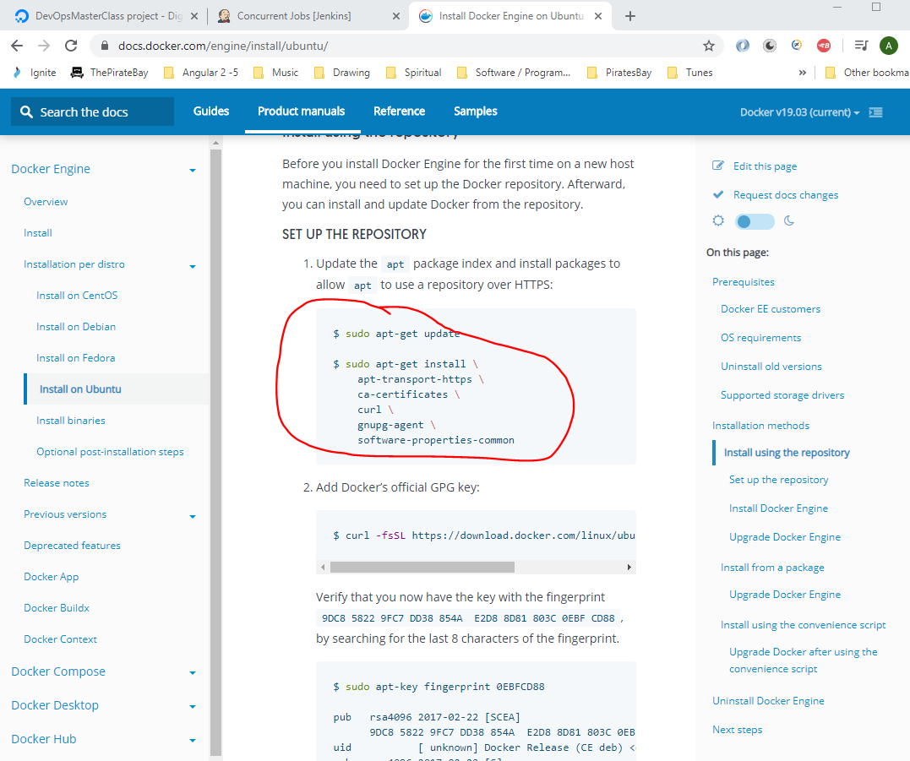

So enter the following into Putty session:-

sudo apt-get update

then:-

sudo apt-get install \

apt-transport-https \

ca-certificates \

curl \

gnupg-agent \

software-properties-common

Press ‘Y’.

Then enter this:-

curl -fsSL https://download.docker.com/linux/ubuntu/gpg | sudo apt-key add -

To find out what version you have installed type this:-

lsb_release -a

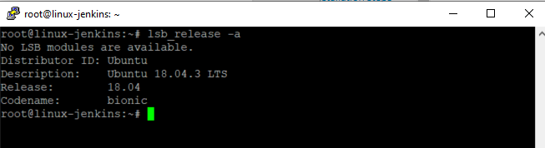

So go for this version:-

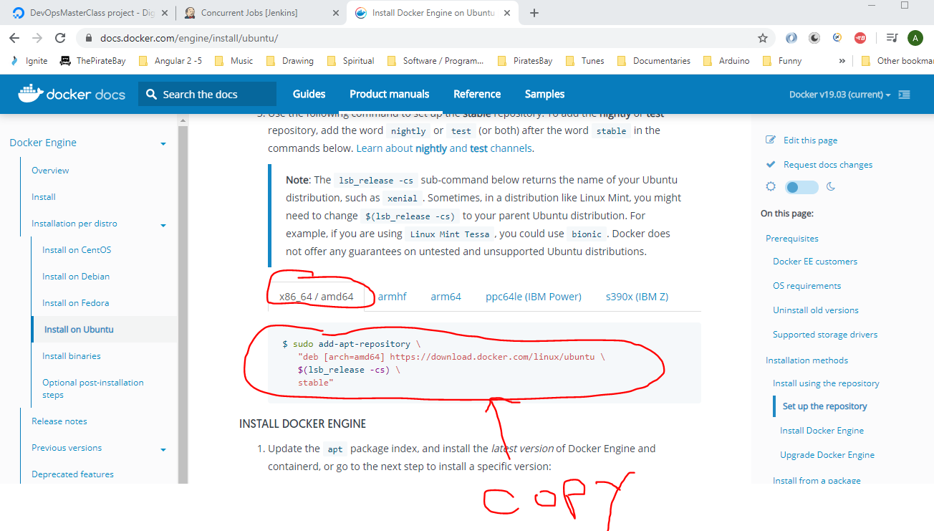

Paste the above into Putty:-

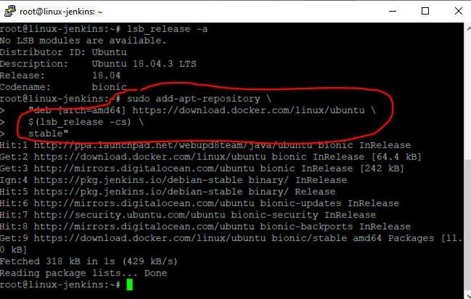

Then enter the following:-

sudo apt-get update

Then, enter this:-

$ sudo apt-get install docker-ce docker-ce-cli containerd.io

Press ‘Y’.

Now check the version of Docker installed. Enter:-

*docker version*

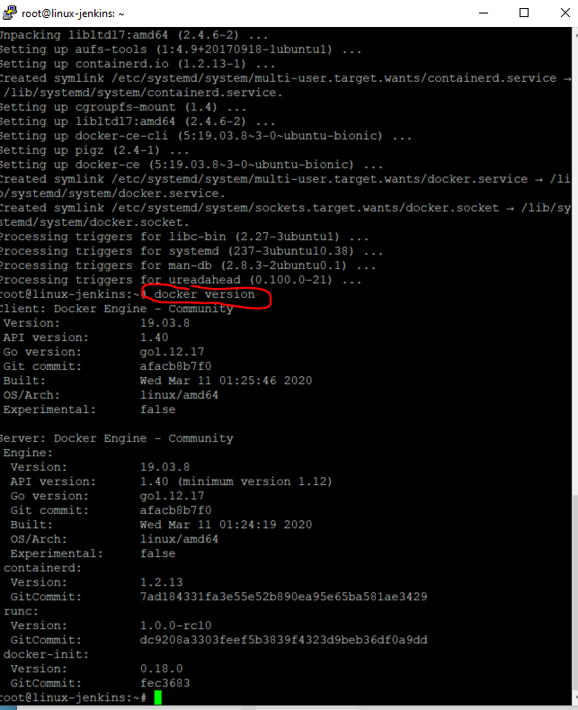

Now add a user to the Docker user group so that the user does not get prompted to enter passwords when performing commands:-

*sudo usermod -a -G docker $USER*

To test that your Docker installation is working correctly type:-

*docker run hello-world*

**Terminology**

Image - the application you want to run

Container - contains a running instance of the application. You can have multiple containers running the same image

Create an account at Docker hub:-

<https://hub.docker.com/>

Login Credentials:-

Username - testking77

Password - dudeegg1977

Email- divine.moment.of.truth1@gmail.com

Docker hub is where you can save you application images.

You can search for existing Docker repo’s by entering a name in the search box here:-

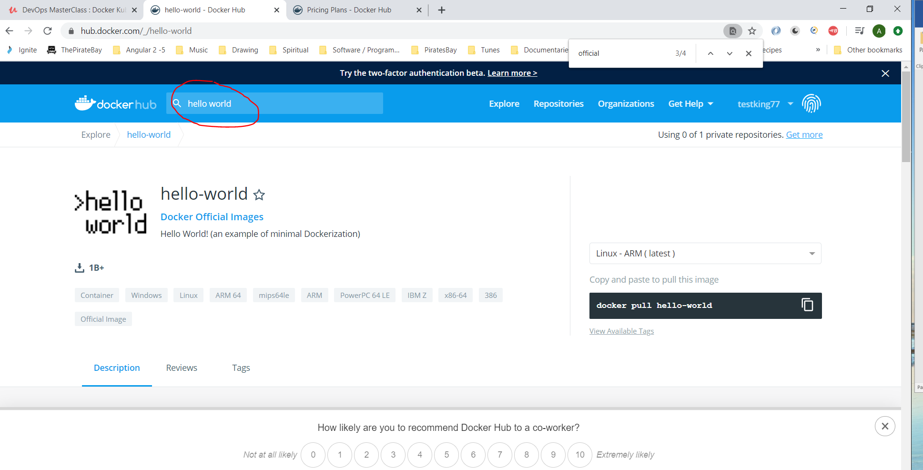

Now go to the Cloud based Linux machine (master Jenkins machine – ‘linux-jenkins’), by opening Putty:-

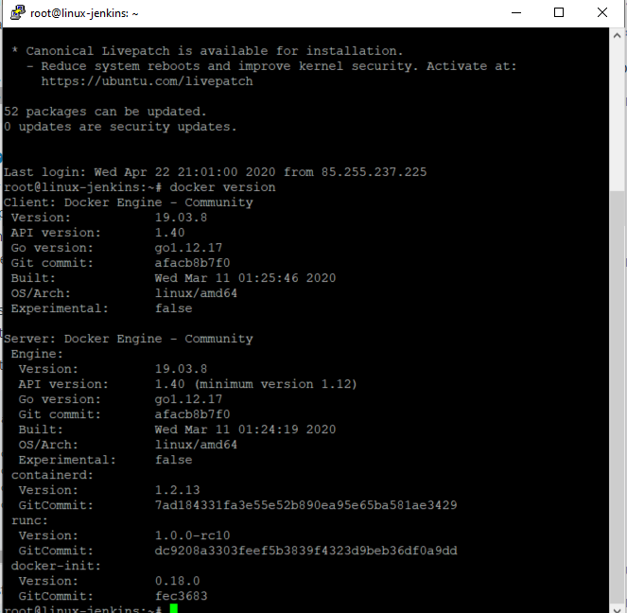

Type the following command to get information about Docker:-

*docker info*

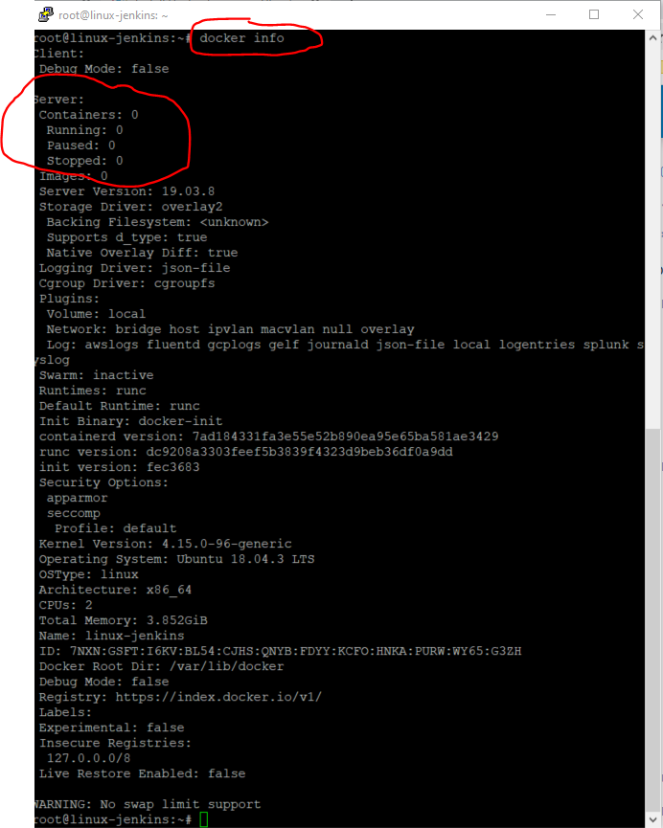

Now if you can to execute the command to run the ‘hello world’ container from Docker Hub, then type the following:-



Now if you want to execute the ‘hello world’ container which is stored in Docker Hub, then type the following:-

*docker container run hello-world*

Now, to test that the imahge has been installed type:-

*docker info*

See Image: 1:-

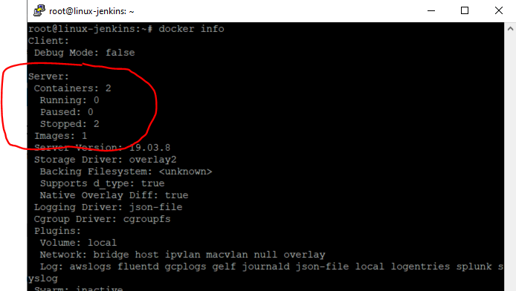

Now install the ‘Nginx web-server’ image onto the cloud machine:-

Go to Docker Hub and search for ‘nginx’:-

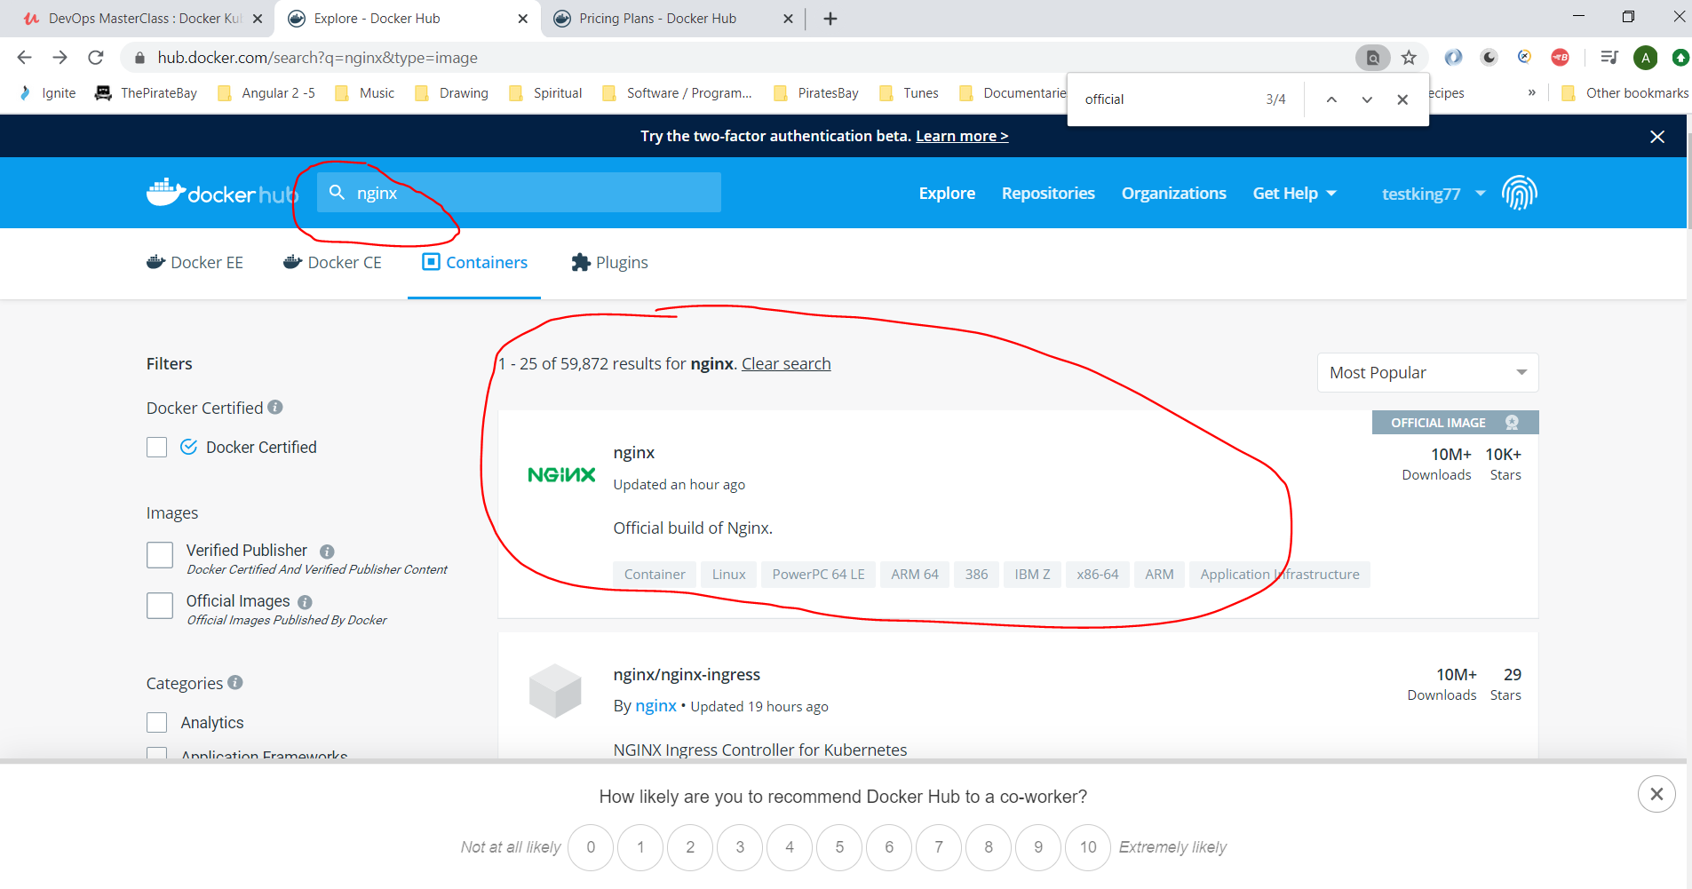

In your master Jenkins Cloud based Linux machine (linue-jenkins) Putty session type the following:-

*docker container run --publish <host_port:container_port> <image_name>*

which would be:-

docker container run --publish 80:80 nginx

The port number in the above is the port number that will allow the application to route the traffic to. The port where the app is accessible on, on the host machine (the master Jenkins linux machine)

When the image is downloaded then open a browser on your local machine and enter the following url to access the ‘nginx’ image:-

http://104.248.171.236:80

104.248.171.236 - this is the ip address of the jenkin-linux machine

Note:- You may need to open port 80 on the Linux machine. To do this do the following in Putty:-

*sudo ufw allow 80 http*

Stop container by typing:-

*[CTRL] + c*

To run container in detach mode type:-

*docker container run --publish 80:80 --detach nginx*

Running the above command returns the container id:-

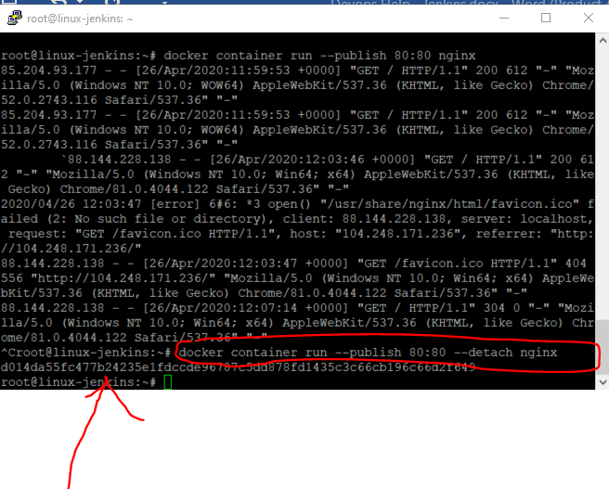

You can also choose different ports to access by doing this:-

*docker container run --publish 8081:80 --detach nginx*

Now you can access the site by entering the following <url:->

<http://104.248.171.236:8081/>

or:-

<http://104.248.171.236:80/>

So the application is running on two separate ports on a single machine

To see what containerfs are running on a machine type the following into Putty:-

*docker container ls*

**To stop running containers or remove running containers:-**

Go to Docker hub:-

<https://hub.docker.com/>

Search for an image e.g. hello-world

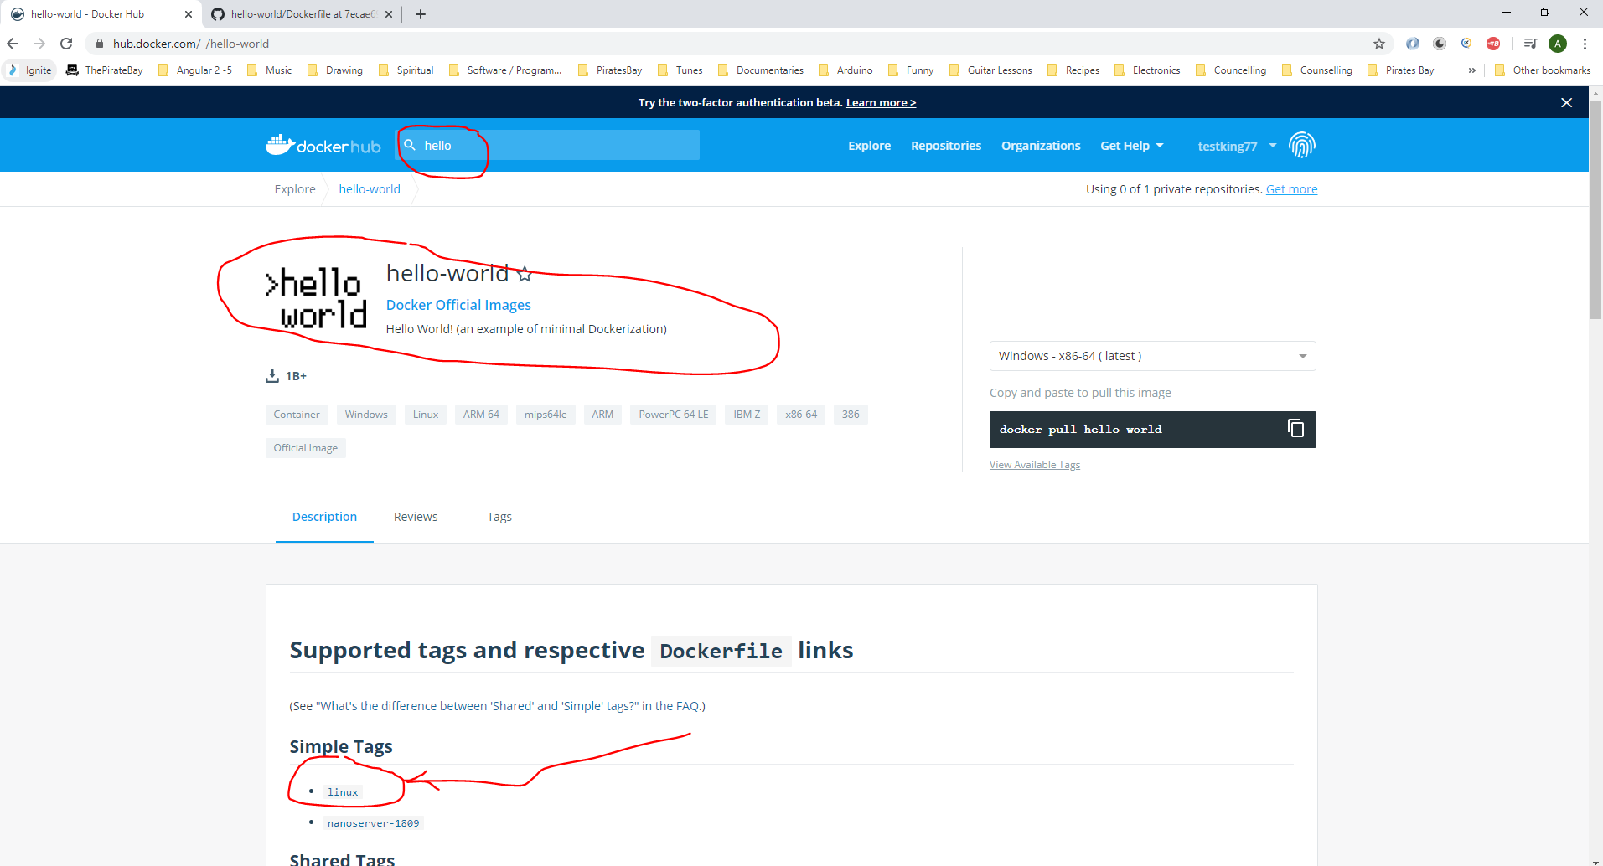

Right click the ‘linux’ link and select open in a new tab. This will open:-

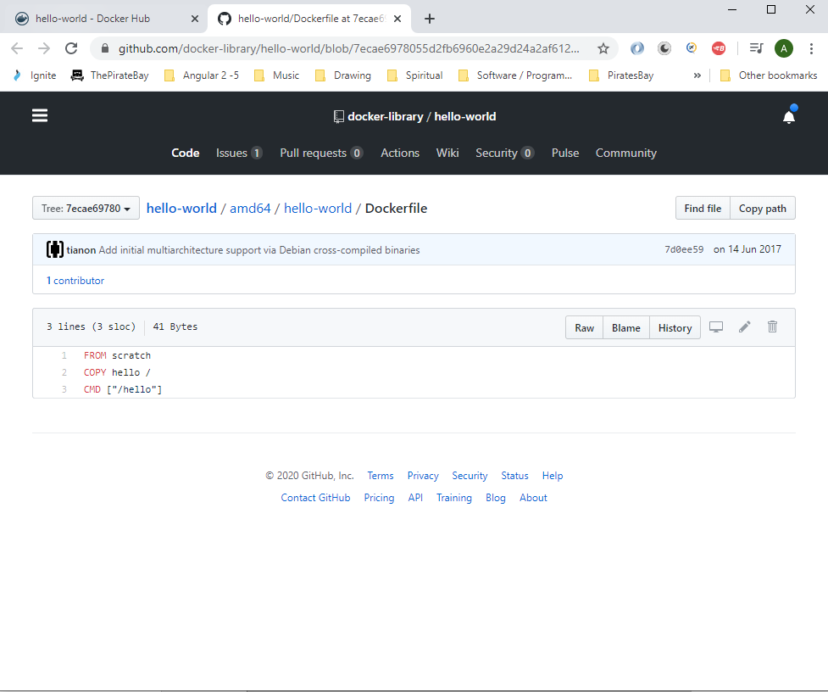

The above is opening the ‘dockerFile’ in GitHub. See the content of the dockerFile:-

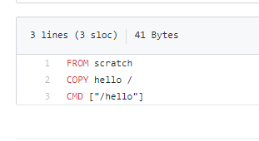

**Docker Commands:-**

FROM - Initialises a new build stage and sets the basic image e.g. FROM <image_name>

LABEL -

RUN - Executes any command in a new layer on top of current layer e.g. running Linux commands – *RUN apt-get update*

CMD - Used to run the software contained by the image e.g. CMD [Executable”, “param1”,”param2”]

EXPOSE - Indicates the port on which a container listens for connections e.g. EXPOSE <port>

ENV - Sets the environment variable e.g. <KEY> <value>

ADD - Copies new files, directories or remote URLs from <src> and adds them to the filesystem of the image at the path <dest> e.g. *ADD hom* /mydir/ - this copies all files starting with ‘hom’*

VOLUME - Used to expose and database storage, or files/folder created by the Docker container

WORKDIR - Sets the working directory for any RUN, CMD or ADD instruction

**Create a Docker file for our project**

Go to Jenkins and click on ‘Tomcat Application’ tab:-

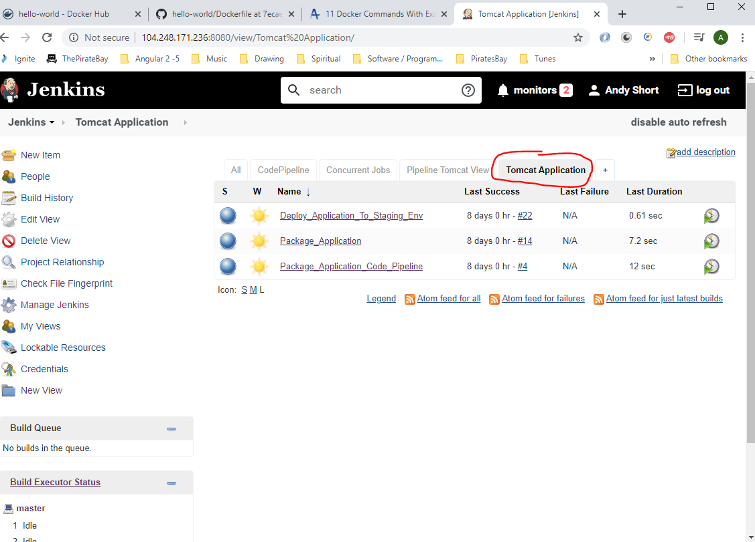

Click on ‘Package Application Code Pipeline’ job:-

Go to project in GitHub:-

<https://github.com/divine-moment-of-truth/Jenkins_Upgradev3>

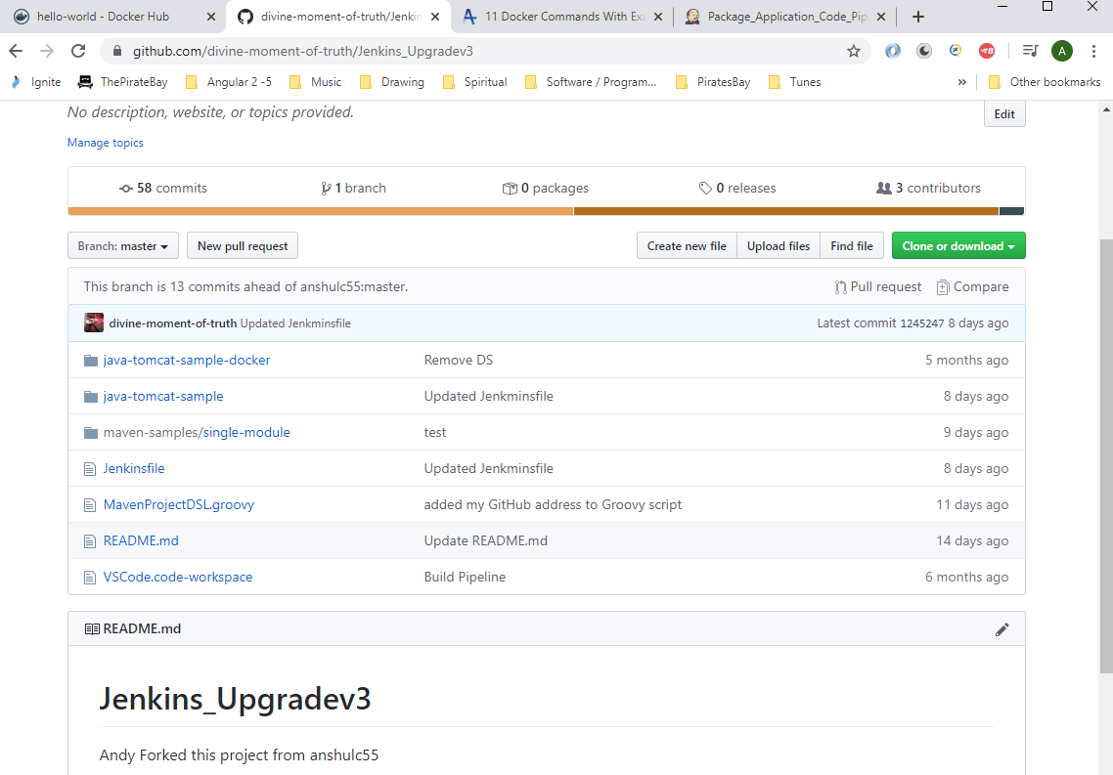

Open Visual Studio Code and see Docker project:-

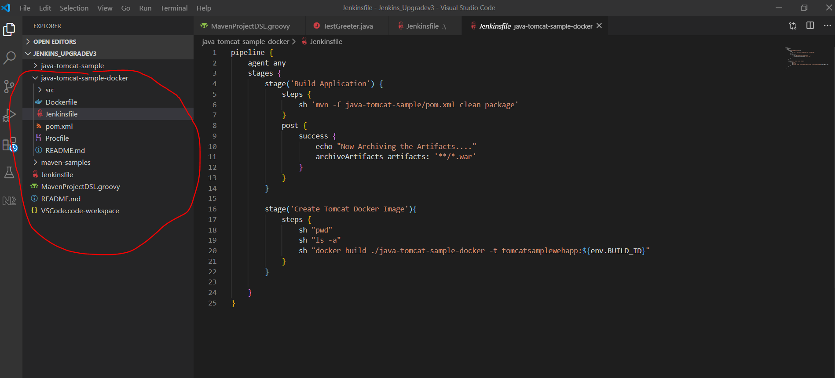

See Jenkinsfile (above)

Create the Docker file – ‘Dockerfile’:-

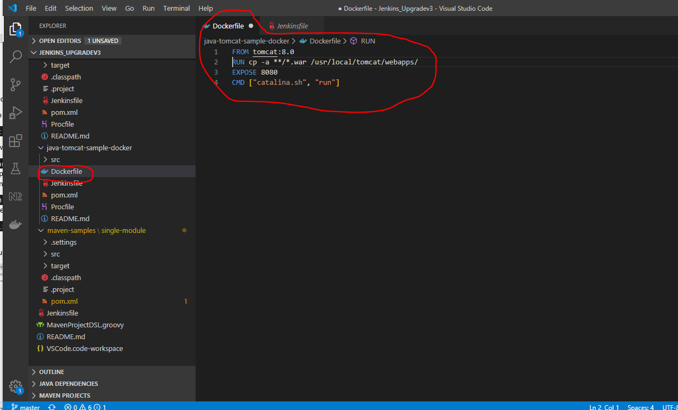

So we need to download the ‘Tomcat’ server:-

FROM tomcat:8.0

Above line downloads version 8.0 of Tomcat

RUN cp -a **/*.war /usr/local/tomcat/webapps/

Above line copies the tomcat .war file to this location on the Docker container server - /usr/local/tomcat/webapps

EXPOSE 8080

Above line opens port 8080 on the container

CMD ["catalina.sh", "run"]

Above line is used to run the Tomcat server (this was taken from Docker hub – see below)

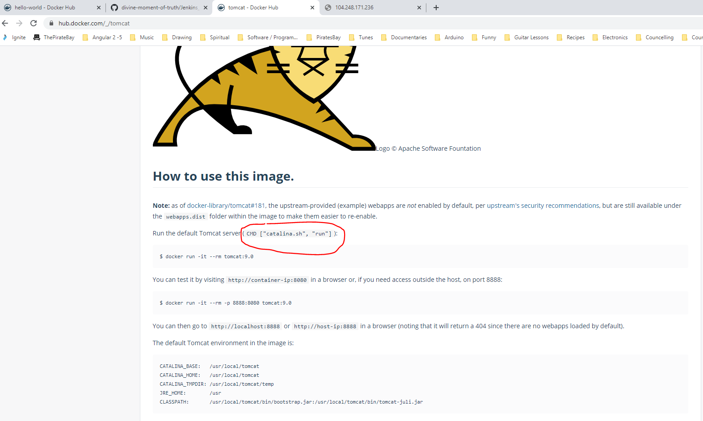

Now modify the ‘Jenkinsfile’ to run the above Docker script:-

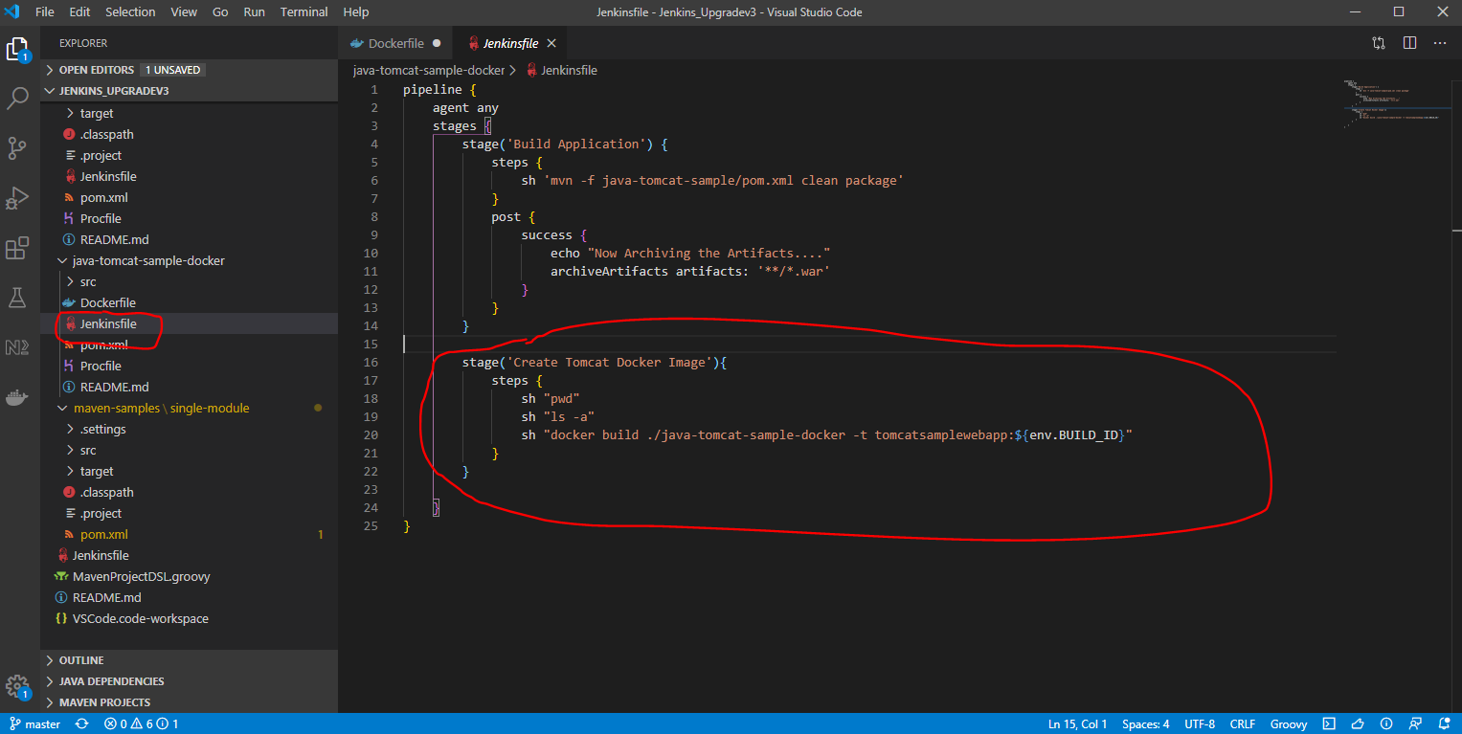

**Build and tag Docker Images:-**

Go to Jenkins and create a new view:-

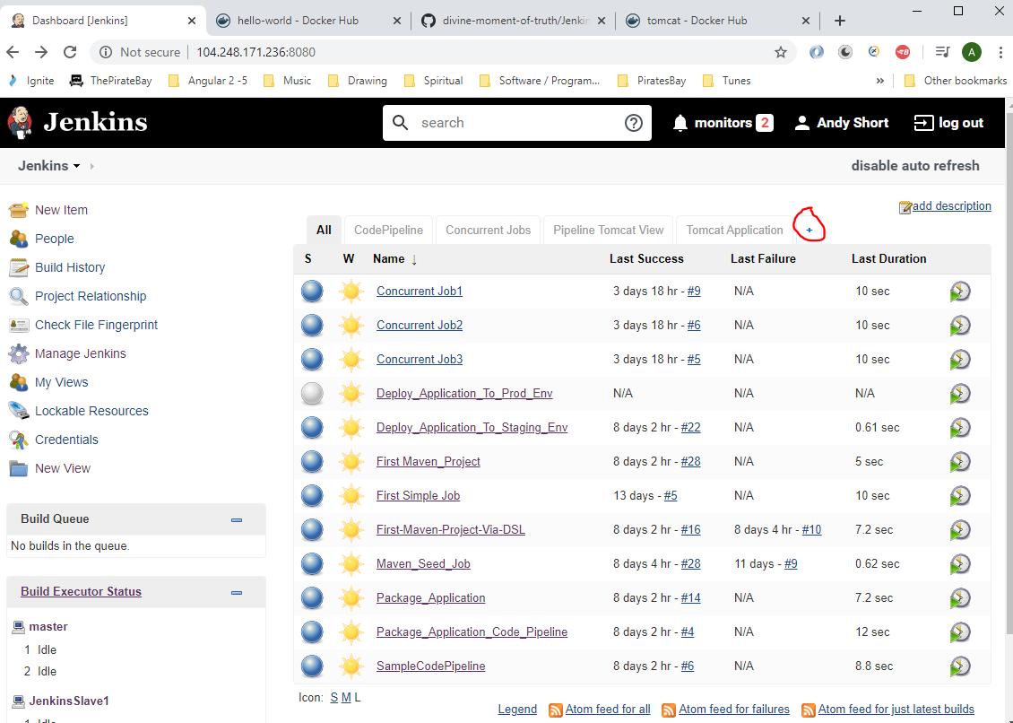

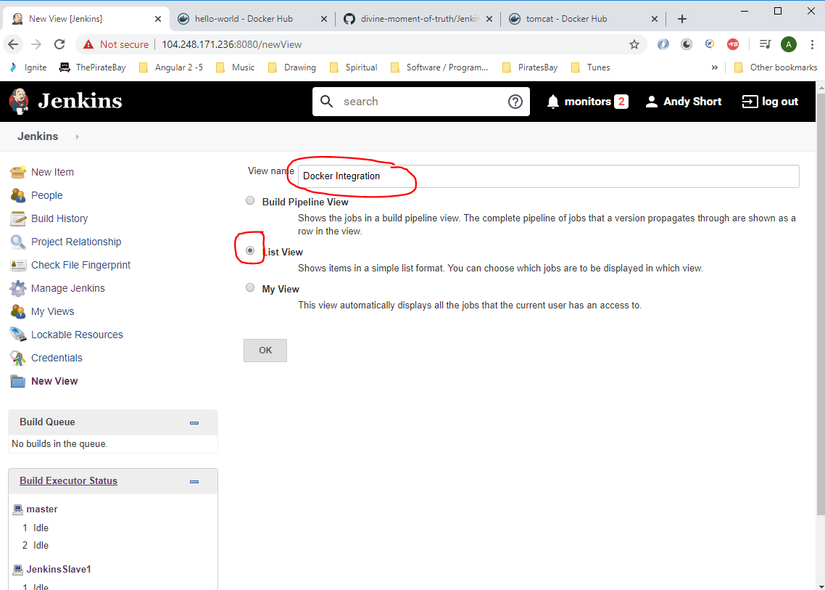

Now go to GitHub and create a new repo:-

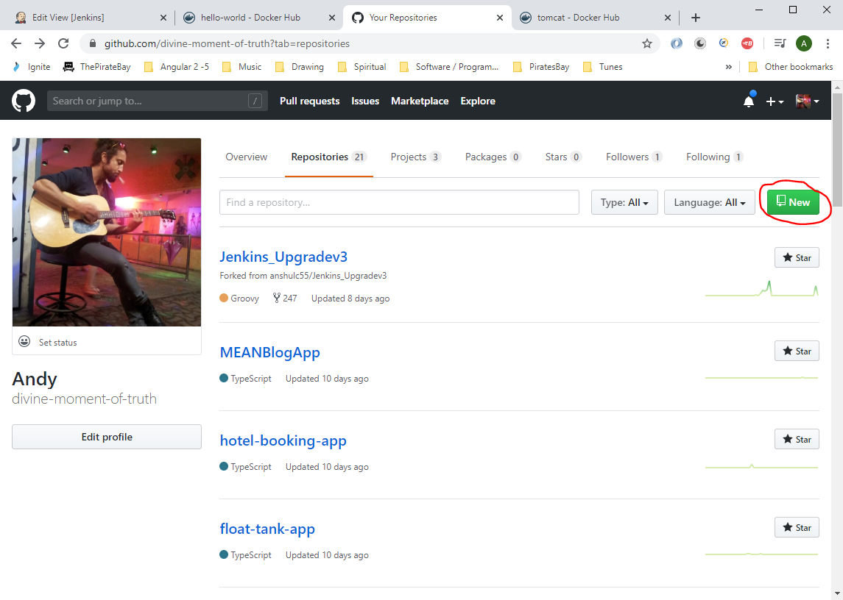

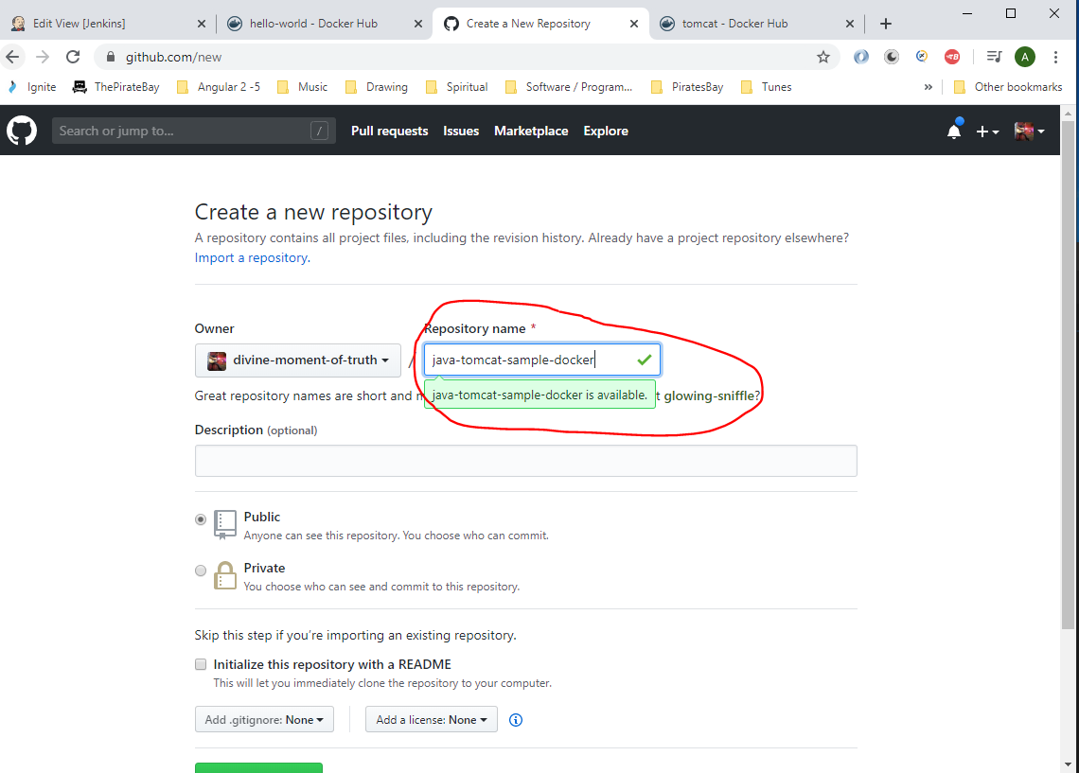

The click ‘create repository’ button.

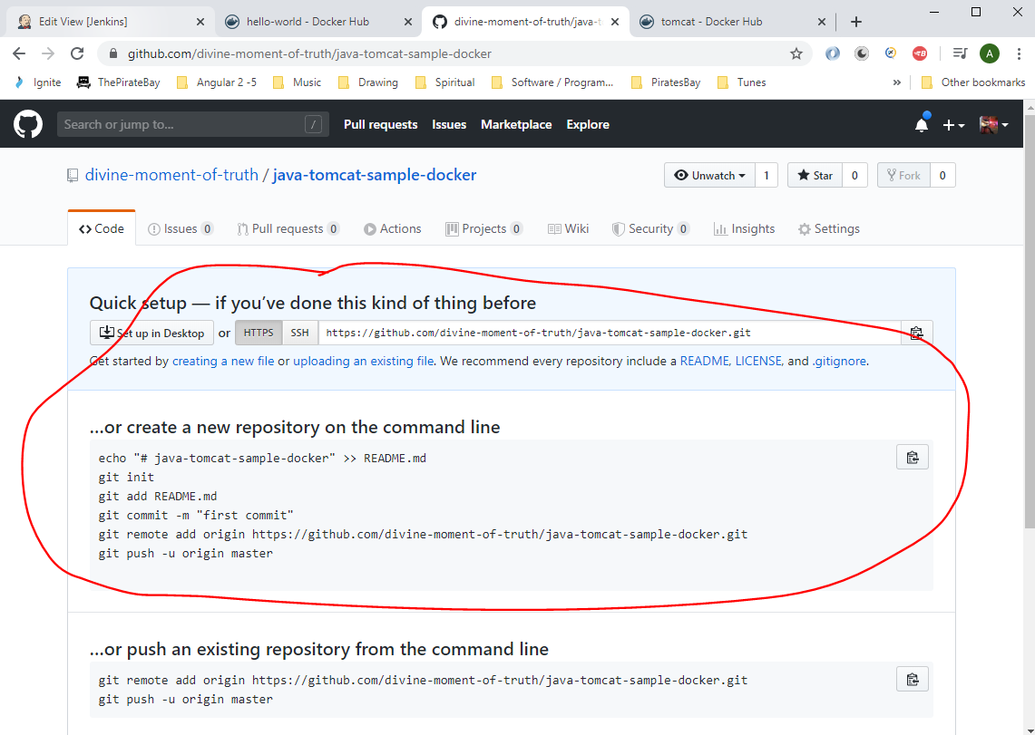

On your local directory now make a copy of your project folder:-

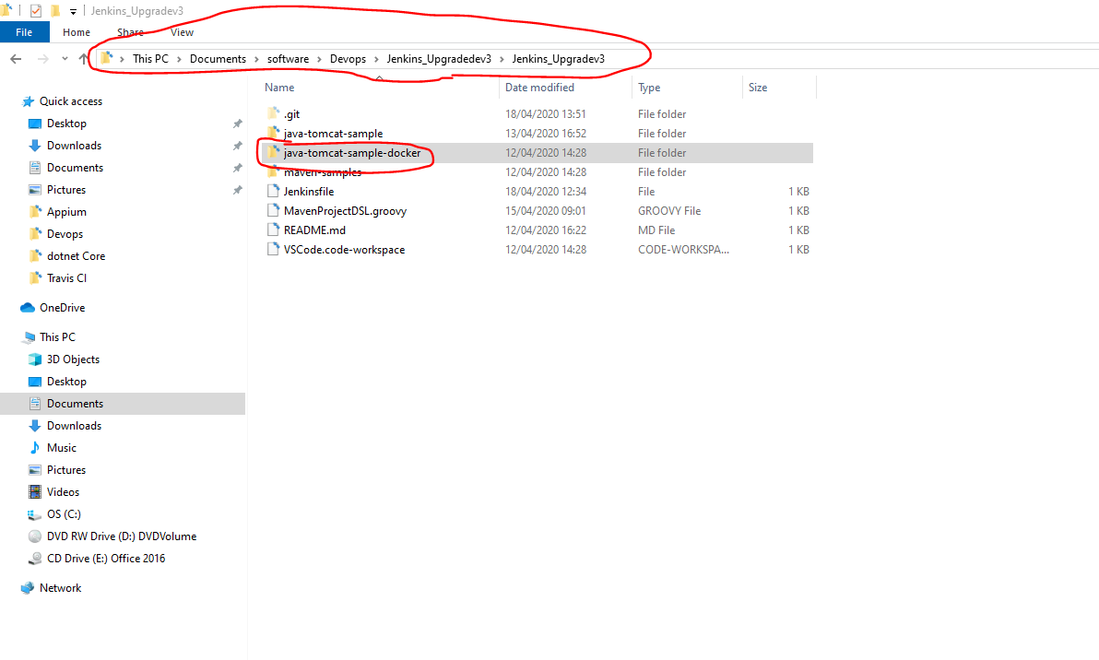

Paste project here:-

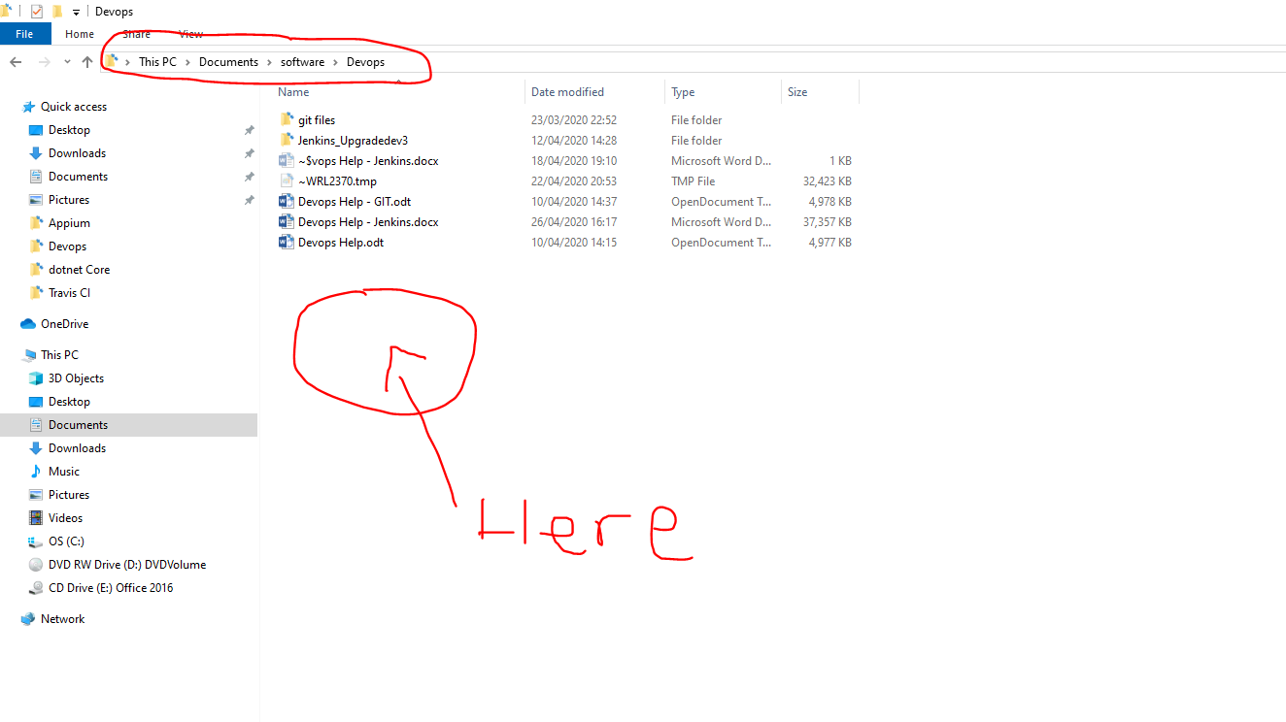

See location:-

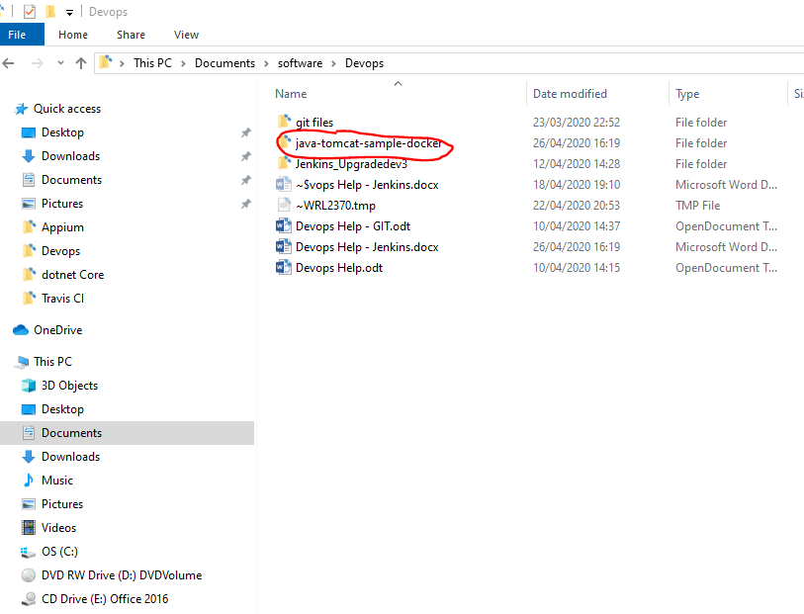

Now open Git Bash in the project folder:-

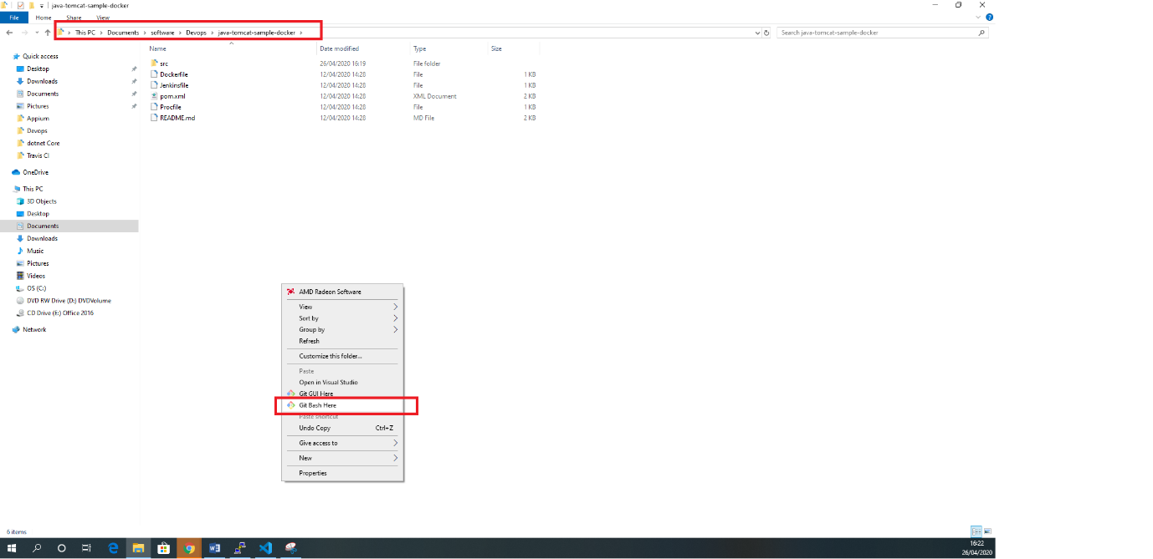

Now enter the Git commands from the repo in Git Hub into Git Bash terminal:-

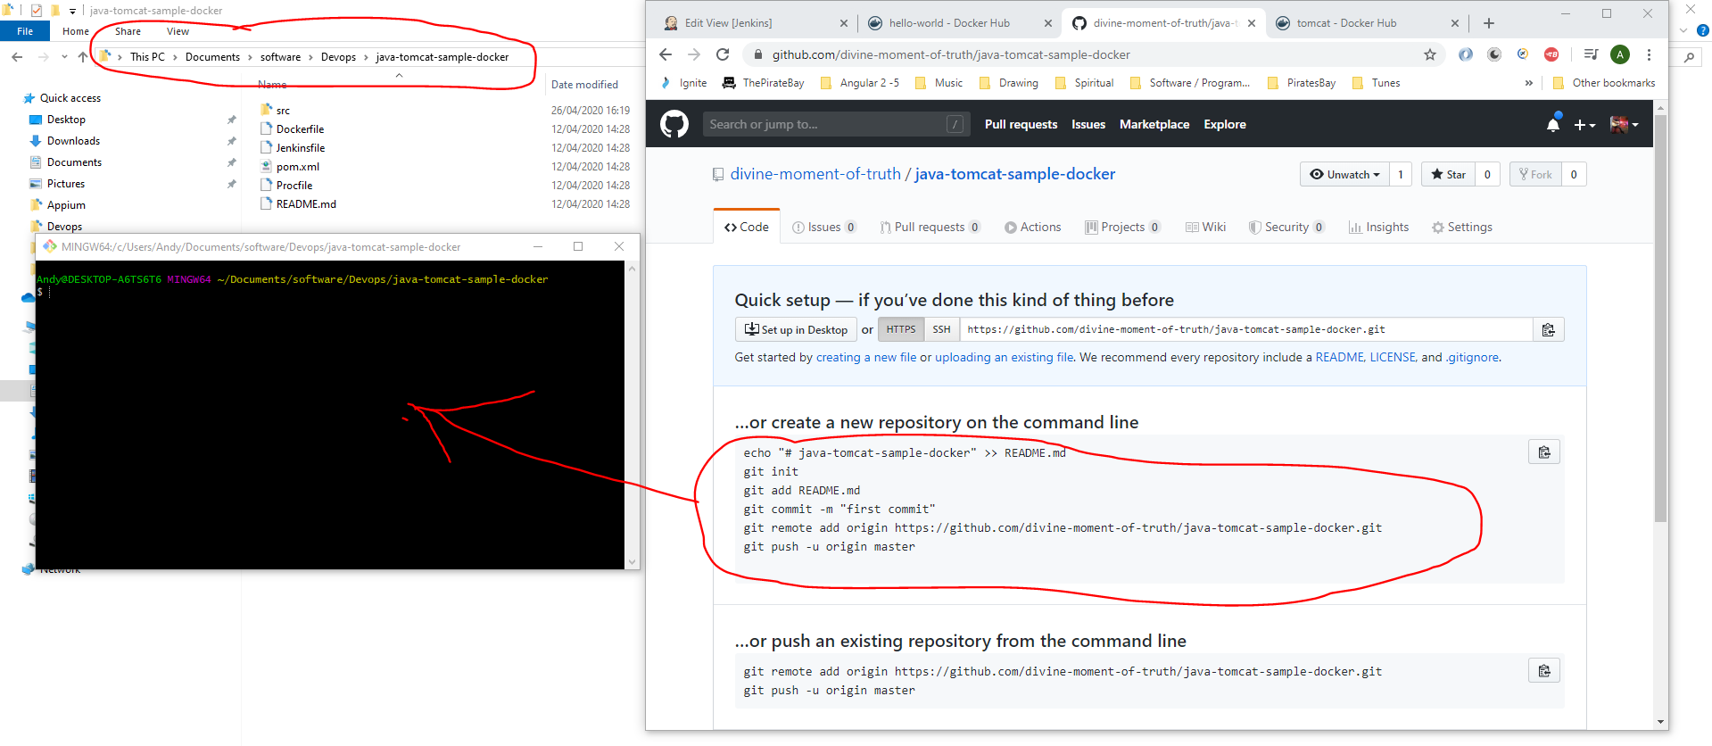

See commands entered into Git Bash:-

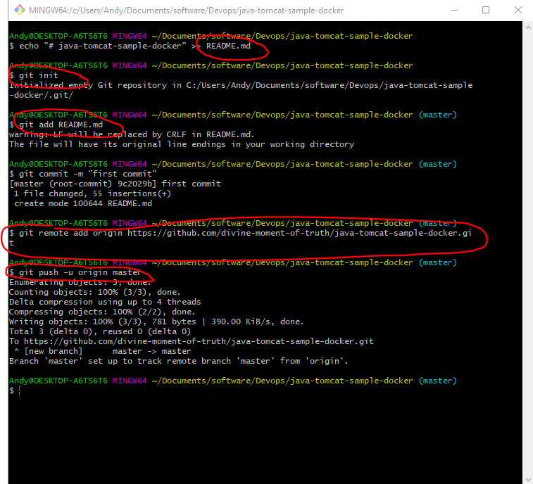

Now commit your project to the GitHub repo:-

*git add .*

*git commit -am “Docker project”*

*git push*

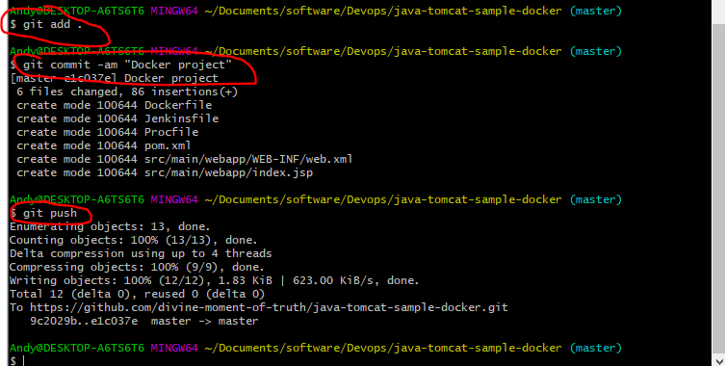

See uploaded file in GitHub repo now:-

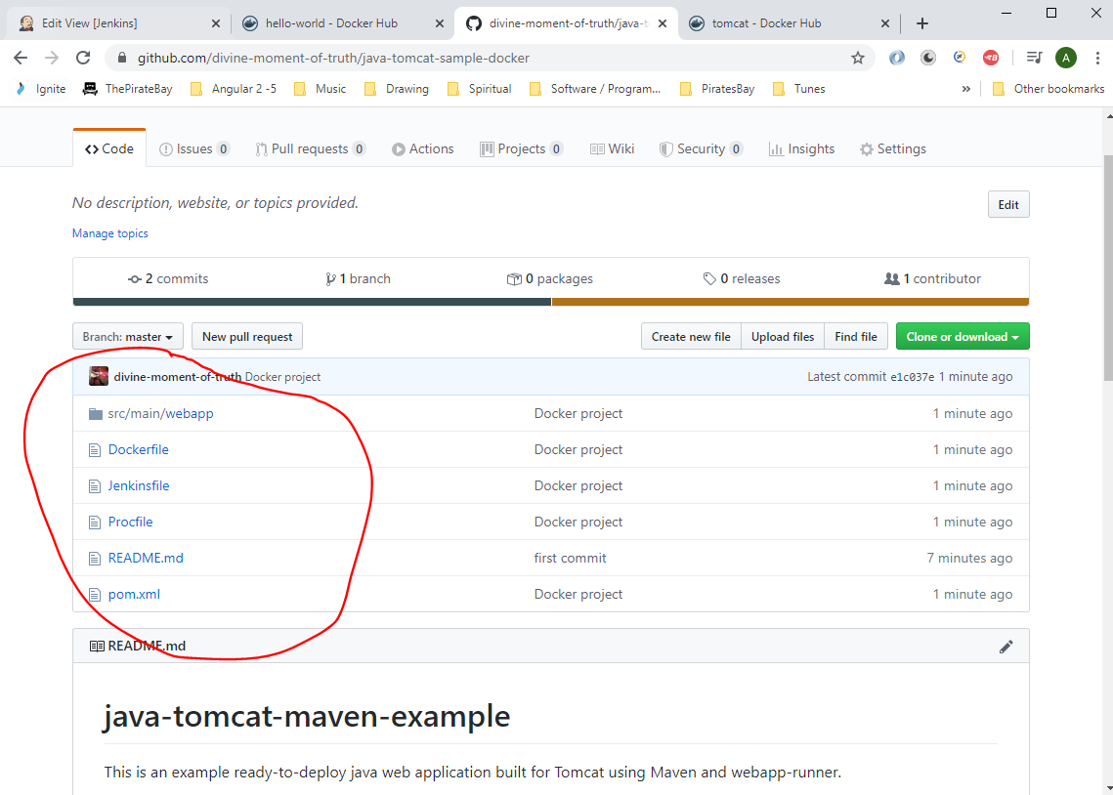

Now modify Jenkins file to use this new repo:-

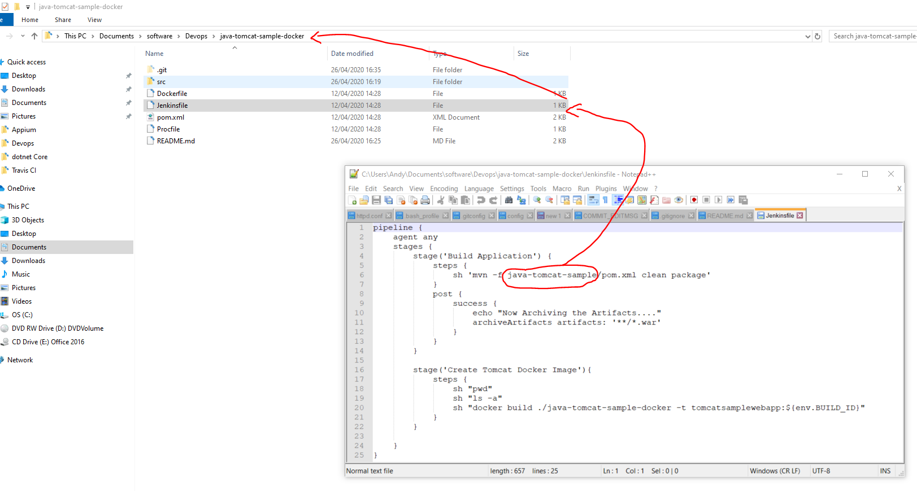

Remove the above path – ‘java-tomcat-sample/’ because the pom.xml file is in the same directory as the ‘Jenkinsfile’.

Also, remove this part:-

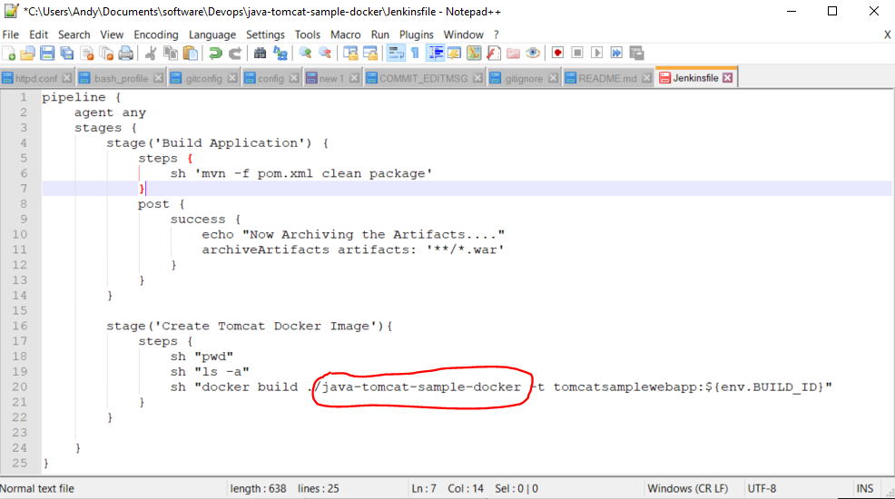

So file now looks like this:-

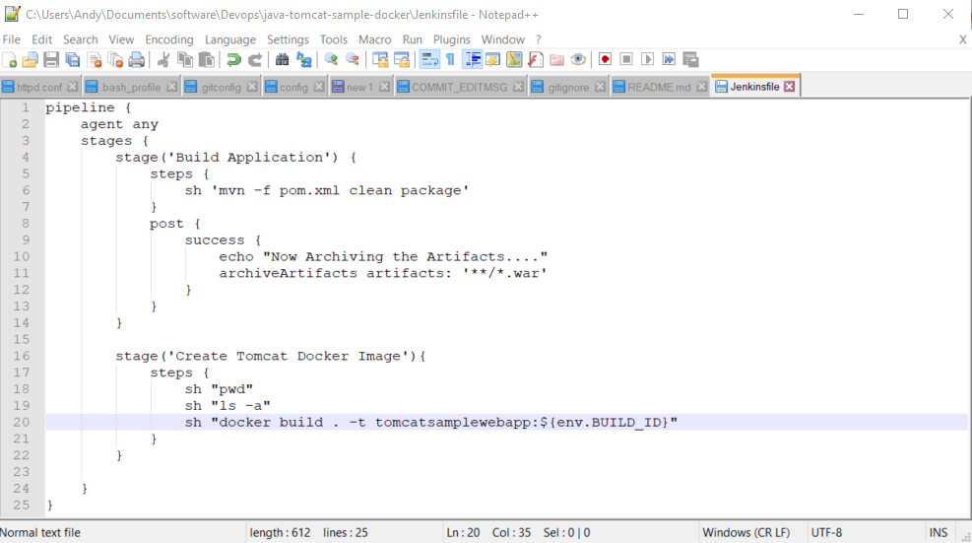

Now save file and commit and push to remote repo in GitHub. Type the following in Git Bash:-

*git add .*

*git commit -am “Modified Jenkinsfile”*

*git push*

Now go to the Jenkins server and create a new job under the ‘Docker Integration’ tab:-

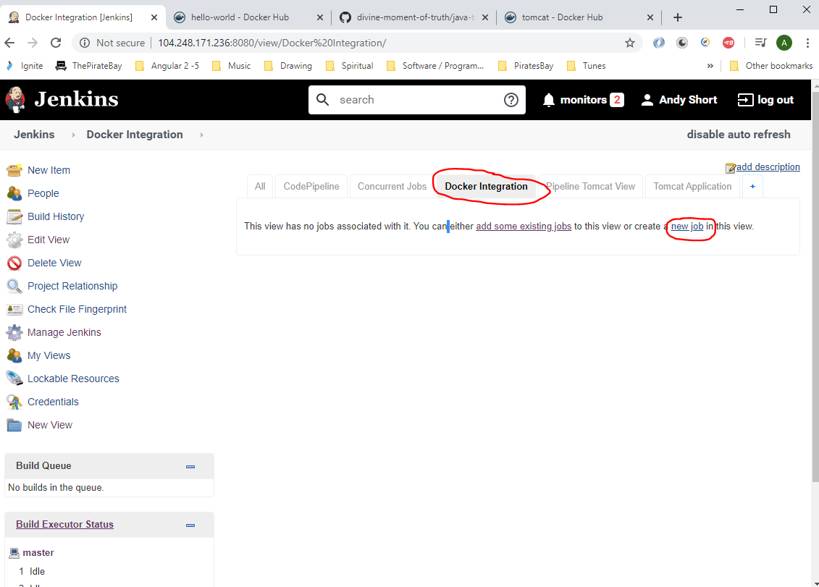

Enter the following:-

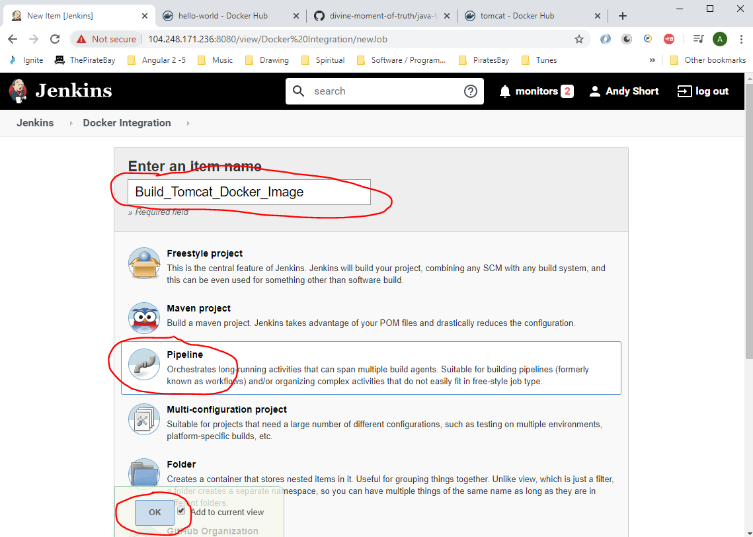

Enter the following:-

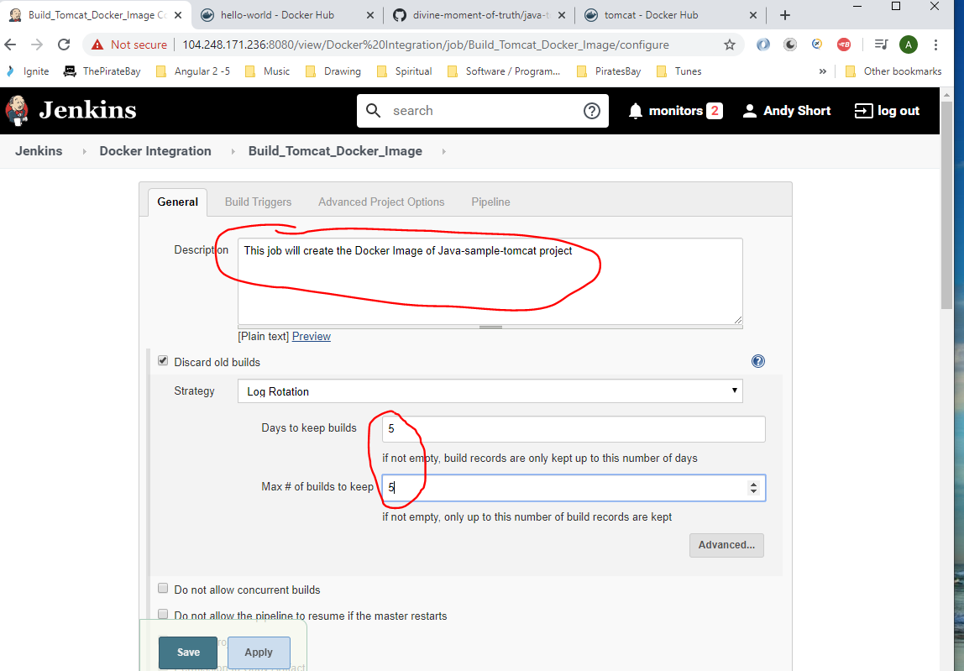

Select this:-

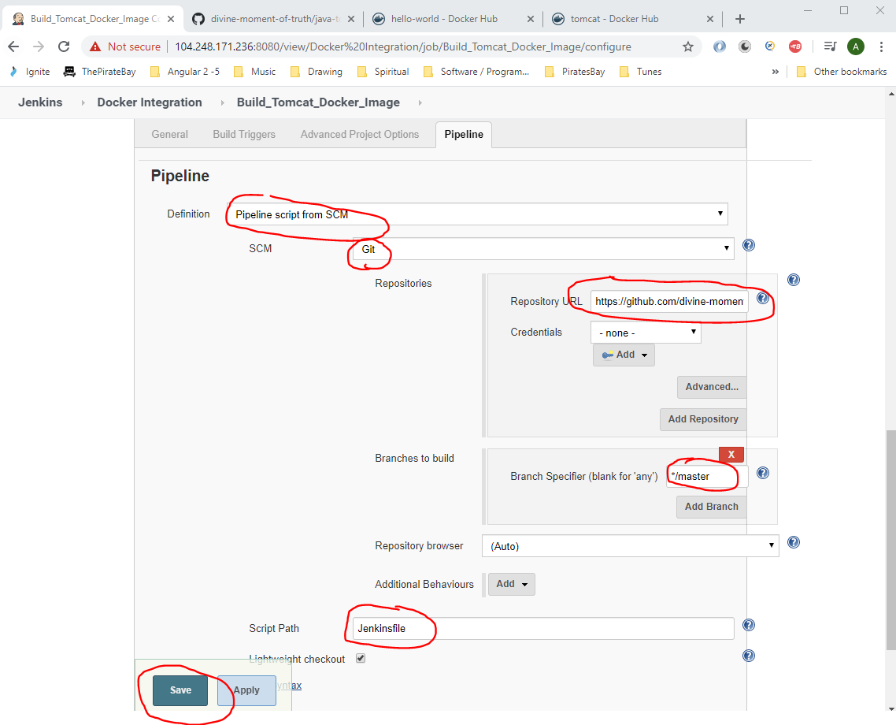 Click ‘Save’. Then click ‘Build Now’ to execute this job.

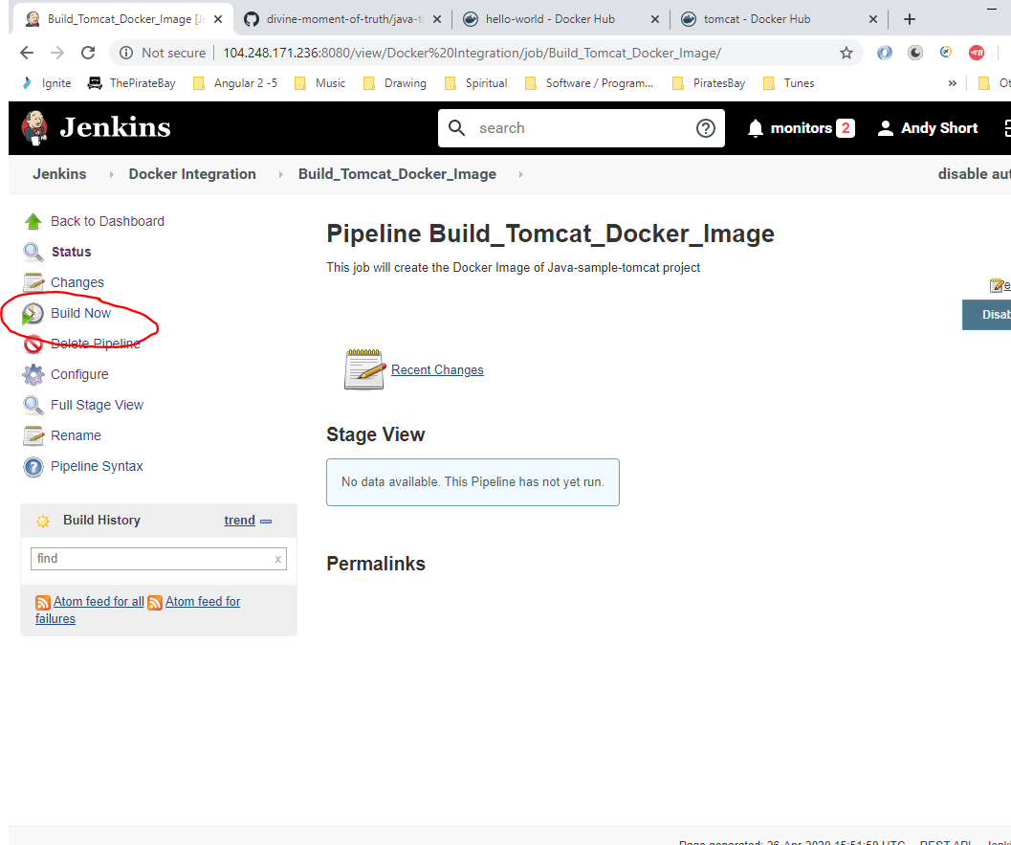

There is an error when running see below:-

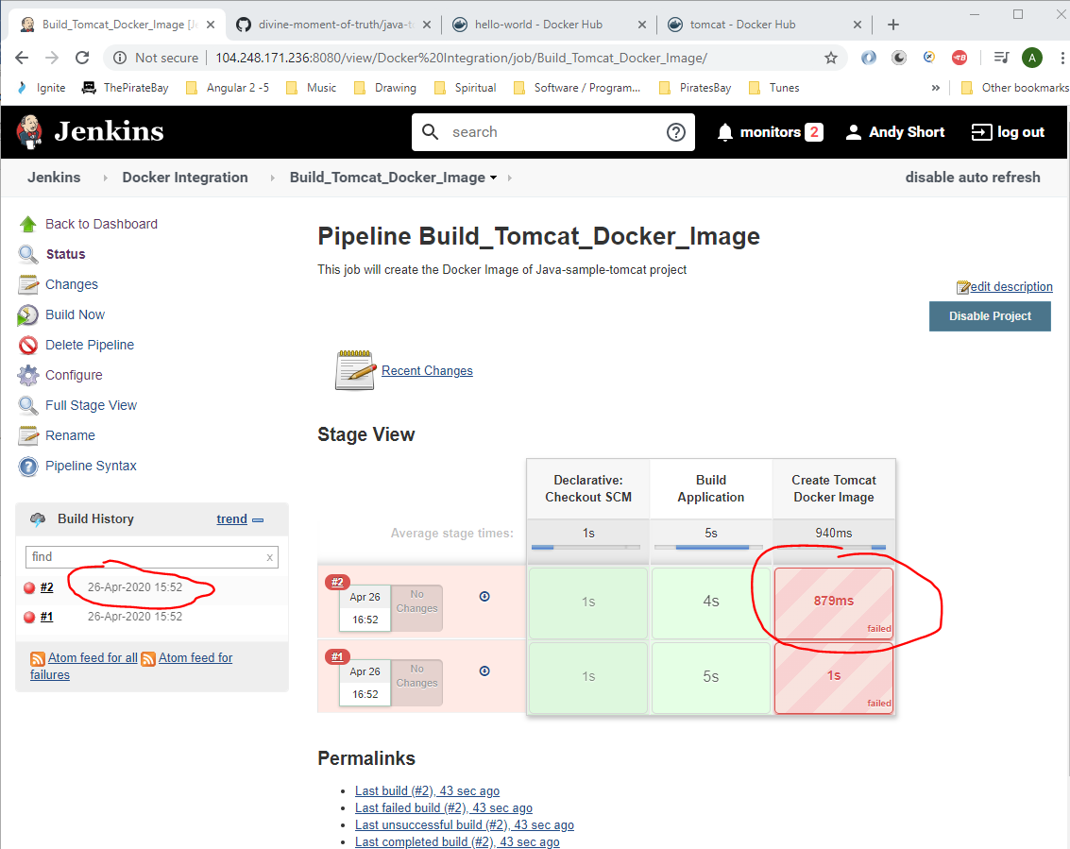

Click on the time stamp to view error in console.

Change the ‘Dockerfile’ (see section below):-

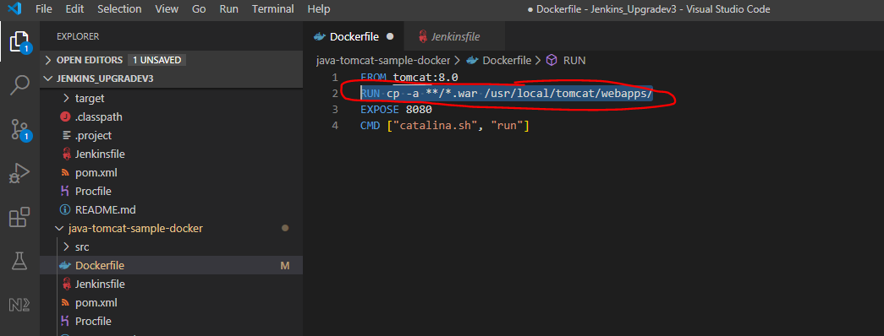

Change to:-

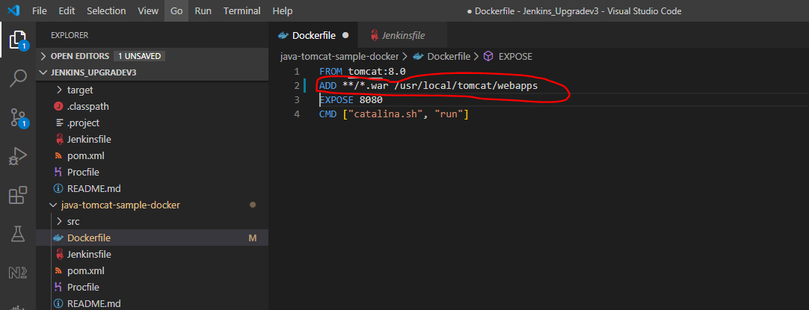

Then commit and push changes to git hub remote repo:-

*git add .*

*git commit -am “Modified Dockerfile”*

*git push*

Then go to Jenkin s again and click ‘Build Now’ again.

The last step may fail (see below):-

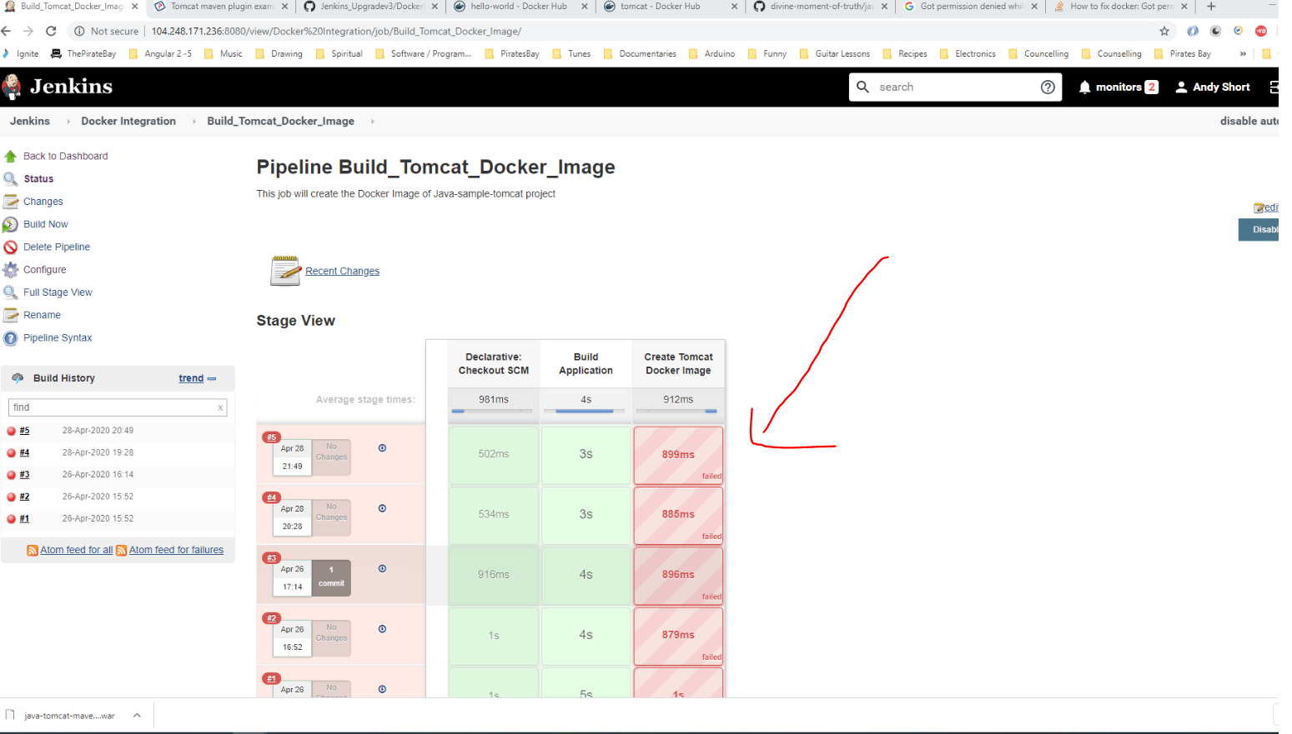

Clicking on Console Output gives this:-

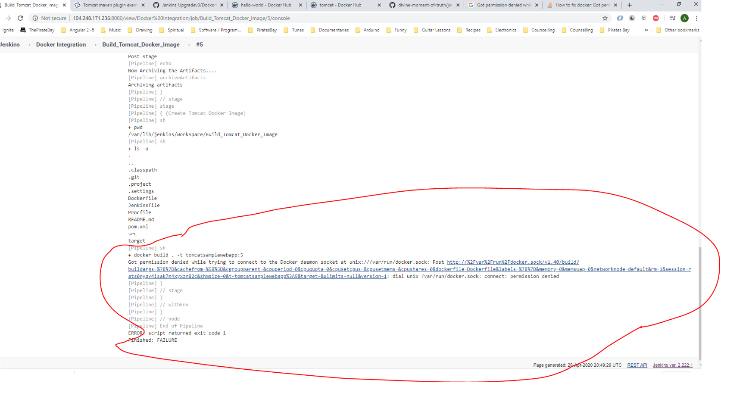

This issue is caused by the user that is creating the Docker imagine does not have enough privileges. These can be added by going to the Master Putty session and logging in and entering the following commands:-

*sudo groupadd docker*

*sudo usermod -a -G docker jenkins*

*sudo chmod 666 /var/run/docker.sock*

*newgrp docker*

The following command line restarts the machine:-

*Systemctrl restart Jenkins*

Now run the BUILD NOW job in Jenkins. See it passes:-

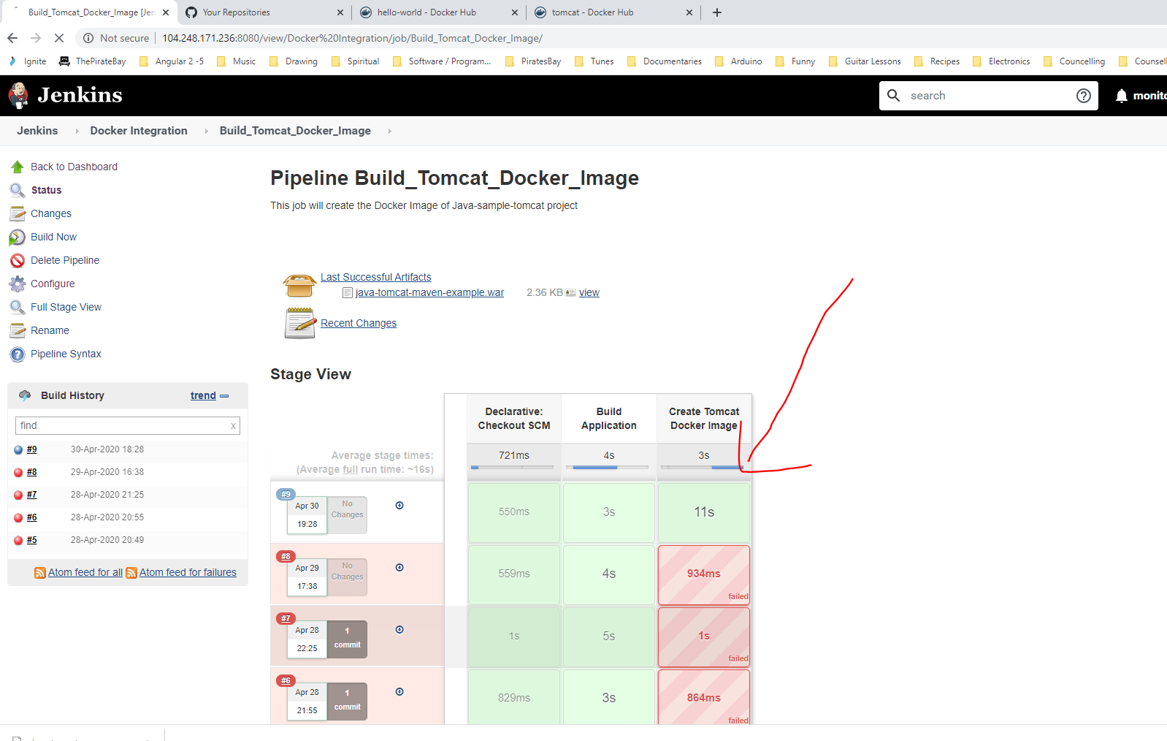

Now to test that the Tomcat image has been created go to Putty and type this:-

*docker images*

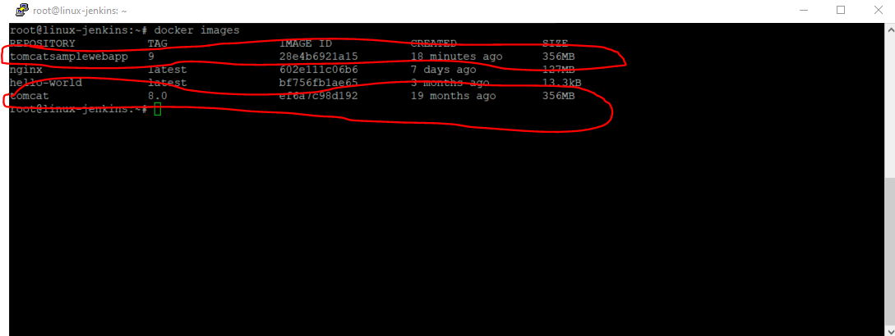

To run/start the ‘tomcatsamplewebapp’ on the cloud machine type the following into Putty:-

***docker container run -p 9090:8080 tomcatsamplewebapp:11***

9090 - this is the port we want to connect to the tocat server on

8080 - this is the port that we exposed in the container (see Dockerfile below):_

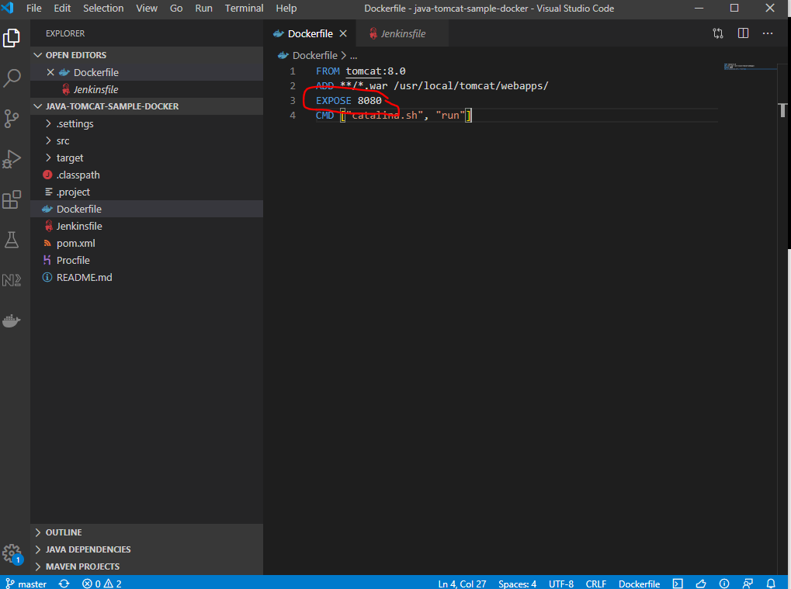

*tomcatsamplewebapp - Comes from screen shot below*

11 - comes from screen shot below too

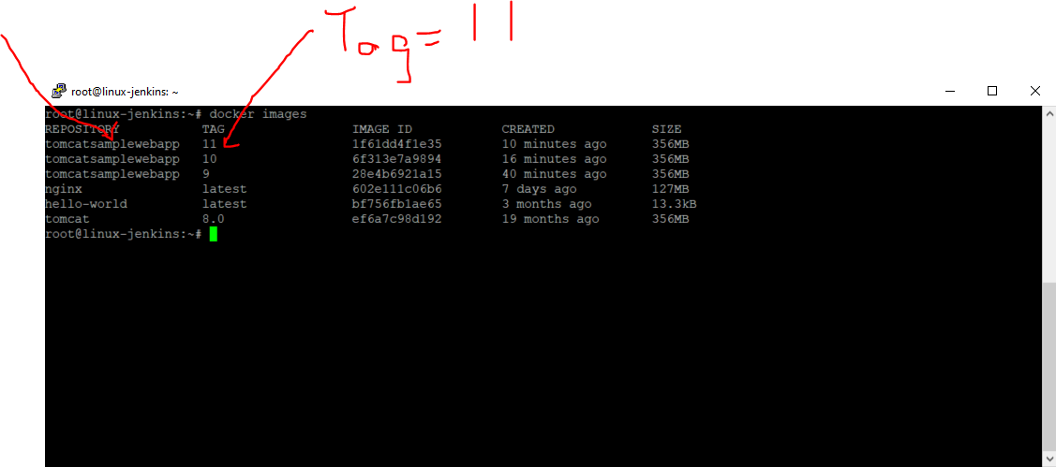

Press [ENTER]

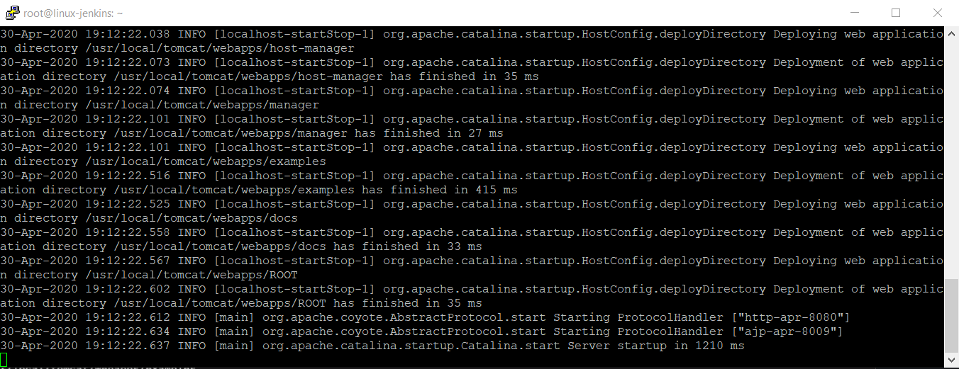

Tomcat server has started up.

To check that the tomcat server has started enter the following into the browser on your local machine:-

<http://104.248.171.236:9090/>

104.248.171.236 - this is the ip where the Jenkins machine is and also where the tomcat server is running in the Docker container

9090 - this was the port that we set the container to be connected on.

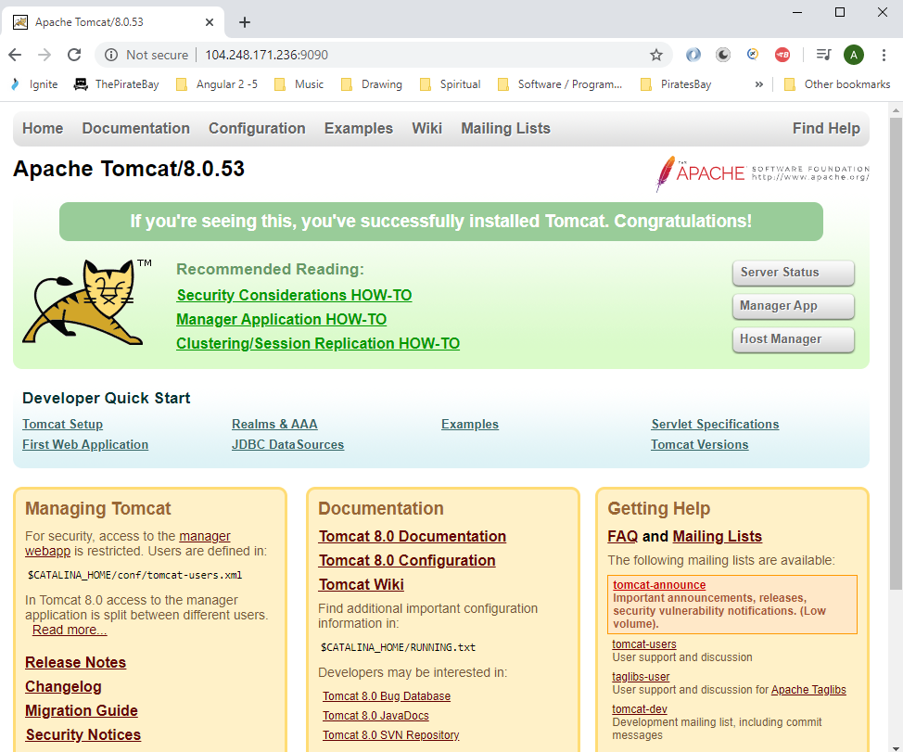

To access the application you will need to add the name of your jar file. This name will come from here:-

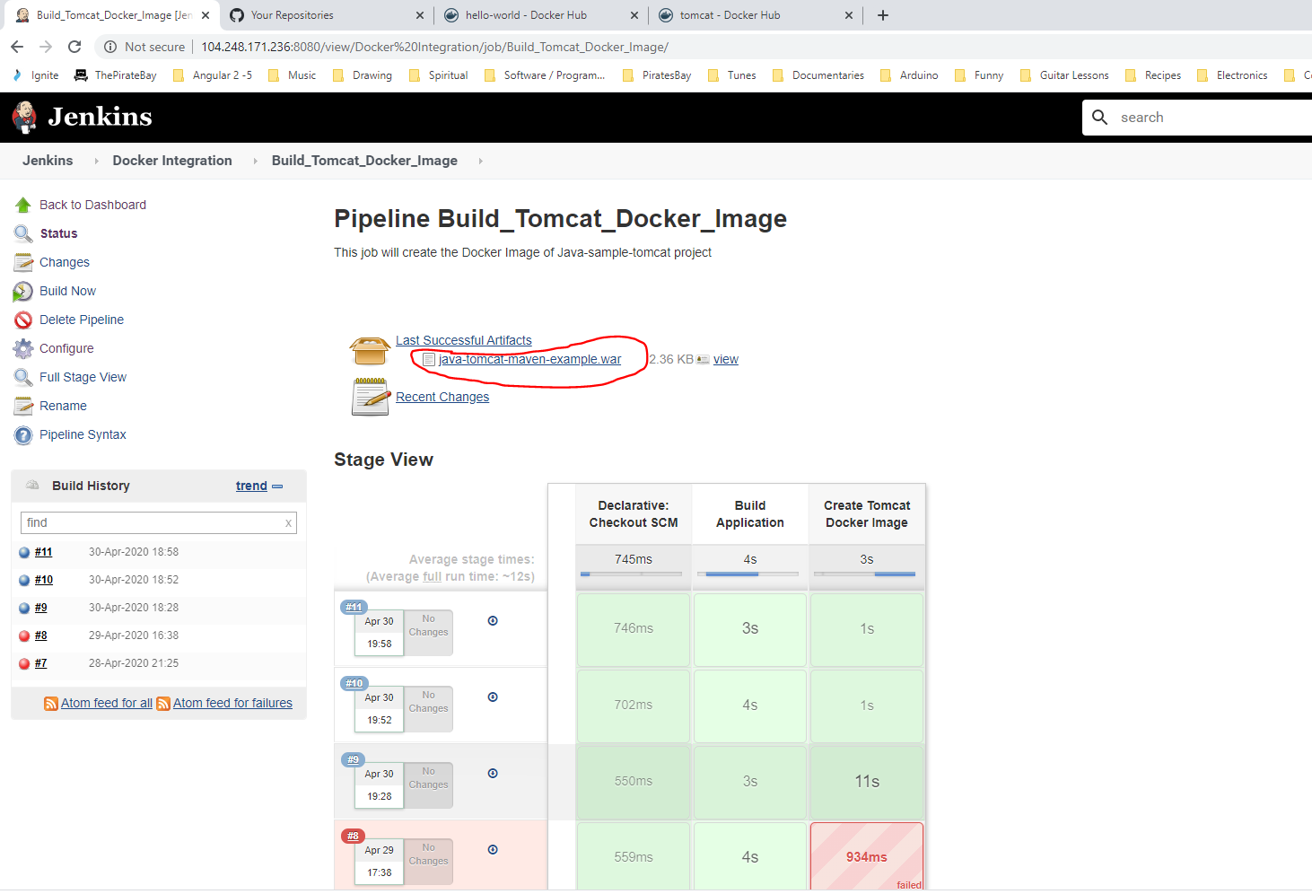

So add this to the browser address (remove the .war bit though):-

<http://104.248.171.236:9090/java-tomcat-maven-example/>

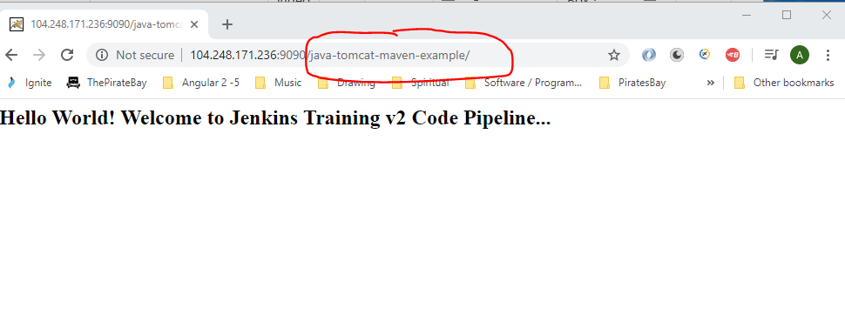

The above file can be found in the project here:-

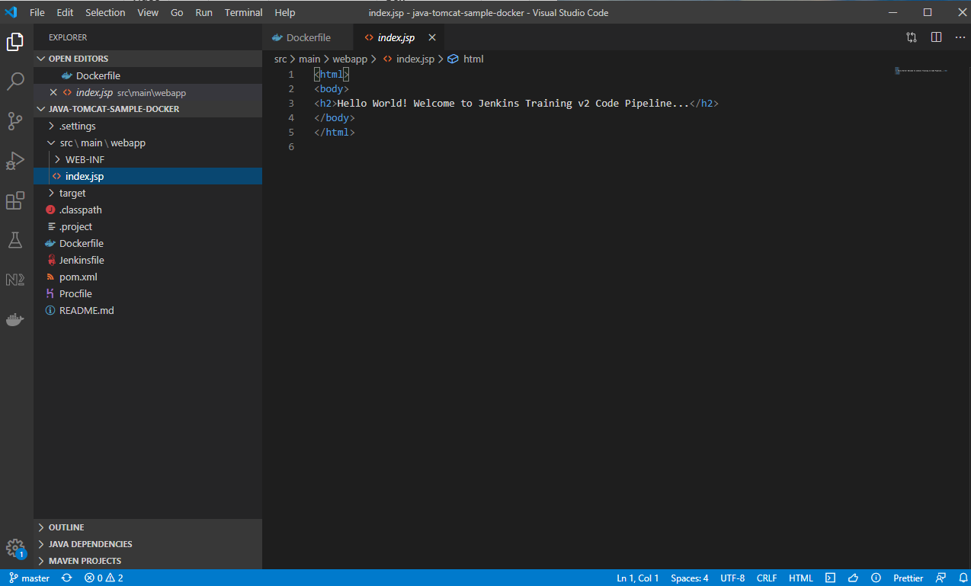

Make a change to the above file:-

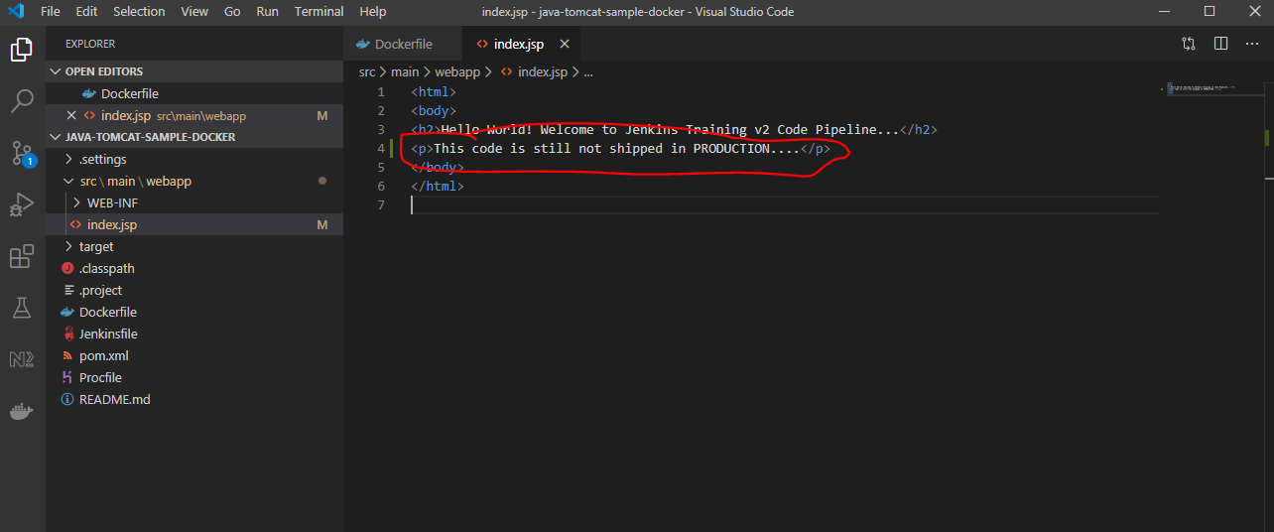

Modify your Jenkins job:-

Click on ‘Configuration’:-

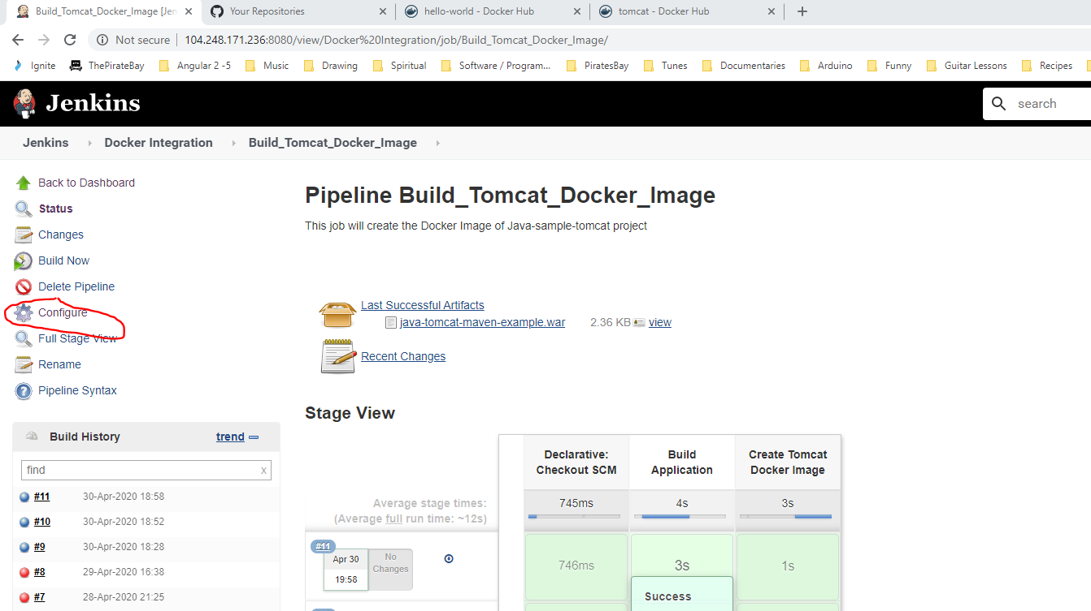

Then add this:-

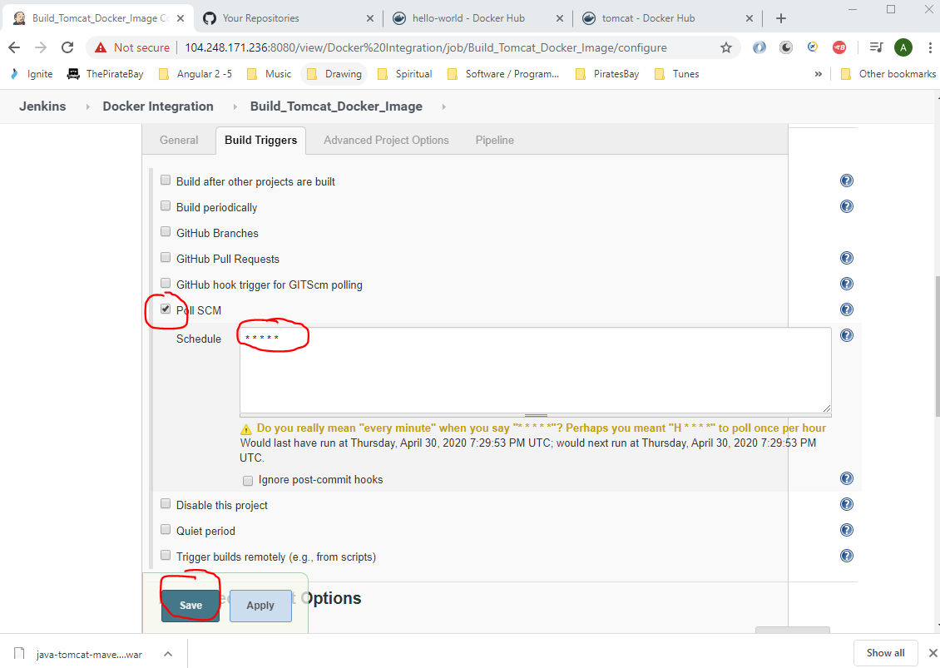

So that any changes to the Git repo then a new build will be trigger and installed into the Docker container.

Now commit code changes in Git Bash:-

*git add .*

*git commit –am “Changed index.jsp file”*

*git push*

Now, see that new Jenkins job has automatically been kicked off:-

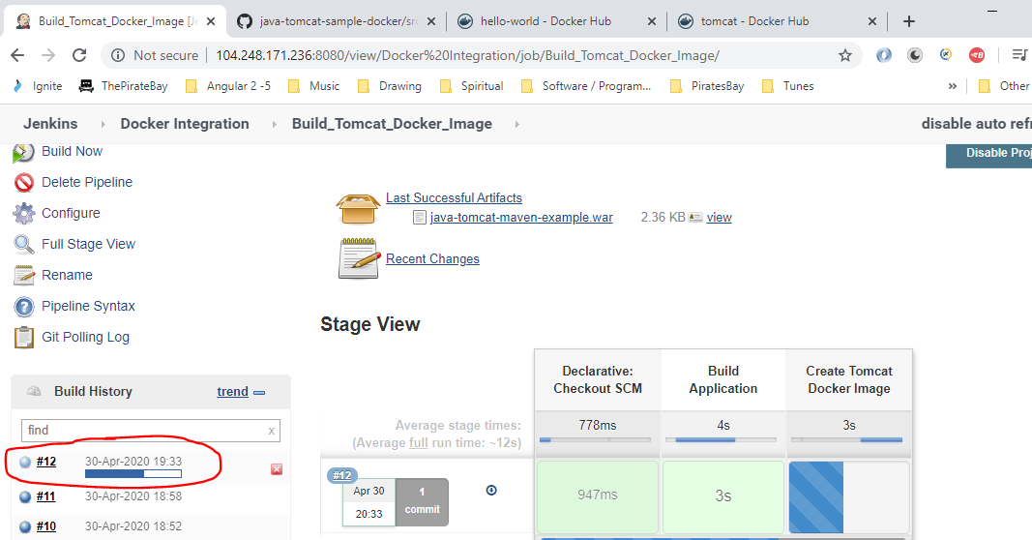

Now open a new Putty session and see new image created for the Tomcatwebapp:-

Type:-

*docker images*

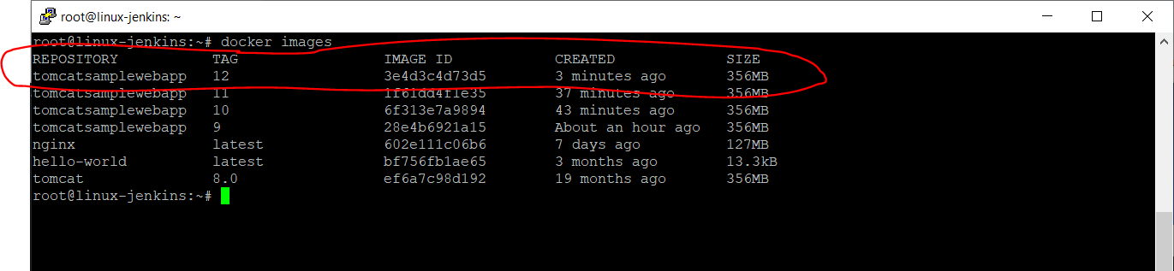

Then to run the above application type:-

***docker container run -p 9095:8080 tomcatsamplewebapp:12***

Note the port 9095 was used in this case, and TAG 12 is used because this is the new tomcatsamplewebapp TAG number.

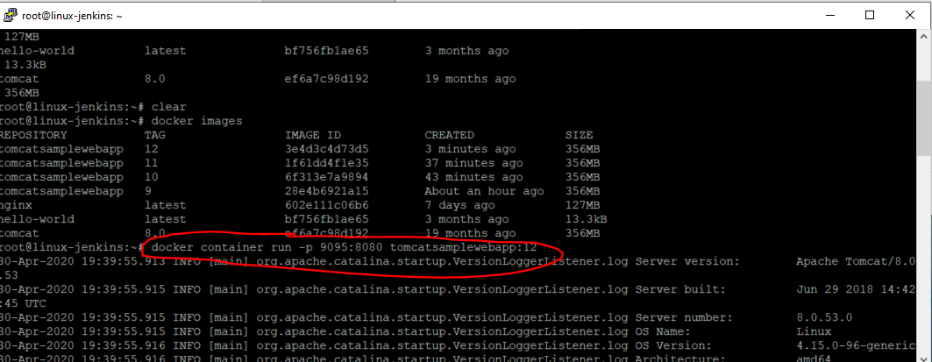

Enter the following into a new browser:-

<http://104.248.171.236:9095/java-tomcat-maven-example/>

See new line of code:-

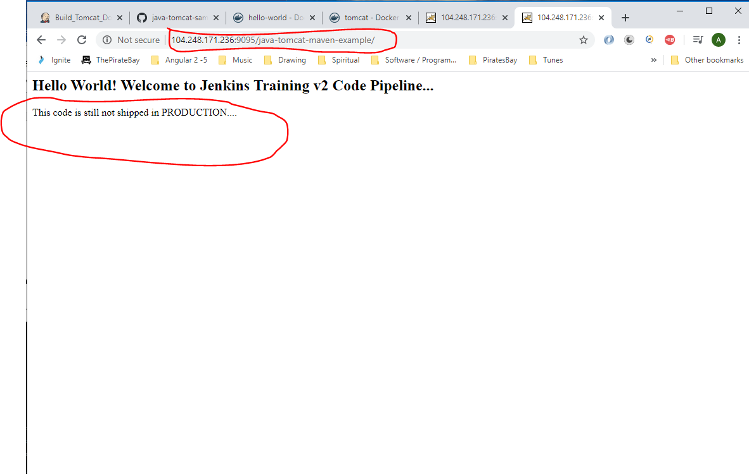

**APPENDIX**

**To test if Java is installed on your local machine (your laptop) – THIS IS NOT REQUIRED THOUGH – IT IS JUST FOR REFERENCE**

Open command prompt and type the following to get Java version that is installed:-

java --version

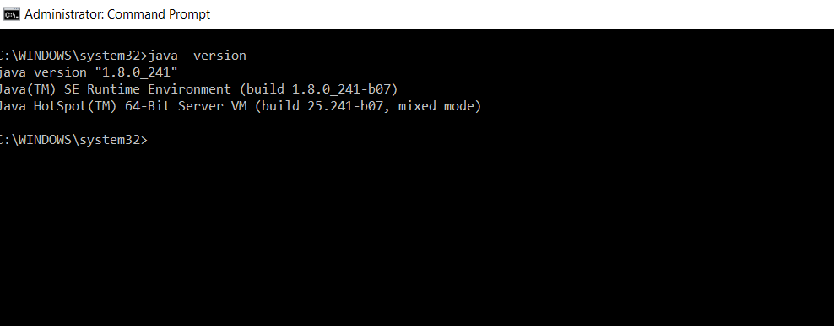

The above version is 1.8.0_241 - this means that Java version 8 with update 241 is installed.

(This is the correct version that needs to be installed).

If you need to install Java 8 then click the link below:-

<https://www.oracle.com/technetwork/java/javase/overview/java8-2100321.html>

To log onto my Digital Ocean linux-jenkins machine:-

IP Address:- 104.248.171.236

username:- root

password:- dudeegg1977

My Jenkins login:-

URL:- http://104.248.171.236:8080/

username:- test_king77

password:- dudeegg1977